新聞資料NEWS LETTER
MIRDC Tree-planting Event Creating a Beautiful New Forest Life

MIRDC was established in 1963, it has long been accompanying the industry in the face of internal environmental changes and rapid changes in the global industry and has worked hand in hand with the industry and academia to move forward. Under the impact of global warming and rapid climate change, energy conservation and carbon reduction have become a global trend. In recent years, MIRDC has invested heavily in technology R&D in the fields of sustainable forward-looking energy, low carbon, carbon negative, recycling, and other net-zero technologies, and also assisted the government in promoting the training of carbon management talents, carbon footprint verification and the introduction of low-carbon technologies, and uses the power of scientific research to assist the industry in its net-zero transformation.

In this year marking the 60th anniversary of MIRDC, MIRDC is eager to actively contribute to the Earth and carbon reduction efforts. Tree planting is one effective way to reduce carbon emissions and mitigate climate change. In addition to using the power of research to drive national policies and assist industries, MIRDC is leading by example in greening the environment. Through tree-planting activities, it aims to contribute to Earth's protection, minimize the negative impact of greenhouse gas emissions on the environment, and play its part in addressing climate change. Therefore, on December 5, 2023, a public tree-planting event was held in District 15 of Qieding. The tree planting area is located on the south side of Qieding Wetland, a bird-watching resort for black-faced spoonbills. It was originally the Chuhu Salt Flat but gradually fell into disuse after being exposed to the sun. It is a local-level wetland and one of the winter habitats for migratory birds in southern Taiwan. Through corporate adoption, MIRDC gives new life meaning to this barren land. MIRDC adopted a total of 300 saplings this time and cooperated with I Plant For Life Corporation Aggregate to maintain the newly planted saplings for three years and then return them to nature, allowing them to coexist and grow with the surrounding environment. This not only represents MIRDC's determination and hard work to preserve nature, but more importantly, it accentuates that MIRDC is a part of Kaohsiung and has a strong connection and mission to local industries and regional development.

This event was led by Chairman Ren-Yi Lin and President Yung-Hsiang Lai, accompanied by 20 first-level executives who personally participated in the planting. Throughout the process, participants were guided in selecting tree species and properly watering the trees within the context of ecological knowledge. They also gained insights into the damage caused by invasive species to the land and the importance of protecting native plant habitats. Furthermore, participants deepened their understanding of how native tree species overcome water scarcity and soil salinization. Each sapling planted during the event symbolized hope, emphasizing the importance of forests and promoting the spirit of environmental sustainability. It signifies the extension of environmental consciousness into everyone's daily lives, contributing collectively to the creation of an urban forest. The tree-planting activity serves as a pledge for MIRDC to uplift its green and environmentally conscious initiatives, paving the way for a prosperous coexistence with forests.

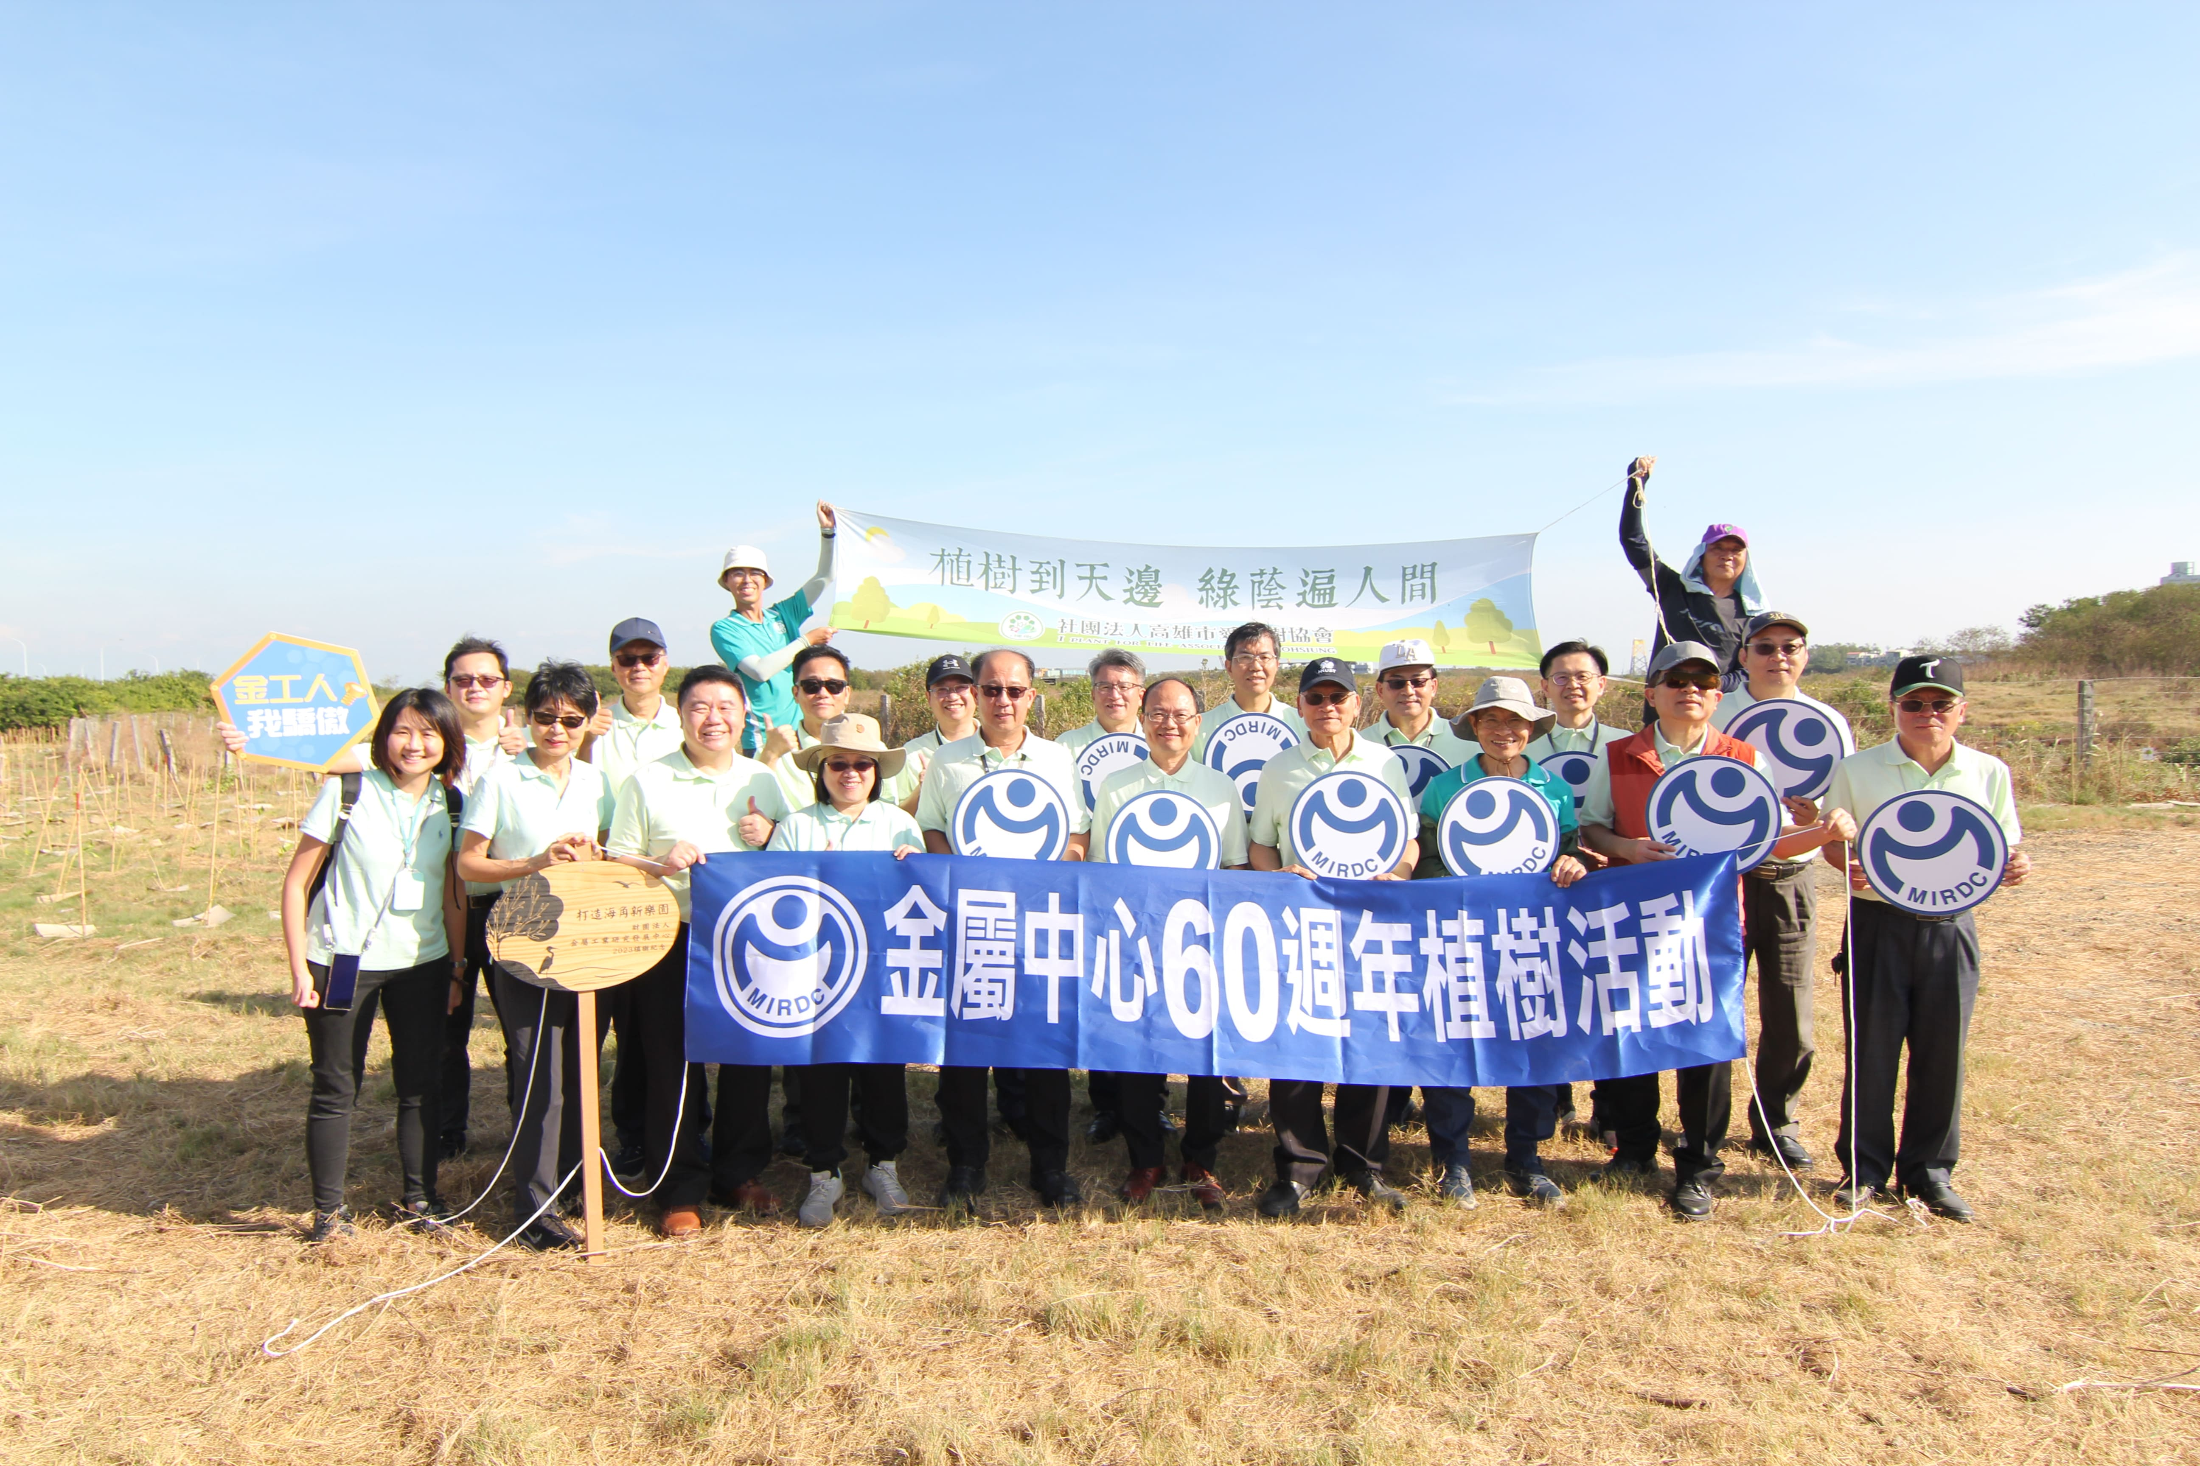

Picture 1、Group photo of the managers of MIRDC at the public tree-planting event

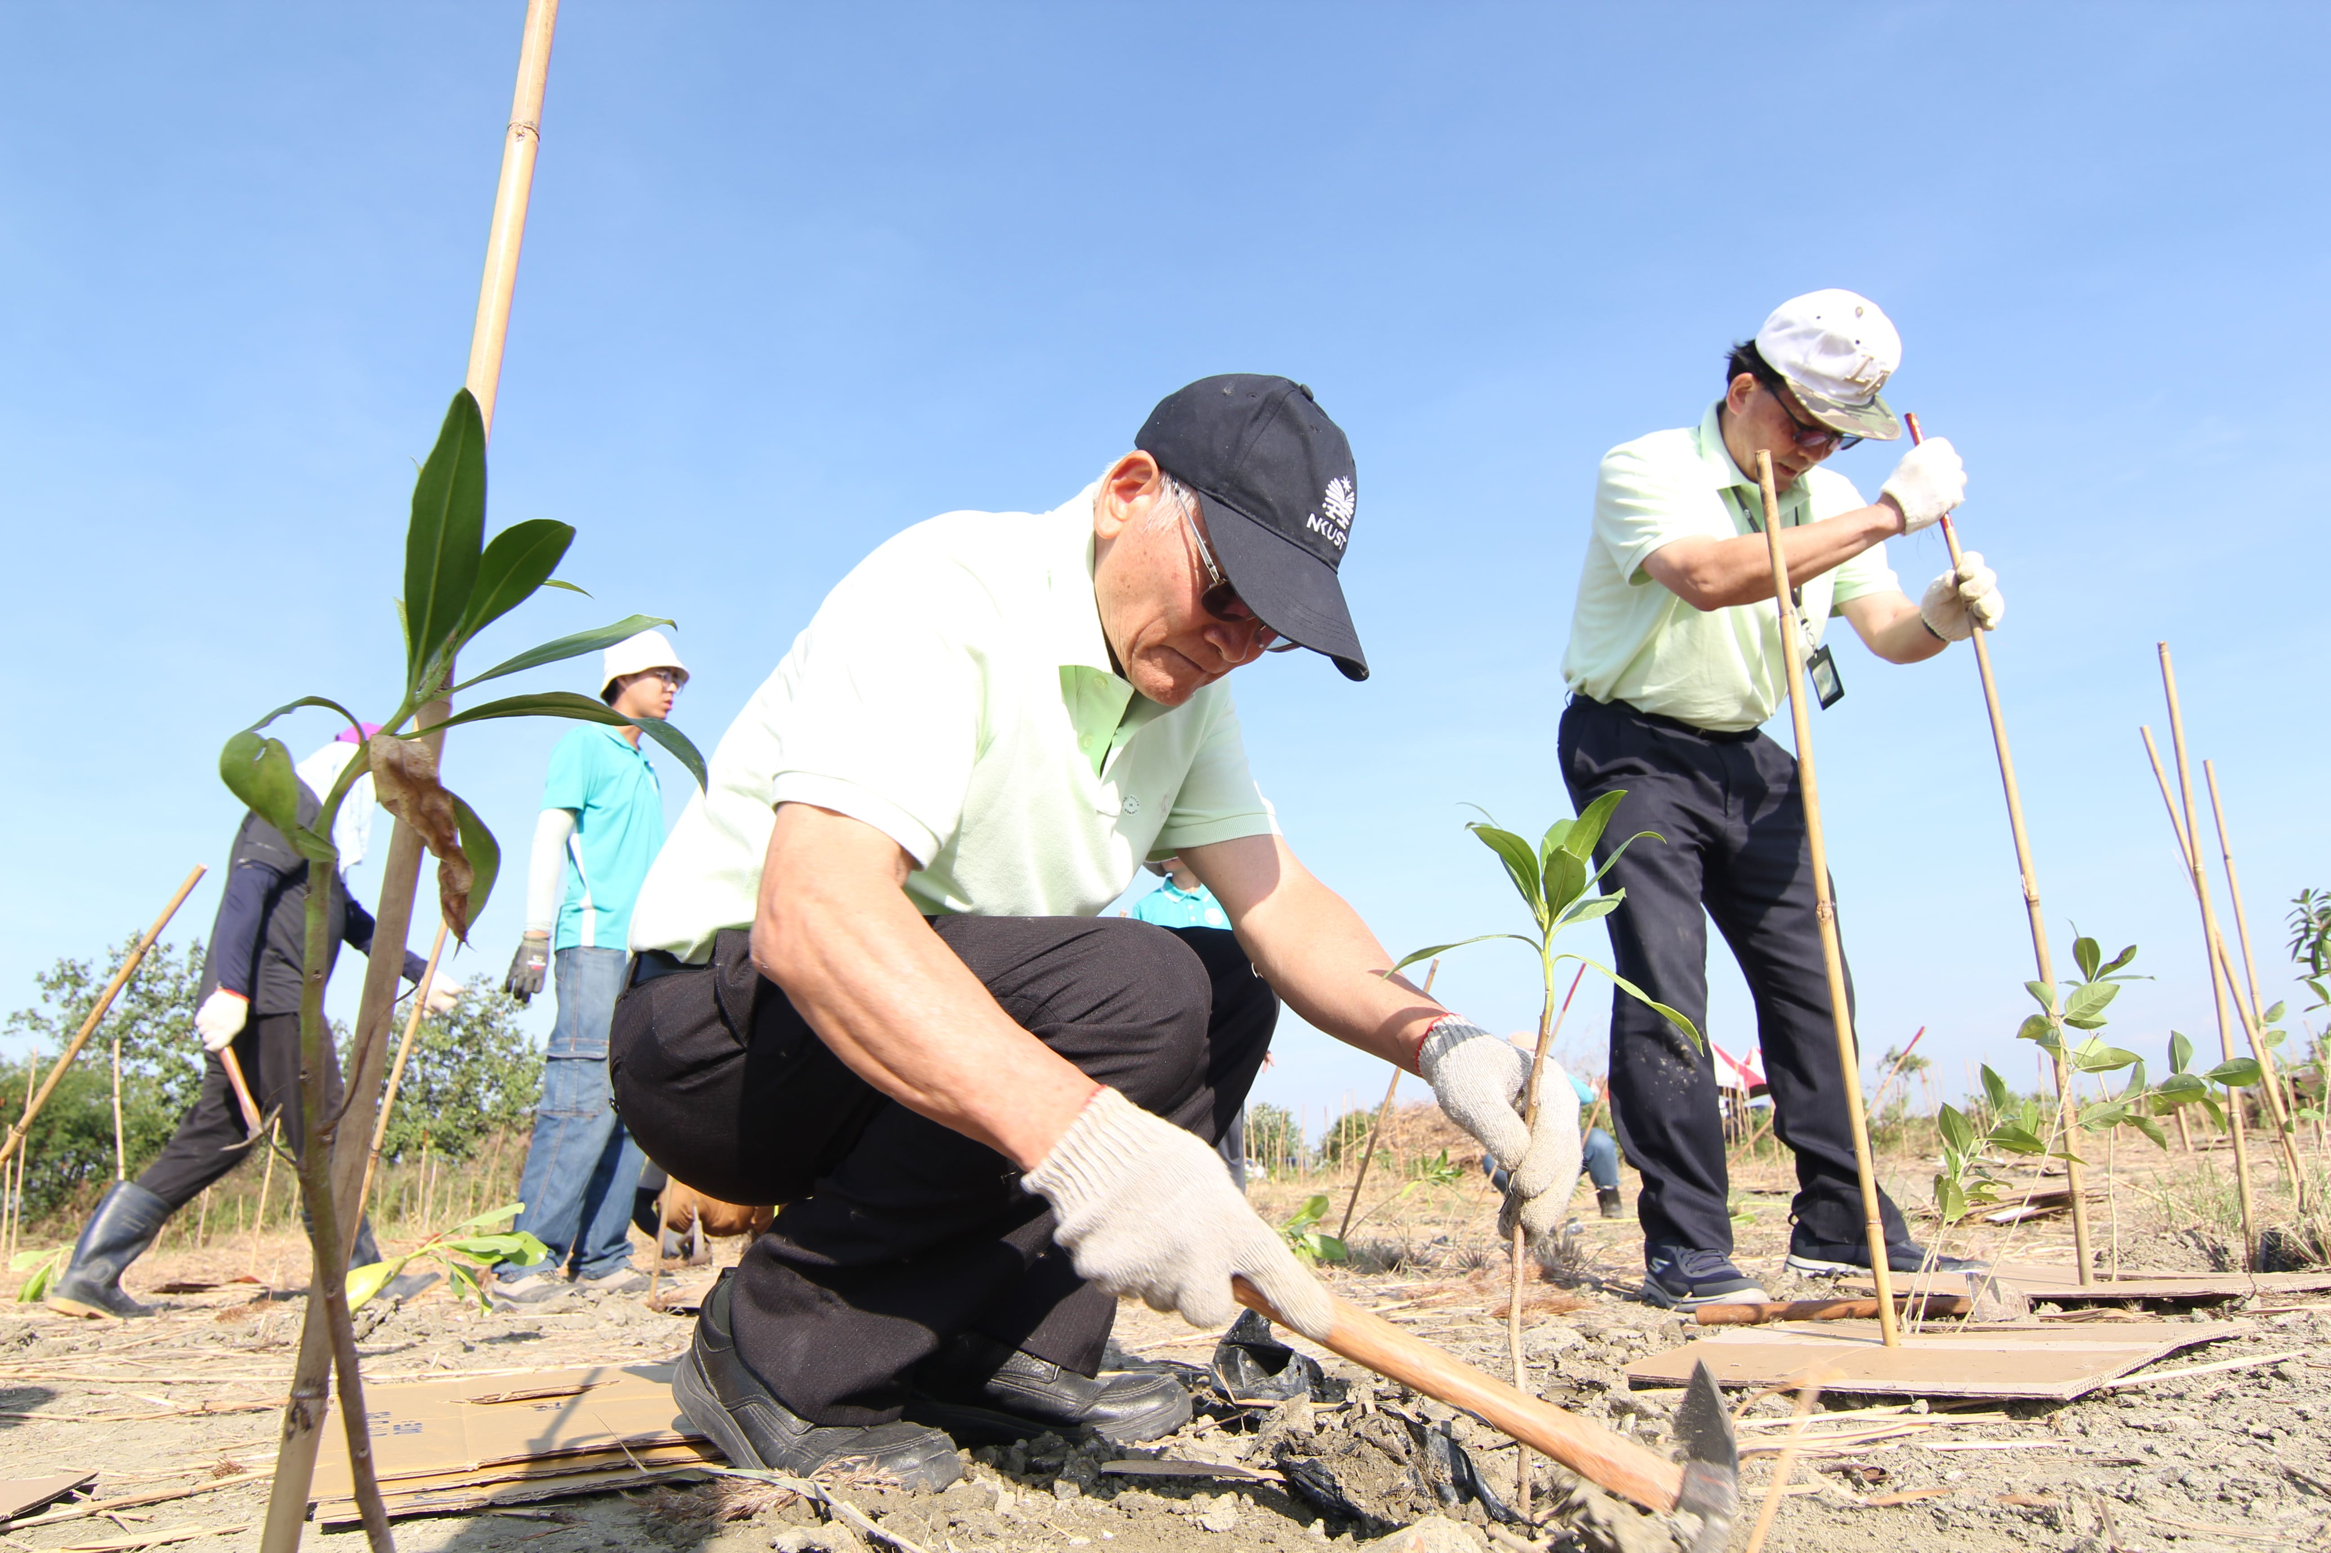

Picture 2、MIRDC Chairman Ren-Yi Lin plants a sapling as a symbol of hope

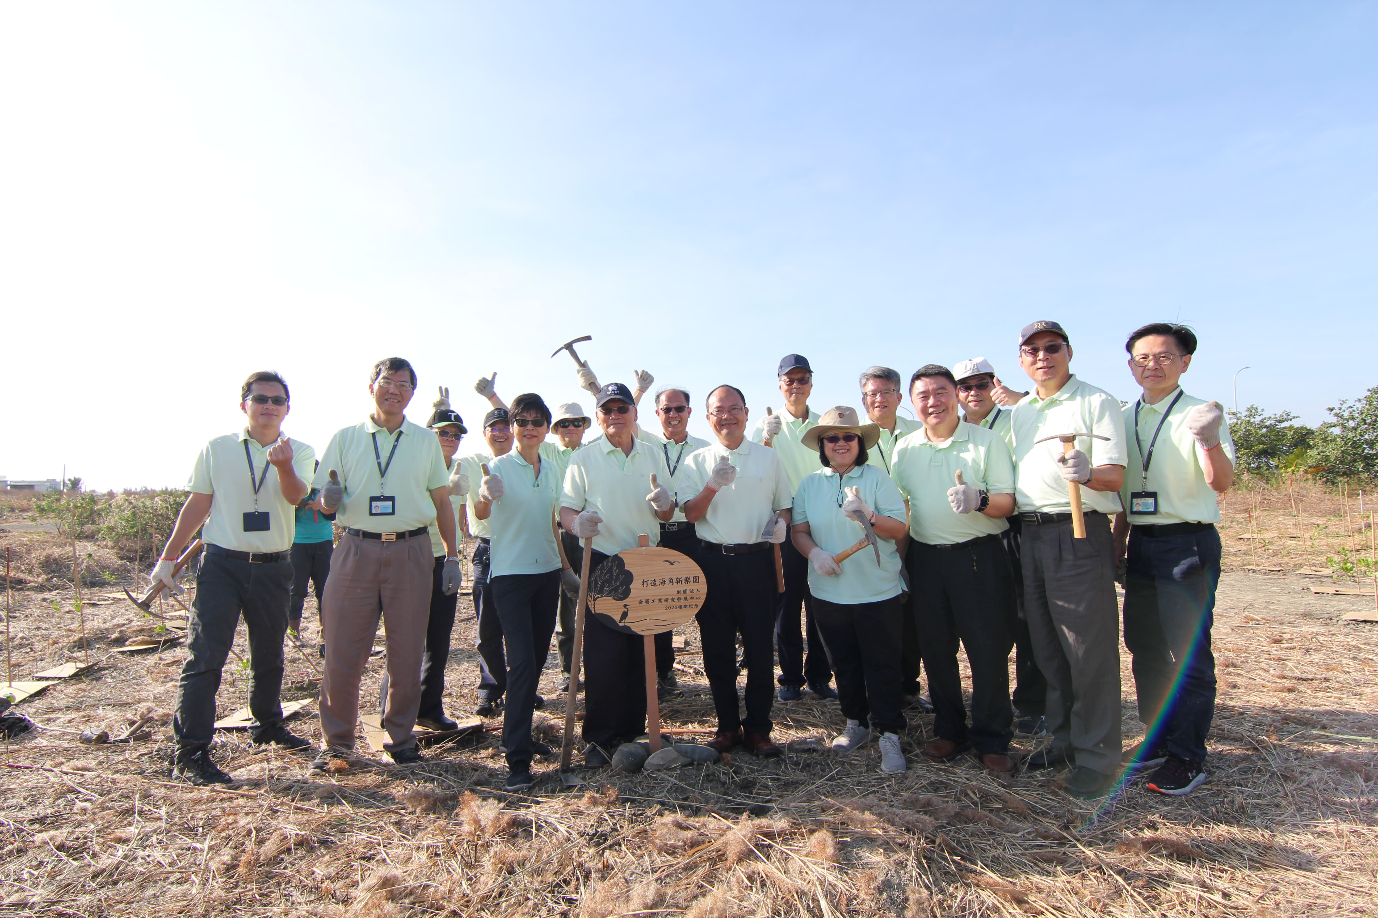

Picture 3、Group photo of the managers of MIRDC and the public tree-planting sign

