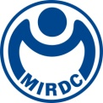
新聞資料NEWS LETTER
MIRDC promotes the establishment of the Asia-Pacific Vacuum Heat Treatment Synergy Center to accelerate Taiwan’s precision industry towards high-value

On the 13th of December, 2023, MIRDC and ECM Group jointly promoted the establishment of the Asia-Pacific Vacuum Heat Treatment Synergy Center. Section Chief Hsiang Wei Ho of the DOIT, Ministry of Economic Affairs, Vice-President Chung Chun Wu of the Taiwan Society for Metal Heat Treatment (TSMHT), Supervisor Yung Chang Kang of Taiwan Mold& Die Industry Association, Secretary General Wen Chen Chen of Taiwan Automation Intelligence and Robotics Association, Country Director François Cotier of Business France Taiwan, General Manager Stéphane Peden of French Chamber Taiwan, Witnessed by Director LPC Lei Zhao of ECM Group, Chairman Ren Yi Lin and President Yung Hsiang Lai of MIRDC, MIRDC joined hands with France's ECM Group to jointly strive to increase the value of Taiwan's precision manufacturing and components industry and establish the Asia-Pacific Vacuum Heat Treatment Synergy Center will target industrial applications such as optoelectronic semiconductors, medical materials, electric vehicles, and communications in the future, helping Taiwan component manufacturers seize more than NT 20 billion dollars in business opportunities.

Section Chief Hsiang Wei Ho of the DOIT, Ministry of Economic Affairs, stated that Taiwan's domestic precision machinery components are of high quality, with an output value of more than NT 20 billion dollars. The technical level is as good as Japan in Asia, and the industrial supply chain system is complete, with advantages such as cluster effect, it has long been a major supplier of precision components in Europe, the United States, Southeast Asia, Central and South America and other countries. The demand for mechanical components has increased as the global market for machinery, vehicles, electronics, and other products and equipment has increased in recent years. With regional advantages and good manufacturing quality, Taiwan has an excellent opportunity to become a global supply center for mechanical components. To develop higher value-added precision components, heat treatment technology plays a critical role, especially in issues such as low deformation control, high-efficiency energy-saving processes, and high-reliability intelligent equipment design. Under the guidance of the Ministry of Economic Affairs, supported by DOIT's Environmental Construction Plan and Key Plan as Technology Development Programs, which has entrusted MIRDC, it has gradually established complete heat treatment-related process development, simulation and testing analysis capabilities, combined with the internationally renowned French ECM Group as their design in Vacuum heat treatment equipment and high-precision control experience will assist Taiwan's heat treatment industry in establishing a total solution from materials, processes, and systems to equipment, making Taiwan a significant backing in the global supply chain of important precision components.

Chairman Ren Yi Lin of MIRDC stated that ECM Group’s heat treatment equipment has a high market share in the global market and has international cooperation with more than 400 companies in 29 countries. It is an internationally renowned equipment manufacturer; MIRDC has established a comprehensive heat treatment company. It has advantages in energy-saving process development and AI detection and verification capabilities and has continuously won international awards such as R&D100 and Edison Awards. Especially for highly complex structures or precision transmission components, it can generate the best process parameters through heat treatment simulation analysis and predict the quality of the product after the process. It can quickly establish the process parameters and enter the furnace for production according to product or functional requirements. The dimensional accuracy characteristics have enabled domestic product quality to reach international standards. Through technology transfer, it has cooperated with industries such as Hota Industrial MFG, SHA YANG YE Industrial Co. Ltd, Ming Shan Industrial Co., Ltd, NEW KAILUNG GEAR CO., LTD. more than 50 manufacturers, and then helped to enter the major international car manufacturers Tesla/Benz/BMW/JLR/Ford, etc., and received a total order of more than NT 6 billion dollars.

MIRDC has established an international cooperation with the French ECM Group to establish the Asia-Pacific Vacuum Heat Treatment Synergy Center to provide the domestic industry with an international-level development and trial production platform. It will be based on high-pressure gas quenching vacuum carburizing equipment and connected in series with the equipment and technical experience of the French ECM Group, MIRDC's manufacturing process, and industry verification. With the energy of the three parties to further expand in technology, talents, products, and application markets in the future. It shortens the development period that used to be sent to France from 1 to 2 months to only 1 to 2 weeks, effectively considering international competitive advantages such as quality, delivery time and cost and providing product development and trial production for potential customers in Taiwan's industry. Establishing the Synergy Center will not only enhance the local R&D and manufacturing level of heat treatment technology. Still, it will also further promote the development of Taiwan's semiconductor and precision machinery through cooperation with the French ECM Group in developing semiconductor crystal growth energy-saving equipment and semiconductor components as well as the industry's international competitiveness.

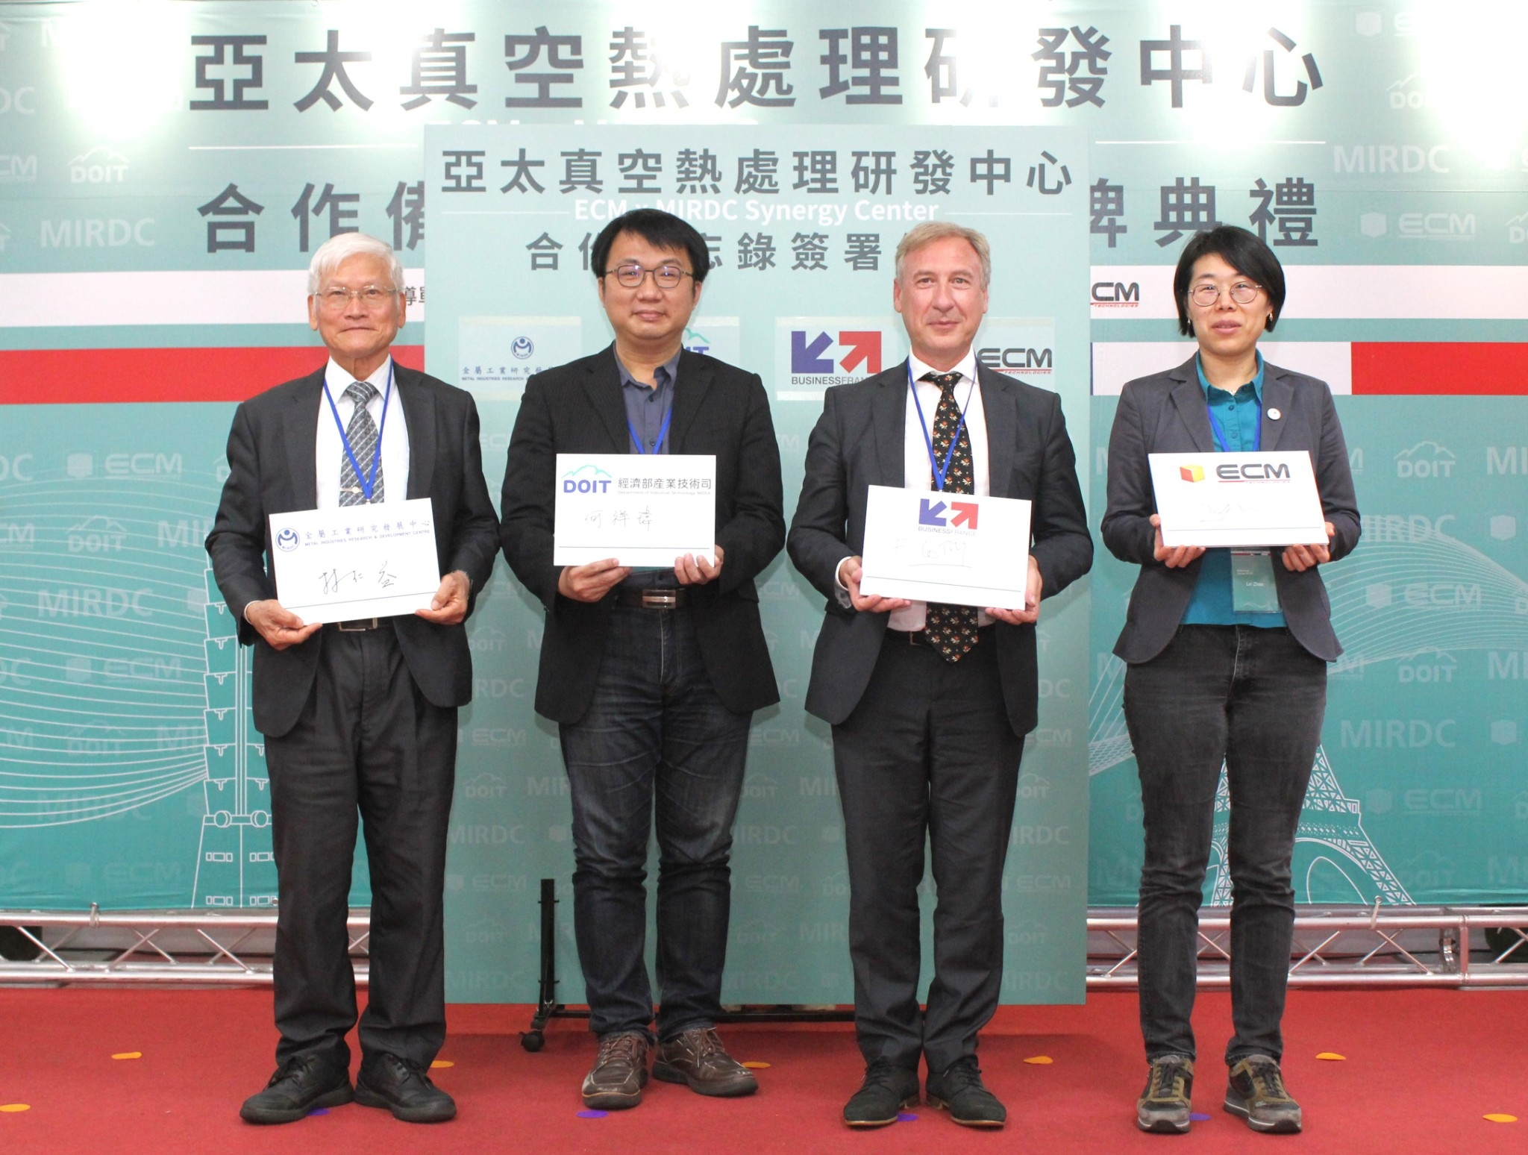

Fig1, A group photo of the MOU signing ceremony of the Asia-Pacific Vacuum Heat Treatment Synergy Center establishment. From left to right are Chairman Ren Yi Lin of MIRDC, Section Chief Hsiang Wei Ho of the DOIT, Country Director François Cotier of Business France Taiwan, and Director LPC Lei Zhao of ECM Group.

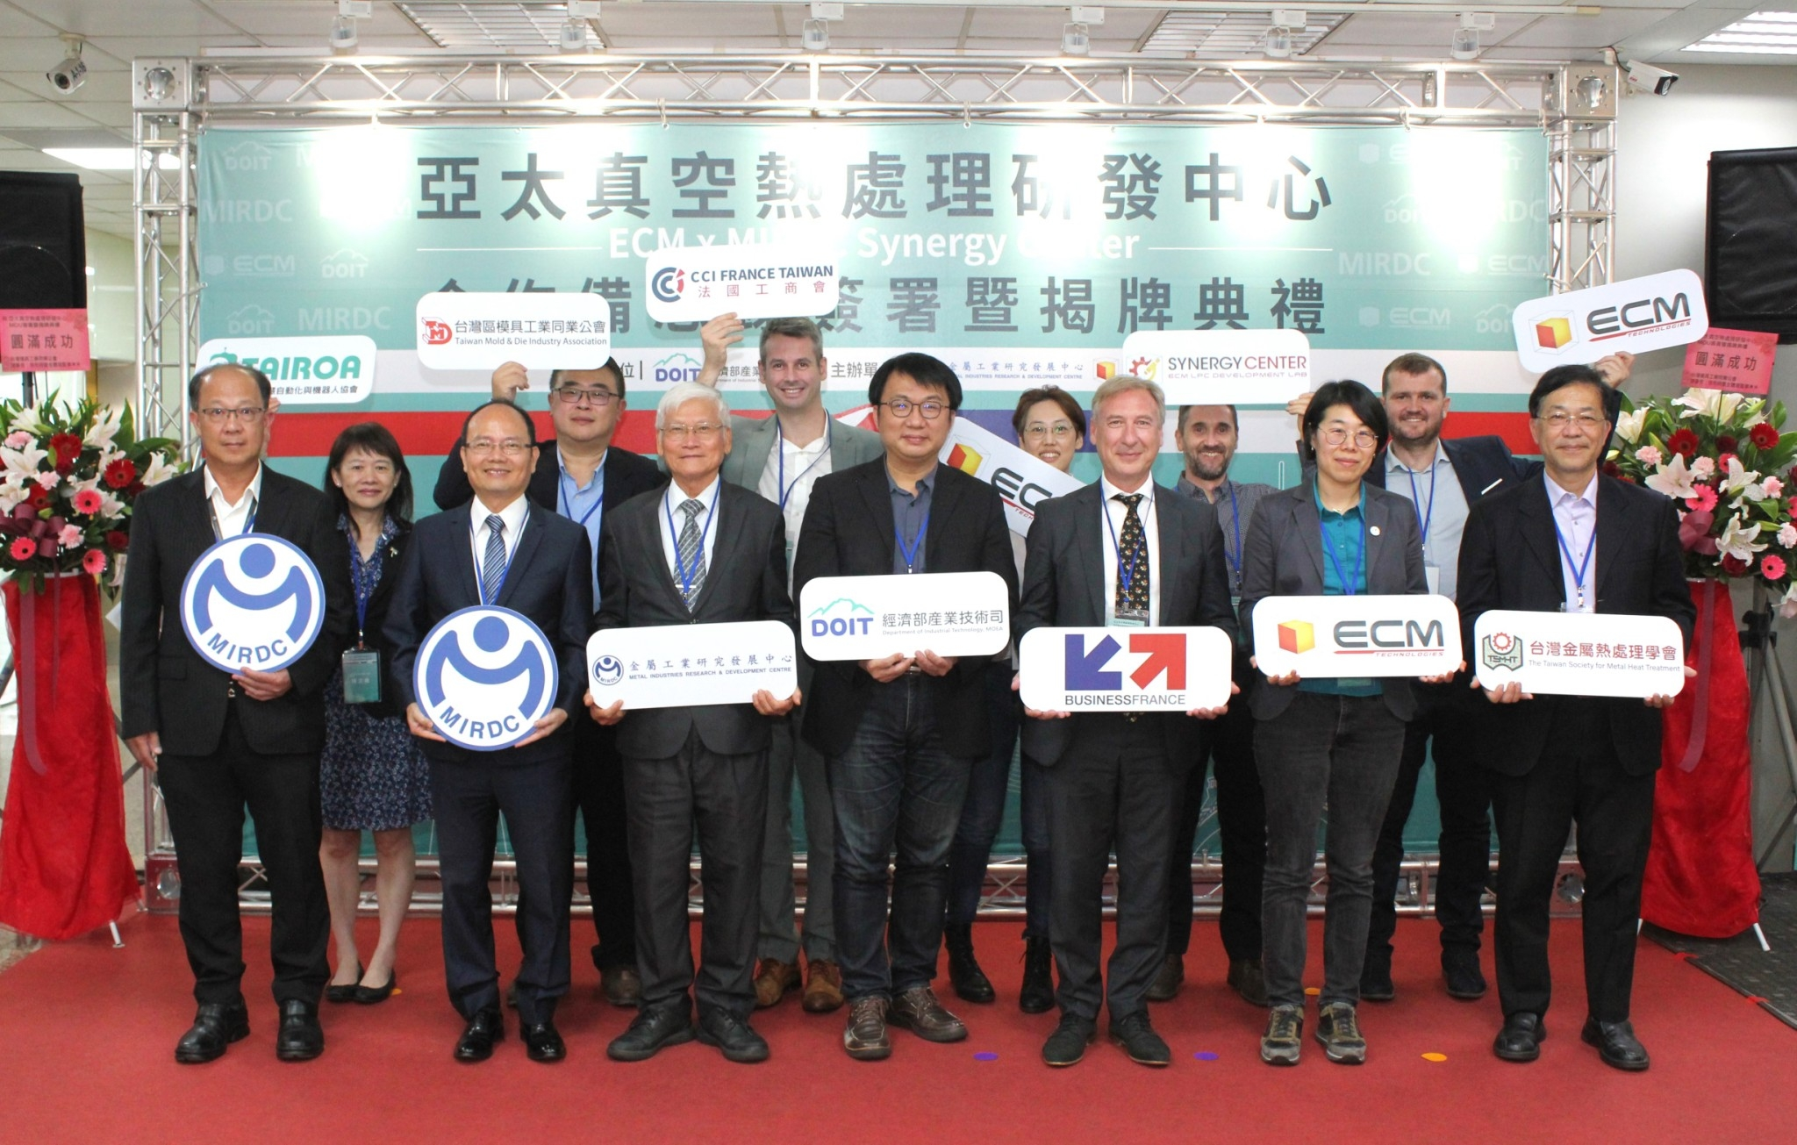

Fig2, Representatives from industries, government, academia, and R&D institutes jointly witnessed the MOU signing ceremony of the establishment of the Asia-Pacific Vacuum Heat Treatment Synergy Center. From left to right on the first row are Vice-President Chun Chieh Wang of MIRDC, President Yung Hsiang Lai of MIRDC, Chairman Ren Yi Lin of MIRDC, Section Chief Hsiang Wei Ho of the DOIT, Country Director François Cotier of Business France Taiwan, Director LPC Lei Zhao of ECM Group, and Vice-President Chung Chun Wu of TSMHT. From left to right on the second row are Secretary General Wen Chen Chen of Taiwan Automation Intelligence and Robotics Association, Supervisor Yung Chang Kang of Taiwan Mold& Die Industry Association, General Manager Stéphane Peden of French Chamber Taiwan, General Manager Linda Chang of Taiwan ECM group, Expert Metallurgy Yves Giraud of ECM group, and Sales Manager Cedric Villard of ECM group.
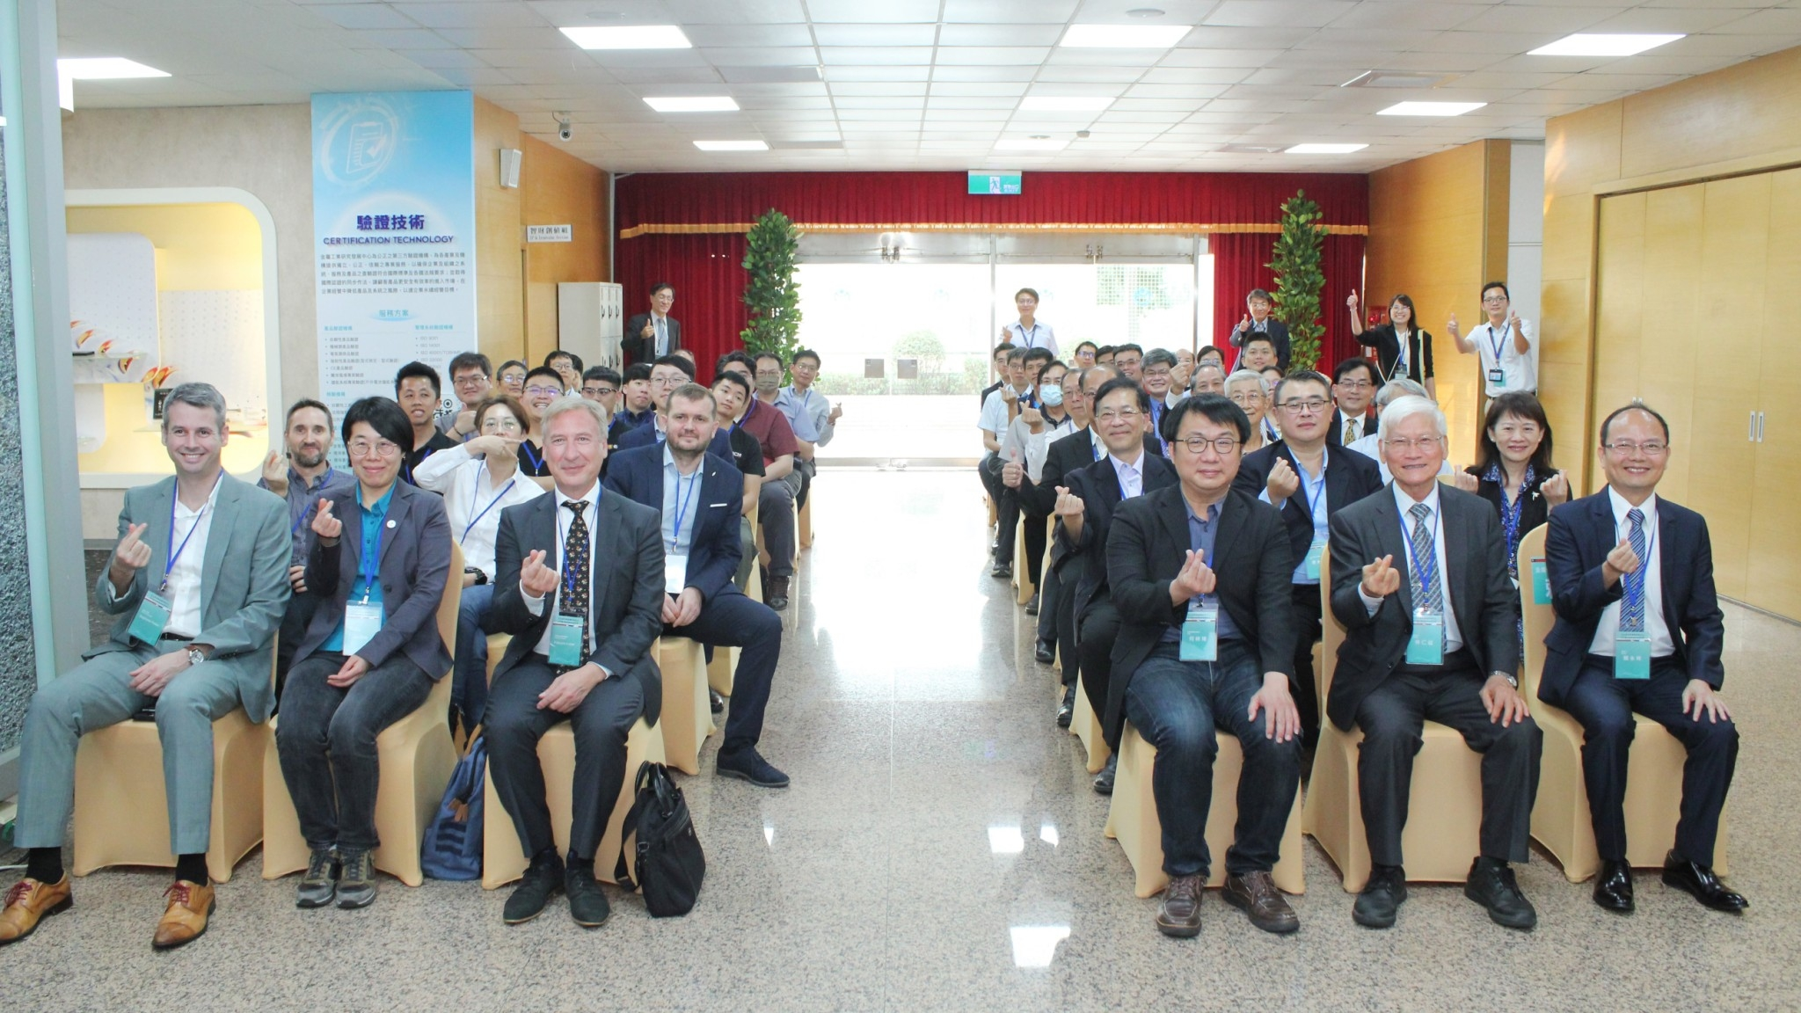

Fig 3, Another group photo of the signing ceremony of the Asia-Pacific Vacuum Heat Treatment Synergy Center establishment.
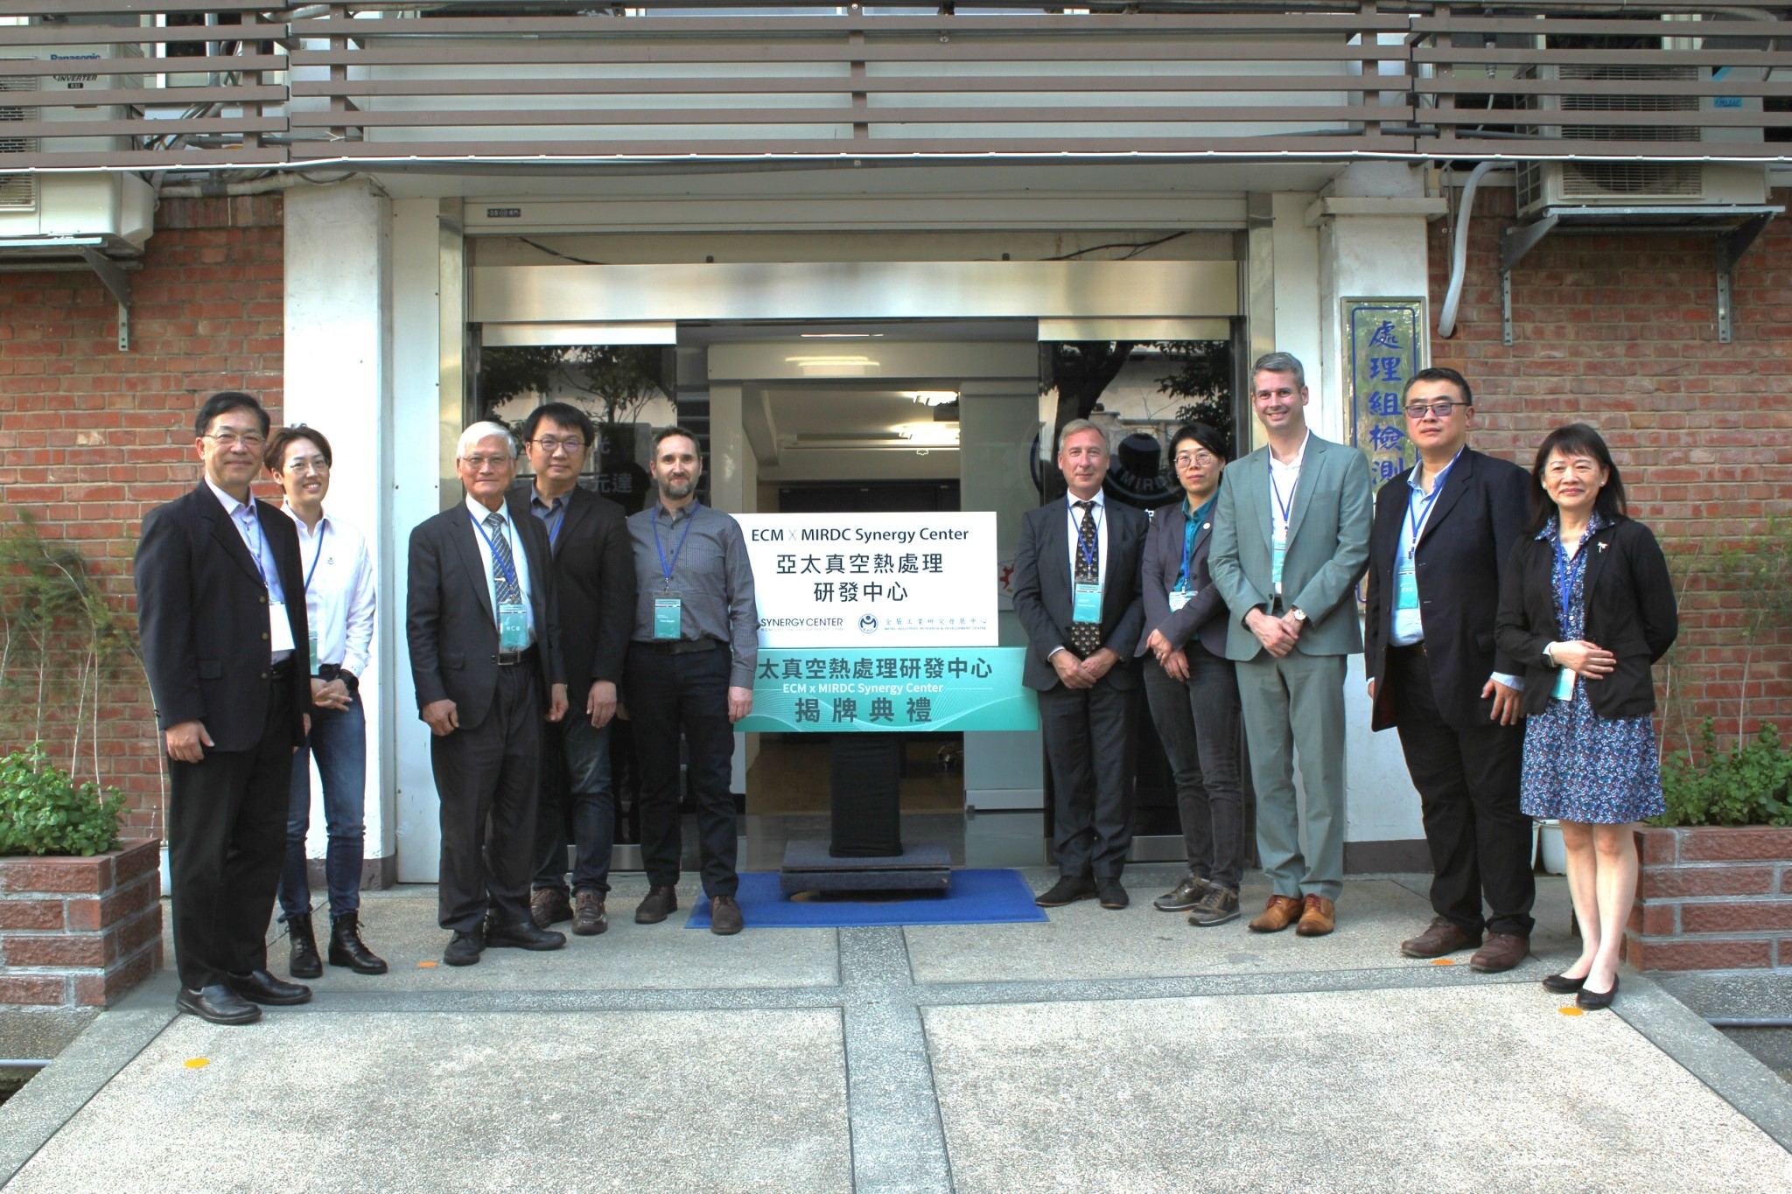

Fig 4, Another group photo of the unveiling ceremony. From left to right are Vice-President Chung Chun Wu of TSMHT, General Manager Linda Chang of Taiwan ECM group, Chairman Ren Yi Lin of MIRDC, Section Chief Hsiang Wei Ho of the DOIT, Expert Metallurgy Yves Giraud of ECM group, Country Director François Cotier of Business France Taiwan, Director LPC Lei Zhao of ECM Group, General Manager Stéphane Peden of French Chamber Taiwan, Supervisor Yung Chang Kang of Taiwan Mold& Die Industry Association, and Secretary General Wen Chen Chen of Taiwan Automation Intelligence and Robotics Association.

