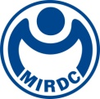
新聞資料NEWS LETTER
The "Ørsted Sustainable Innovation Accelerator" competition campus briefing has kicked off, widely inviting innovative technology and professional talents to join forces and thrive in the onshore and offshore wind power industry locally.

MIRDC has long-term implemented the Maritime Technology Innovation Center (MTIC) of the Energy Administration, Ministry of Economic Affairs, actively promoted offshore wind power talent training, and provided several professional course modules and customized courses. The talent training center already has dual certifications from the Global Wind Organization (GWO) and Offshore Petroleum Industry Training Organization (OPITO) and has accumulated solid training energy. In 2022, it was awarded the title of "Highly Recommended Training Institution-Safety and Standard Compliance" by the Global Wind Organization (GWO) among more than 500 training institutions around the world. The First "Ørsted Sustainable Innovation Accelerator" competition, organized by the MIRDC in collaboration with global sustainable energy leader Ørsted Energy, officially began in January of this year. Promotional activities and campus briefings in various regions soon followed suit. Students and professionals are welcome to participate, the submission deadline is April 30, 2024.

To accelerate Taiwan's green energy transformation and talent cultivation in innovative technologies, this competition invites various "innovative" and "sustainable" development proposals related to offshore wind power. The innovation includes innovative technologies related to the investigation, construction, development, operation and maintenance, and decommissioning of offshore wind farms, and proposes solutions or improvements to problems encountered in industrial practice, such as environmental surveys, construction technology, wind farm operation and maintenance systems, detection methods, material recycling, power grid efficiency, material applications, management, social communication, and other software and hardware technologies or services. For Sustainability, it should have the benefits of promoting the sustainable development of offshore wind farms in the environment, society, or industry, including but not limited to reducing the environmental pollution in the construction or material production process through technological improvements or innovative methods, improving habitat biodiversity, industrial localization sustainable development plans, and specific plans for fishery transformation, etc.

This competition, jointly organized by MIRDC and Ørsted Energy, aims to promote energy transition through technological innovation, cultivate talents in the offshore wind power industry, nurture local capabilities, and encourage proposals that can be implemented realistically. Therefore, teams selected through the preliminary round will receive startup funds for the first phase. The ultimate winning team can receive a total prize of up to NT$500,000. Additionally, Ørsted Energy will match the selected teams with expert resources from global companies based on the different themes of their proposals, assisting and guiding them to further optimize their final proposals. Moreover, potential teams participating in the competition will also have the opportunity to receive follow-up counseling from MIRDC, assisting them in proposing government grant projects, integrating industry research and development capabilities, and thereby enhancing the industry's localization capabilities, allowing Taiwanese enterprises to upgrade and thrive.

The promotional activities of the "Ørsted Sustainable Innovation Accelerator" competition have been started in major universities and colleges from the end of February. And three campus briefings in various regions will soon follow suit. The information is as follows, please copy this link ( https: //reurl.cc/eLZaRW ) to register.

[Taipei] March 19th (Tue.) 18:30 National Taiwan University College of Engineering International Conference Hall (Room 203, 2nd Floor, Engineering Complex)

[Taichung] March 14th (Thurs.) 9:00 National Chin-Yi University of Technology (College Administrative Building Lecture Room B2)

[Kaohsiung] March 12th (Tue.) 10:10 National Kaohsiung University of Science and Technology Jiangong Campus (Lecture Hall M304, 3rd Floor, Department of Mechanical Engineering)

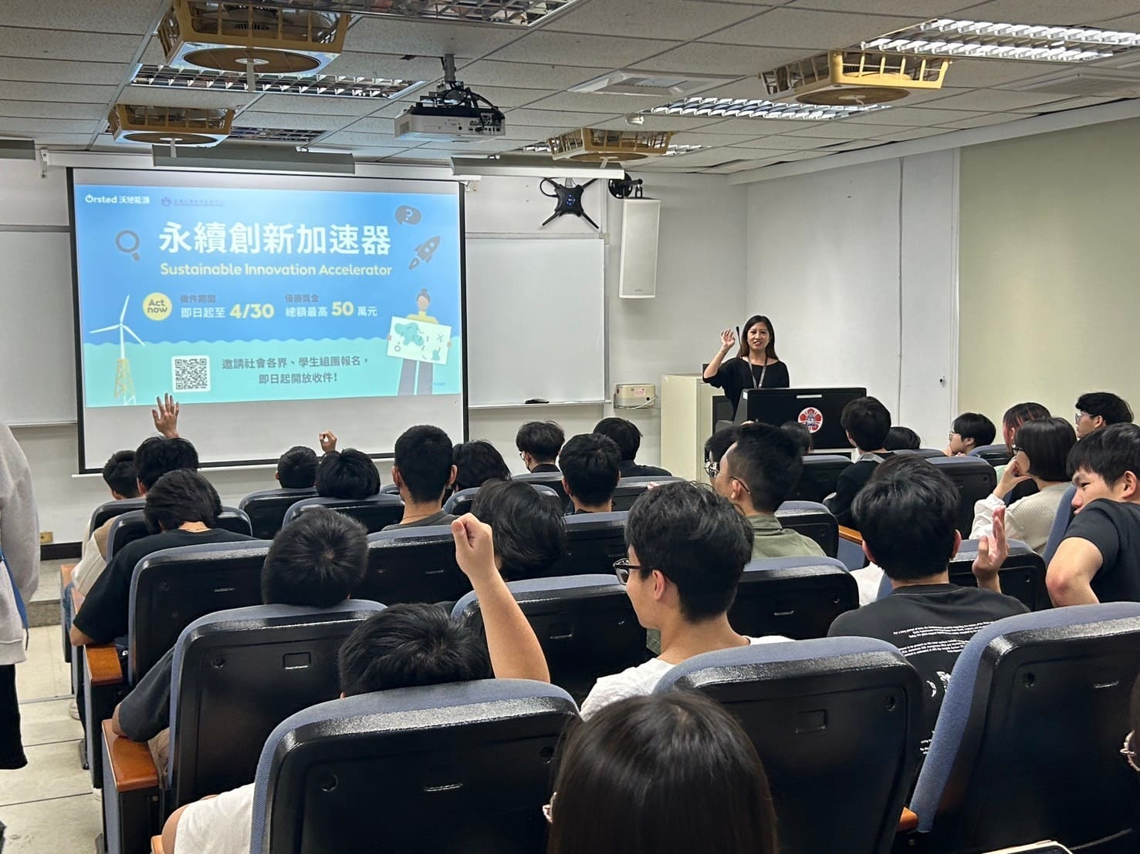

Picture 1. The promotional activities of the "Ørsted Sustainable Innovation Accelerator" competition have been started at the end of February. Then publicities will be carried out in various universities and colleges.

