
新聞資料NEWS LETTER

MIRDC signs medical collaboration MOU with Taipei Medical University Hospital, Taichung Veterans General Hospital, Kaohsiung Veterans General Hospital, and Kaohsiung Medical University Chung-Ho Memorial Hospital - Jointly Elevating Precision Medical Surgery and Providing High-Quality Medical Services

The Asia-Pacific region's largest healthcare technology industry event, the Healthcare+ Expo Taiwan, took place from November 30 to December 3 at the Taipei Nangang Exhibition Center! With the support of the Department of Industrial Technology, Ministry of Economic Affairs, MIRDC showcased a prototype of the "Real-Time Dynamic Imaging Spinal Surgery Assistance System" during the exhibition. On the opening day (November 30), MIRDC signed a clinical trial and service cooperation MOU with Taipei Medical University Hospital, Taichung Veterans General Hospital, Kaohsiung Veterans General Hospital, and Kaohsiung Medical University Chung-Ho Memorial Hospital. This strategic alliance aims to introduce domestically developed spinal minimally invasive surgery assistance systems to major medical centers, collaboratively enhancing the precision, safety, and efficiency of medical surgeries, and providing high-quality medical services.

Chien-Cheng Tai, Senior Technical Specialist of the Department of Industrial Technology, Ministry of Economic Affairs stated that Taiwan will enter a super-aged society in 2025, and the incidence rate of osteoporosis, chronic back pain, and other diseases is increasing rapidly, resulting in an increasing demand for orthopedic surgeries. According to statistics from Research And Markets, the number of global spinal surgeries has increased from 5.2 million cases in 2017 to 7.6 million in 2022. According to statistics from the Ministry of Health and Welfare, it is estimated that there will be approximately 70,000 spinal fusion surgeries in Taiwan in 2022, the average annual compound growth rate in the past ten years is as high as 7.6%. At present, in clinical operations, spinal surgery still has problems such as high radiation dose and unstable operation. To improve the accuracy of surgery, surgical robot-assisted systems are increasingly used in clinical applications.

Chih-Lung Lin, Vice President of MIRDC stated that to implement precision medicine, MIRDC developed 3D composite optical tracking, automatic spine segmentation, and navigation, and intraoperative tracking real-time compensation technology, integrated domestic robotic arms, and developed the world's first "Real-Time Dynamic Imaging Spinal Surgery Assistance System.” This system has experimented with humans on 13 cases, with a success rate of 98%, shortening the operation time by 25%, and assisting surgeons to achieve precise, safe, and efficient complex long-spine surgeries. It will be combined with teaching hospitals and medical centers for clinical collaboration. In addition, Shih-Ann Chen, Superintendent of Taichung Veterans General Hospital stated that they have been awarded the World's Best Smart Hospitals for two consecutive years. It has also recently signed a letter of intent to cooperate with the MIRDC for clinical trials and field verification, and will start substantial cooperation with the “Real-Time Dynamic Imaging Spinal Surgery Assistance System”, cooperation in human subject research and clinical fields will make a better contribution to industrialization, commercialization and internationalization of Taiwan's biomedicine in the future.

Through the MOU on clinical trial and service cooperation strategic alliance with Taipei Medical University Hospital, Taichung Veterans General Hospital, Kaohsiung Veterans General Hospital, and Kaohsiung Medical University Chung-Ho Memorial Hospital, Kun-Hui Chen, Director of Orthopedics of Taichung Veterans General Hospital was specially invited to share the latest development and application on minimally invasive spine surgery and computer-assisted spine surgery. Through the collaboration between research institutes and hospitals, we will further enrich the medical capabilities of domestic smart spine minimally invasive surgery auxiliary systems and establish data and evidence for the " Real-Time Dynamic Imaging Spinal Surgery Assistance System". It is expected that a new spin-off company will be established next year and apply for U.S. FDA 510K and Taiwan TFDA clearances. After the product is certified and launched in the future, they will work together to compete in the international medical market, showcasing Taiwan's medical and medical equipment industry on the global stage.

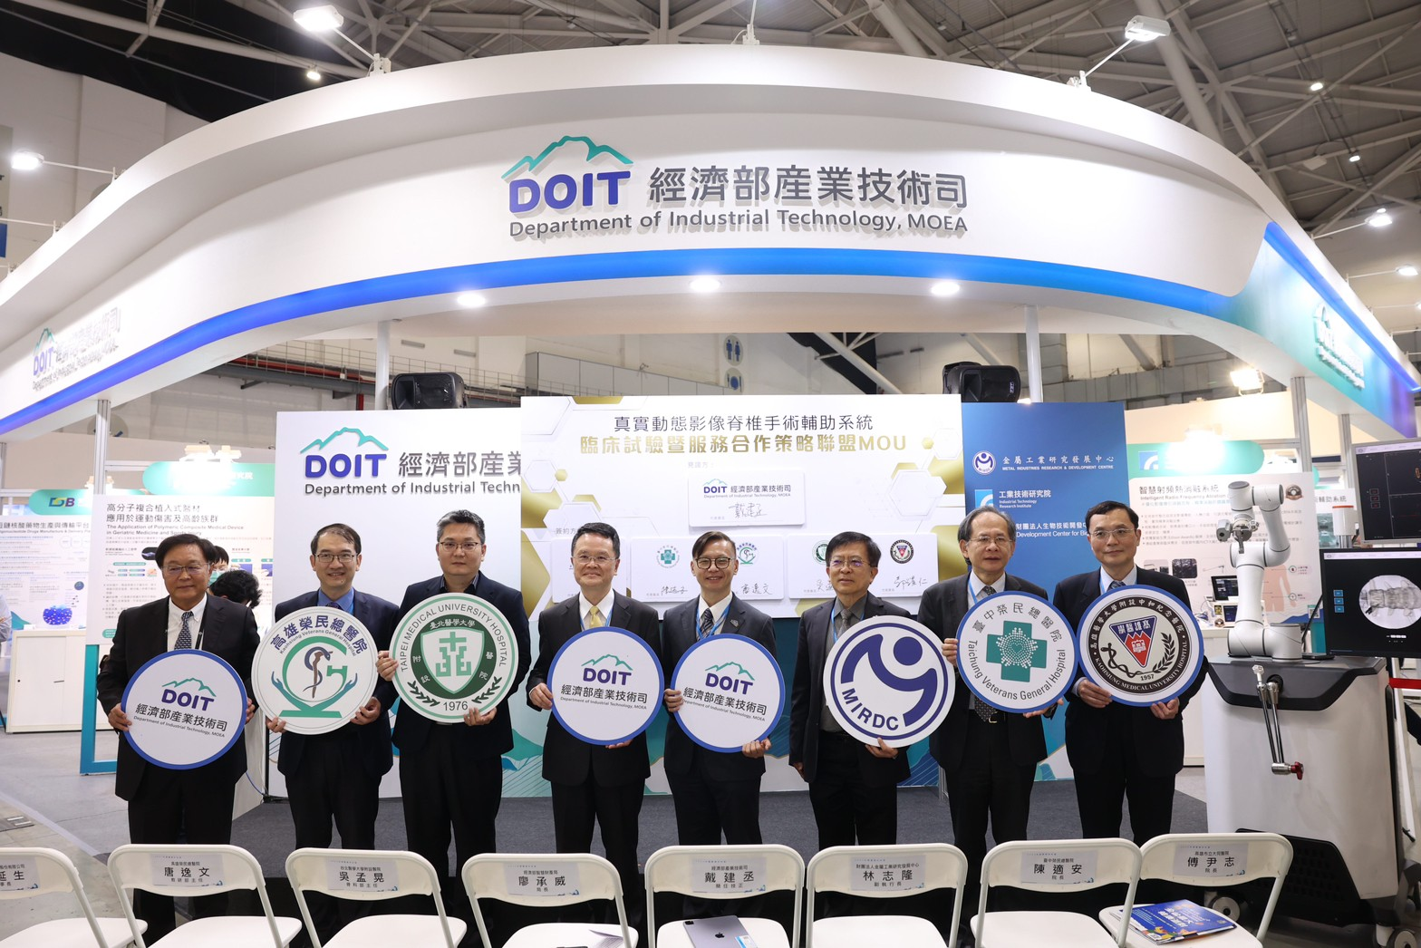

Witnessed by the Department of Industrial Technology, MOEA, MIRDC signed a MoU on clinical trial and service cooperation strategic alliance with Taichung Veterans General Hospital (TCVGH), Kaohsiung Veterans General Hospital (KSVGH), Kaohsiung Medical University Hospital (KMUH), and Taipei Medical University Hospital (TMUH). From left are Jason Lin, Chairman of United Orthopedic, Yih-Wen Tarng, Director of KSVGH, Wei-Pin Hsu, M.D. of TMUH, Cheng-Wei Liao, Director General of Intellectual Property Office, MOEA, Chien-Cheng Tai, Senior Technical Specialist of Department of Industrial Technology, MOEA, Chih-Lung Lin, Vice President of MIRDC, Shih-Ann Chen, Superintendent of TCVGH, Yur-Ren Kuo, Professor of KMUH.

