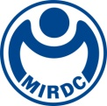
新聞資料NEWS LETTER
Aluminum Recycling Shows Promising Trends: MOEA and MIRDC’s APEC Forum Gathers Nine Major Economies

To strengthen Taiwan’s metal recycling technology and promote industry sustainability through policy planning, Metal Industries Research & Development Centre (MIRDC) is hosting a 3-day international forum titled “Promoting Sustainable Metal Industry through Circular Economy” today, November 6, in Kaohsiung, with support from Department of Industrial Technology, Ministry of Economic Affairs (MOEA), and Asia-Pacific Economic Cooperation’s (APEC) Policy Partnership for Science, Technology and Innovation (PPSTI). The forum brings together competent authorities from nine major economies, namely Japan, South Korea, Peru, Thailand, Vietnam, the Philippines, Malaysia, Singapore, and Taiwan. Experts and scholars will jointly discuss the development and application of recycled aluminum technologies, continue to deepen cooperation in sustainable development and innovation in metal industries amongst APEC economies, and accelerate the sustainable transformation of the region’s metal industries.

In his opening speech, Neng-Kai Chang, senior technical specialist at Department of Industrial Technology, MOEA, stated that promoting net-zero emissions is an urgent priority. By focusing international efforts on recycled aluminum production, significant benefits can be achieved, with reductions in carbon emissions of up to 92%. He emphasized that Taiwan is actively supporting industries in establishing high-value green manufacturing production lines, thereby increasing the recycling rate of waste aluminum materials each year. By leveraging innovative technologies to produce low-carbon recycled aluminum through circular processes, the goal is to reduce reliance on virgin materials and significantly cut carbon emissions. The forum not only draws on Taiwan’s experience in technological innovation but also fosters the exchange of ideas among industry, government, academia, and research sectors through innovative policies on metal recycling and sustainable development. The aim is to collaboratively discuss the future development and needs of the aluminum industry.

Vice President Chun-Chieh Wang of MIRDC stated that the focus of the forum is to exchange insights on the current development of aluminum recycling technologies across various economies, with discussions centering on two main topics: “Trends in Recycled Aluminum Technology Development” and “Experience Sharing on Metals Recycling Applications in Various Economies.” Taiwan has accumulated a wealth of experience in promoting recycled aluminum technologies, including development of waste aluminum recycling and refining technologies, improving the processing performance of recycled aluminum, and successfully connecting the upstream and downstream supply chains to build a one-stop solution. These are all critical success factors in advancing recycled aluminum. This APEC international exchange not only enhances Taiwan’s visibility in the field of international metal recycling technologies but also aligns with future efforts by MIRDC to support government policies. MIRDC will actively promote international cooperation in this field, assisting industries in achieving green transformation, reducing industrial burdens, and confidently addressing challenges of net-zero emissions.

In recent years, MIRDC has achieved excellent results in promoting the recycling of aluminum materials, including development of clean technologies, slag reduction technologies, and low-energy and high-efficiency waste reduction applications. These advancements have successfully addressed issues related to upstream materials and the downcycling of processes, laying a foundation for high-value-added processing in downstream industries. As a demonstration of Taiwan’s strengths in the recycled aluminum industry, the event specially arranged visits of two leading domestic companies—C. S. Aluminum Corporation and FoundtainCan Corp. for distinguished guests from various economies. Those guests gained firsthand insight into recycled aluminum production processes and low-carbon production technologies, and that showcased Taiwan’s experience in practical applications in aluminum recycling.

It is hoped that the experience exchanges and sharing and technology demonstrations at this APEC forum will inspire more plans and ideas for metal recycling technology policies and promote industrial technology development. It also provides valuable experience for APEC economies in advancing and developing metal recycling solutions.
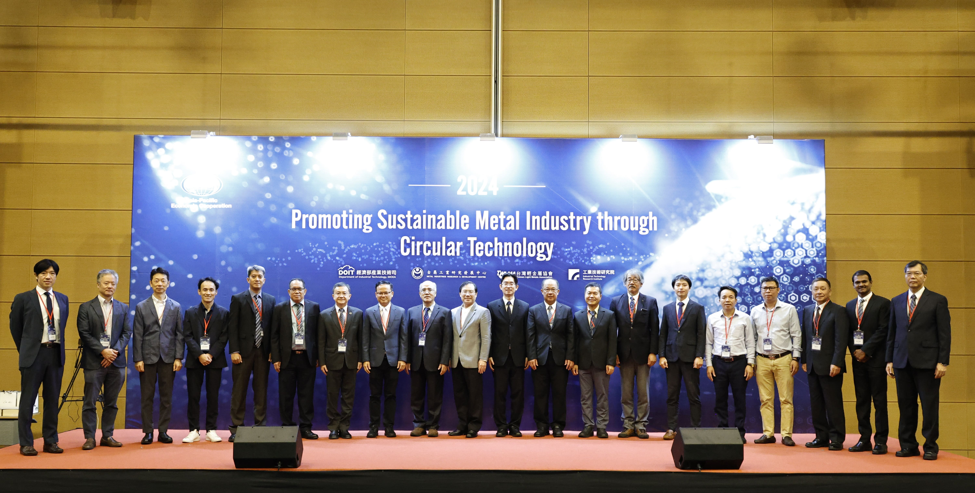

Photo: 2024 APEC “Promoting Sustainable Metal Industry through Circular Economy” international forum was officially launched with distinguished guests in attendance. These guests included: Neng-Kai Chang, senior technical specialist at Department of Industrial Technology, MOEA (10th from the right); Chuan-Neng Lin, consultant at Taiwan Electrical and Electronic Manufacturers’ Association (10th from the left); Chun-Chieh Wang, vice president of MIRDC (9th from the right); Ping-Hui Su, consultant at Mobility Taiwan Auto Research Consortium (mTARC) (9th from the left); Chih-Lung Li, executive director of Taiwan Light Metals Association (8th from the right); Chung-Shih Tu, senior official of Department of Science and Technology for Economic Technical Branches of Vietnam (5th from the right); Sawamitree Romyos, chief at Ministry of Higher Education, Science, Research and Innovation (MHESI) of Thailand (remote); Kitipong Prowaong, council member of Chiang Mai University (8th from the left); Tetsuya Nagasaka, professor at Tohoku University (7th from the right); and Jae-Hwan Kim, chief researcher at the Korea Institute of Industrial Technology (KITECH) (6th from the right).

