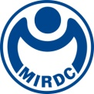
新聞資料NEWS LETTER
MIRDC Joins Hands with International Partners to Promote Modular Hydrogen Transport and Storage Pipeline Technologies

Amid the global clean energy transition, countries are increasingly investing in hydrogen applications and technological advancements. Facing the challenge of hydrogen transport and storage, the trend toward modular pipelines for hydrogen transport and storage has become increasingly important within the hydrogen industry. Under the guidance of Department of Industrial Technology, Ministry of Economic Affairs, Metal Industries Research & Development Centre (MIRDC) has focused on developing hydrogen combustion for industrial applications, as well as high-pressure transport and storage technologies since 2023. This year, MIRDC further expanded collaborations with domestic and international enterprises to advance modular pipeline technologies for hydrogen transport and storage, leveraging cross-border partnerships to accelerate the development of a domestic hydrogen industry chain. On November 11, MIRDC held the Hydrogen Application Safety Technology Seminar, featuring General Manager Po-Yang Huang, Taiwan representative of Bronkhorst, the Dutch Company, along with Chairman Yun-Peng Tan of CTCI Machinery Corporation and Deputy General Manager Shih-Hsiung Tu of Yean Hern Corp., who shared insights on the importance of international collaboration in advancing the hydrogen industry.

To ensure the safety, maintainability, and flexible deployment of hydrogen applications, the international community has begun developing modular control valve stations for hydrogen blending combustion. Modular design helps reduce the number of pipeline connections, allowing for quick installation, maintenance, repair, calibration, and inspection. It also effectively reduces the size of valve assemblies and lowers both installation and maintenance costs. Taiwan currently lacks relevant expertise in this field. In response, MIRDC has partnered with Bronkhorst, the Dutch flow control leader, and Powertech Labs Inc., the Canadian systems integration and testing company. This collaboration also includes domestic partners of Yean Hern Corp. and CTCI Machinery Corporation, forming a multinational team focused on advancing related technologies. Looking ahead, MIRDC plans to collaborate with domestic boiler and industrial furnace manufacturers to conduct on-site testing, accelerating the development of industrial hydrogen applications and hydrogen refueling stations in Taiwan. This initiative aims to enhance the export potential of Taiwan’s industrial capabilities in the international market.

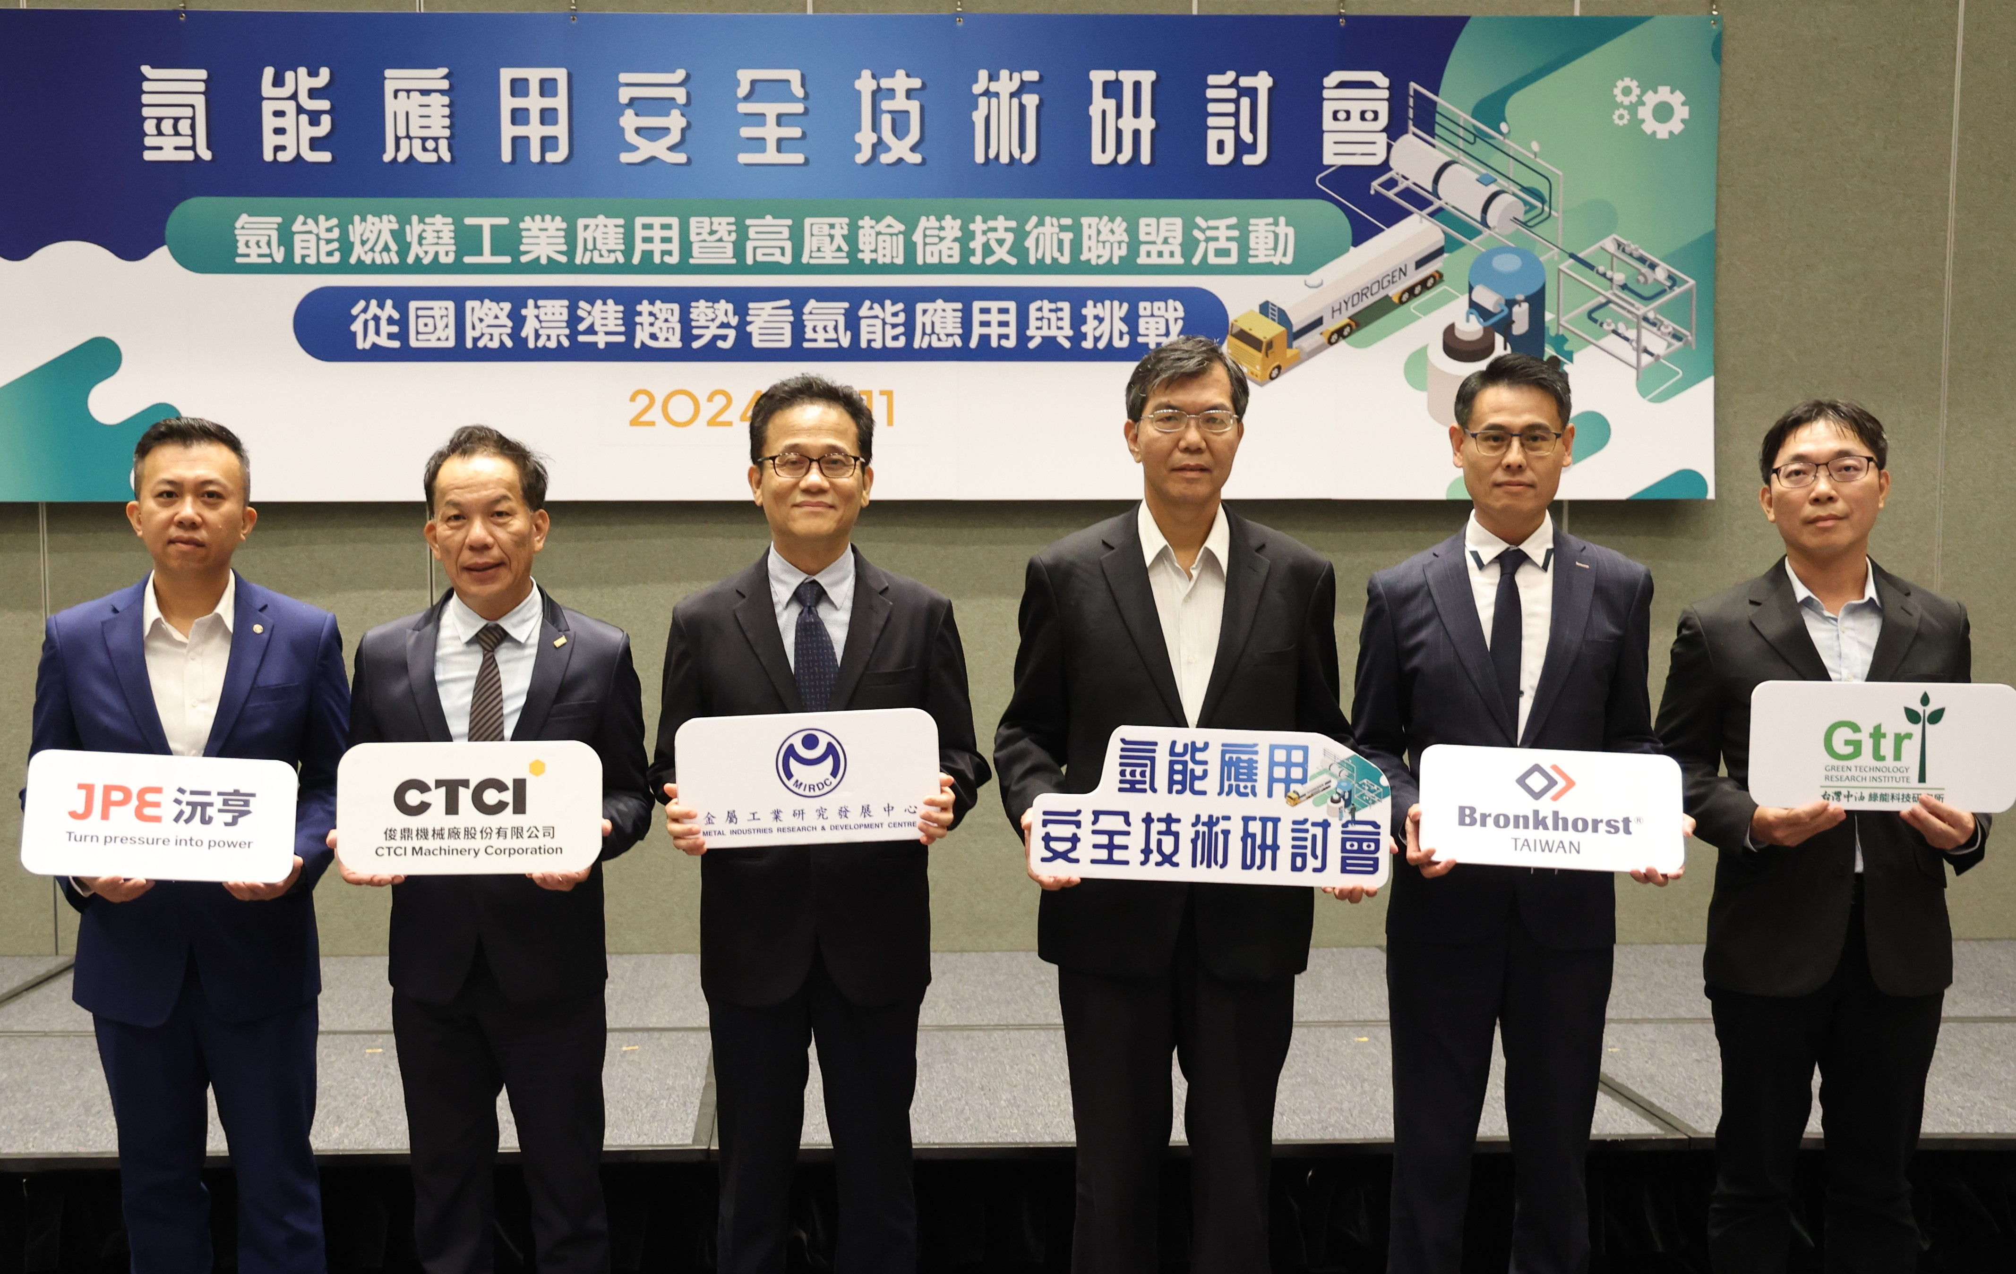
During the seminar, MIRDC Hydrogen Team shared insights into current technological advancements in the industrial hydrogen transport and storage sector, along with trends in international hydrogen applications. The event also featured presentations from CPC Corporation, Taiwan, and Bronkhorst Taiwan Co., Ltd., who discussed safety measures for hydrogen applications and technology promotion. Additionally, experts from TÜV Rheinland Taiwan, Linde LienHwa, and Yean Hern Corp. shared real-world case studies of hydrogen applications and explored trends in international standards for the hydrogen supply chain. This rich and diverse range of topics facilitated in-depth exchanges among Taiwanese industry players, injecting fresh perspectives and momentum into the future development of Taiwan’s hydrogen industry, thereby driving the sector toward greater international competitiveness.

Photo. MIRDC joined hands with domestic and international manufacturers to drive hydrogen industry development (From left to right: Deputy General Manager Shih-Hsiung Tu of Yean Hern Corp., Chairman Yun-Peng Tan of CTCI Machinery Corporation, Director Hun-Yu Lin of MIRDC’s Industrial Upgrading Service Department, Director Ping-Kuo Cheng of MIRDC’s Metal Processing R&D Department, General Manager Po-Yang Huang of Bronkhorst Taiwan Co., Ltd., and Section Chief Yang-Chuang Chang of Green Technology Research Institute under CPC Corporation, Taiwan)

