
新聞資料NEWS LETTER

MIRDC’s Soft Power Enhances Solid Foundation of Hardware Industry: Seizing Global Supply Chain with Ten Outstanding Achievements

2024 Taiwan Int’l Tools Expo x Int’l Hardware Expo Taiwan, the only and largest event of its kind in Taiwan and a major occasion for Asia’s hardware industry, successfully concluded at Taichung International Exhibition Center from October 16 to 18. Over the course of just three days, 300 exhibitors set up more than 700 booths, attracting over 5,500 visitors. Aiming to seize new business opportunities in the post-inflation era, the event targeted a global market worth hundreds of billions! Echoing the event’s theme of “Global Super Supply Chain, Top-Notch Hardware in Taiwan,” Metal Industries Research & Development Centre (MIRDC) leveraged its years of experience serving the fastener and hand tool industries to showcase ten outstanding, forward-looking technologies developed in recent years. These included innovations in manufacturing processes, digital simulation, precision die adjustment, and other fields. Leveraging soft power of R&D to enhance solid foundation of Taiwan’s industrial strength, MIRDC aimed to further elevate the country’s hardware industry to new heights, ensuring it faces future challenges with unwavering confidence.

Export value of global fastener industry is approximately US$42.6 billion, with a compound annual growth rate in demand of about 4%. Taiwan ranks as the third-largest exporter of fasteners worldwide, with around 1,600 fastener manufacturers employing 40,000 workers and generating a total output value of NT$150–160 billion. The export ratio reaches as high as 93%, underscoring Taiwan’s leadership in the global fastener industry. In response to industry trends, a wide range of precision manufacturing technologies is employed to sustain the production of high-quality fasteners and ensure a stable supply to the global market. A well-established supply chain cluster further enhances innovative R&D capabilities, allowing Taiwan’s fastener industry to diversify and expand into sectors such as electric vehicles, aerospace, semiconductors, electronics, healthcare, and energy. This diversification has driven substantial foreign exchange earnings, highlighting the strong competitiveness of Taiwan’s industry.

A highlight of MIRDC’s exhibit was “Near Net Shape Forging Technology,” which captured significant attention from the industry. In the past, hand tool products were produced using traditional forging processes, resulting in excessive burr waste, high defect rates, and complicated and time-consuming post-machining procedures. The introduction of near net shape forging technology into manufacturing incorporates digital simulation analysis before die creation, enabling effective control of optimal forging process parameters and die design. By utilizing servo forging equipment and closed-die forging modules, material utilization rate is increased from 50% to 95%. In addition, forged products more closely match the final product’s appearance and dimensions in terms of quality, greatly reducing the need for subsequent machining. This not only improves material utilization but also effectively reduces material waste by 45% and process energy loss by 25%, achieving innovative low-carbon green manufacturing. The technology has obtained three domestic patents and is widely applied to various hand tool products, such as combination wrenches, adjustable wrenches, pliers, hammers, and sockets, all of which require high strength and functionality in forging. It has also been successfully transferred to external parties, addressing technological gaps in domestic industries. This achievement facilitates fully MIT (Made in Taiwan) production, enhancing product value and autonomy.

Another exhibit that drew overwhelming interest was “Smart Machine Box (SMB)” for Production-Line Quality Monitoring of Metal Forming Machines (5G AIoT Solution). Traditional forming machines in domestic fastener production lines lack real-time quality monitoring devices, requiring manpower to inspect the lines every two hours. However, when abnormalities occur, immediate machine shutdown is not possible, resulting in piles of defective products and significant energy waste. Furthermore, the lifespan of dies and components is unpredictable, affecting product yield rate. Fasteners are manufactured at high speed, but current random inspections (e.g., for size and appearance defects) during production often fail to prevent defective products from being mixed in. Once defects are detected, the entire batch (barrel) must either be scrapped or undergo full inspection due to the lack of real-time quality monitoring. To address these issues, MIRDC independently developed Smart Machine Box (SMB), which detects forging force and forming forging force on fastener production lines. The device uses real-time AI to monitor the forging quality of each fastener. When a forging abnormality occurs, the device immediately intervenes, stops the machine, and indirectly assesses the degree of die damage, informing the operator of the machine’s current status. This innovation reduces large-scale production of defective fastener products, improves machine utilization rates, and achieves low-carbon smart manufacturing.

At the expo, MIRDC not only garnered great interest from the industry for its surface treatment technologies but also actively engaged in discussions on innovative applications for rust prevention and hardness enhancement across different materials. Additionally, our testing and verification capabilities attracted enthusiastic inquiries from international manufacturers. MIRDC has long been focused on understanding industry needs and is committed to upgrading the domestic metal and related manufacturing industries. With the support of government-backed science and technology resources, MIRDC has developed numerous innovative technologies that are not only applied across various industries but also assist in steering them toward smart technology and net-zero sustainability goals. Looking ahead, MIRDC will continue to refine its technological innovations, contributing its exceptional forward-looking research capabilities to the domestic industry.

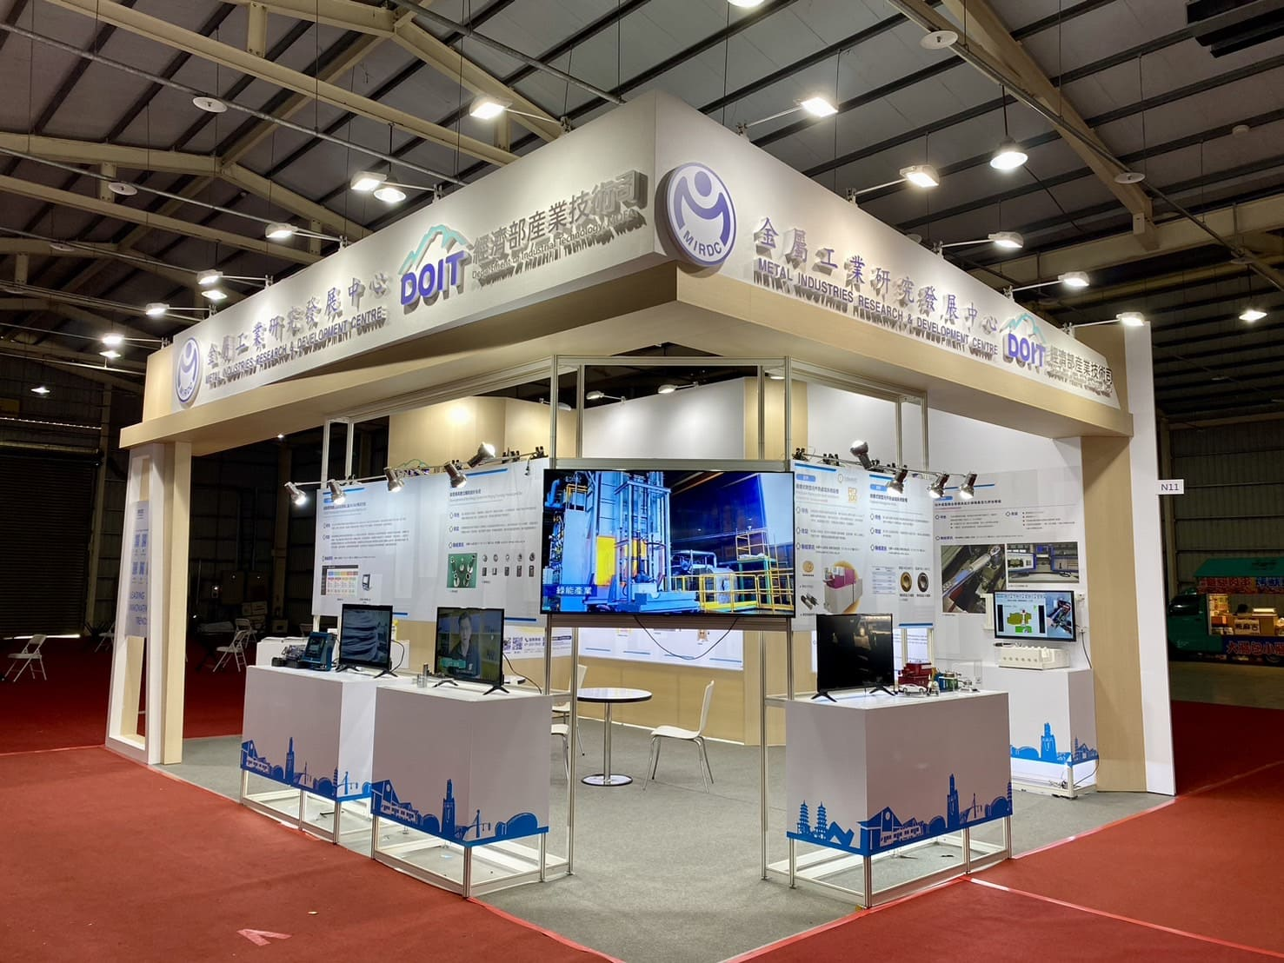

Photo 1: At 2024 Taiwan Int’l Tools Expo x Int’l Hardware Expo Taiwan, MIRDC showcased ten outstanding achievements in fastener, hand tool, and other industries, highlighting its technological R&D capabilities.
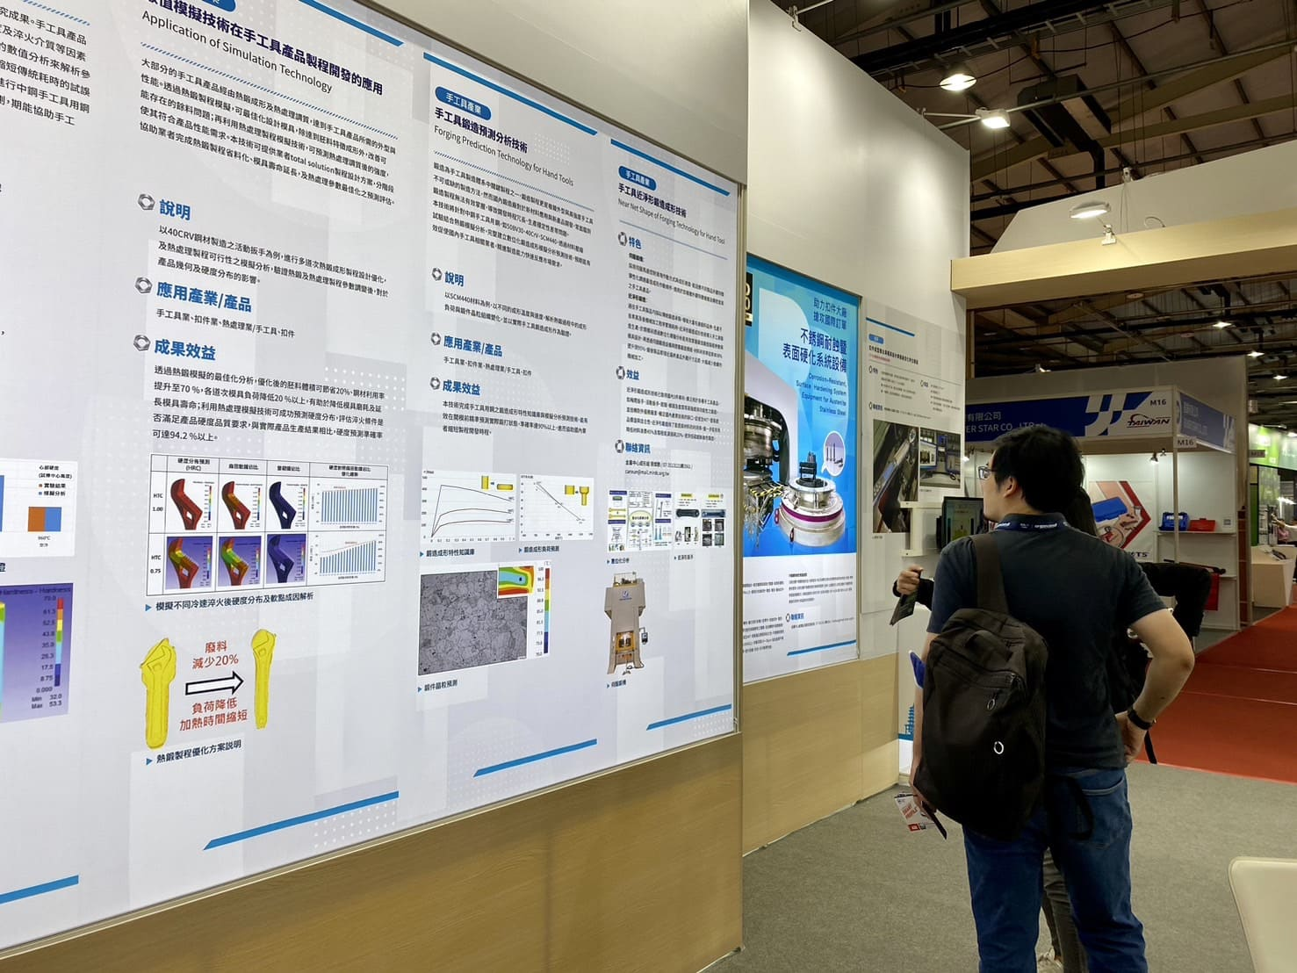

Photo 2: Visiting companies closely examined and learned about “Near Net Shape Forging Technology” for hand tool applications through poster display.

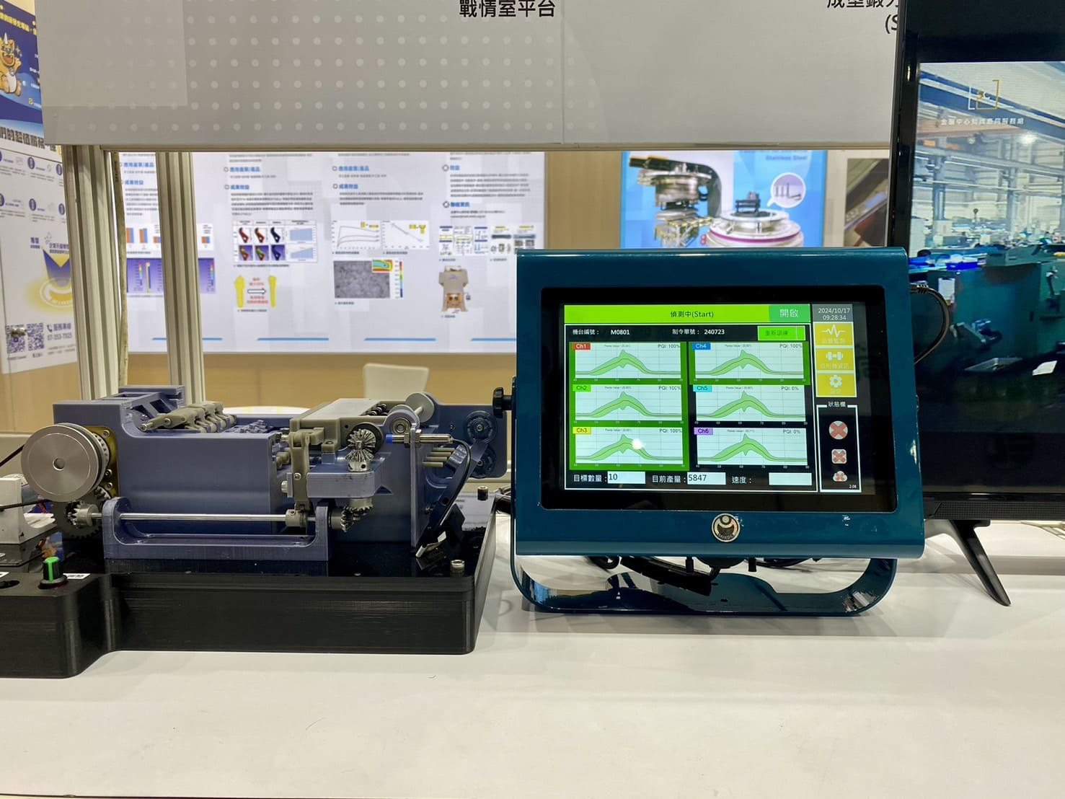

Photo 3. Smart Machine Box (SMB) for Production-Line Quality Monitoring of Metal Forming Machines (5G AIoT Solution)

