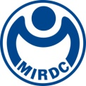
新聞資料NEWS LETTER
MIRDC’s Innovative R&D Results Drive Industry Upgrades: Spotlight on Metal Technologies and Smart Medical Devices

For promoting development of metal-related fields, with support from Department of Industrial Technology, Ministry of Economic Affairs, Metal Industries Research & Development Centre (MIRDC) hosted 2024 Preliminary R&D Results Presentation on October 29. The event showcased the latest technological advancements and trends to the industry through a live online broadcast. The presentation brought together seven innovative technologies in areas such as new material development, process innovation, precision medical technology, and more, fully demonstrating MIRDC’s extensive expertise in technology R&D. Furthermore, over 100 patented technologies were available for licensing or transfer. These R&D results are expected to be effectively applied to domestic industries to achieve technological integration, inject new R&D momentum into the sector, drive enterprise innovation and development, and accelerate the upgrade and transformation of Taiwan’s industries.

The event primarily focused on “metal technologies” and “smart medical devices.” For
“metal technologies,” innovations included “Monitoring Module Technology of
Stamping-forging,” which can significantly improve precision and quality of metal forgings. In addition, “Low-carbon Copper-containing Waste Liquid Recovery and Treatment Technology” focuses on efficiently recovering copper resources from sludge, enabling resource recycling. Lastly, “Low-resistance & Anti-corrosion Coating Technology for Pre-coated Stainless-steel Plate” utilizes pre-coated metal coils to reduce production cost of bipolar plates by 30-40%, significantly improving production efficiency. This advancement is beneficial in enhancing the market competitiveness of hydrogen fuel cells and water electrolysis hydrogen production technology.

In the field of “smart medical devices,” the newly released “Speech Interactive Therapy Software System” uses advanced AI technology, integrating treatment gamification, AI guidance, and post-session assessment features to significantly improve speech therapy efficiency and deliver accurate treatment guidance to meet global market demand. Furthermore, in the field of precision medicine, advancements included “Technology of Passive Sensor Readout,” which enables data reading and visualization of passive implants. Additionally, “Passive Bone Implant Sensing System” provides force monitoring of intraoperative suture and long-term postoperative tracking, thereby supporting precise development of rehabilitation plans.

MIRDC aims to promote cooperation between industries and R&D institutions via this event, and further strengthens technological exchanges and resource integration to create additional opportunities for transformation and upgrading of Taiwan’s industries. In the future, MIRDC will continue investing in R&D of forward-looking technologies to help companies address the changes and challenges of global market.

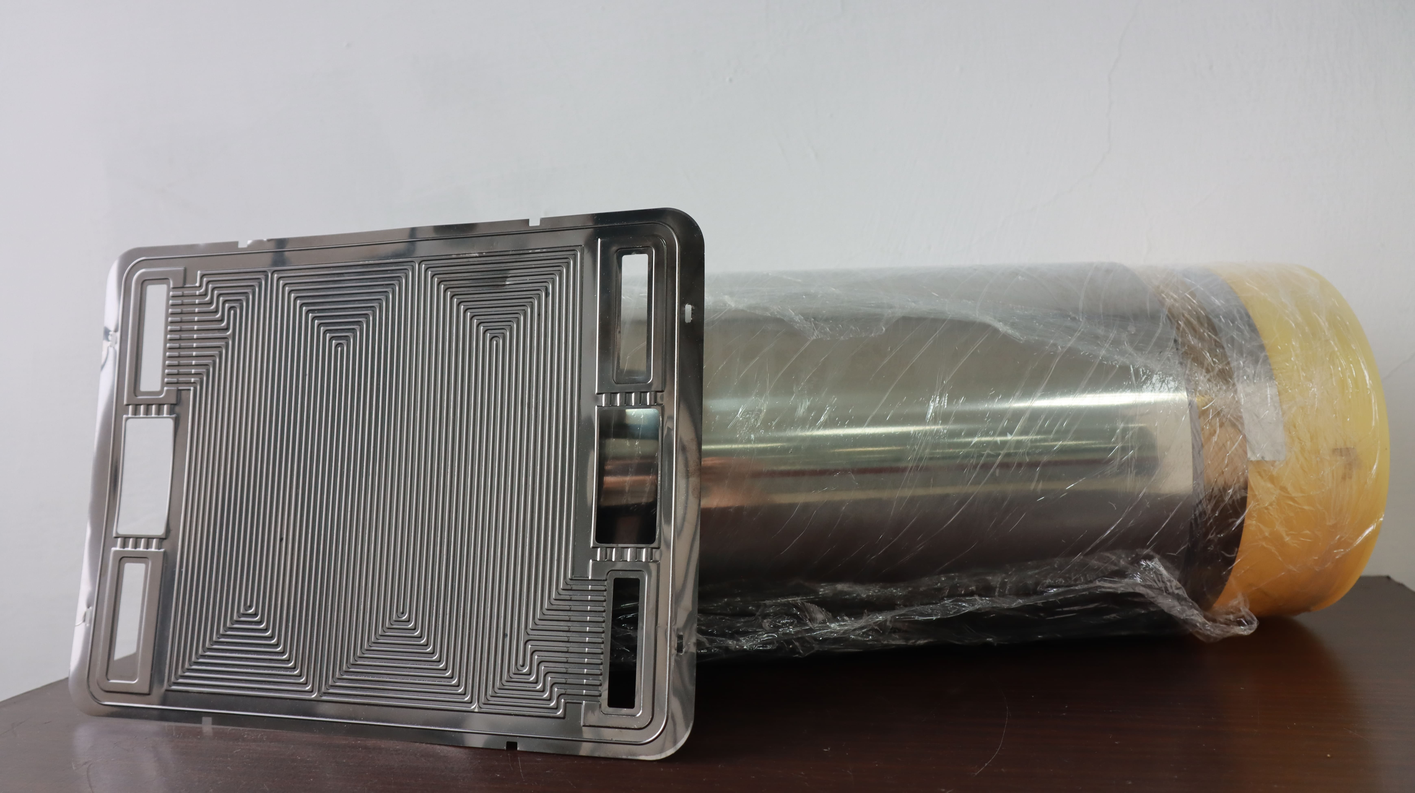

Photo 1. “Low-resistance & anti-corrosion coating technology for pre-coated stainless-steel plate” leverages pre-coated metal coils to produce bipolar plates, reducing costs and improving production efficiency.



Photo 2. “Speech interactive therapy software system” automatically assesses grammar, semantics, and pragmatic abilities, quantifies progress, and provides analyses of weaker areas to enhance therapeutic effectiveness.

