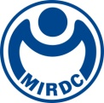
新聞資料NEWS LETTER
Aesthetics and Science - MIRDC's Electromagnetic Tracking Systems Wins Red Dot Award: Product Design 2024
In response to global aging population and high demand for minimally invasive procedures, MIRDC, supported by Department of Industrial Technology, MOEA, has developed Taiwan's first Electromagnetic Tracking Systems (MIS-EMTs), which won Red Dot Award: Product Design 2024. This system uses a micro electromagnetic sensor that is as thin as a needle, and placed it at the tip of a flexible endoscope or instrument to instantly calculate the instrument's position within the composite magnetic field of a transmitter. Additionally, it integrates biological image fusion to provide a precise 3D perspective inside a body cavity. This technology allows surgeons to maintain a clear "penetrative vision" while performing minimally invasive surgeries.
Traditional surgery often requires X-ray imaging to repeatedly confirm surgical sites, exposing both patients and medical staff to radiation risks. MIS-EMTs provides physicians with precise information about the location of organs during surgery. This information aids in accurately positioning and navigation of the lungs, liver, kidneys, bladder, breast, intracranial, and other areas within the body. By integrating registered medical images, such as those from computed tomography (CT), minimally invasive devices equipped with built-in electromagnetic sensors can record and track their spatial position and orientation within a low-frequency electromagnetic field. This allows for precise location determination, similar to using a GPS for navigation, and remains effective even in obstructed environments, such as tunnels. This approach can minimize the need for continuous internal surgical radiography and reduce the overall number of radiation doses during traditional internal surgeries. Using objective measurements helps expand the surgical field of view and accurately position instruments at the correct depth in one attempt, reducing the risk of internal bleeding that can result from multiple punctures. As a result, the amount of X-ray radiation used in each procedure can be reduced by up to 80%.
MIS-EMTs incorporates ClearMind's multifunctional endoscopic system, known as the Axonpen System, designed for minimally invasive neurosurgery to treat spontaneous intracerebral hemorrhage (ICH). This system provides distortion-free magnetic guidance for ICH endoscopic stereotactic navigation, allowing surgeons to perform complex and urgent decompression and blood clot removal surgeries with increased accuracy, stability, and flexibility in the limited cranial cavity. Unlike typical medical machinery and equipment, this system incorporates specific lines that mimic the rhythmic patterns of natural ripples, integrating core magnetic field elements. Considering the operability and space limitations in the operating room, MIS-EMTs provides improved integration of human factors engineering in their interface, allowing medical staff to quickly adjust the direction of the magnetic field transmitter while also ensuring easy stacking and storage in the operating room. Thus, MIS-EMTs received recognition from 2024 Red Dot Jury for offering medical services that integrate innovative technology with enhanced experience for medical staff and patients.
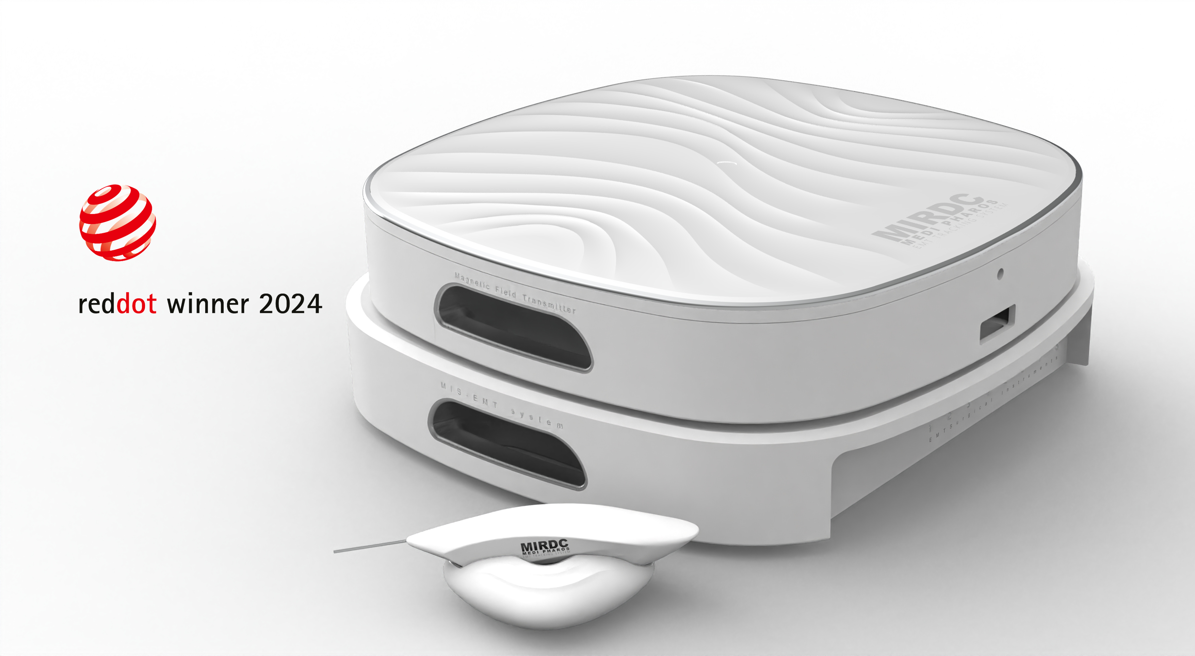
Yung-Hsiang Lai, President of MIRDC, stated that MIS-EMTs are a set of technologies that combine physics, electromagnetics, medicine, and aesthetic design. In the future, electromagnetic tracking and navigation, and endoscopic imaging co-display technology can be integrated into lightweight medical carts. Comparing with larger traditional equipment, these portable devices significantly reduce movement restrictions, allowing for easier transport to remote locations for emergency medical procedures, whether in a hospital or at the site.

Photo 1. MIRDC's MIS-EMTs wins Red Dot Award: Product Design 2024

