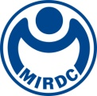
新聞資料NEWS LETTER
MIRDC Signs Memorandum of Understanding with ECM Technologies

On October 23rd, at ECM Technologies' factory in Grenoble, France, Yung-Hsiang Lai, President of MIRDC, signed a Memorandum of Understanding with Yvan Trouillot, General Manager of ECM Technologies. The signing was witnessed by Anne-Laure Pauty, General Manager of the GREX Development Department; Chloé Perony, Project Manager of the International Section, Business France; and Sébastien Gesbert, French Public Investment Bank (Bpifrance). This partnership focuses on developing precision particle media utilizing SMAP (Shot Machine A.one Polish) technology. It incorporates energy-saving of heat treatment processes as the foundation and, through the simulation of the carburizing process, conducts verification of process parameters for the thin gear reducer by integrating both virtual and real aspects. This collaboration among MIRDC, ECM, and Song Lih Shin will analyze and verify the impact of precision particle technologies on enhancing vacuum carburizing capabilities. The research and development results are hoped to extend to electric vehicles, semiconductor industries, and other energy-saving precision manufacturing sectors worldwide.

Yung-Hsiang Lai, President of MIRDC, stated that ECM Technologies Group’s heat treatment equipment holds over 70% of the global market share and maintains international partnerships with more than 400 companies across 15 countries. The company is recognized worldwide as a leading manufacturer of equipment. In May of this year, Mr. Trouillot visited MIRDC to assess the operational status of the Asia-Pacific Vacuum Heat Treatment Synergy Center, which was established in collaboration with MIRDC. During his visit, he also discussed the plans for international cooperation, focusing on energy-saving technology for micro-particle shot polish and vacuum carburizing composite treatment. Furthermore, MIRDC has established strengths in composite heat treatment, energy-saving process development, and AI detection and verification capabilities and has consistently won international awards, including R&D100 Awards and Edison Awards. For highly complex structures or precision transmission components, heat treatment simulation analysis can determine the optimal process parameters and predict the final product quality. It enables the rapid establishment of process parameters based on product specifications or functional requirements, allowing immediate entry into the furnace for actual production. This approach ensures excellent dimensional accuracy, helping domestic quality standards align with international benchmarks.

MIRDC has formed an international partnership with ECM Technologies, focusing on analyzing and establishing process parameters with accuracy through high-pressure gas quenching vacuum carburizing equipment, vacuum oil quenching equipment from the original factory in France, and process simulations from MIRDC to minimize product trials and errors while enhancing manufacturing efficiency. In addition, Song Lih Shin participates the cooperation to perform actual process comparisons and make detailed parameter adjustments for optimizing the manufacturing process. Additionally, we are focusing on developing precision particle media using SMAP (Shot Machine A.one Polish) technology. The goal is to create a synergy in technologies, talent, products, and application markets. This approach will effectively leverage international competitive advantages such as quality, cost, and carbon emissions and offer domestic industry customers support in new product development and trial production while also aligning with the growing trend of carbon reduction. This partnership with ECM Technologies strengthens local research, development, and manufacturing of heat treatment technologies and enhances Taiwan's international competitiveness by investing in energy-saving heat treatment processes by developing precision media blasting technology in collaboration with Song Lih Shin. Through technology transfer and industry services, MIRDC has supported over 50 manufacturers, including Sha Yang Ye, Batom, and New Kailung Gear. This assistance has enabled these manufacturers to engage with major international car companies such as Tesla, Mercedes, BMW, JLR, and Ford, resulting in total orders exceeding NT$6 billion.
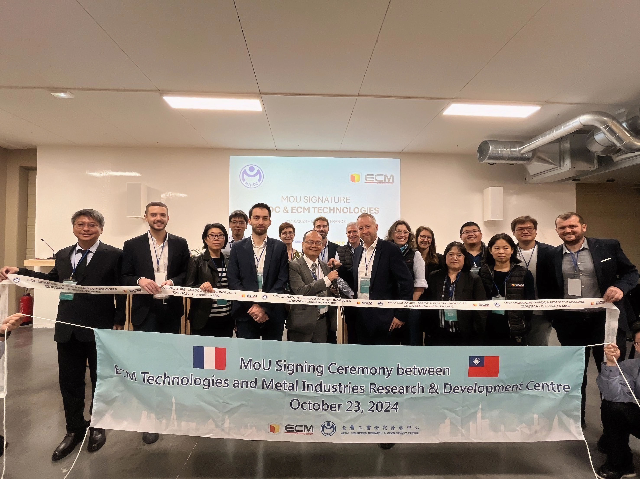

Photo 1. Group photo of MoU signing between MIRDC and ECM (fourth from the left: Arthur Pelissier, General Manager of ECM Group; fifth from the left: Yung-Hsiang Lai, President of MIRDC; fourth from the right: Yvan Trouillot, General Manager of ECM; third from the right: Yueh-Hsiu Lee, Director of MIRDC)
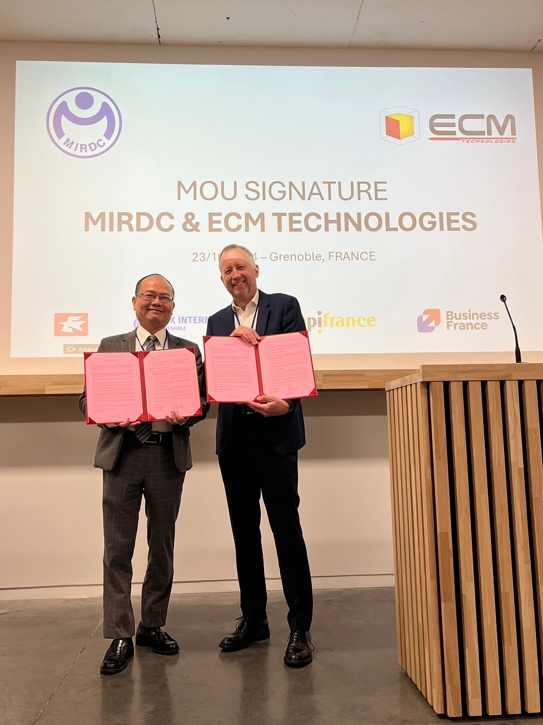

Photo 2. Photo of MoU signing between both parties (left: Yung-Hsiang Lai, President of MIRDC; right: Yvan Trouillot, General Manager of ECM)
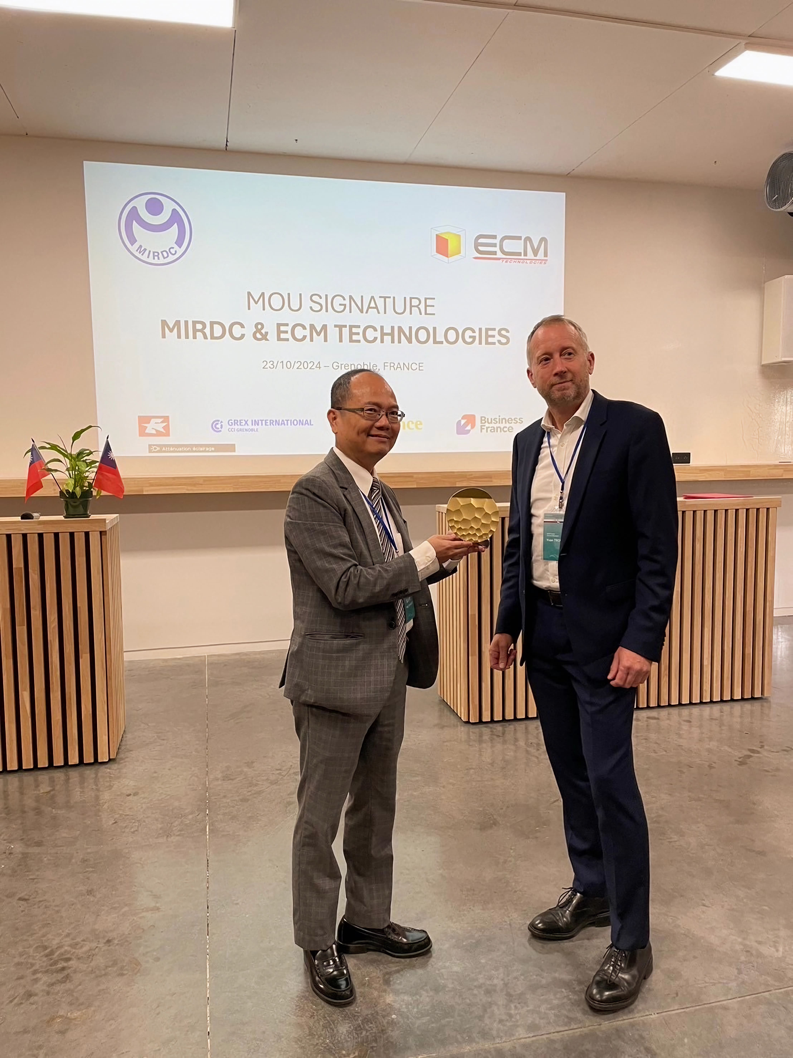

Photo 3. MIRDC gifting ECM a Douxteel plate (left: Yung-Hsiang Lai, President of MIRDC; right: Yvan Trouillot, General Manager of ECM)
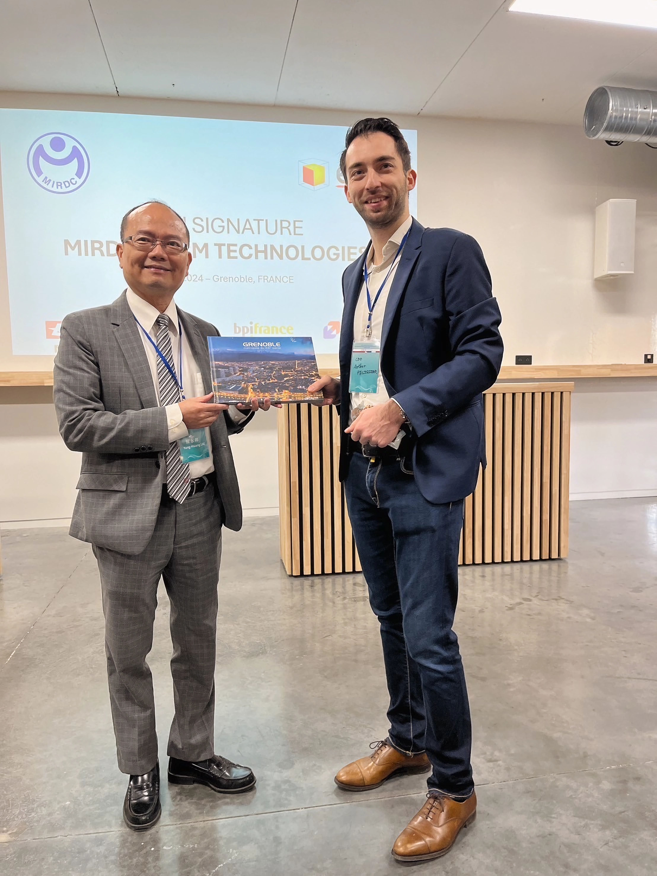

Photo 4.ECM giving MIRDC a gift (left: Yung-Hsiang Lai, President of MIRDC; right: Arthur Pelissier, General Manager of ECM Group)

