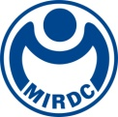
新聞資料NEWS LETTER

MTIC Receives Dual Recognition with the Prestigious GWO Contribution to Community & Industry and Young Achiever Awards

Maritime Technology Innovation Centre (MTIC), established in 2017 with approval from Executive Yuan, is managed by Metal Industries Research & Development Centre (MIRDC) under the commission of Energy Administration, Ministry of Economic Affairs. After obtaining certification from Global Wind Organization (GWO) in January 2021, MTIC has continuously expanded its curriculum. In November 2023, MTIC achieved another milestone by receiving accreditation from OPITO, a leading international training organization for offshore oil and gas industry. This made MTIC the first training center in Taiwan to meet both of these international standards. Currently, MTIC offers up to 29 training modules, providing comprehensive training solutions ranging from foundational to advanced and high-level courses in safety, technical, and customized training programs. As such, MTIC has become a key offshore wind energy training institution in Asia-Pacific region. As of June 2024, the total number of trainees exceeds 2,500, coming from 42 countries including Taiwan. This has laid a solid foundation for full-scope talent training for more than 140 companies across Taiwan and Asia-Pacific region. Looking ahead, MTIC is preparing to develop training capabilities and equipment for future floating wind farm, unmanned underwater vehicle for maritime engineering, dynamic positioning, and offshore crane training, with plans to begin offering courses in the first half of 2025.

2024 GWO Safety & Training Awards Ceremony was grandly held in Orlando, Florida, on October 7, 2024 (U.S. time). After being selected and awarded for two consecutive years, MTIC once again stood out from 596 global training institutions, winning the prestigious Contribution to Community & Industry award at 2024 GWO Safety & Training Forum and Awards. Representatives from Energy Administration under Ministry of Economic Affairs and MIRDC accepted the award on behalf of MTIC. Additionally, Meng-Shan Wu, a new instructor who joined MTIC last year, was honored with Young Achiever of the Year award. This recognition not only highlights Taiwan’s continuous excellence in the global wind energy industry, earning the admiration of GWO members, but also acknowledges MTIC’s ongoing efforts to update training modules and facilities. As Taiwan’s leading wind energy talent training center, MTIC is committed to becoming the most comprehensive training hub in Asia-Pacific region.

The development of offshore wind power plays a crucial role in Taiwan’s energy transition. In 2019, grid connection of Formosa 1 in Zhunan Township, Miaoli County was successfully completed. Since then, Taiwan has maintained a leading position in offshore wind power development in Asia-Pacific region. The wind energy industry requires continuous training for all industry players to enhance their skills and create a safer work environment. Since its launch, MTIC has been dedicated to providing offshore wind personnel with a safe working environment. Having won a prestigious award for top training institutions, MTIC will continue to expand standardized and customized courses in line with Taiwan’s offshore wind power development. This will position MTIC as a training hub for wind power and maritime engineering professionals in Taiwan and Asia-Pacific region, supporting Taiwan and the region in achieving the target of 2050 net-zero emissions.

For more information, please contact: Scott Wang, Marketing and Business Manager, Mobile: 0919 828 632, Email: scott.wang@mail.mirdc.org.tw

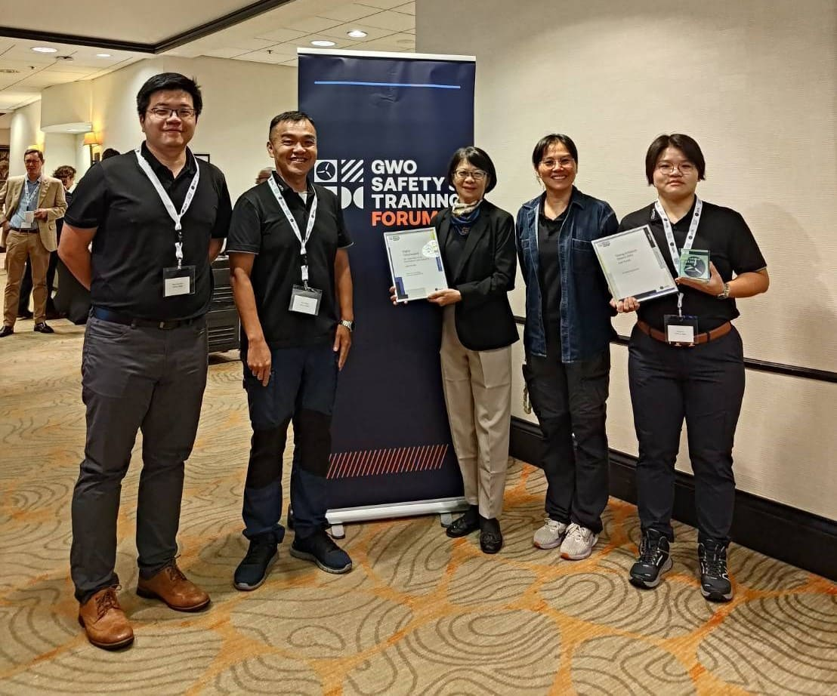

Photo 1. At 2024 GWO Global Safety & Training Awards, MTIC of MIRDC received the Contribution to Industry & Community award. The award was accepted by Ju-Min Cheng, assistant chief of Renewable and Prospective Energy Development Division of Energy Administration, Ministry of Economic Affairs (third from the left), who led the team in receiving the honor. In addition, MTIC’s Meng-Shan Wu (first from the right) won Young Achiever award for Asia-Pacific region, bringing double honor to the institution.

