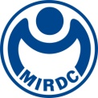
新聞資料NEWS LETTER
13 Industry companies, including MIRDC and C.S. Aluminium Corporation (CSAC), formed the Low-Carbon Circular Aluminum Alliance to foster a green aluminum supply chain

MIRDC and C.S. Aluminium Corporation (CSAC), in total of 13 aluminum industry stakeholders, including upstream, midstream, downstream, and recycling facilities, have jointly established the "Low-Carbon Circular Aluminum Alliance." With Taiwan's 2050 net-zero carbon emission national policy as their goal, led by CSAC, the alliance integrates research institutes' cutting-edge technologies and companies' practical experience. The aim is to enhance the development of the low-carbon circular aluminum industry and build a mutually beneficial industry chain within the low-carbon circular aluminum’s manufacturing strategy.

In 2022, Taiwan's aluminum production was valued at approximately NT$129.5 billion, with 440 manufacturers (accounting for 26% of metal materials). It is one of the top three metal materials industries in Taiwan. In response to the EU's Carbon Border Adjustment Mechanism (CBAM) for high-carbon emission products (aluminum, steel, etc.) entering into force in 2023, major international manufacturers have launched low-carbon aluminum products. By using recycled materials such as recycled aluminum materials (recycled aluminum content exceeds 50%) and low-carbon aluminum (carbon emissions of less than 5 metric tons of CO2/metric ton of aluminum). And relevant carbon neutrality practices have also been proposed to produce low-carbon-emission products. Product design and development are to make products easy to disassemble and recycle while reducing the amount of primary aluminum used. It is obvious that recycling aluminum can effectively reduce greenhouse gas emissions and make low-carbon transformation imperative.

Data in 2021 points out that the export price of scrap aluminum (NT$49/kg) is higher than the import price (NT$47/kg), causing companies to perceive that domestic recycling and reprocessing efficiency was low and with the higher export prices, they preferred exporting. Due to various reasons, Taiwan's aluminum scrap exports experienced a trade deficit of 11,000 metric tons for the first time in 2021. The deficit even expanded to 33,000 metric tons in the first half of 2022, causing a loss of domestic aluminum resources.

The Chairman of the CSAC, Jye-Long Lee, stated that the purpose of establishing the alliance is to integrate the aluminum industry and improve the domestic scrap aluminum recycling process chain. Promoting recycled aluminum material distributors (Zuda Metal Co. Ltd., Forewise Co. Ltd., Hua Chi Metal Co. Ltd., etc.) to establish technology for the recycling of household aluminum waste. Slitting processing and shaping companies (Yah Chiao Enterprise Co. Ltd., Harvard Enterprises Inc., Renme Trading Co., Ltd., Te Kuan Co. Ltd., King Da Long Enterprise Corp., Fountain Can Corporation, etc.) have established industrial aluminum scrap recycling system operations. Recycling aluminum ingot factories (Charng Chyi Aluminum Co. Ltd., Bright Metal Tech. Co.Ltd., Jingsong Metal Co. Ltd., etc.) mainly cooperate with pre-treatment processes such as stripping, degreasing, and demolding of aluminum scrap to complete the remelting of aluminum scrap into low-carbon recycled aluminum ingots. CSAC makes it into aluminum embryos for downstream processing into aluminum coils/plates/sheets and finally produces eco-friendly products. Hoping that through the alliance's efforts, the annual processing capacity for recycling aluminum can reach 36,000 metric tons per year, which is expected to reduce 354,600 metric tons of CO2 emissions. It is committed to promoting low-carbon recycled aluminum materials and completing material certification to create a Taiwan Aluminum Circular Economy Team.

The President of MIRDC, Yung-Hsiang Lai, stated that MIRDC assists in establishing high-quality, low-melting-point secondary smelting ingot technology to enhance the smelting efficiency of recycled aluminum materials. During the processing, it complies with waste gas environmental regulations and reduces the aluminum dross volume. The recycling of aluminum materials achieves a low loss rate of only 6-10%. Also, The alliance will utilize the expertise of its members to comprehensively lay out technologies related to recycled aluminum materials and their applications by establishing this aluminum carbon reduction platform. This will ensure a recycling rate of over 90% for recycled aluminum materials, enabling the independent supply of cost-effective and high-quality recycled aluminum materials in the future. This stability in the domestic supply of critical raw materials is expected to contribute to creating an environmentally friendly, low-carbon circular environment.

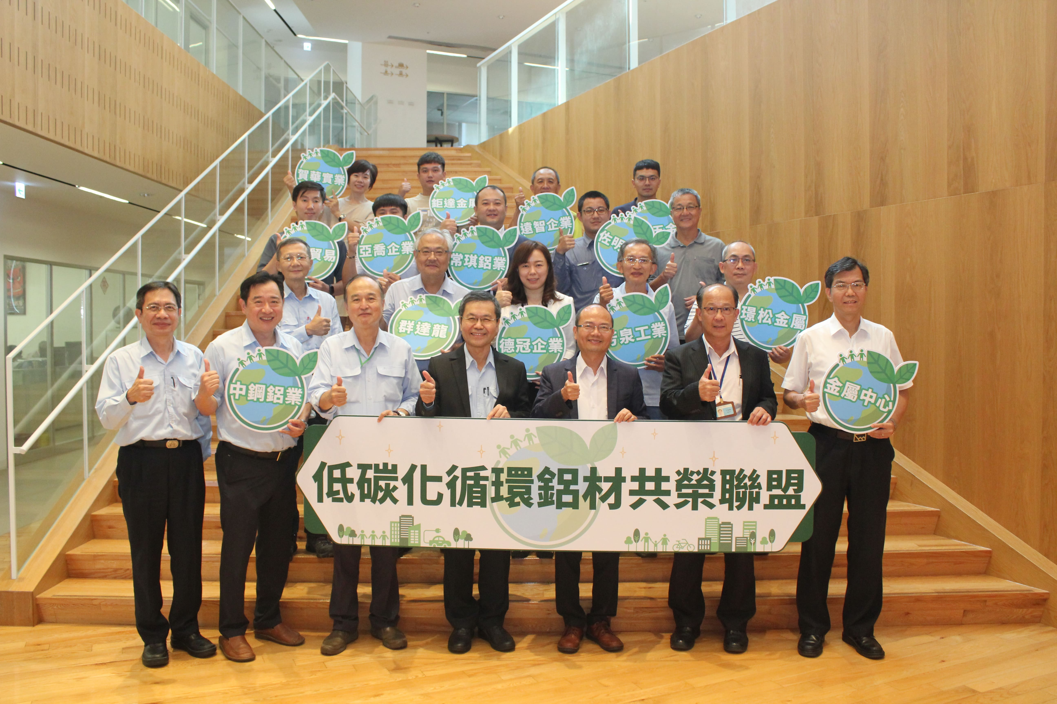

Picture 1、MIRDC and CSAC jointly work with in total of 13 companies to form the “Low-Carbon Circular Aluminum Alliance” (Left 4 of front row) The Chairman of the CSAC, Jye-Long Lee (Left 5 of front row) The President of MIRDC, Yung-Hsiang Lai

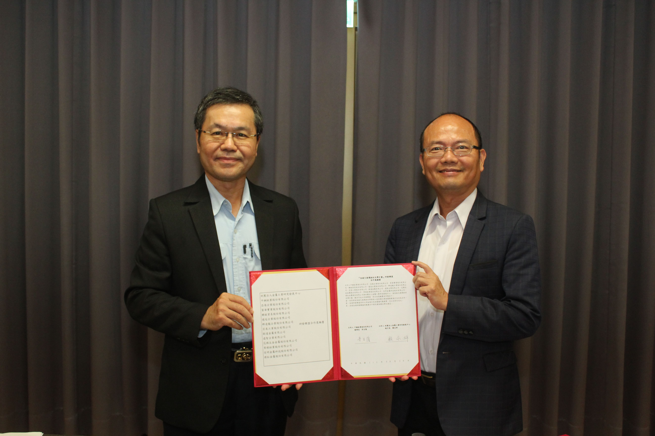

Picture 2、The Chairman of the CSAC, Jye-Long Lee(Left) completed the alliance signing ceremony on behalf of the alliance industry stakeholders with The President of MIRDC, Yung-Hsiang Lai

