
新聞資料NEWS LETTER
MIRDC holds a nickel workshop to build consensus to
improve the stability and resilience of related metal supply chains

In the post-epidemic era, global industrial chains have become chaos. Under the influence of politics in various places, nickel has become a critical resource that countries compete for due to its particular market value. Therefore, since 2022, the violent fluctuations in global nickel prices have led to relatively significant changes in Taiwan's nickel industry costs, affecting the production of related industries. To help the industry grasp the real-time supply and demand situation of nickel metal materials and industry development trends, the Metal Industries Research & Development Center (MIRDC) held a workshop based on improving the consensus on the resilience of the nickel industry on August 30 to mobilize Taiwan's nickel metal industry to focus on significant industry issues exchanges on topics and promote the steady development of the industry.

Whether nickel is traditionally used as a raw material for stainless steelmaking, used in the battery material industry that has experienced explosive growth in recent years, or even a unique alloy application that has attracted attention due to international political reasons, these all highlight the importance of nickel metal in industrial development. Because of this, to help the industry grasp the real-time supply and demand of base metals, MIRDC, under the guidance of the Industrial Bureau, implements the " Taiwan Base Metals Supply and Demand Situation Development Monitoring" project to continuously observe the supply and demand situation, quantity and price development of nickel. MIRDC convened nickel industry representatives to conduct exchanges and discussions on significant industry issues to build consensus and improve supply chain stability and resilience.

Participation in this workshop was very active. Fourteen managers from 7 domestic stainless-steel manufacturers, nickel alloy and battery materials attended the meeting. Communicate on critical indicators of price trends. In addition, it also focuses on the impact of waste on the industry under the chaotic raw material prices and the net zero trends. The discussion can improve the industry's resilience by recycling nickel-metal materials in batteries. The workshop also mentioned that nickel should refine its manufacturing process and increase the use of waste materials in industrial planning to reduce cost fluctuations and achieve the carbon reduction goal. MIRDC also shared the unique post-epidemic budget of the Ministry of Economic Affairs. For the metal electromechanical industry, it will set up human resources training courses on carbon inventory, provide smart subsidies, transformation fund subsidies and other programs to help the industry move towards intelligent and low-carbon production. As for the chaotic pricing model, MIRDC will continue to resilience communication platform by using the nickel industry to assist the Industrial Bureau in promoting regular positive exchanges and interactions among industry players, grasp price information and real-time supply and demand situation, promote the prosperity and development of Taiwan's nickel industry and help maintain the domestic market stable operation.
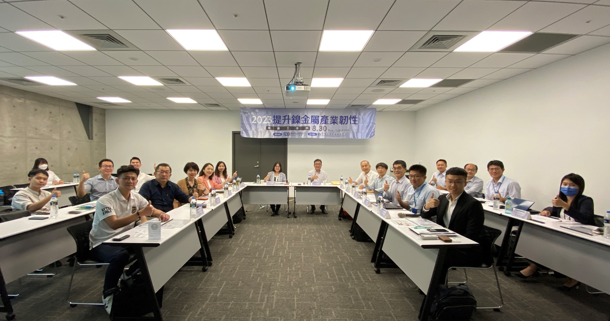
Fig1, a group of the workshop based on improving the consensus on the resilience of the nickel industry of 2023

