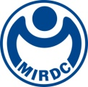
新聞資料NEWS LETTER
MIRDC jointly works with Taiwan Generator Industry Association to promote the development of the generator industry

On the 23rd of May, the MOU signing ceremony of Human Resource Development for Power Generation Equipment took place in the Innovation Value-added Center of Traditional Industry, MOEA. Signed by MIRDC’s Chairman Ren-Yi Lin and President Jung-Pin Shen of the Taiwan Generator Industry Association, and witnessed by Secretary General Chung-Pin Chou of the Industrial Development Bureau, MOEA（IDB）and one of the Members of the Legislative Yuan Tai-Hua Lin. The MOU was based on the Regional Industry Integration Development Plan supported by Industrial Development Bureau, MOEA（IDB）, to cooperate with the systematic talent cultivation needs of the development of the generator industry.

There are more than 1,000 generator-related industries nationwide and nearly 50,000 employees. Almost all industries use generators for temporary power consumption and emergency power generation. Although the generator industry is widely used and the operation is complicated, there is no professional training and relevant professional technical certificates for generator operators in the industry, so in the past, due to the unfamiliarity of the operators or maintenance personnel, the test motor got an electric shock, and the generator battery burst and corroded water spray accidents such as splashing, electric shock during power distribution construction, etc.

Secretary General Chung-Pin Chou of the Industrial Development Bureau, MOEA（IDB）, stated the Regional Industry Integration Development Plan. It mainly promotes the upgrading and transformation of the southern industry and assists the public associations in dealing with industrial needs, including industrial human resource development, process technology, etc. In the future, it will continue to assist various industry associations in developing professional certificate courses and jointly award certificates, provide quick solutions, fill in the gaps in existing industries to meet industrial needs and promote upgrading potential sectors in the south.

The Member of the Legislative Yuan Tai-Hua Lin, also stated that since generators are used in a wide range of fields, it is necessary to cooperate with the Ministry of Economic Affairs and the Metal Center to assist in training talents in the generator industry and to train personnel using equipment through a professional training system. Therefore, in the future, it will continue to help the generator industry in the face of challenges the problems.

The President Jung-Pin Shen of the Taiwan Generator Industry Association stated that Through MIRDC, courses in generator-related fields have been planned. The training content includes subject knowledge and technical practice. Therefore, it is not only practical but also rich. Up to now, the number of applicants for professional training courses for generator decoration engineers that have been planned has been enthusiastic and complete, and they have been started one after another. Many of the participants are sent by the company for training because of work needs, and many are individuals who want to improve their strengths. They hope that obtaining relevant certificates can increase their employment competitiveness, and they also expect to be able to work after professional training courses. It helps to improve work skills or enhance employment competitiveness, so many people have a strong demand for professional and technical personnel training in the field of generators.

MIRDC’s Chairman Ren-Yi Lin stated that MIRDC has more than 40 years of experience in industrial training. Regarding promoting the southern industry and upgrading, MIRDC has worked closely with Taiwan Fastener Trading Association、Taiwan Industrial Fasteners Institute、and Taiwan Instruments United Association to build an Industry-specific talent cultivation model. He emphasized that MIRDC will continuously train specific talents for its own needs in solving insufficient technical skills faced by the industry. In other words, deploy troops in advance of the future knowledge and human resources in providing customized industry demand service and talent solutions. Furthermore, we can formally launch a cooperation model of human resources for innovative power generation equipment.

After the signing ceremony, the two parties will set up a human resource development promotion team for power generation equipment. With the help of MIRDC's long-term energy in industrial human resource development and industrial function course development, establishing courses related to generators can show a systematic and systematic key talent Nurturing formula. In the future, the group will also actively work with the industry to promote the development of human resources for power generation equipment and work towards the goal of promoting the certification of skills and occupational tests to solve the common problem of talents faced by the industry, enhance the strength and competitiveness of the industry, and achieve sustainable development and talent cultivation for the development of the generator industry.

For further information related to the course, please contact Yen-Ting Chen at 07-3513121, ext 2448 or via e-mail: cyt1216@mail.mirdc.org.tw

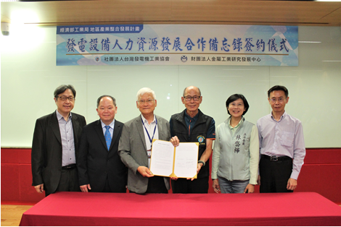

Fig1, MIRDC’s Chairman Ren-Yi Lin (third from the left) and President Jung-Pin Shen (third from the right) of the Taiwan Generator Industry Association signed the MOU. Secretary General Chung-Pin Chou (second from the left) of the Industrial Development Bureau, MOEA（IDB）and one of the Members of the Legislative Yuan Tai-Hua Lin (second from the right), Witnessed the MOU.

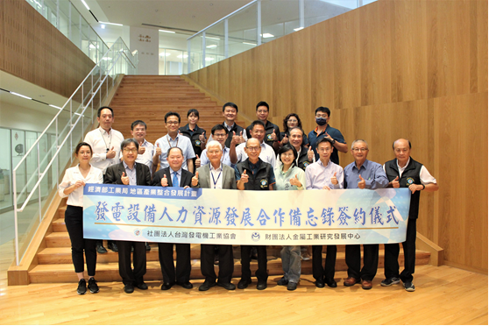
Fig2, a group photo of all participants

