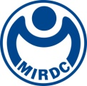
新聞資料NEWS LETTER
MIRDC wins 1 Silver and 1 Bronze at the 2023 Edison Awards also known as the "Oscars of Innovation"

Edison Awards is recognized as one of the most innovative awards and the award-winning technologies and products are excellent in innovation. With the support of the Department of Industrial Technology, Ministry of Economic Affairs, MIRDC won two 2023 Edison Awards, a silver for Continuous Tracking Surgical Assistance System (CTSAS) and a bronze for 4D (3D+Dissimilar) Printed of Solid State Process. These honors are the result of our commitment to innovative and breakthrough technologies and show our determination to continuous dedication to R&D. We expect to perform outstandingly in science and technology worldwide and lead Taiwan to make the R&D capabilities be seen.

The Continuous Tracking Surgical Assistance System (CTSAS), which won the silver at the 2023 Edison Awards, creates a digital medical solution. This is a new development of marking and tracking technology which greatly reduces the positioning tag that takes up space size and maintains the accuracy of positioning. It can provide surgeons with real-time visualization during the operation. The existing surgical navigation system is limited by the problem that the positioning markings are too large. The actual target object’s spatial information cannot be detected and updated continuously. Therefore, it can provide only static navigation image information and the positioning information is affected by the cumulative error and breathing rhythm during the operation. Surgeons need to do image registration repeatedly for complex spinal surgery. The 3D Composite Optical Tracking System developed by MIRDC using the dodecahedral markers overcomes optical tracking technical obstacles of positioning tag minimization. Dynamic tracking can be made with more than six vertebrae continuously per image registration. Experiments for humans have been carried out in Show Chwan Hospital. The accuracy rate is 98%, and the operation time is shortened by 25%. It assists surgeons to achieve an accurate, safe, and efficient complex long-spine surgery.
The 4D (3D+Dissimilar) Printed of Solid State Process, which won bronze at the 2023 Edison Awards, is the first technology that can combine the advantages of dissimilar metals through friction stir welding demonstration production line to create high-strength and lightweight products. With the expansion of policies and business types, the technology is also expanded to the low earth orbit satellite industry by degrees. Therefore, MIRDC has developed the 4D (3D+Dissimilar) Printed of Solid State Process, which can integrate dissimilar materials to produce multi-layer structures through the additive manufacturing method of the solid-state process according to the demands of the products. Overcoming the limitation of the existing additive manufacturing process. This technology has a defect-free commissure. Compared with manual arc welding, it saves welding time by 70%, increases welding strength by 25%, saves equipment costs by 90%, improves the utilization rate of metal materials, and reduces waste of processing materials by 40%. Utilizing the complement of the characteristics of dissimilar metals can meet the demand for 3D surface modeling and dissimilar material products. And it is a green process with low energy consumption and no welding fumes. The technology can be used to make orbit satellites relatively lightweight to improve product performance. It has been applied to the fuel tanks of space satellites and reflectors for 5G/6G antenna measurement systems.

MIRDC Acting President Chi-Lung Lin stated that MIRDC’s direction of innovative R&D is always to fulfill the task of being able to satisfy industrial demands. In recent years, we also expanded the scope of R&D and promotion to emerging industries such as smart medical and low earth orbit satellites, etc. Through our team efforts, the two technologies have won many domestic and international recognitions such as the R&D 100 Awards, the National Industrial Innovation Award, the National Innovation Award, and the Reddot Award. Demonstrating MIRDC’s breakthroughs in technological innovation. In the future, we will continue to push boundaries with our R&D to the world, and let us be seen!
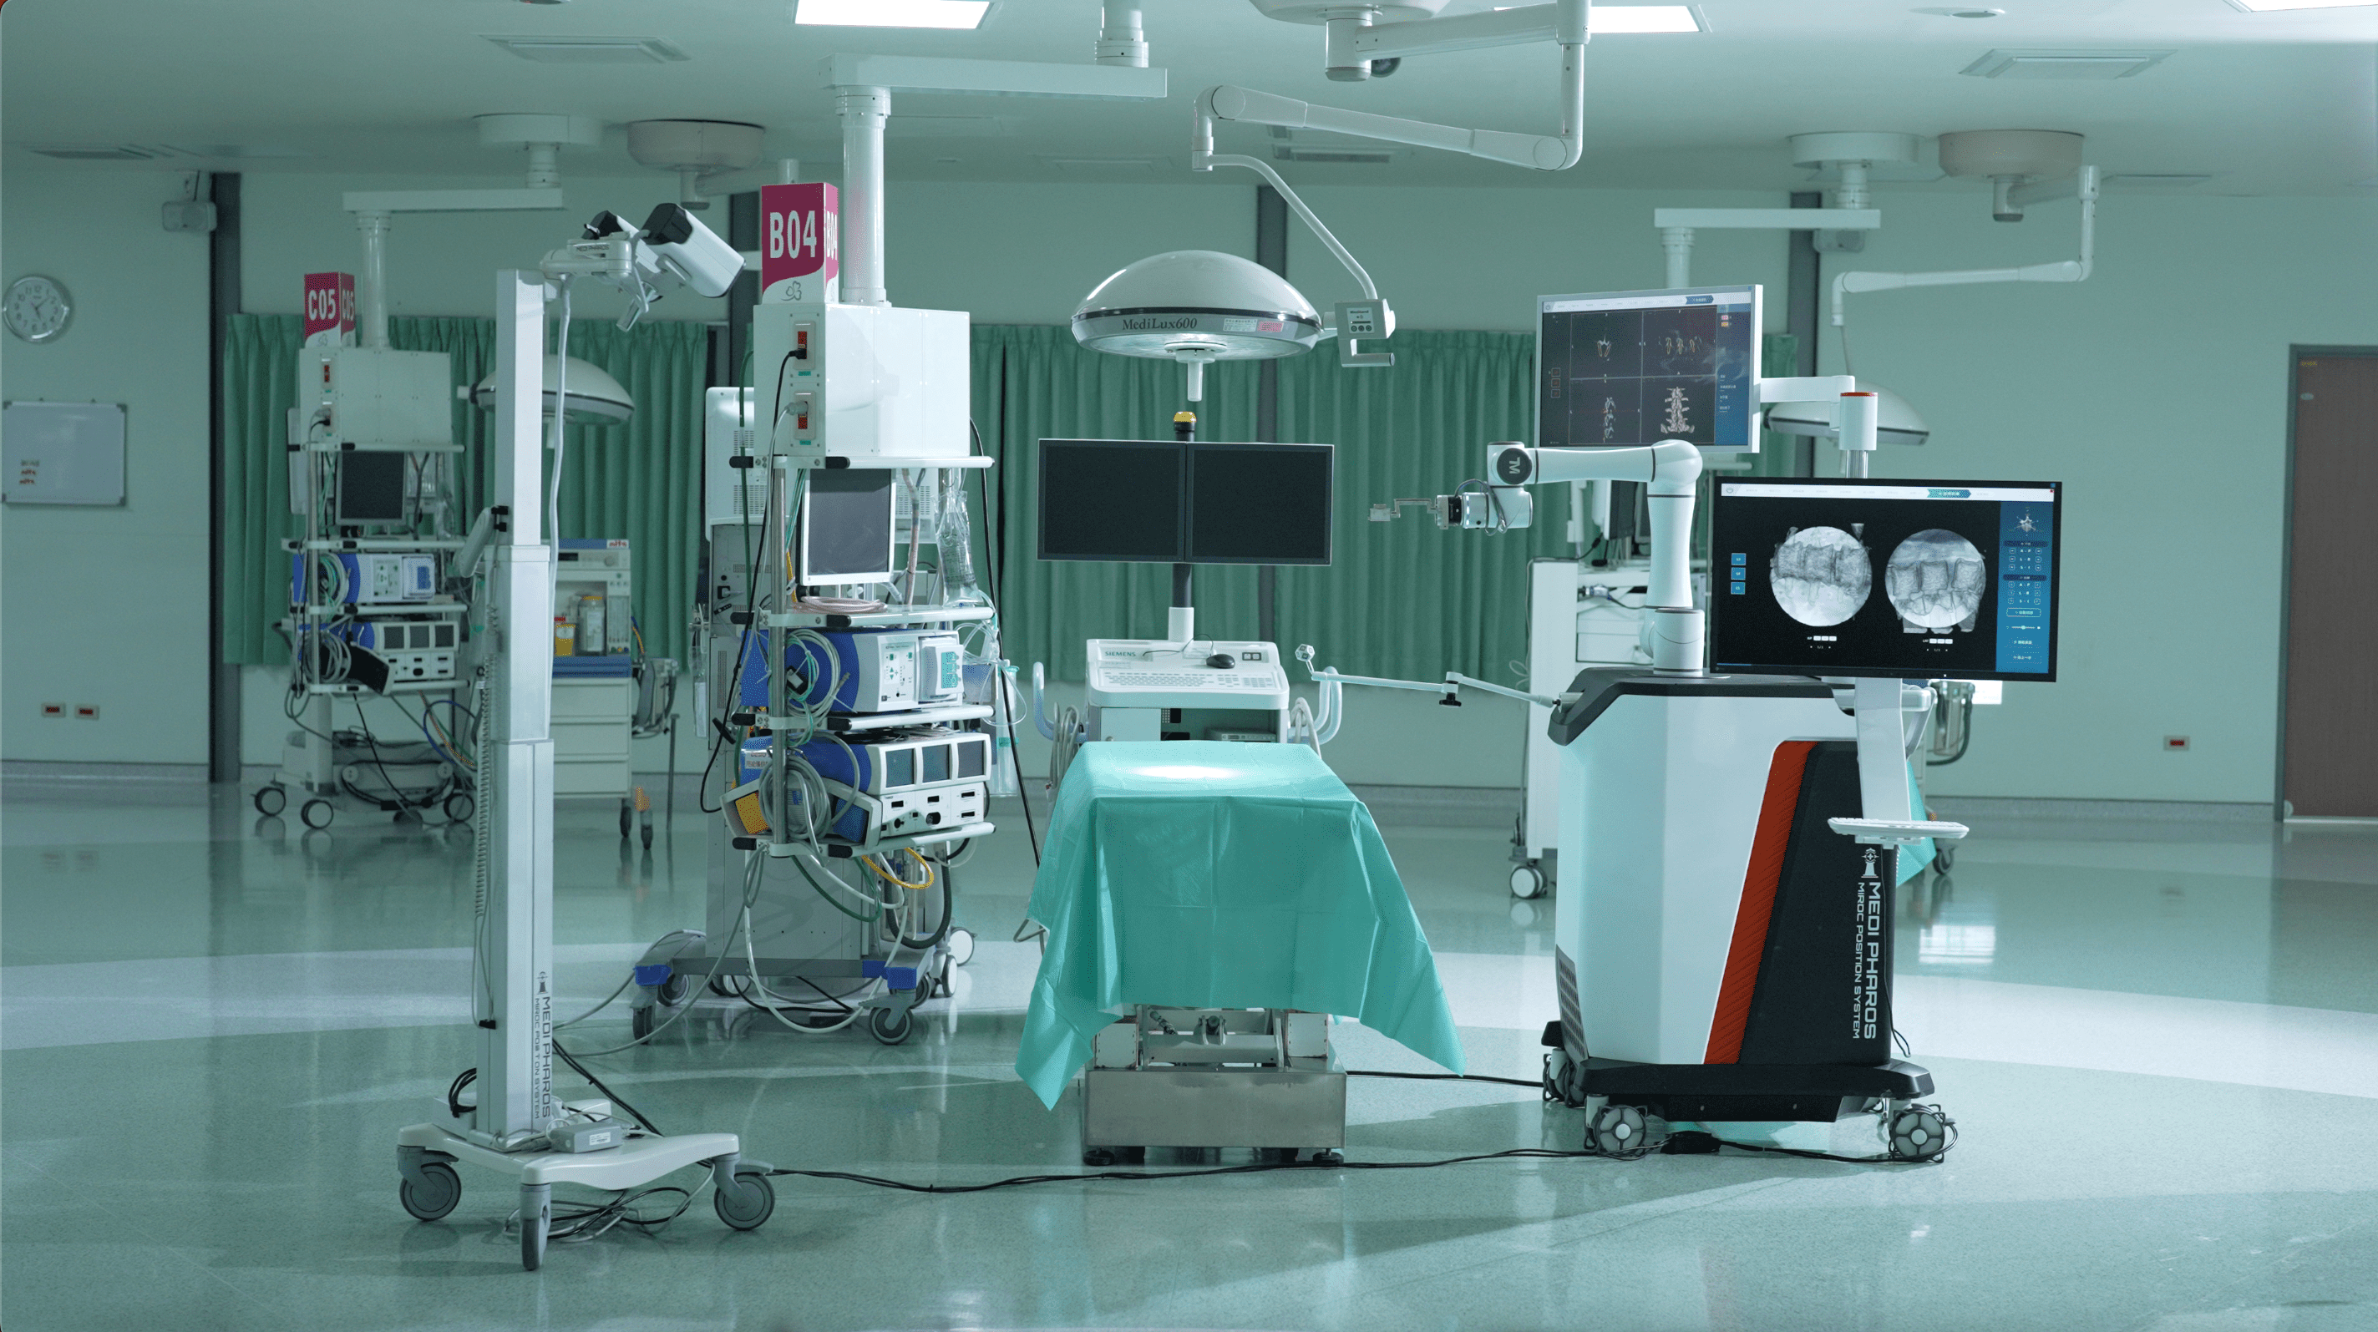

Picture 1、 The silver at the 2023 Edison Awards: The Continuous Tracking Surgical
Assistance System (CTSAS)
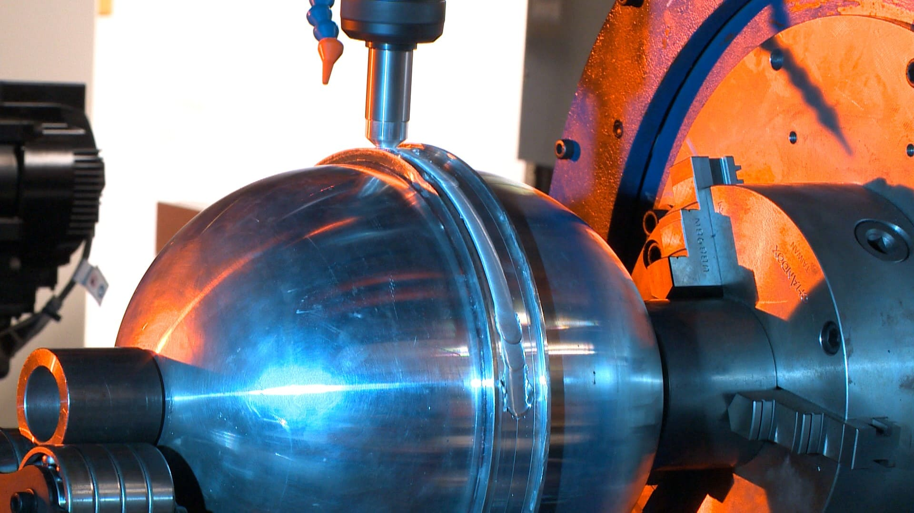

Picture 2、The bronze at the 2023 Edison Awards: The 4D (3D+Dissimilar) Printed
of Solid State Process

