
新聞資料NEWS LETTER
Hydrogen Combustion Industrial Application and High-pressure Transmission and Storage Technology Alliance for industry-university-institute collaboration to open up the future hydrogen energy business opportunities.

Facing the impacts of climate change, net-zero transformation has become under the global spotlight. In response to the challenge of net-zero by 2050, President Tsai announced in March, 2022 that the next phase of "energy transition" will be invested in the research and development of "hydrogen energy". The National Development Council also announced the pathway to net-zero emissions in 2050, listing hydrogen energy as one of the 12 key strategies for Taiwan’s net-zero transformation.

Section Chief of the Department of Industrial Technology (DoIT), the Ministry of Economic Affairs (MOEA), Hsiang Wei He said that in response to the global goal of 2050 net-zero transformation, hydrogen energy will become an important fuel for carbon reduction. Therefore, the DoIT attaches great importance to the development of hydrogen energy and demands in the industry and academia, and also invest in hydrogen energy technology. In the "Hydrogen Energy Combustion Industrial Application and High-Pressure Transmission and Storage Technology Development Program", the MIRDC commits to the research and development of key technologies, mainly to the development of anti-hydrogen embrittlement welding materials, welding technology and hydrogen prevention for the high-pressure transmission and storage industry, infiltration surface treatment technology, as well as applications in hydrogen and natural gas co-firing technology in heating process, burner design and development and integration of industrial furnaces.

Under the Technology Development Programs (TDP) of the DoIT, the MIRDC established the "Hydrogen Combustion Industrial Application and High-pressure Transmission and Storage Technology Alliance" on March 28th, 2022, focusing on two key independent technologies of hydrogen combustion industrial application & storage and transportation.
Companies from the gas industry, metal material industry, furnace body industry, equipment manufacturing industry, terminal valve industry, hydrogen energy end users as well as academia, and research institutes were invited for cross-domain collaboration. Companies invited are respectively Walsin Lihwa Co., Ltd. Stainless Steel Business Group, Donghe Iron and Steel Enterprise Co., Ltd., Linde LienHwa Industrial Gases Co., LTD, Lianglian Industrial Co., Ltd., Shourui Welding Consumables Industrial Co., Ltd., Taiwan Rheinland Technology Guardian Consulting Co., Ltd., Zhihao Industrial Co., Ltd., Songpeng Thermal Energy Co., Ltd., the team of Associate Professor Xu Sheng-Yan of National Sun Yat-Sen University, and the team of Professor Cai Jian-Xiong of National Pingtung University of Science and Technology, and the 10 organizations signed an MOU. It aims that through the interaction and technology development of industrial chain alliance manufacturers, a hydrogen energy application demonstration site and industrialization will be established.

Chi-Lung Lin, Acting President of the MIRDC, stated that in response to the demand of hydrogen energy transmission and storage and the combustion industrial applications, it is essential to dedicate to key technology development and introduction to industrial applications verification to develop domestic independent technology development. MIRDC leads the early-stage technical collaboration through the "Hydrogen Combustion Industrial Application and High-pressure Transmission and Storage Technology Alliance." Working hand-in-hand with industry chains to build our hydrogen energy base, to promote hydrogen mixed combustion industrial furnaces and high-pressure transmission and storage for oxygen and hydrogen technology applications demonstration line. In the hope to attract more organizations to join this technology alliance in the future. By hosting regular meetings and exchange actives among the members, it fosters the development of Taiwan’s hydrogen energy industry chain and open for more opportunity for industry collaboration.

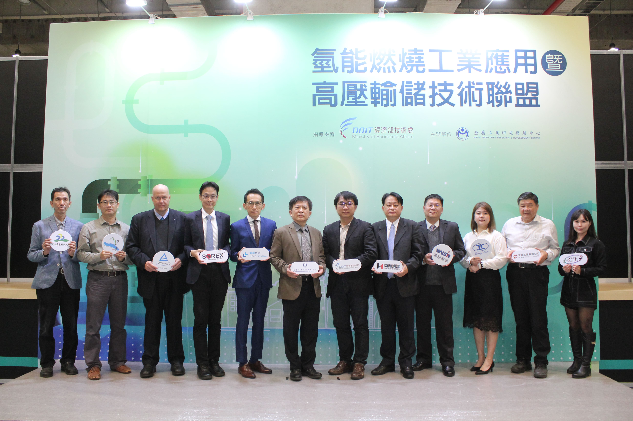

Photo 1、MIRDC Signed the MOU with 10 companies and academia for "Hydrogen Combustion Industrial Application and High-pressure Transmission and Storage Technology Alliance." The photo from left to right are Professor Cai Jian-Xiong of National Pingtung University of Science and Technology, Associate Professor Xu Sheng-Yan of National Sun Yat-Sen University, Mr. Andreas Klinker , President Zhou Xi-Cheng of Shourui Welding Consumables Industrial Co., Ltd., General Manager of Hsu Cheng-Han Linde LienHwa Industrial Gases Co., LTD, Acting President Lin Chi-Lung, of the MIRDC, Section Chief He Xiang-Wei of the Department of Industrial Technology (DOIT), MOEA, CEO Huang Bing-Hua of Donghe Iron and Steel Enterprise Co., Ltd., Division Chief Yang Chuan-Zhong of Walsin Lihwa Co., Ltd., Executive Assistant to General Manager XUE SHUN-WEN of Lianglian Industrial Co., Ltd., General Manager Chang SONG-ZHU of Zhihao Industrial Co., Ltd., and President Cheng Yi-Rong of Songpeng Thermal Energy Co., Ltd.

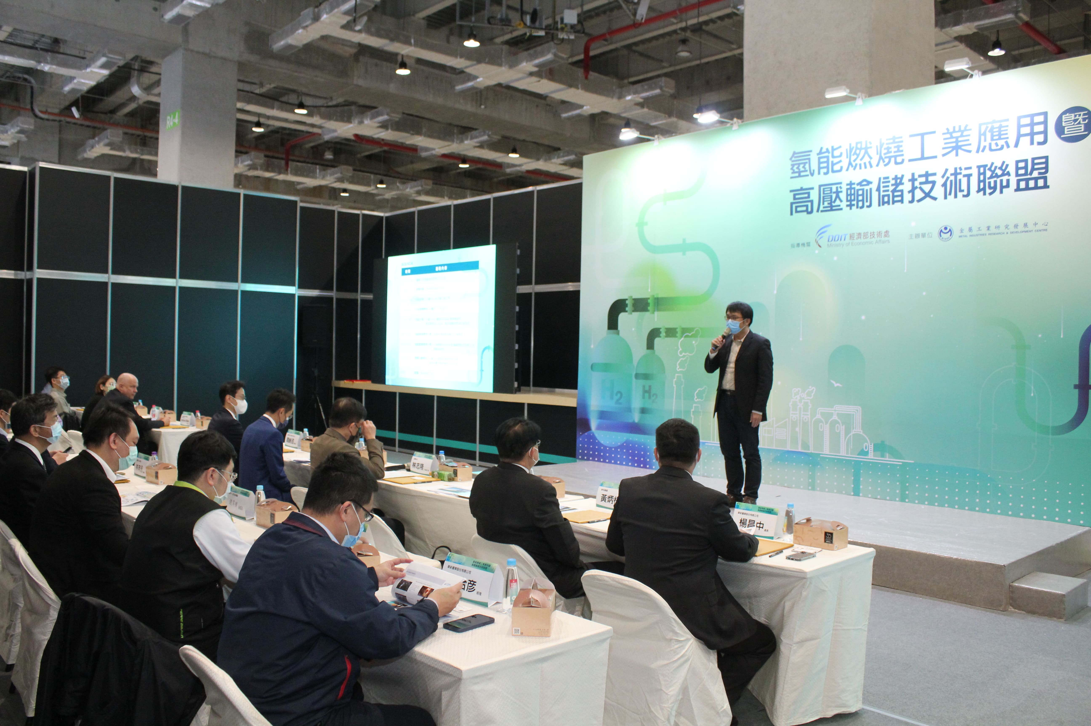

Photo 2、 Section Chief He Xiang-Wei of the Department of Industrial Technology (DOIT), MOEA presented to witness "Hydrogen Combustion Industrial Application and High-pressure Transmission and Storage Technology Alliance” founded by the MIRDC.
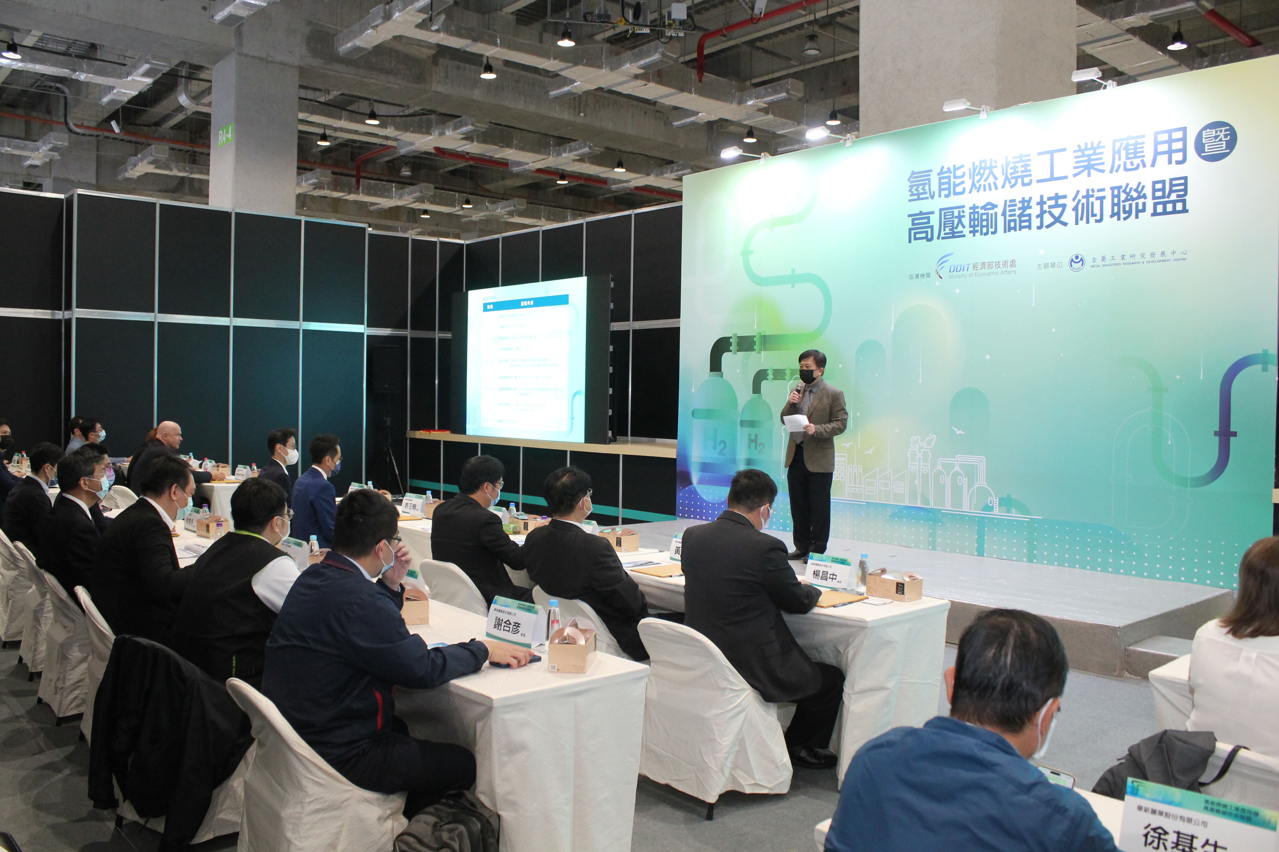

Photo 3、Acting President Lin Chi-Lung, of the MIRDC led the foundation of "Hydrogen Combustion Industrial Application and High-pressure Transmission and Storage Technology Alliance”

