新聞資料NEWS LETTER
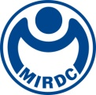
The determination to transform and upgrade to net zero carbon reduction is imperative, as MIRDC jointly works with Taiwan Steel & Iron Industries Association to establish the Expert Service Group in the Steel Industry of Carbon Reduction

MIRDC has cooperated with the Industrial Development Bureau (IDB), Ministry of Economic Affairs to promote the industrial net zero carbon emissions, and together with the Taiwan Steel & Iron Industries Association (TSIIA) held the “Symposium of the Expert Service Group in Steel Industry Carbon Reduction” Many Steel companies and the related experts were invited to share the topic of the operation mechanism of the Carbon Reduction in working together to drive carbon reduction in Taiwan's domestic steel-related industries. This symposium was driven by the Senior Executive Officer of the IDB, Shang-Chun Chang, the Executive Officer of the TSIIA, Min-Hsiu Tsai, the Director of the CSC, Yi-Min Wu, and the Acting President of the MIRDC, Chih -Lung Lin. With more than 50 representatives from the on-site industry-university-research institutes, including Taiwan Steel & Iron Industries Association, China Steel Corporation (CSC), Dragon Steel Corporation (DSC), C.S. Aluminum Corporation (CSAC), Feng Hsin Steel Co., Ltd, Tung Ho Steel Enterprise Corporation, Yieh United Steel Corp. (YUSCO), Prosperity Tieh Enterprise Co., Ltd, GMTC Gloria Material Technology Corp. (GMTC), Yieh Phui Enterprise Co. Ltd, Walsin Lihwa Corporation, Shyeh Sheng Fuat, Wei Chih Steel, Hai Kwang Enterprise Corporation, and Tung Mung Development Co., Ltd.

In the first stage, The Expert Service Group in the Steel Industry of Carbon Reduction would ask manufacturers to fill out the main energy-consuming equipment survey form through visits, and MIRDC would send experts to the manufacturers to conduct a preliminary inventory of major energy-consuming equipment and produce reports. In the second stage, The Group would conduct advanced diagnosis and evaluation and provide suggestions for improvement plans in producing diagnosis reports. By guiding and introducing government subsidy resources, it guides manufacturers to enter low-carbon improvement. In the third stage, baseline measurement would be carried out to measure the energy consumption of process equipment and process baseline analysis for the iron and steel industry. The industry participants at the scene expressed high affirmation and expectations for the future development of The Group.

The Senior Executive Officer of the IDB, Shang-Chun Chang, stated that net-zero carbon reduction is an international trend, and large iron and steel plants can play a leading role, leading the small with the big and guiding the downstream steel users based on their own industry experience and carbon reduction promotion results industry. The Industrial Development Bureau (IDB) of Ministry of Economic Affairs has integrated resources to assist the steel industry to be prepare, thereby enhancing the international competitiveness of the steel industry. The Acting President of the MIRDC, Chih -Lung Lin, who also stated that, MIRDC would fully support the Ministry of Economic Affairs to promote net zero carbon reduction in the industry and cooperate with the Iron and Steel Association to assist in the carbon inventory capacity training of the supply chain system, and introduce the energy of the expert service team to introduce the energy reduction Carbon technologies to accelerate net-zero carbon reduction for the overall steel industry.

The Director of the CSC, Yi-Min Wu, suggested that after the diagnosis is completed, manufacturers can understand that through the guidance of MIRDC, with data provided to know better about the carbon reduction costs and carbon reduction performance, also through carbon reduction benchmarking for steel to clarify the gap between itself and the best in the industry allows manufacturers to understand how carbon reduction works. Since the symposium ended that day, several steel industry players have actively asked about the net-zero carbon reduction practices of the steel industry.

Under the full promotion of the Ministry of Economic Affairs' carbon reduction resources, MIRDC will integrate resources related to net zero carbon reduction resources and establish a complete one-stop service platform, aiming at linking government resources with the iron and steel industry and other related metal industries, with industry-university-research service capabilities, to assist industry players in capacity building, such as carbon inventory and carbon reduction technologies, and to move towards the goal of low-carbon transformation.

The contact person of The Expert Service Group in the Steel Industry of Carbon Reduction：The Project Manager of the MIRDC, Chen Chiu
Telephone：07-3513121 ext 2412
E-mail：chiujen@mail.mirdc.org.tw

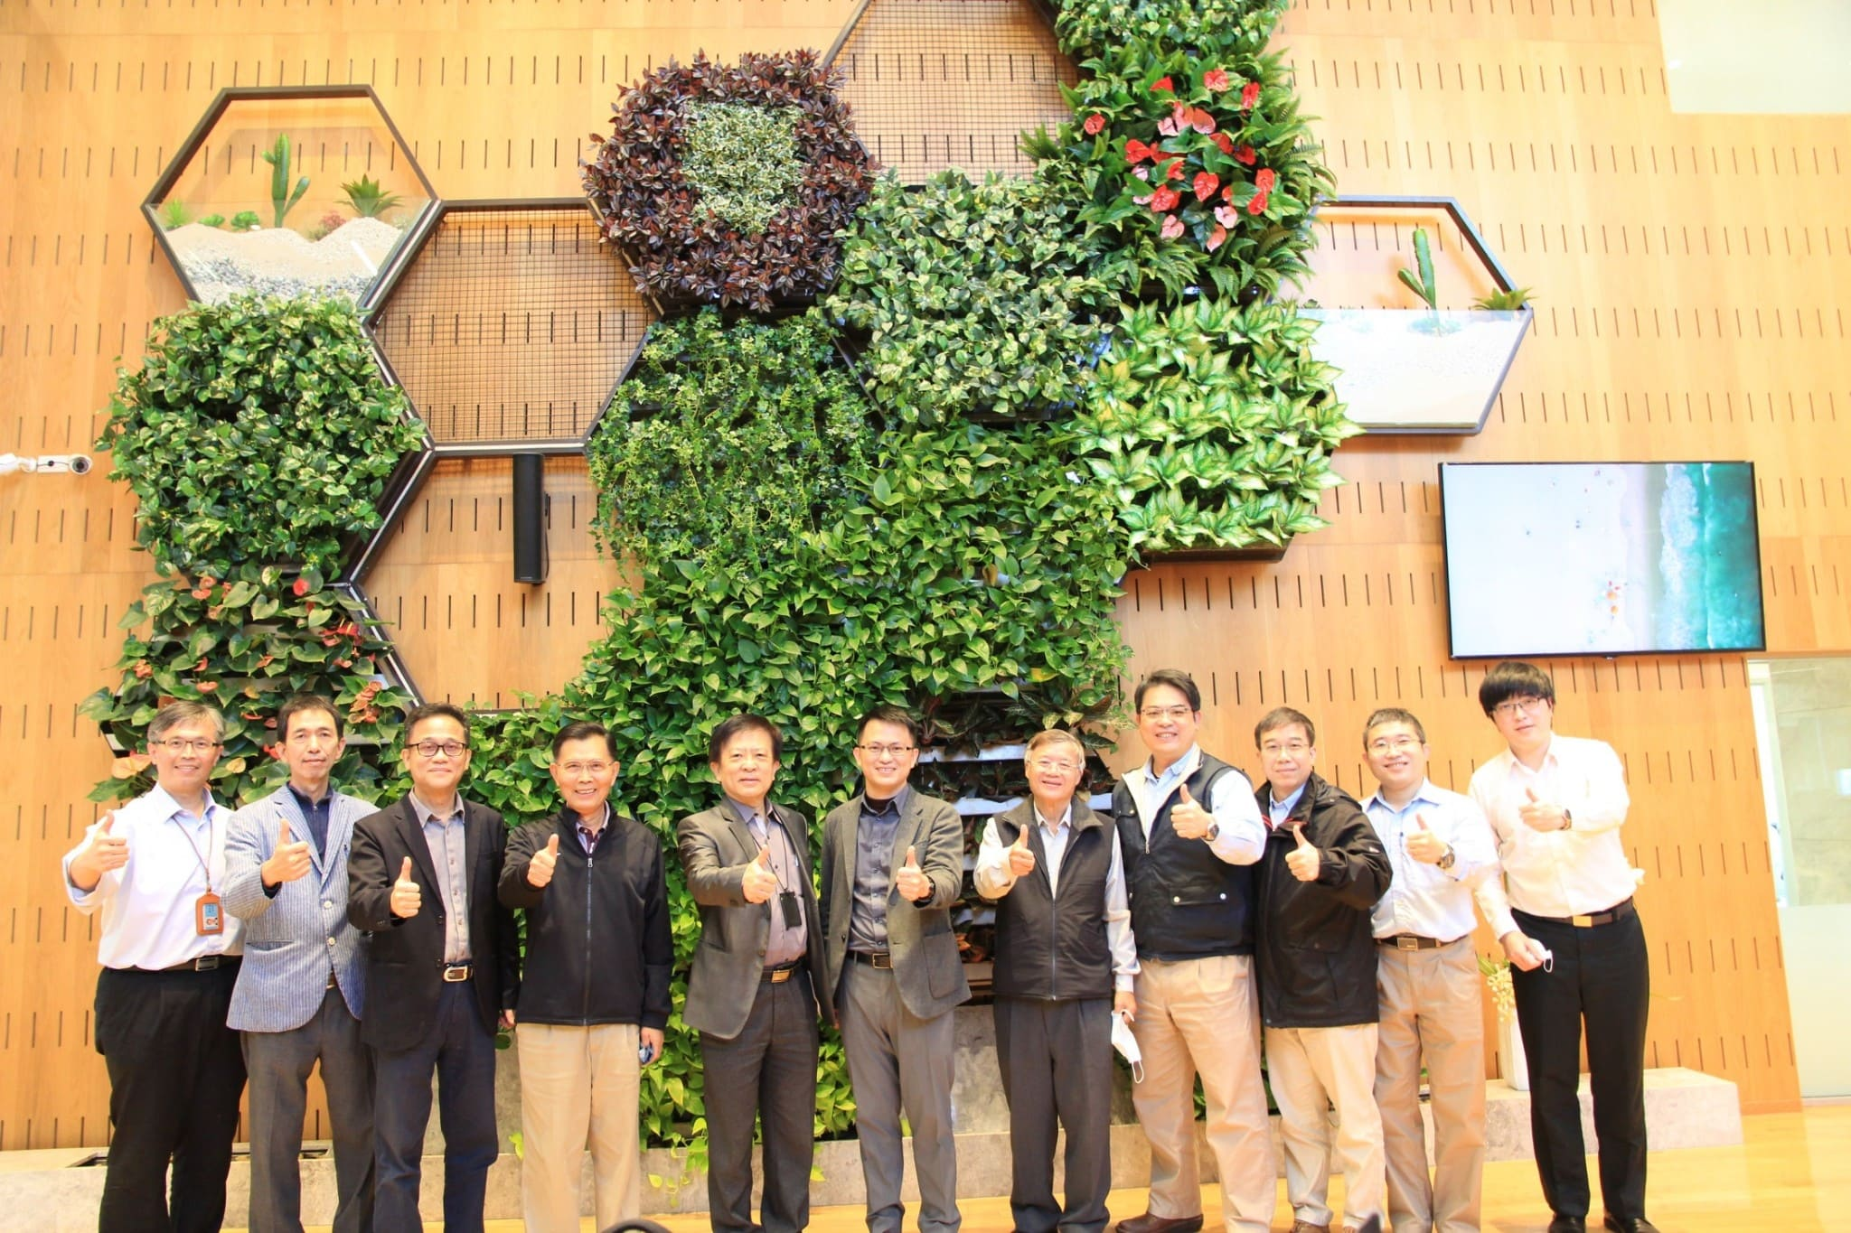

Fig 1, a group photo of The Expert Service Group in the Steel Industry of Carbon Reduction. (The acting President of the MIRDC, Chih-Ling Lin (the fifth from left), The Senior Executive Officer of the IDB, Shang-Chun Chang (the sixth form left), The Director of the CSC, Yi-Min Wu (the fourth form right), and the Executive Officer of the TSIIA, Min-Hsiu Tsai (the first form right))

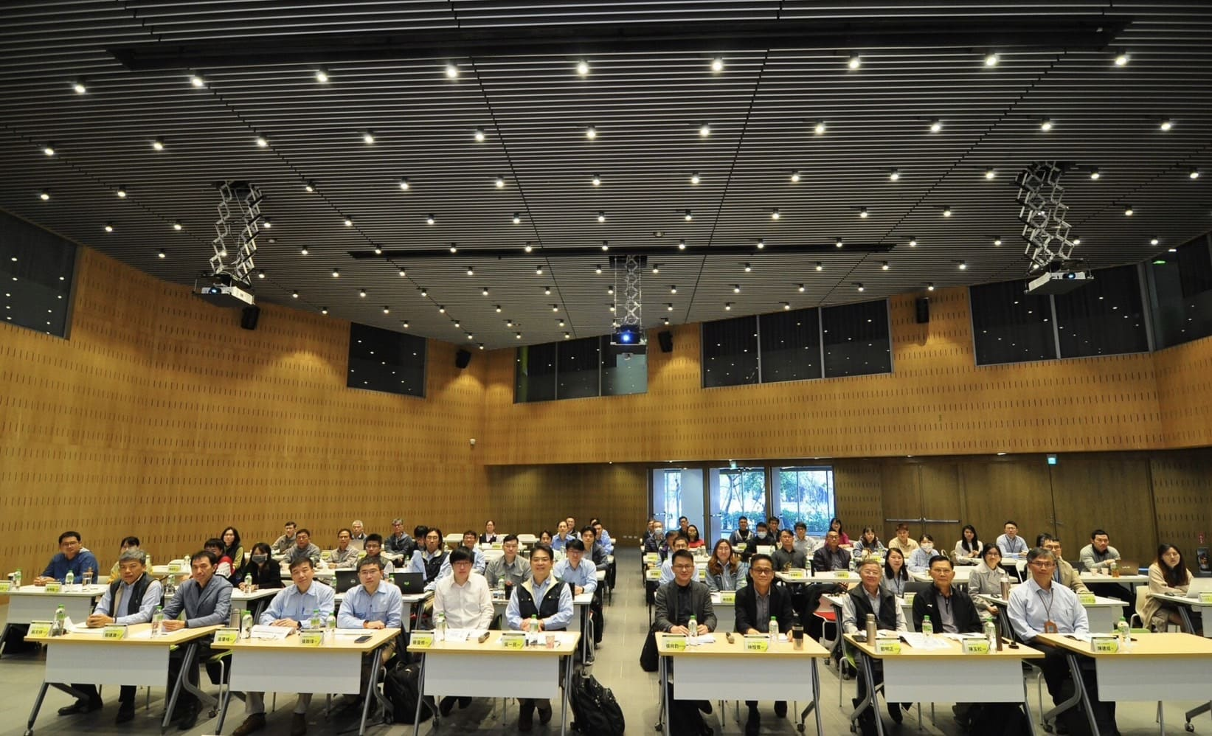

Fig 2, a group photo of the participants at the scene

