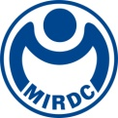 | NEWS LETTER

Counseling the Net Zero Transformation and Upgrade of the Fastener Industry
Metal Industries Research & Development Centre (MIRDC) Establishes a One-stop Resource Platform for Carbon Reduction Services

In response to the Industrial Development Bureau’s promotion of net zero across industries, MIRDC partnered with Taiwan Industrial Fasteners Institute and Taiwan Institute of Economic Research to host the Seminar for Promoting Low Carbon Transformation in the Fastener Industry on February 7th. The event provided preliminary details for the EU’s Carbon Border Adjustment Mechanism (CBAM), its impact on the fastener industry, and discussed government resources that will be allocated in response. Ministry of Economic Affairs (MOEA) Vice Minister Chuan-Neng Lin, Industrial Development Bureau Director General Ching-Chang Lien, Kaohsiung City Government Economic Development Bureau Director-general Tai-Hsiang Liao, Taiwan Industrial Fastener Institute Chairman Tu-Chin Tsai, China Steel Corporation (CPC) Chairman Chao-Tung Wong, MIRDC Chairman Jen-Yi Lin, central government representatives, and industry-academia departments joined more than 400 businesses in online and offline forums.

During the seminar, MOEA Vice Minister Chuan-Neng Lin stated the fastener industry’s significant contributions to our nation’s economic development. Concerning the international trends of carbon neutrality and net zero, MIRDC and CPC already possess professional technologies and experience while the Industrial Development Bureau has consolidated resources to assist industries in preparation. Instead of being a risk, CBAM will be an opportunity to enhance the fastener industry’s global competitiveness. At the seminar, MIRDC Chairman Jen-Yi Lin also stated his full support for the MOEA’s efforts to drive industries towards net zero and carbon reduction, enhance the cultivation of carbon reduction talents, and comprehensive counseling services offered to industries.

In regard to the MOEA’s consolidation of carbon reduction resources and the fastener industry cluster’s green responsibilities, MIRDC offers a one-stop service platform to help businesses. As noted by Deputy Chiefs Chia-Wei Chao and Yung-Cheng Wu, the platform aims to connect government resources and guidance policies with industry-academia services to help businesses establish capabilities in carbon inventory and carbon reduction technologies as they transition towards the objective of low carbon transformation.

In 2022, MIRDC counseled a major automobile fastener supplier in Southern Taiwan. The introduction of smart manufacturing to reduce carbon and a carbon tracking system for their products helped the business achieve an annual reduction of 153 tons in carbon emissions as well as the benefit of saving 42,000 kWh (approximately NT $130,000) in electricity consumption. Aside from saving substantial economic costs, businesses can also utilize a carbon tracking system for their products to understand consumption in their various manufacturing processes, thereby resulting in decisions to increase investments into carbon reduction technologies for increased efficiency. On the other hand, the system optimizes data input for carbon footprint activities to enhance the efficiency of data collection and reducing the threshold for businesses to invest in carbon footprint investigations for their products.

Currently, MIRDC has organized carbon reduction experts in industry and academia to provide assistance in both carbon inventory counseling and tracking product carbon footprint. This includes connection to ERP/MES data integration modules and capturing the amount of electricity and natural gas used by equipment to achieve batch tracking of product carbon data and building a visual situation room capable of tracking factory-wide emissions data. Event attendees and businesses expressed a high level of interest and gained further understanding to the importance of joining the ranks in carbon reduction. Once carbon hot spots are identified in factories, visual tracking technology that integrate elements of smart manufacturing are introduced to improve manufacturing processes.

When the seminar concluded, tens of fastener businesses actively inquired how their industry can implement net zero practices to reduce carbon. With full support from the MOEA and MIRDC, carbon reduction related resources shall be integrated into a comprehensive one-stop services platform to provide the industry with total net zero solutions. Services from expert groups and government resources will be utilized to host workshops while benchmark enterprises will share their practices and carbon management tools to help businesses accelerate their transition into carbon reduction through diverse channels. MOEA also announced a post-COVID special budget in the future that will be provided counseling in the themes of “smart manufacturing” or “carbon reduction”. MIRDC will assist the fastener industry in proposing improvement plans, reviewing the effects of energy conservation, and achieving the goal of carbon reduction to enhance their advantages.

One-stop carbon reduction services contact person:
Carbon reduction expert service group contact person: MIRDC Project Manager Jen Chiu
Contact Number: 07-3513121 ext. 2412
E-mail: chiujen@mail.mirdc.org.tw

Digital transformation optimization counseling services contact person: MIRDC Deputy Section Chief Chia-Ming Chan
Contact Number: 07-3513121 ext. 3536
E-mail: cmjan@mail.mirdc.org.tw

URL to digital presentation file of the Seminar for Promoting Low Carbon Transformation in the Fastener Industry, February 7, 2023: https://reurl.cc/587xDR

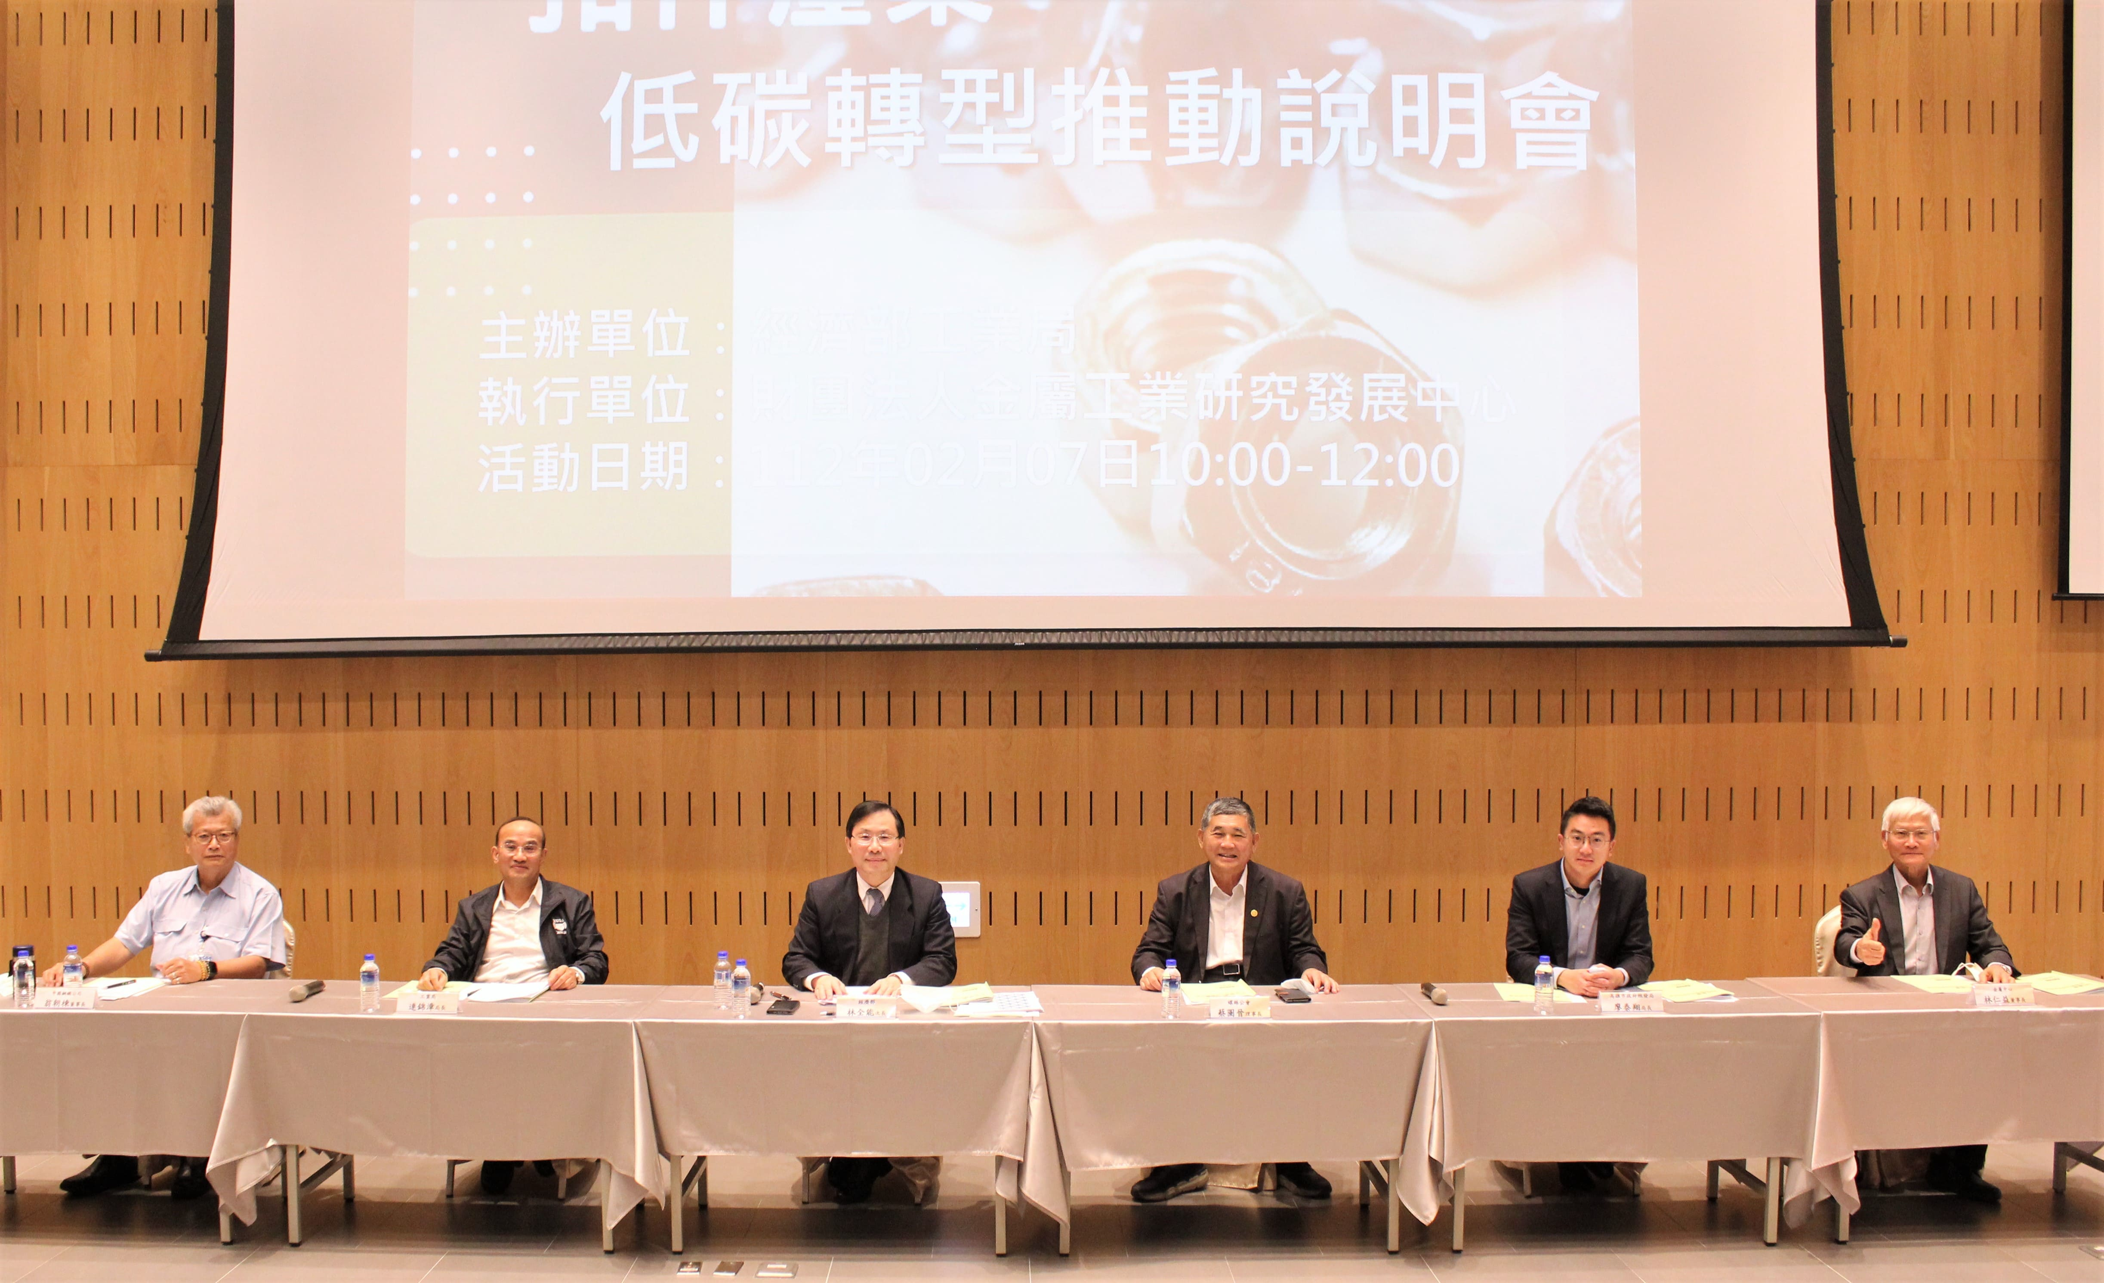
Caption: Group photo with guests (left to right) CPC Chairman Chao-Tung Wong,Industrial Development Bureau Director General Ching-Chang Lien,MOEA Vice Minister Chuan-Neng Lin,Taiwan Industrial Fastener Institute Chairman Tu-Chin Tsai,Kaohsiung City Government Economic Development Bureau Director-general Tai-Hsiang Liao,and MIRDC Chairman Jen-Yi Lin.

