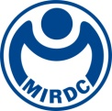
新聞資料NEWS LETTER
MIRDC continues to innovate and grow, once again earning the 2023 R&D100 Awards

Taiwan's R&D capacities are world-renowned. The R&D100 Awards is one of the most prestigious awards in the international R&D community. Under the guidance of the Ministry of Economic Affairs, MIRDC has once again received recognition from the R&D 100 professional judging panel. It has stood out from thousands of global technical submissions and received this award. It is on par with international laboratories such as the Massachusetts Institute of Technology (MIT) Lincoln Laboratory, Sandia National Laboratories, Oak Ridge National Laboratory, and Idaho National Laboratory. This represents the deep recognition of MIRDC's research and development and innovation prowess, solidifying Taiwan's international position and image in industrial technology.

Yung-Hsiang Lai, President of MIRDC, pointed out that the award-winning technology is "Electrochemical Machining System for Intelligent Electrode with 3D Variable Curvature (EMS)", which combines electrical discharge machining technology to replace traditional machining and can be applied to the processing of structural parts with complex structures and difficult-to-machine materials. Currently, it has been successfully used in the manufacturing verification of aerospace turbofan engine diffusers. It can also be used in various processing such as special structural parts of aircraft fuselage or aerospace fasteners. In particular, whether the processed materials have difficult-to-cut characteristics, or the overall structure has an ultra-thin curved shape, and there is no residual stress on the surface of the material after processing, this technology can be completed in one go, effectively increasing production efficiency by more than three times. This technology contributes to the introduction of domestically developed independent technologies into the international aerospace component supply chain. In addition, MIRDC's technical team has also collaborated with the Georgia Institute of Technology, allowing MIRDC's independent R&D technology to be promoted internationally.

With the long-term support of the government, MIRDC has overcome the processing bottlenecks in the metal-related industry and can realize the forming of complex components and small-scale customized requirements, strengthening the order-taking capacity and international competitiveness of Taiwanese manufacturers. Particularly in the context of diverse manufacturing applications in the future, it actively deepens R&D results of science and technology programs to be innovative, which will not only enrich Taiwan's industrial research capacities but also promote the growth and development of Taiwan's next-generation industries. This year's technical achievements have once again received recognition from the R&D 100 Awards. MIRDC will keep up the good work and continue to promote the capacity of R&D achievements internationally and leap onto the global stage.

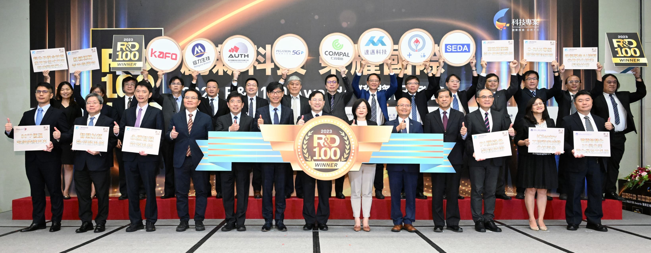
Picture 1、Guests at the joint press conference of the 2023 R&D 100 Awards
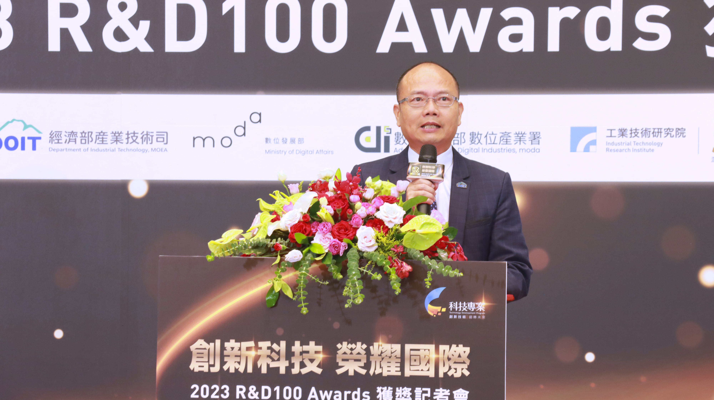
Picture 2、Speech by Yung-Hsiang Lai, President of MIRDC
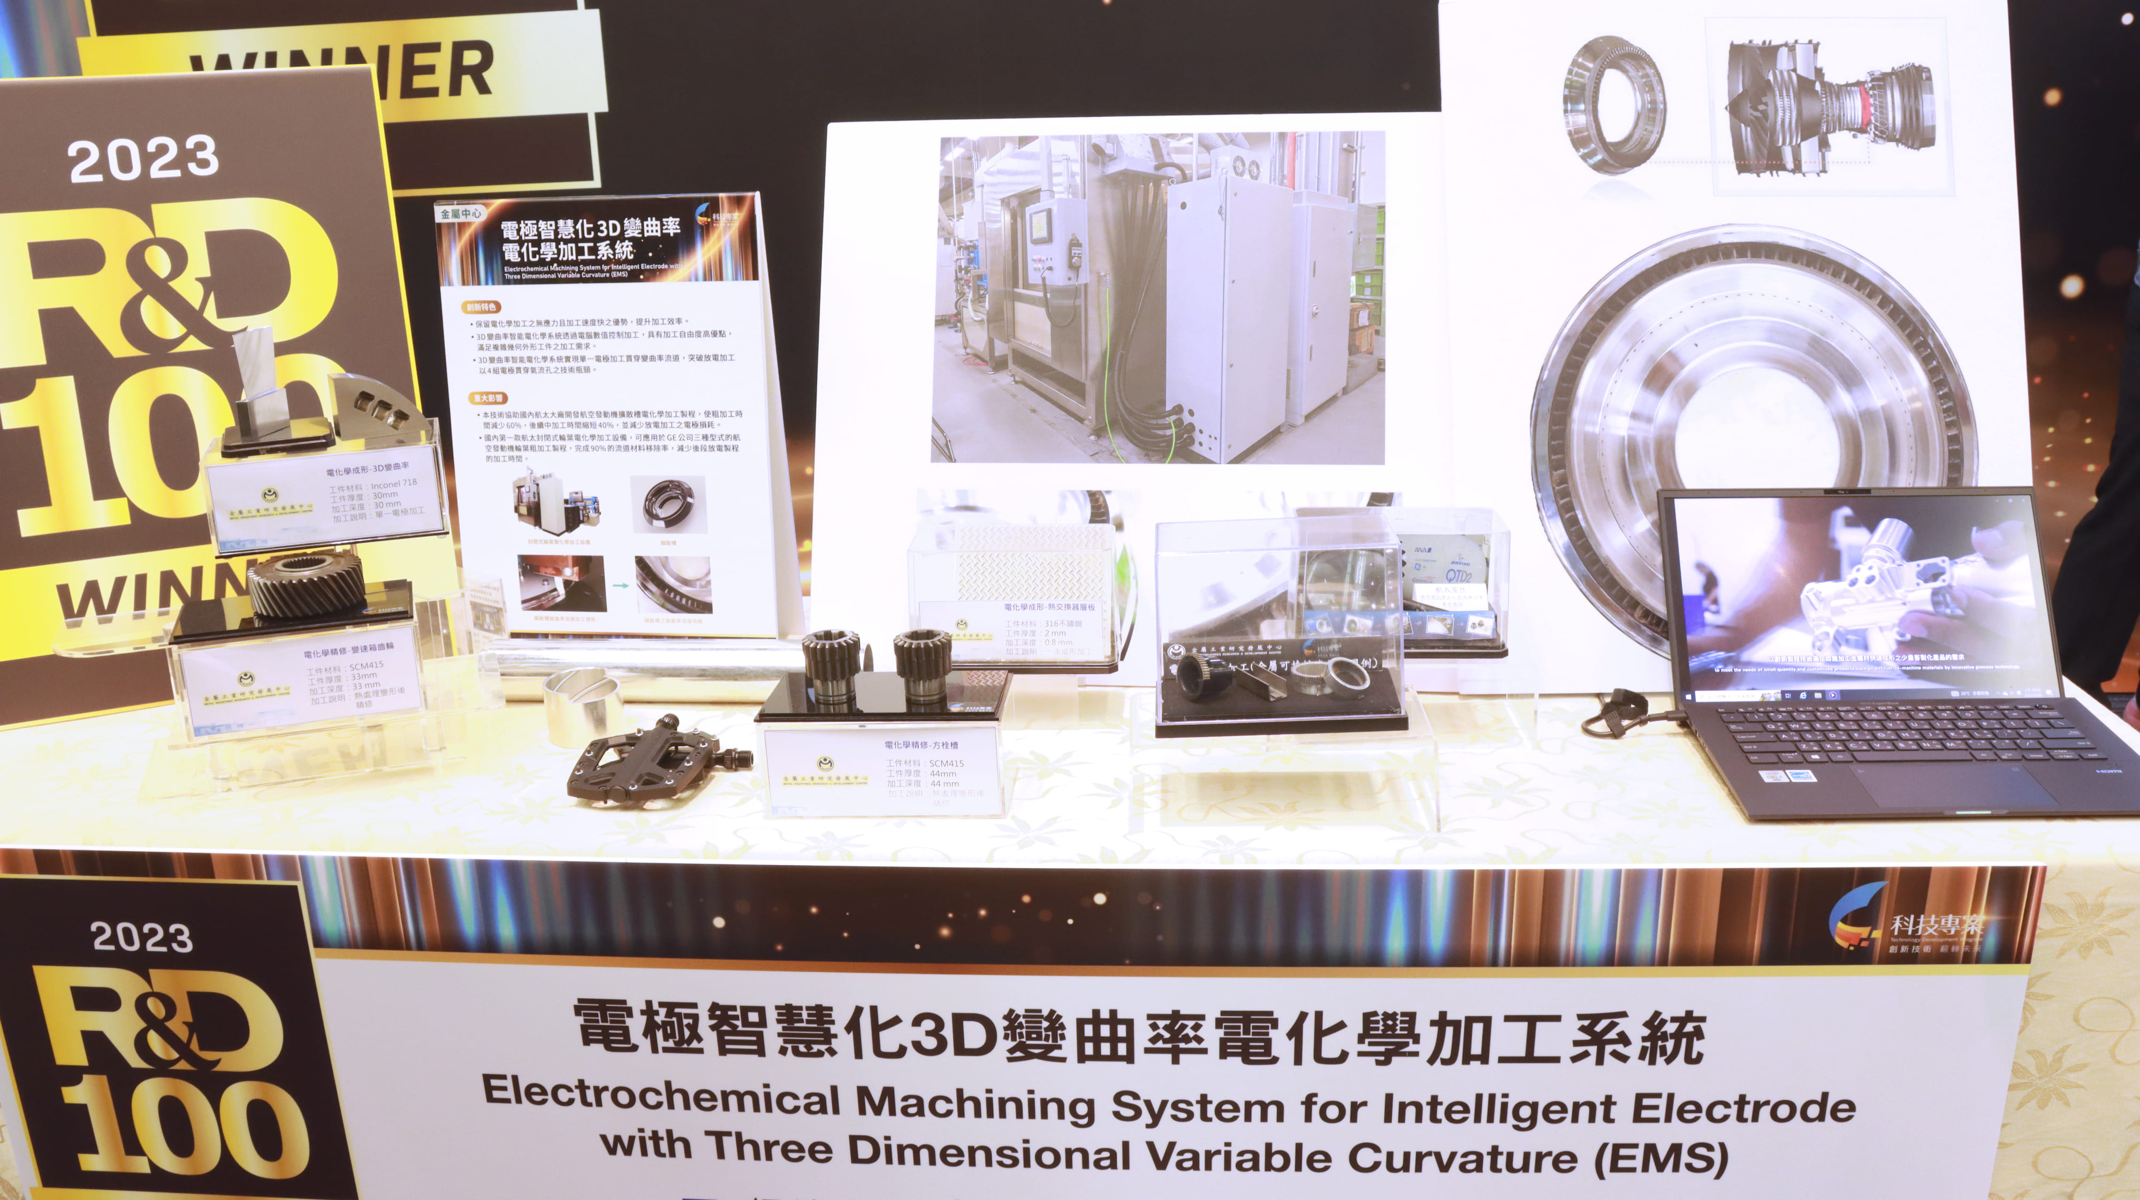
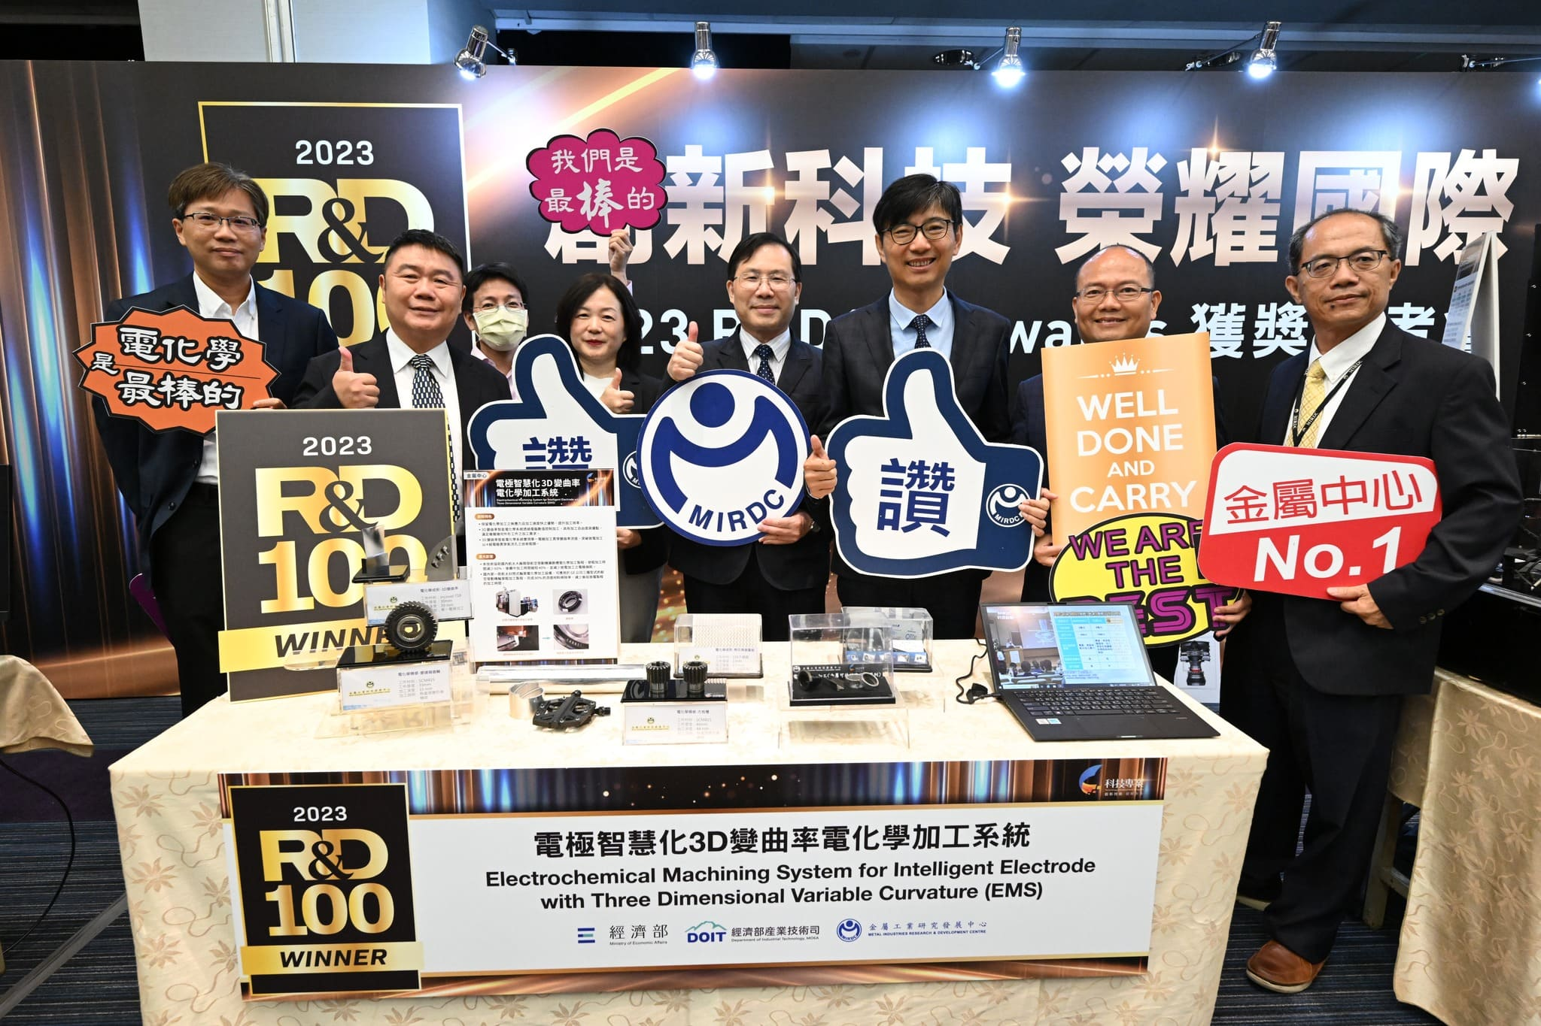
Picture 3、2023 R&D 100 Awards MIRDC’s Award-winning Technology: “Electrochemical Machining System for Intelligent Electrode with 3D Variable Curvature (EMS)”
Picture 4、 Chuan-Neng Lin, Deputy Minister of the Ministry of Economic Affairs, and Chyou-Huey Chiou, Director of the Department of Industrial Technology took a group photo with the award-winning technical units

