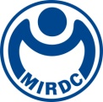
新聞資料NEWS LETTER
The development of Offshore Wind Industry is all the range, and MIRDC and
Wenzao Ursuline University of Languages launched an Offshore Wind Energy Program

Since Taiwan set the goal to raise its offshore wind power capacity to 5.7 GW by 2025, many big companies in the world have been invited to invest in Taiwan, And many of them founded Asian headquarters or branches to be ready to deepen the business and develop Asian markets. In such an international industrial workplace environment, fluent English and communication skills are necessary for this popular job. The scope of the offshore wind power industry covers a wide range of students with electrical and electronic-related majors. Therefore, Wenzao Ursuline University of Languages cooperated closely with Maritime Technology Innovation Center (MTIC) of MIRDC to launch an Offshore Wind Energy Program. The project assistance training program is to help elites with humanities degrees have the opportunities to become talented with a million-dollar job.

The high-quality education Wenzao Ursuline University of Languages has won the recognition of enterprises across the nation and was awarded the 2022 Best Education University by Global Views Monthly. The University also won the Enterprise's Favorite Undergraduated Student by Cheers and 1111 Job Bank's 2022 Enterprises' Favorite University Competition which was highly rated. In 2022, the University first cooperated with MTIC of MIRDC, had industry experts joined to offer the Industrial Practice Experience course to the public. The course focuses on practical project assistant of offshore wind power industry that meets needs of project management domestic and foreign manufacturers in the offshore wind power industry and international talent in the offshore wind power industry. In other words, the program is committed to cultivating the strength of Taiwan's offshore wind power industry that exceeds international standards.

Taiwan's offshore wind power is about to enter the third stage of block development from 2026 to 2035. Investment promotion operations have been carried out one after another, and the market will continue to recruit talents. In addition to providing Global Wind Organization, MTIC of MIRDC (GWO)'s international certificate training, through training cooperation with all walks of life, conducts various customized training courses and completes the offshore wind power professionals required in various fields. The course was specially tailored for Wenzao Ursuline University of Languages, from the introduction of knowledge in the various fields of the industry, including global energy trends, Taiwan policy development, the introduction of wind turbine structure, airframe operation system, wind farm operation, and maintenance strategies, etc. to wind power English professional terms both teaching and learning. The course will also arrange on-site visits for the teachers and the students. So that students can integrate the knowledge they have learned; at the same time, two industry lectures are planned for the humanities degree students. Through the perspective of WPD and SMC Global Power, students with humanities degrees can be part of offshore wind power-related industries, having opportunities to perform well and show their achievements.

A total of 23 students in this class have undergone 11 weeks of intensive course study. They will be selected by the cooperative manufacturers in the second semester of the 2022 school year and then enter the industry for more intensive and rigorous internships. After graduation, hopefully, the students would inject new ideas into offshore wind power development in Taiwan. MTIC of MIRDC will continually cooperate with various universities, colleges, departments, and institutes in Taiwan on industrial training courses to encourage more cross-field talents to invest in the wind power field together. Net zero goal efforts.

For more press, please contact
l MTIC of MIRDC: Marketing business manager Scott Wang at 0919-828-632 or via scott.wang@mail.mirdc.org.t, or the assistant Irene Yen at (07)698-889, ext 7232 or via ireneyen211@ mail.mirdc.org.tw
l Wenzao Ursuline University of Languages: Assistant Professor Sophie Mei-Fei Lu at (07)342-6031, ext 1301 or via 86005@mail.wzu.edu.tw, or the Promotion Department Director Yi-Chen Lin at (07)342-6031, ext 3501 or via 94072@mail.wzu.edu.tw

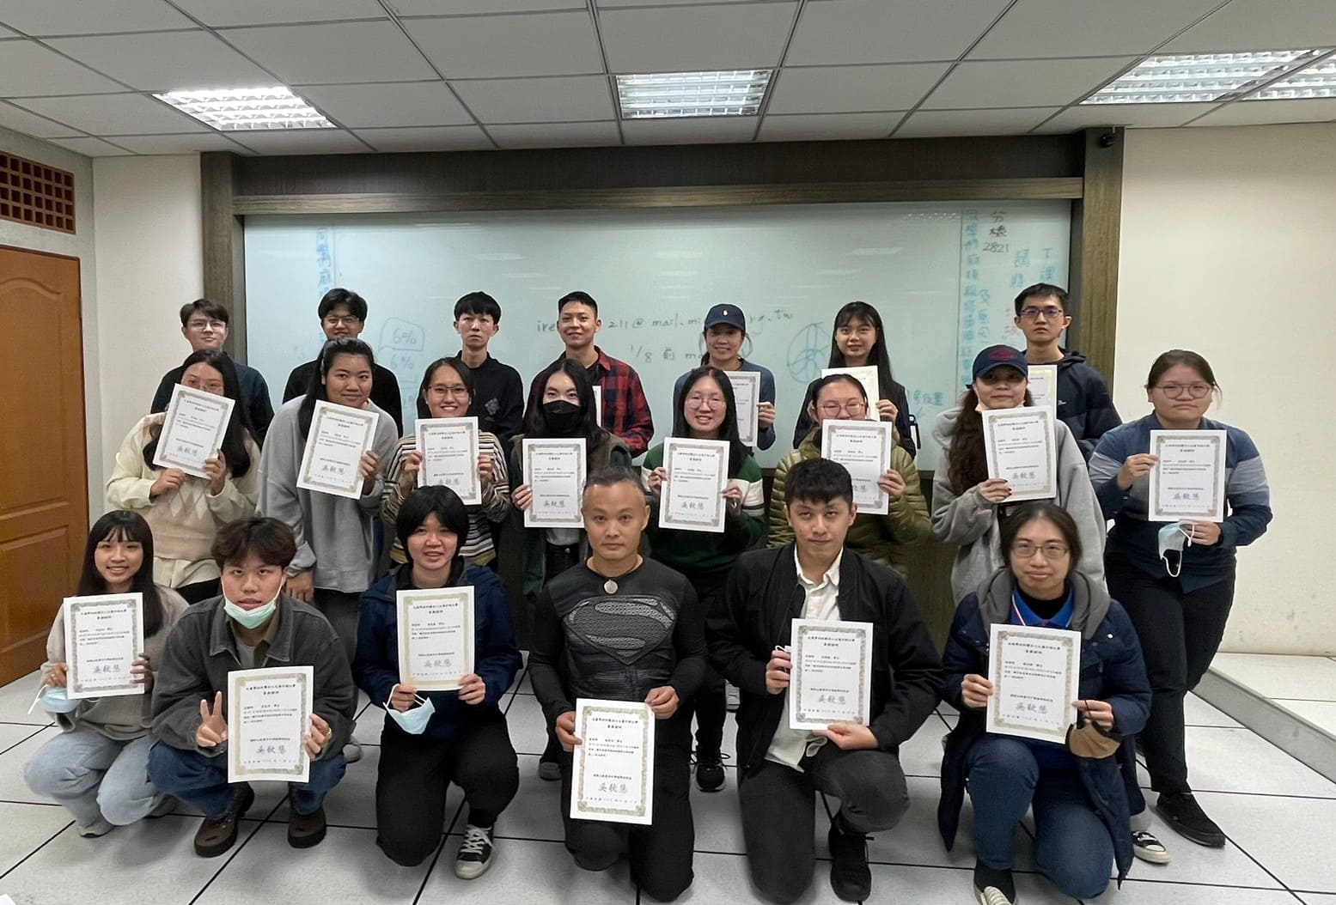

Fig, Group photo of certified students

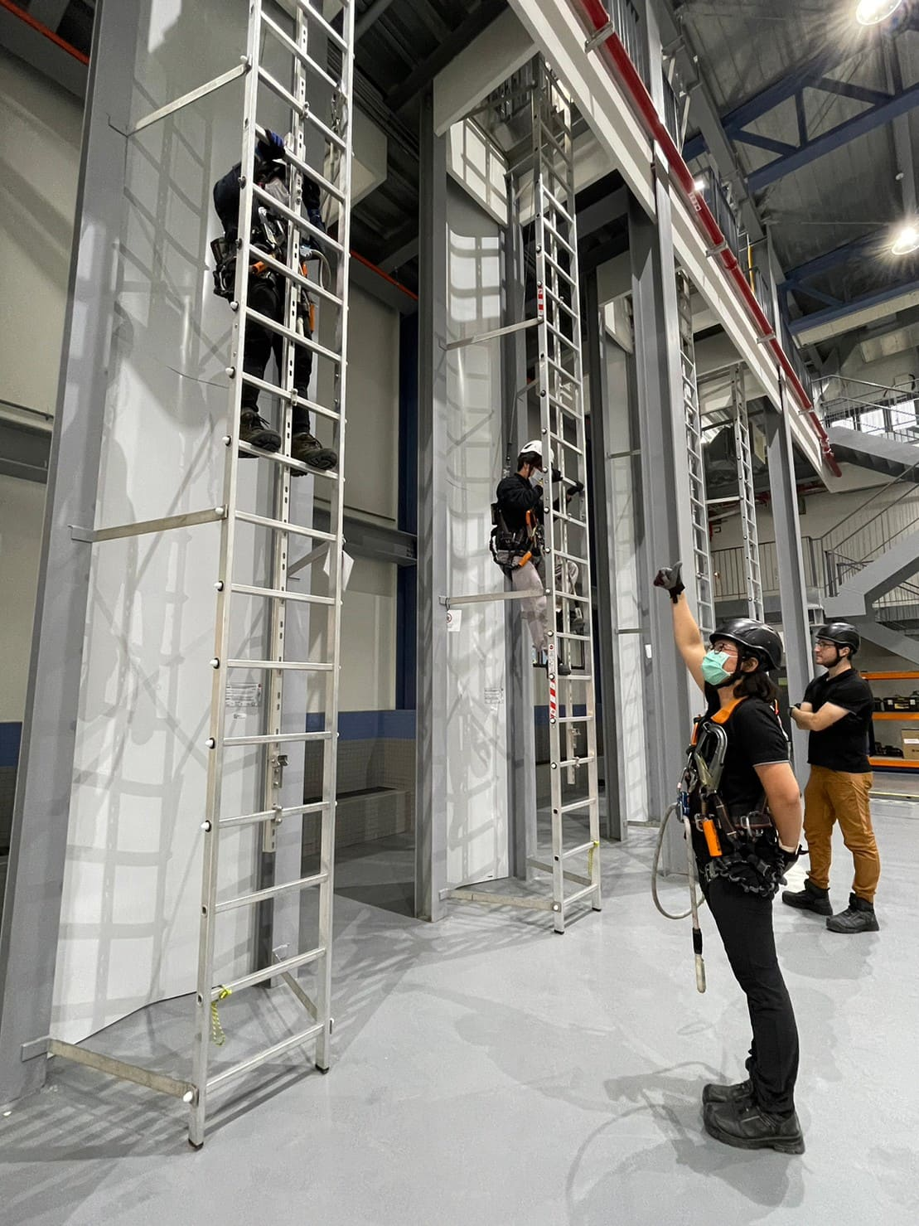

Fig2, Group photo of WAH practice
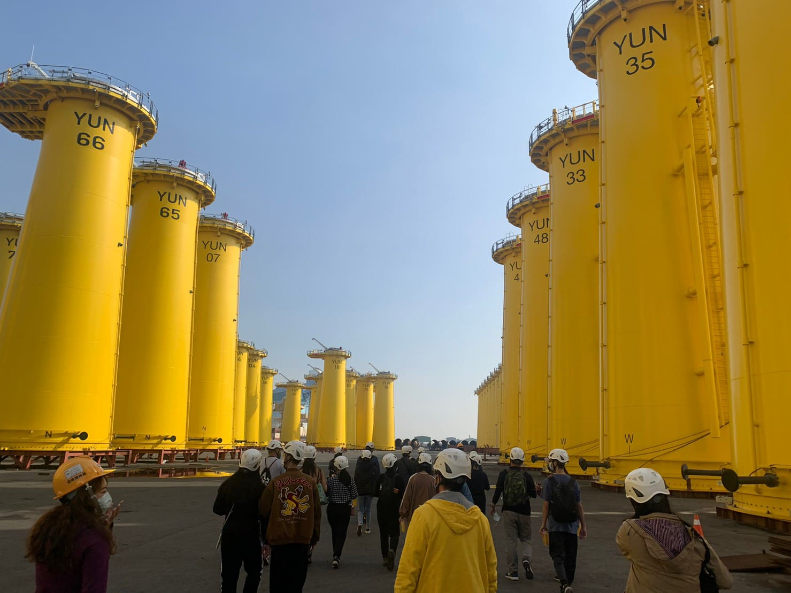

Fig3, Group photo of on-site visits

