新聞資料NEWS LETTER
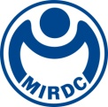
MIRDC organized the "Medical Equipment CDMO Surface Treatment Technology Industry Alliance"

MIRDC held the founding meeting of the "Medical Equipment CDMO Surface Treatment Technology" Alliance at the Luzhu Science Park in Kaohsiung. MIRDC linked spinal implant medical device companies BAUI Biotech Co., Ltd. and J.O. Corporation., micro intraoperative medical device company Clearmind Biomedical Inc., orthopedic medical device company Hung Chun Bio-S Co., Ltd., dental medical device companies Taiwan Implant Technology Co., Ltd., Huang Liang Biomedical Technology Co., Ltd., surface treatment company Dexnano Chemicals Technology Co., Ltd. and other domestic industries and research institutes jointly organized and established the alliance. It is expected that the interdisciplinary integration within the industry to establish breakthrough surface treatment technology in our country. This initiative aims to enhance the capacities of Taiwan's medical device companies in building surface treatment technology and OEM trial production and mass production.

As the international situation changes, major European and American manufacturers have begun to reorganize their supply chains and actively seek new supply chain partners. Taiwan's medical material manufacturers are beginning to prepare to enter the international market of high-end medical materials. In response to the global demand for "Contract Development and Manufacturing Organization (CDMO)" services. It will ultimately drive Taiwan's medical materials industry to a higher level. With the support of the Department of Industrial Technology, MOEA, MIRDC cooperates with the national medical equipment industry policy, mainly targeting the clinical needs of medical equipment, taking product development as the guidance of the key process development plan of CDMO of medical equipment, and establishing key surface treatment technologies and the development of the process of CDMO of medical equipment. The sucessful development of the "Biological Plasma Spraying Process Production Line" and the "High-Value Medical Device Surface Treatment Process Production Line", along with the collaboration with domestic implant and surgical instrument and other medical equipment manufacturers to provide development and trial production services for medical device-related surface treatment. It drives the added value of the overall supply chain and brand manufacturers and strengthens the domestic capabilities in medical device surface treatment.

Lei-Chuan Lin, Vice President of MIRDC stated that although the aging population has led to an increase in the demand for medical care, the domestic medical equipment industry actually has the ability to precision process metal equipment. In recent years, the government has extended and amended regulations on the "ENAct for The Development of Biotech and New Pharmaceuticals Industry". CDMO was included for the first time, launching a promotion model for Taiwan's biomedical industry that places equal emphasis on "R&D and manufacturing" and "contract manufacturer", driving Taiwan's medical industry forward. In the future, after the product concept design is confirmed in the early stage of medical equipment development, the industry can link MIRDC’s surface treatment process service to provide initial product development parameter testing and prototyping. Regarding functional verification, it can be linked to MIRDC’s internal and external verification units to conduct product function verification. In terms of manufacturing processes, corresponding quality systems can be established for different types of products. With the Metal Center's ISO 13485 quality system for surface treatment, customers do not need additional time and cost on quality control at the manufacturing end. Standardizing product process parameters can enhance batch production stability. If it is put into mass production in the future, it can be directly connected. For subsequent mass production, you can directly link with the testing parameters for production, saving time and human resources wasted on initial testing, allowing Taiwan to seize the opportunity to restructure the global supply chain, assist the domestic medical equipment industry transform and upgrade CDMO to create new industries, and Taiwan's medical industry will soon be world-renowned in the future.

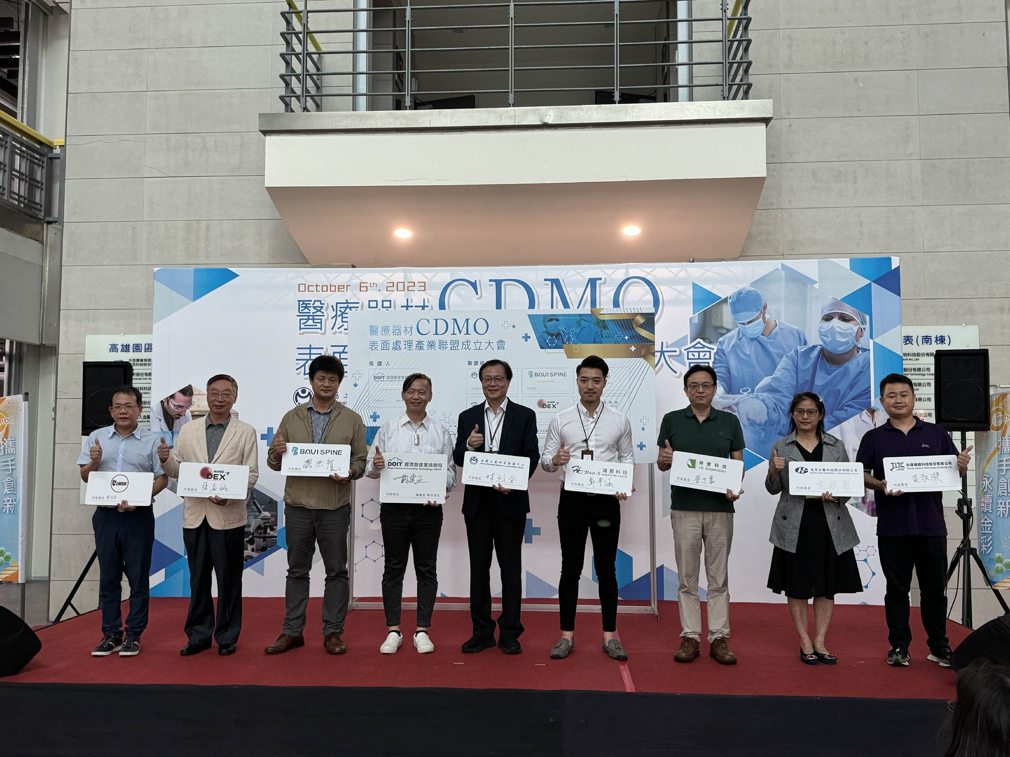

Picture 1: The guests at the establishment of the "Medical Equipment CDMO Surface Treatment Technology Industry Alliance". From left to right are Yu-Ming Chang, associate manager of Lon Sheng Industries Co., Ltd., Dr. I-Cheng Chang of Dexnano Chemicals Technology Co., Ltd., Chung-Kai Wei, R&D manager of BAUI Biotech Co., Ltd., Chien-Cheng Dai, senior technical specialist of Department of Industrial Technology, MOEA, Lieh-Chuan Lin, deputy CEO of the MIRDC, Yu-Han Cheng, Director of Hung Chun Bio-S Co., Ltd., Chih-Hao Liang, Manager of J.O. Corporation, Min-Li Chen, Manager of Huang Liang Biomedical Technology Co., Ltd., and Ching-Chieh Huang, Manager of Taiwan Implant Technology Co., Ltd.

