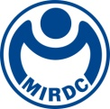
新聞資料NEWS LETTER
MIRDC launches Taiwan's first "Wind Power Technician Internship Program"
Students brave the wind and the billows to advance to the offshore wind field

Metal Industries Research and Development Center (MIRDC), together with Siemens Gamesa Renewable Energy S.A., SGRE (SGRE) and National Kaohsiung University of Science and Technology (NKUST), jointly launched Taiwan's first "Wind Power Technician Internship Program" for current students so that they can take Internship Program as a wind power technician at an offshore wind farm. After multiple rigorous screenings, the four students who finally stood out completed MIRDC and SGRE pre-employment training. This semester, they have successfully moved to offshore wind farms and offshore wind turbine pre-assembly plants. They are now working with active technicians. Together, they are responsible for the service operation and maintenance of offshore wind farms and the onshore assembly of wind turbines. During the 2023 Energy Taiwan, the exhibition week at World Trade Center Exhibition Hall 1 on the 18th of October, MIRDC exhibited the "Marine Technology Industry Innovation Zone" to implement offshore wind power international licenses, talent training and matchmaking, and operation and maintenance technology research and development and services. And the prospects of the offshore engineering center. Interns from the SGRE and NKUST were invited to share Taiwan's first student offshore internship program and their experiences and thoughts on offshore internship life.

MIRDC assists the Energy Administration Ministry of Economic Affairs in establishing and operating the Maritime Technology Innovation Center (MTIC) in Xingda Port. In addition to providing a variety of safety technical training that meets international standards for active wind power practitioners, MIRDC has also worked with Manufacturers and schools to cooperate to cultivate wind power industry talents actively. the MTIC has been implementing the "Training Course for New Industry Elites for Unemployed Nationalities" for three consecutive years and has successfully matched people to find jobs in the offshore wind power industry chain. This year, it also joined hands with world-renowned wind turbine system manufacturers and leaders from the Southern Taiwan University of Science and Technology to successfully launch the first wind farm internship program for current students, allowing teachers and students at the school to directly participate in the work of energy transformation while they are still studying.

SGRE is the world's leading wind turbine system provider. Since participating in the construction and development of Taiwan's first offshore wind farm in 2016, SGRE has been committed to cultivating local talents, including the first batch of offshore wind power pre-assembly and offshore operation and maintenance talents, as well as Taiwan's first wind turbine The technicians needed at the pre-assembly plant not only achieve the goal of bringing the latest offshore wind turbine technology to Taiwan but also develop talent training in critical technologies. SGRE has fully demonstrated its determination to be ahead of its peers in talent cultivation. It actively carries out a "Wind Turbine Technician Internship Program" and selects outstanding talents in advance to enter front-line wind farms for the internship, thereby accumulating valuable practical experience. We look forward to a seamless transition into our careers in the future, applying the relevant knowledge and practical skills we have learned to inject new vitality into the industry.

NKUST is the only university in Taiwan that has its terminal. It has a rich foundation for crew training. The green energy industry is in a great need of local talent. The university has established an "Elite Training Base for Offshore Wind Power Industry and Maritime Engineering" with the support of the Ministry of Education.", and obtained GWO certification, becoming the only university in Taiwan that can issue certificates, allowing more localized professionals to enter the offshore wind power workplace. This time, two students from the wind power program and two from the electrical engineering department were matched through MIRDC to participate in the SGRE Internship Program. They experienced internship life in the wind power field, which is entirely different and challenging from other students. It shortens the adaptation time and allows them to work in the wind power field. Maritime and foreign technicians cooperate smoothly, and at the same time, they can experience first-hand the experience of working in a multinational and diverse team with foreign professionals. We hope that students can accumulate practical experience and assist the industry.
Academic provides talent for industry, and the development of the wind power industry requires close cooperation between industry, government and academia. Through MIRDC's industrial promotion and talent media mechanisms, especially in the part of talent cultivation and development, the industry has been successfully developed in the early stages. It matches the required talents to truly localize wind power construction, operation, and maintenance personnel, thereby establishing Taiwan's leading position in wind power development in the Asia-Pacific region.

To find out more about the Internship Program, please contact
- MIRDC- Mr. Chen Chang WANG, Marketing Manager from MTIC, 0919828632 scott.wang@mail.mirdc.org.tw
- SGRE- Mr. Chang Yung Chen, Senior Manager of SGRE,0903-028-587 bernice.chen@siemensgamesa.com
- NKUST-Ms. Shih Hsin Chang, Administrator from Alumni Service Career Development Center of NKUST,0911988552 cchsome@nkust.edu.tw

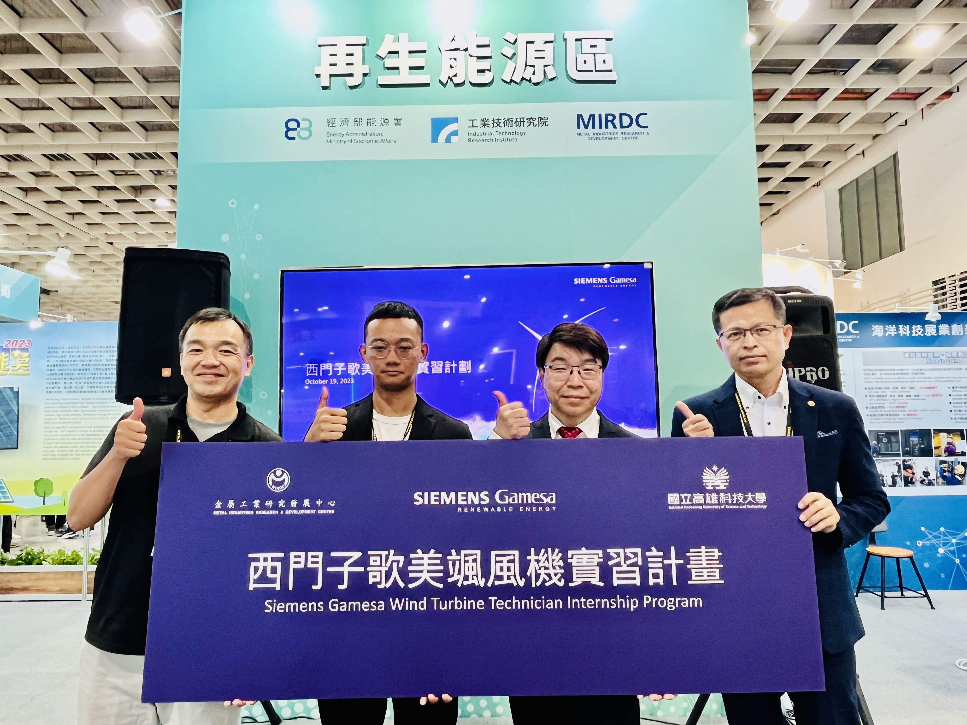

Fig1, from right to the left, are Mr. Ming Chih Chen of NKUST’s Administrator from Alumni Service Career Development Center, Mr. Chung Wu Li of Siemens Games, Mr. Ming Hsuan Tsai of NKUST, and Mr. Chen Chang Wang of MTIC, MIRDC.
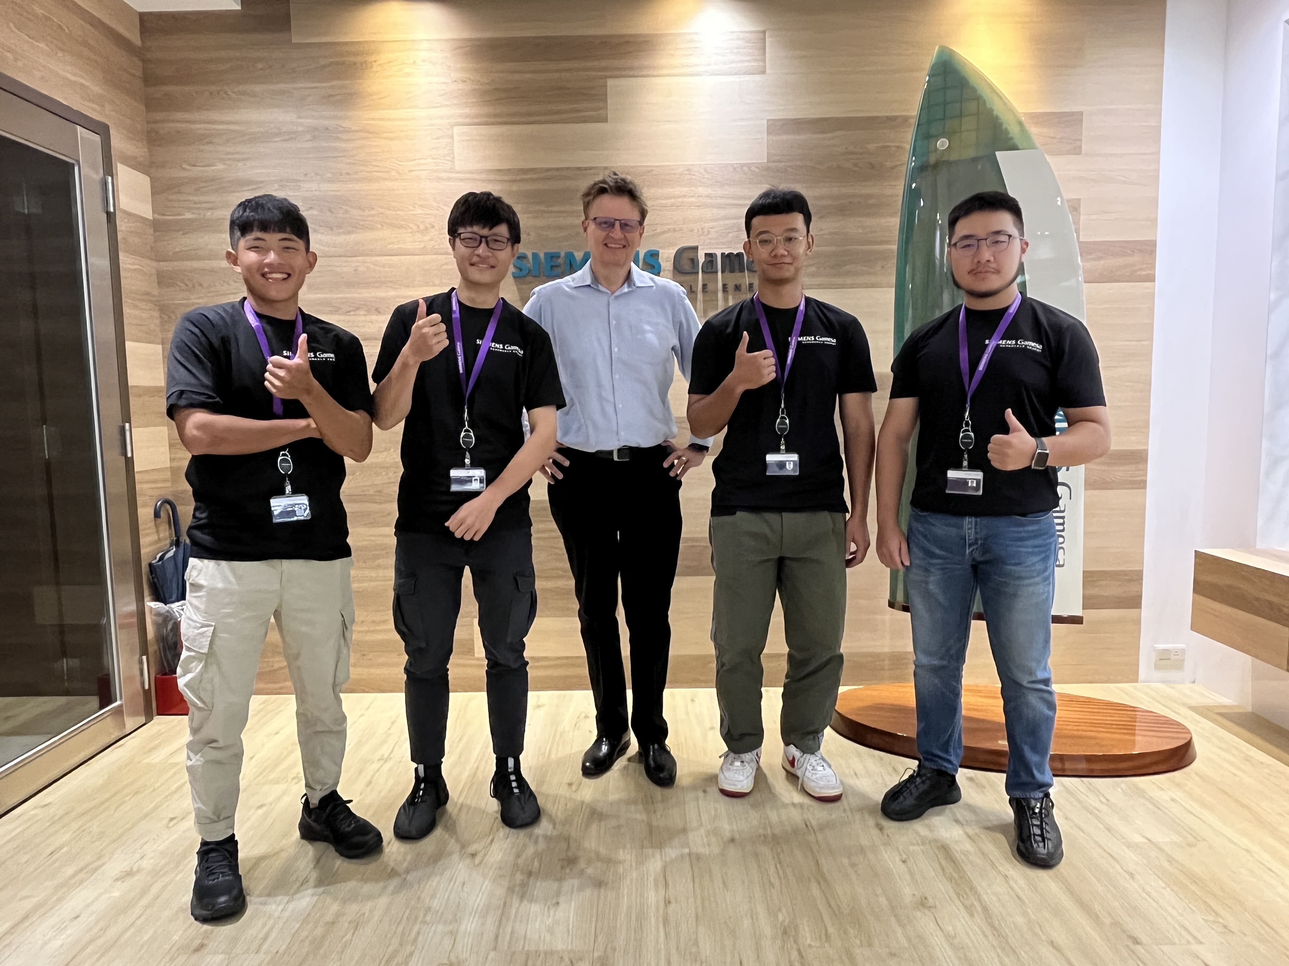

Fig1, A group photo includes Mr. Niels Steenberg from Siemens Gamesa (in the middle), and Ting Jui Lin, Ming Hsuan Tsai, Cheng Yu Shih, and Wei Lun Huang, the trainees from NKUST.

