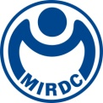
新聞資料NEWS LETTER
Industry resilience is important, A Titanium Collaboration Workshop - MIRDC partners with industry to improve supply chain stability

Amidst the global challenges posed by the pandemic, disruptions in industrial supply chains, and geopolitics, the importance of ensuring supply stability and resilience has gained prominence. Titanium, owing to its unique market value and the growth of aerospace, space, and emerging energy industries, continues to see vibrant utilization, making it one of the key critical metals. To help industries better understand the supply and demand dynamics of titanium materials and enhance industrial resilience, MIRDC organized the "2023 Consensus Workshop on Enhancing the Resilience of the Titanium Industry." This workshop serves as a platform for Taiwan's titanium industry players to exchange insights on critical industrial matters, thereby promoting the robust development of the industry.

Under the guidance of the Industrial Development Administration, Ministry of Economic Affairs, MIRDC assists the industry in grasping the real-time supply and demand situation of basic metals, implements the "Monitoring the development of supply and demand situation of basic metals in Taiwan" plan, and continuously monitors the development situation of supply, demand, volume, and price of six major metals: steel, stainless steel, copper, aluminum, nickel, and titanium. In addition to its application in the aviation, national defense, and petrochemical industries, titanium has also expanded into industries such as automobiles, motorcycles, bicycles, medical components, sports and leisure products, and architectural landscapes. In response to the development of space and emerging energy industries, titanium plays an indispensable role. For instance, in the Critical Raw Materials Act proposed by the EU, the EU has committed to strengthening the independence of the supply of raw materials that are crucial to the technology and green energy industries and reducing its dependence on third countries. Among them, titanium related to satellites, drones, additive manufacturing, and other technologies is also included, which shows its importance.

Participation in this workshop was enthusiastic, including top management from Taiwan’s major titanium material, processing, and downstream application manufacturers and relevant public associations, who came to provide guidance and jointly discuss major issues in the titanium industry. Most industry players at the workshop stated that the current scale of the titanium industry is still small, and it is imperative to expand downstream applications (emerging industries such as electric vehicles, marine, petrochemicals, and space), and the upstream and downstream supply chains should be properly integrated to effectively improve the overall supply chain resilience. Secondly, industry players are also demanding the certification required to break into the aerospace industry, as well as exhibition fee subsidies. To achieve net-zero sustainability, industry players also believe that there are potential development opportunities in titanium scrap recycling and certification. MIRDC will continue to maintain positive exchanges and interactions with industry players to grasp the real-time supply and demand situation and important industry issues to promote the stability of Taiwan's titanium supply chain, and enhance resilience.
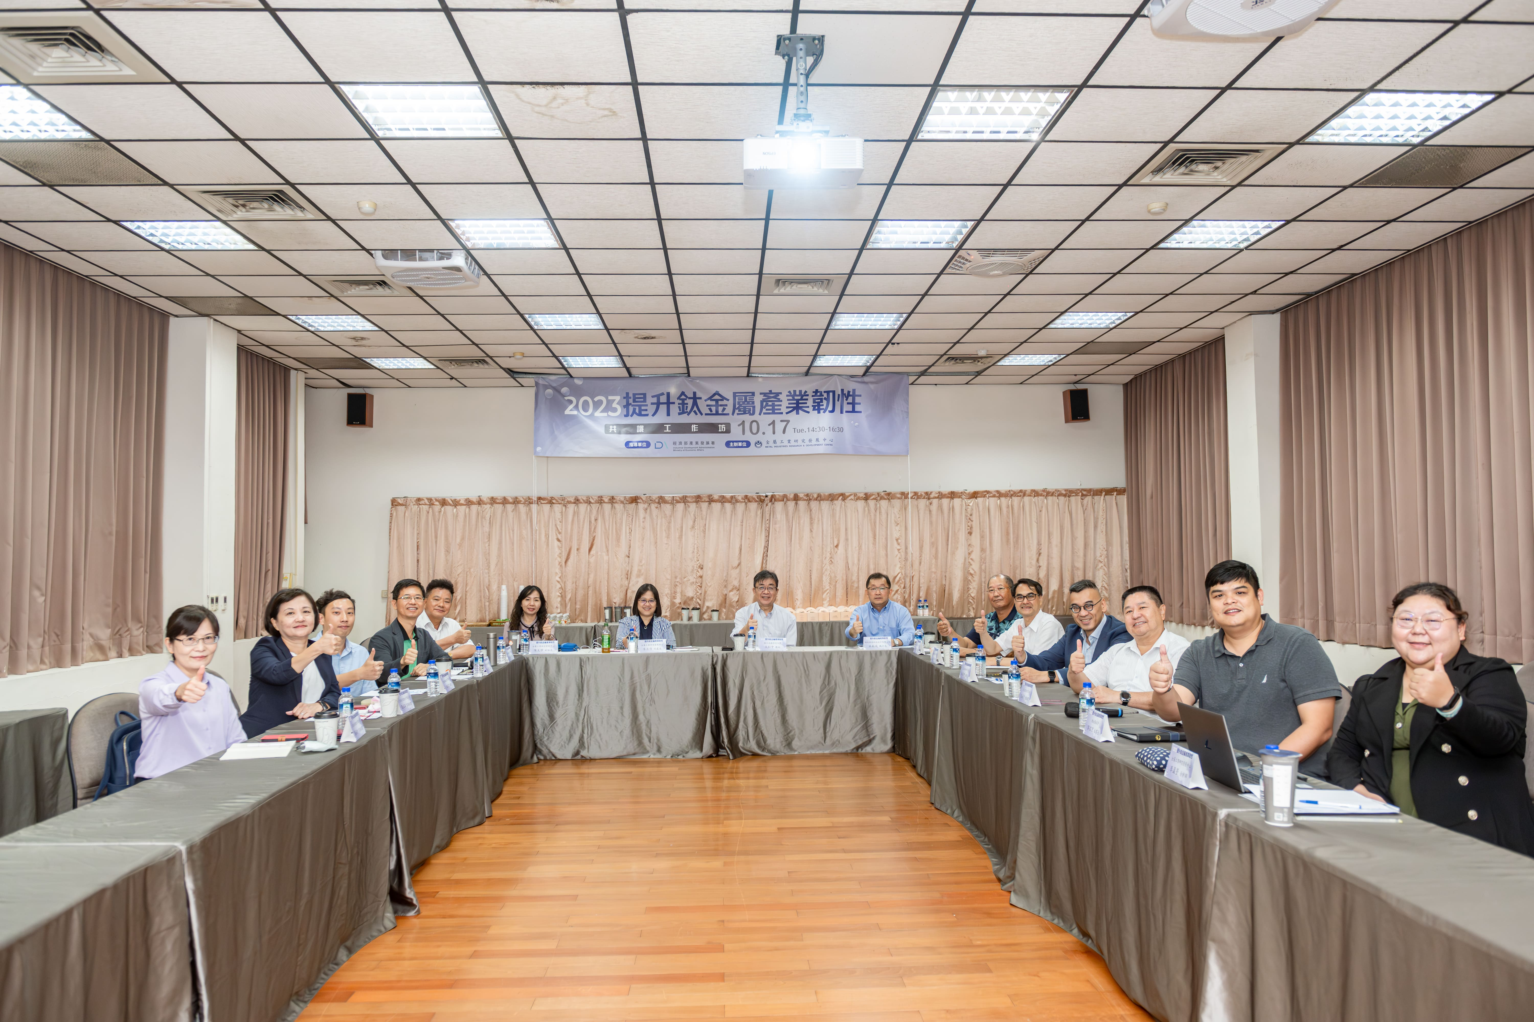

Picture 1、Group photo at the "2023 Consensus Workshop on Enhancing the Resilience of the Titanium Industry"

