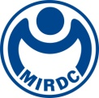
新聞資料NEWS LETTER
MIRDC assists the Bureau of Stands, Metrology, and Inspection (BSMI) in establishing the largest domestic energy storage system safety testing laboratory

In response to the energy transformation, the government has accelerated the implementation of the "Green Energy Technology Industry Promotion Plan" with the goal of renewable energy accounting for 20% of the total energy by 2025. Energy storage has been designated as one of the four key pillars of green energy development. The Executive Yuan's approved Forward-looking Infrastructure Development Program Phase II, with planning and guidance provided by the BSMI, MIRDC is executing the establishment of the "Energy Storage System Safety Testing Laboratory" in the Tongluo Science Park in Miaoli. A beam-raising ceremony was held on 19th September. Han-Chang Hsieh, Acting Director of the Bureau of Standards, Metrology and Inspection, MOEA, Ren-Yi Lin, Chairman of MIRDC, Chun-Chieh Wang, Vice President of the MIRDC, Tung-Yuan Chan, CEO of Legislator Wen-Chi Kung’s Research Office, Wen-Yi Liang, Director of Legislator Chao-Ming Chen’s Office, Hung-Nan Chen, Director of Miaoli County Council, Shu-Chu Chen, Deputy Director of Hsinchu Science Park Bureau, NSTC, Hua-Lung Chiu, Director of the Miaoli District Operations Office of Taiwan Power Company, Kung-Min Lu, Deputy Director of the Taiwan Electrical and Electronic Manufacturers’ Association, Chang-Nien Hsieh, Mayor of Tongluo Township, Chih-Tung Ling, Manager of T. Y. Lin International Taiwan, and Chih-Ming Cheng, Architect of J.C. Yang and Partners, Yi-Chun Chan, Chairman of Tsunghsin Engineering Co., Ltd. and other guests participated in the ceremony, marking the commencement of a new chapter in green energy construction.

The promotion of the green energy technology industry is a new engine for our energy transformation and economic development. The strategy is to develop household, enterprise, and grid energy storage systems and strengthen the grid's stability. It is expected that mass energy storage systems will be set up. It urgently needs to establish an energy storage system safety testing laboratory that meets international standards and combustion tests to set a domestic energy storage safety environment. Thereby ensuring the stable and reliable development of green energy in Taiwan. The BSMI has actively formulated CNS standards and safety specifications related to energy storage and has proposed the establishment of testing capacity and management solutions to meet the industries' needs for test validity and reduce testing costs and time. The establishment and enforcement of regulations of the laboratory are gradually promoted to ensure the safety of the energy storage construction site.

MIRDC Chairman Ren-Yi Lin stated that the completion of the "Energy Storage System Safety Testing Laboratory" will become the largest energy storage system safety testing laboratory in Taiwan. This laboratory is positioned as a "Standard National Energy Storage Testing Laboratory". Its type and combustion test capability planning scale is second only to Japan's "National LABoratory for Advanced Energy Storage Technologies, NLAB", and it will be the second largest in the world. In the future, there will be no need to send equipment overseas for testing. Once completed, this domestic laboratory will provide testing services, ensuring safety for domestic use and providing assurance for companies exporting their products. The laboratory aims to focus on testing the performance and safety of grid-connected energy storage devices, electric bus batteries, and more. It is hoped that this testing facility will serve as a catalyst for the long-term development of the green energy industry.
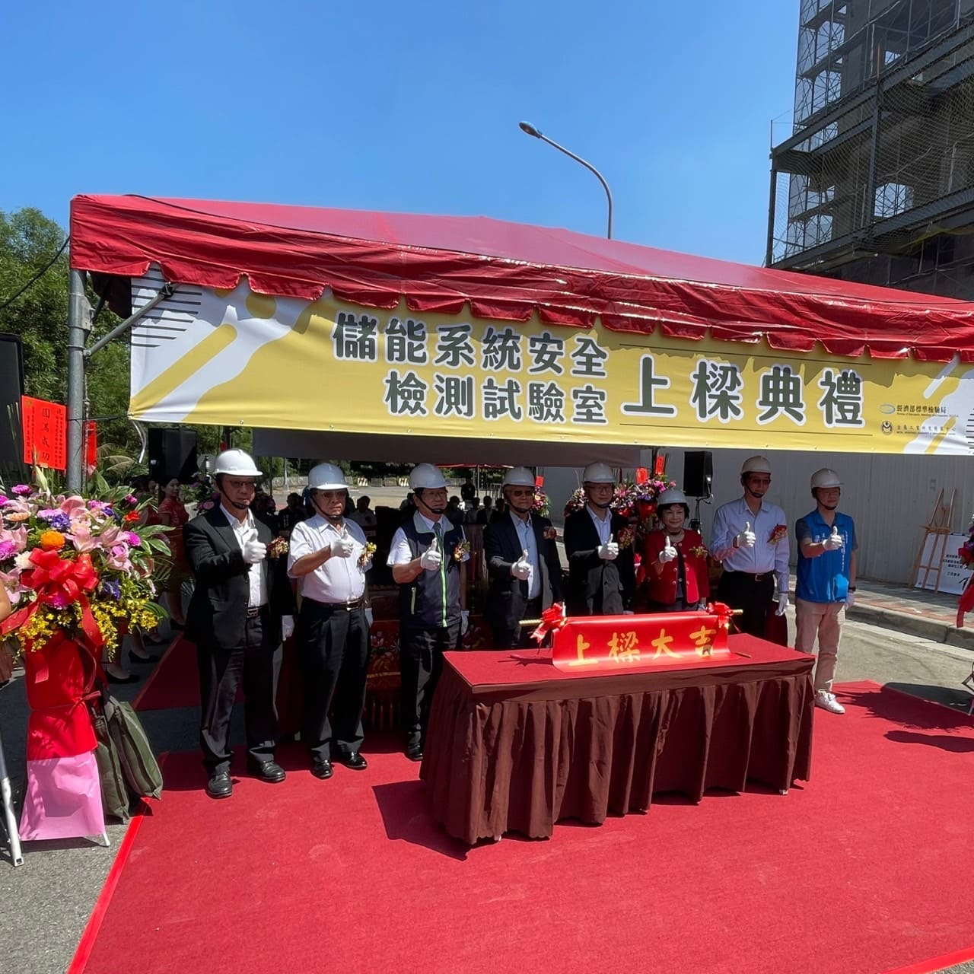

Picture 1、The beam-raising ceremony of “The Largest Domestic Energy Storage System Safety Testing Laboratory”, from left to right are Chun-Chieh Wang, Deputy CEO of the MIRDC (the first at the left), Tung-Yuan Chan, CEO of Legislator Wen-Chi Kung’s Research Office (the second at the left), Hua-Lung Chiu, Director of the Miaoli District Operations Office of Taiwan Power Company (the third at the left), Ren-Yi Lin, Chairman of the MIRDC (the forth at the left), Han-Chang Hsieh, Acting Director of the Bureau of Standards, Metrology, and Inspection (the forth at the right), Shu-Chu Chen, Deputy Director of Hsinchu Science Park Bureau, NSTC (the third at the right), Yi-Chun Chan, Chairman of Tsunghsin Engineering Co., Ltd. (the second at the right) and Wen-Yi Liang, Director of Legislator Chao-Ming Chen’s Office. (the first at the right)

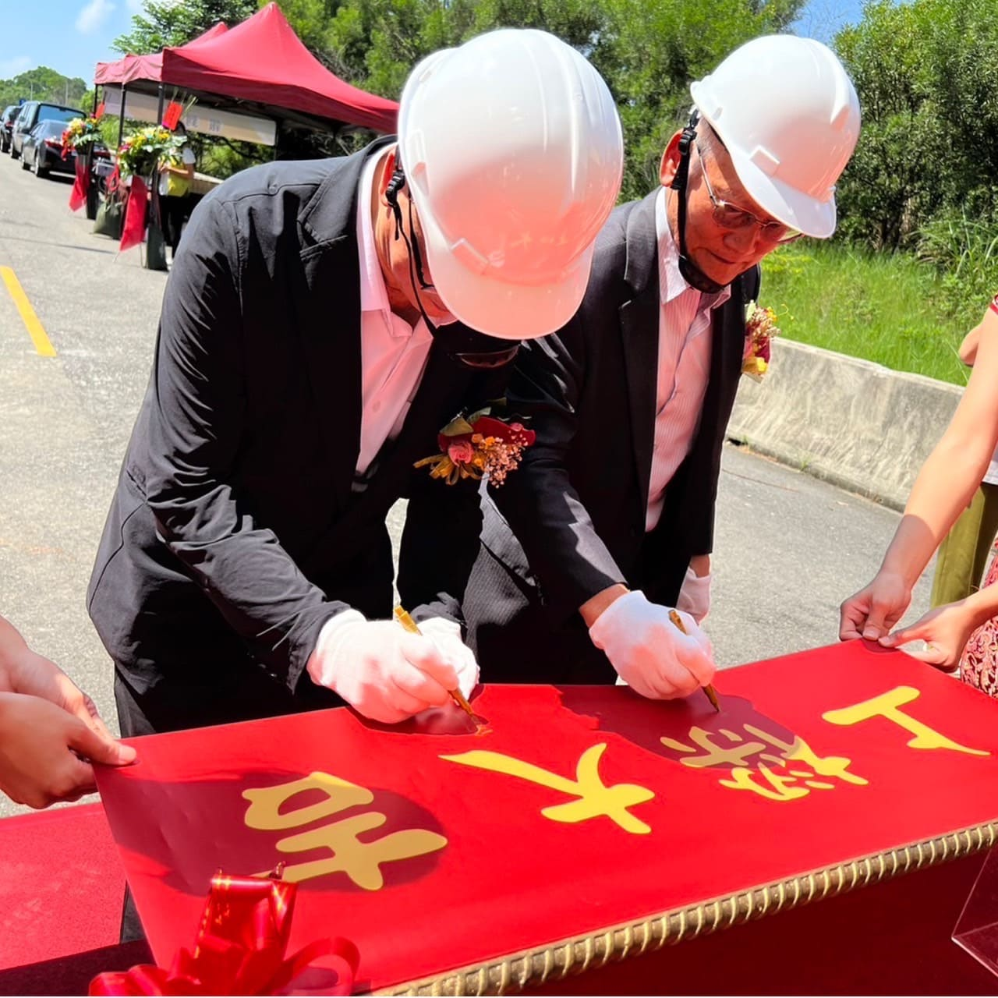

Picture 2、Han-Chang Hsieh, Acting Director of the Bureau of Standards, Metrology and Inspection (left), and Ren-Yi Lin, Chairman of the MIRDC (right) signed and hoping that the construction would be completed on schedule and with high quality.
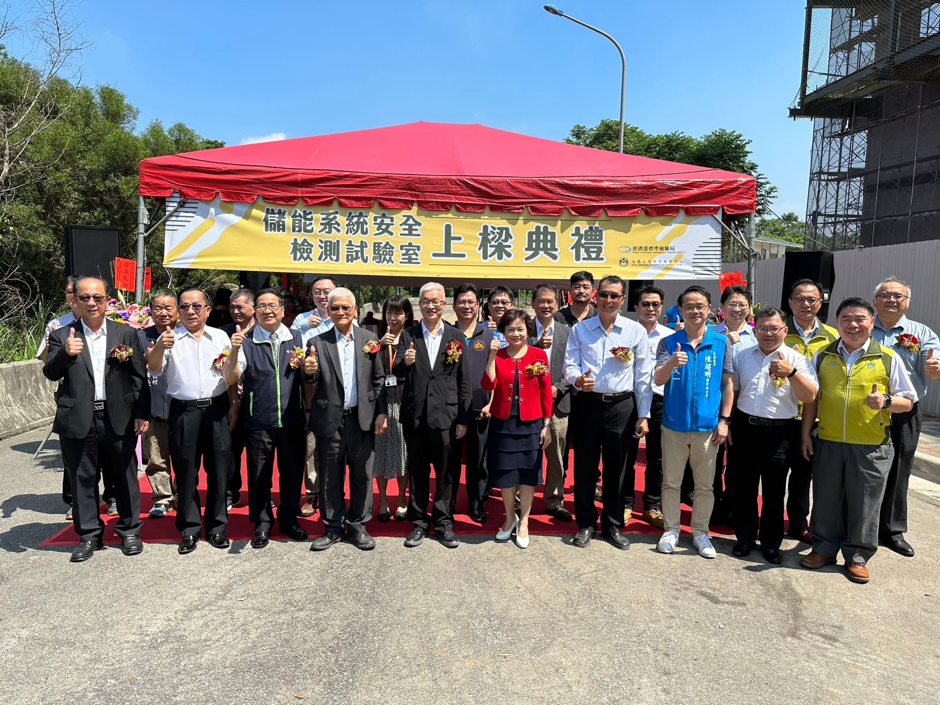

Picture 3、The guests took a group picture in the beam-raising ceremony.

