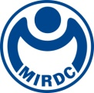
NEWSLETTER
MIRDC Collaborates with NCKU in NSPO Mission
of Lunar Cruiser Payload Development

In accordance with provisional plans of the National Aeronautics and Space Administration (NASA), the “Artemis” program, whose missions contains crewed lunar landing in 2025, will be NASA’s attempt to send humans to the moon and build a permanent base on the lunar surface as an outpost for expedition to Mars or deep space exploration. Without protection by an atmosphere and a magnetic field like the Earth, the Moon is directly struck by solar winds carrying a massive amount of plasma, which would endanger lives on its surface. With the trends of various international Moon exploration missions now under expedited developments and human presence on the Moon, exploring the plasma environment on the Moon’s surface will be an essential topic.

Following the footsteps of the United States, the National Space Organization (NSPO) is currently incorporating the R&D momentum of the academia and research communities as well as its own experience in space-related practices with a view to building its own Moon landing payload to be applied in Taiwan's first lunar exploration mission. With great engagement history in space missions, the National Cheng Kung University (NCKU), one of the top-notch institutes with aerospace specialization, undertakes the NSPO commission under the lead of Prof. Tzu-Fang Chang from the Institute of Space and Plasma Sciences, NCKU. The commission, as a new plasma measurement instrument development project of the institute following the ERG satellite mission under Taiwan-Japan collaboration, encompasses the building of a high-precision “all-sky electrostatic analyzer” available for three-dimensional measurements. MIRDC is engaged in the design/manufacturing and testing throughout the commission process.

In this project emphasizing lunar landing instrument development, MIRDC is responsible for the mechanical design and payload manufacturing of the "all-sky electrostatic analyzer", including the machining of the overall casing, surface treatment, and detection system design, etc., as well as assistance in mechatronics and simulations in extreme environments. A prototype is expected to be rolled out in the upcoming year, with the engineering model (EM) and flight model (FM) scheduled for completion in 2024. According to Chih-Lung Lin, Vice President of MIRDC, as the overall trend of gradual facilitation of space-related supply chains in innovative technology amongst domestic industry, government, academia and research is observed, in the future MIRDC will continue to assist the government to enhance R&D competitiveness in space technology and link the international stage to obtain high-end space technology market with the combination of strengths in domestic semiconductor, ICT, precision machinery and other industries.

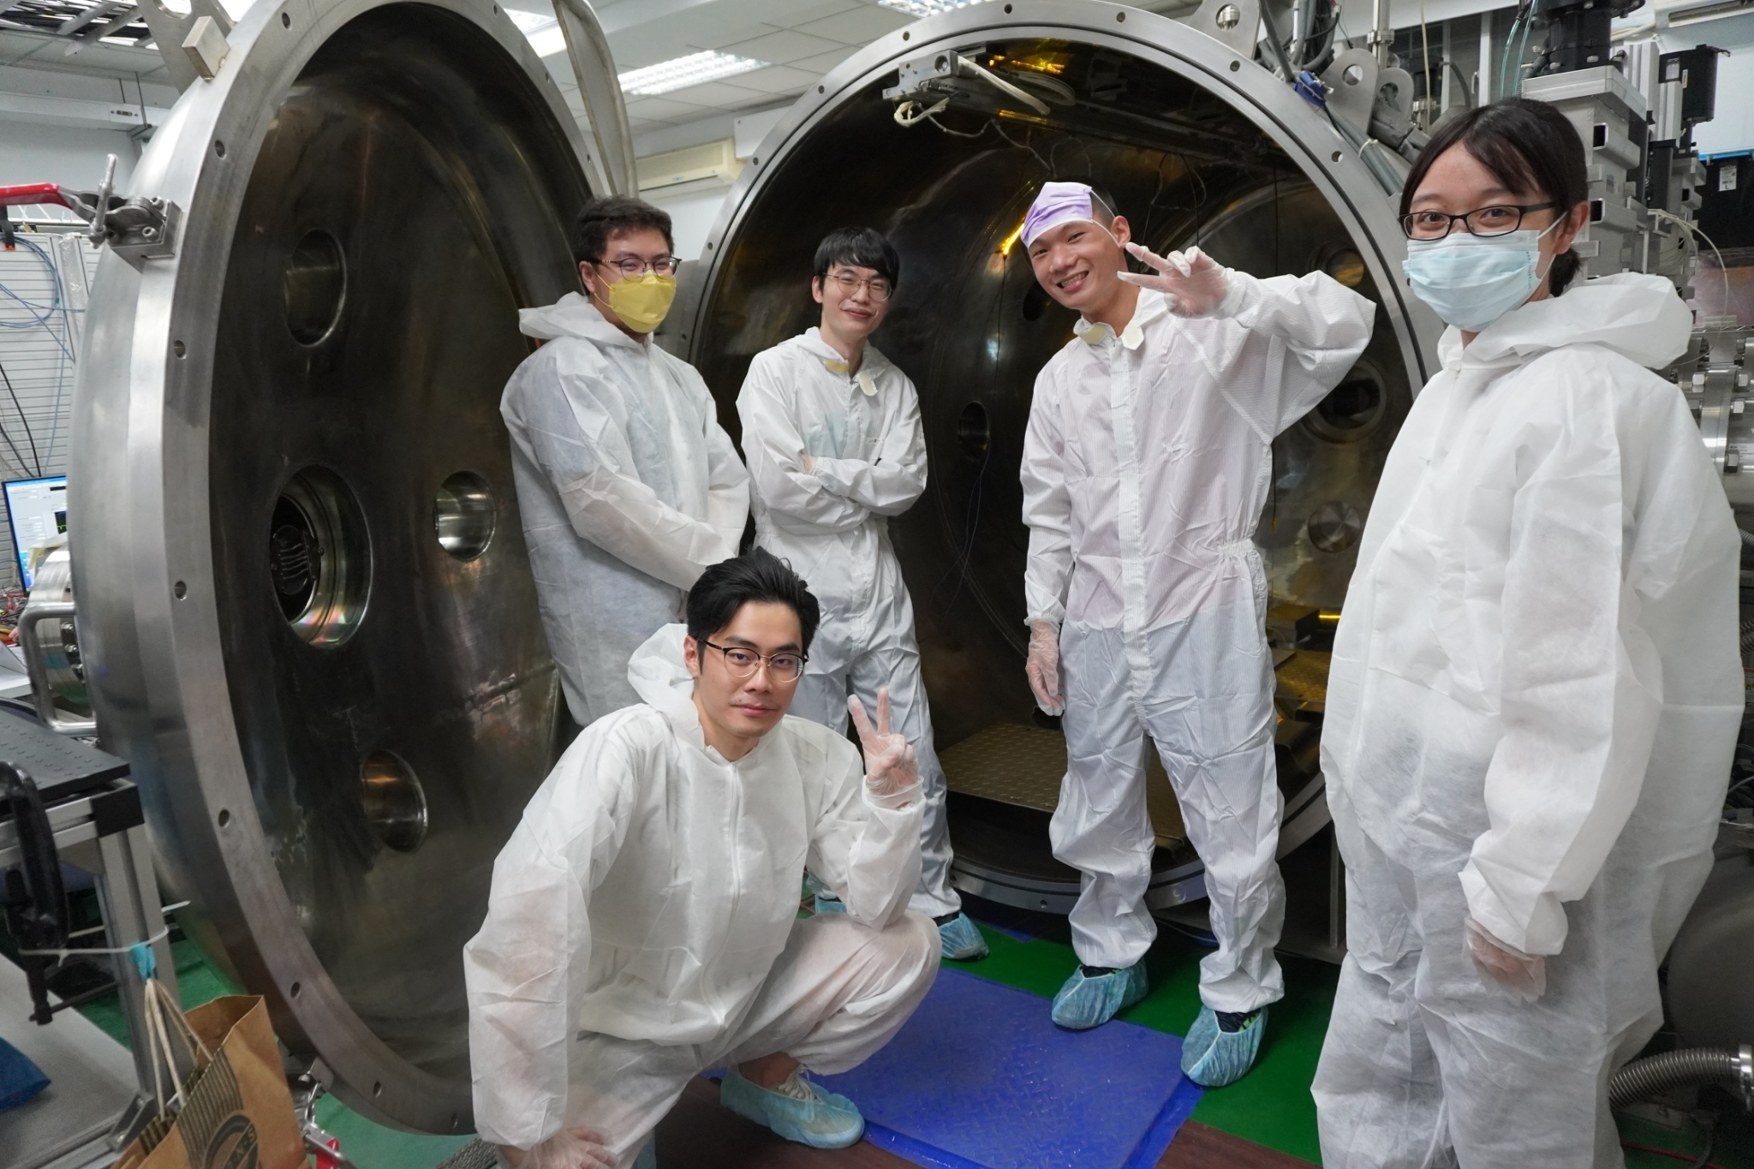
Figure 1. NCKU Space Environment Simulator

