
新聞資料NEWS LETTER
DoIT of the Ministry of Economic Affairs（MOEA）gathered the hydrogen industry together by hosting a related application forum to exchange technology and gain insights into future net zero market opportunities

In response to the global trend of net zero, President Tsai declared that the spread of net zero by 2050 is the goal of the world and Taiwan. In 2021, the Ministry of Economic Affairs proposed a 2*2net zero transition structure of “low-carbon& zero- carbon”, and “energy& industry”, which is to plan forward-looking with a long-term investment. Meanwhile the government also announced that the 2050 net zero emission path, among them, hydrogen accounts for 9% to 12% of the planned electricity, which can be regarded as important the importance of green energy in the future.

The Section Chief of DoIT, the Ministry of Economic Affairs（MOEA）, Hsiang Wei He stated that it has been planned in the hydrogen development strategy to assist the industry since 2020 in establishing hydrogen application for existing processes, and in terms of infrastructure, it will evaluate the transportation and storage technology od the application fields, and start innovative hydrogen production processes in 2030. The introduction and construction of large-scale transportation and storage facilities will make the industry's subsequent carbon reduction process more smoothly. At the same time, DoIT attaches great importance to the demand for hydrogen energy and the difficulties faced by the industry. With the promotion of the Technology Projects, MIRDC gathered experts from industry, government, university, and institute on September 5 to organize the Technology Exchange of Hydrogen Combustion for Industrial Application and High-Pressure Transmission & Storage which allows the industry to understand better the important business opportunities for the industrial hydrogen applications.

This forum invited steel industry and petrochemical industry who need hydrogen energy to participate in the meeting, and also gathered metal industry, gas industry, furnace industry, equipment manufacturing, and pipe valve industry to also join in the forum. Mainly focusing on High-Pressure Transmission & Storage and Hydrogen Combustion for Industrial Application. During the forum, the industry emphasized on the safety norms and the regulations for hydrogen energy which need to be demonstrated and verified, and indicated that the technology required by government, industry and university experts will be researched and studied, focusing on the characteristics and conditions of the domestic industry, and it is recommended to gather everyone's ideas as the basis for future technological development, and hope to jointly promote the domestic’s hydrogen technology industry chain in the future.
.

The global demand for hydrogen will grow from 8.58 trillion cubic meters in 2020 to 24.9 trillion cubic meters in 2050. Looking at Europe, America and Japan, have invested their national policy resources to develop hydrogen. In comparison with these foreign technology development paths, especially pipe valve parts, storage tank technology, and industrial combustion technology should also be put into key development projects. Under the guidance of DoIT, the Ministry of Economic Affairs (MOEA), MIRDC has established the key materials, process, and testing and verification bases required for the autonomous hydrogen storage/transportation system through the advanced technology development plan of hydrogen storage and transportation and industrial combustion application. The preliminary research on the technology and innovative design technology of independent hydrogen mixed combustion will be beneficial to the future development of the hydrogen industry and improve the competitive advantage.

The Director of MIRDC, Heng Yun Lin stated that 22% of carbon emission in domestic manufacturing is caused by combustion, including boilers, melting furnaces, heating furnaces, and other industrial furnaces. In order to Effectively reduce the carbon emissions of industrial combustion, MIRDC has signed a Memorandum of Understanding (MOU) with the furnace manufacturers. In the future, it will connect with the domestic aspiring to develop the hydrogen industry chain together, in cooperating and exchanging on the advanced technology of hydrogen, and by compiling the consensus reached in this exchange meeting, as the future development direction of preparing The Industrial Alliance of Hydrogen Transmission & Storage and Industrial Application Technology in order to prepare the future industrial cooperation of Taiwan's hydrogen industry chain.

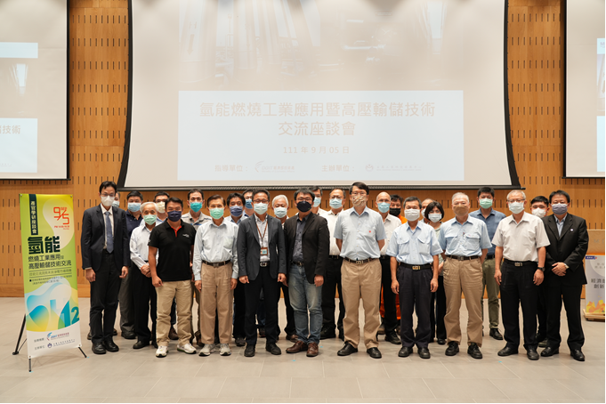
Figure, the picture taken at the forum included Hsiang Wei He of DoIT, Heng Yun Lin of MITRDC, Ssu Hsien Li of Taijun Boiler, Chih Cheng Chou of Sore Welding Co., LTD, Hung Yi Liu of China Steel Corporation, Chih Lung Li of Taiwan Metal Industry Association, Chun Ta Chen of Taiwan Steel& Iron Industries Association, Yu Sen Yang of The Taiwan Society for Metal Heat Treatment, and Ping Hua Huang of Tung Ho Steel Enterprise Corporation.

