
新聞資料NEWS LETTER
MIRDC Helps Tainan's Industrial Transformation by establishing Tainan Circular Economy Industry Alliance

With the support of the Tainan City Government, MIRDC organized the Tainan Circular Economy Industry Alliance in conjunction with the government, academia, industrial associations, non-profited organizations, and the Taiwan local industries related to the circular economy, jointly declaring that Tainan would be the capital of the circular economy. Pioneering the circular economy development of Taiwan City Government in the future by taking the lead in economic development which also completely changes the impression of traditional manufacturing and reshapes the image of a green circular economy. Taiwan Resource Recycling Industries Association, Ming Fu Group, Formosa Copper, Tai & Sons Industrial Co., Ltd, Gain Hwang Paper, National Cheng Kung University, Far East University, and other relevant organizations of the circular economy industry were invited to attend the event. Driven by the ESG wave, topics related to the "circular economy" were discussed during the event. Hope that through this event, Tainan will kick off its circular economy and move towards a sustainable future.

Wang Chun Chieh, the Vice President of MIRDC presented in his remarks that Tainan itself has a good production base,is a city with a century-old development history, as Taiwan has entered a technology city from agriculture and industry in the past. In recent years, driven by the ESG wave, it will be the best time for Tainan's industrial transformation. MIRDC is an R&D Institute of the Ministry of Economic Affairs and the only research corporation headquartered in southern Taiwan. In the past, MIRDC assisted many Tainan manufacturers in metal production technology. In the next industrial transformation, MIRDC will also use the energy of the national-level R&D instituteions to assist local governments in developing strategic new industries to assist Tainan City Government to promote the development of green and sustainable circular economy industries, including green technologies for agriculture, food, plastic, and metal-related materials. We are looking forward to Tainan City's new economy.

Facing the global warming and greenhouse effect, the post-epidemic era, the issue of green sustainability, and the impact of the global supply chain, industrial transformation is inevitable. MIRDC has invested in personal service with fixed-time and fixed-location projects to assist Tainan's industrial development needs. In the past two years, it has regularly stationed in Ho-Shun Industrial Park and YongKang Technology Park to provide consulting services in order to solve manufacturers' problems, and will continue to provide the most professional services in the future. In addition to high-value industrial technologies, we can continue to provide technical services and solutions to assist other industries in Tainan towards the goal of a circular economy, and green and sustainable development.

MIRDC has supported metal products, plastic products, agricultural and food waste recycling technologies in the government science and technology programs and budgets, including aluminum recycling and refining, titanium recycling and refining, supercritical extraction technology, etc., plus the application services in recent years, we hope to continue to extend the local responsibilities of non-profited organization and assist local governments to promote local characteristic industries. High-value technologies can be combined with the innovative development and digital transformation of traditional industries to enhance the local economy and drive the local Life

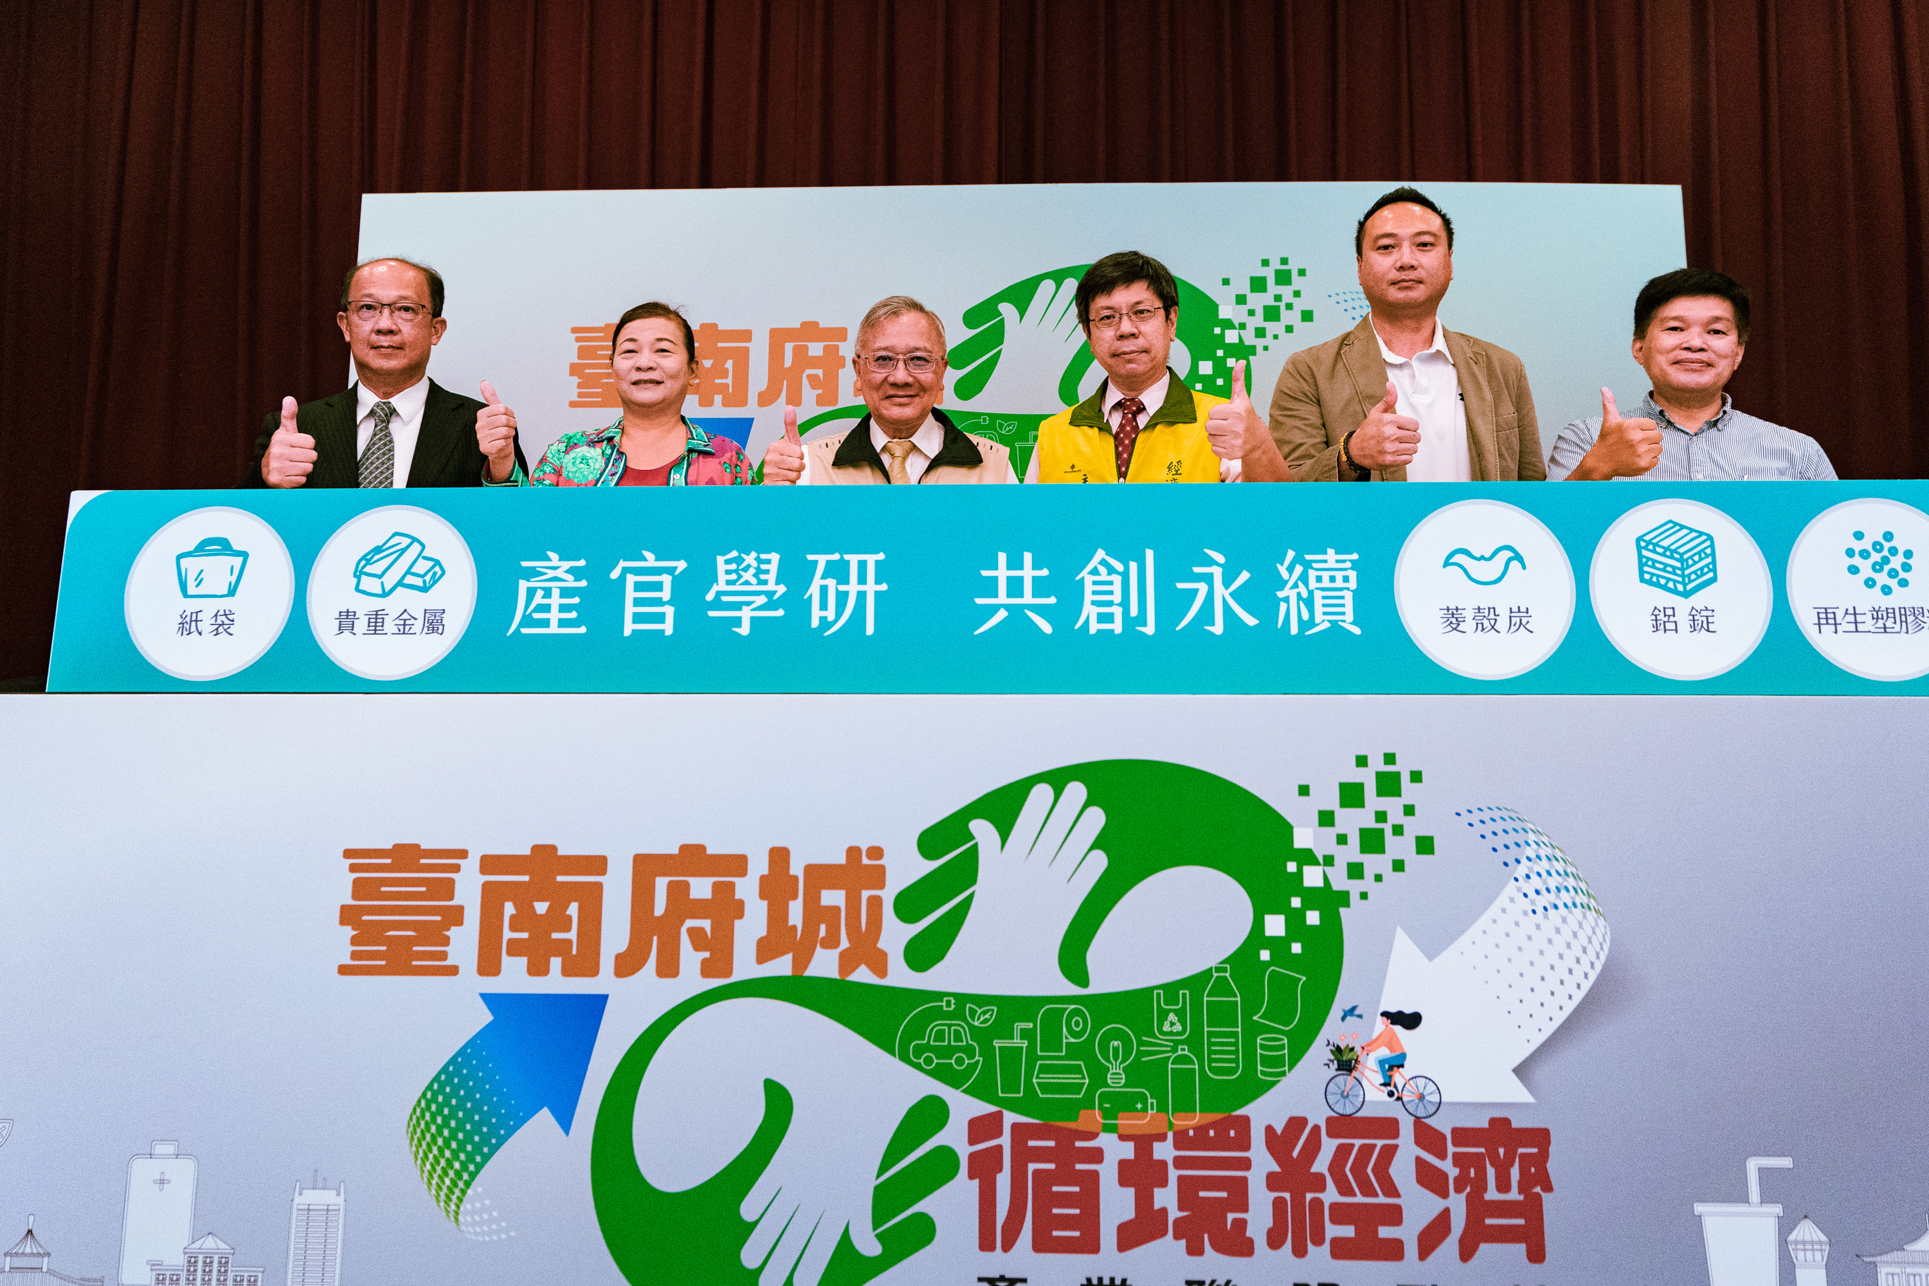

Figure1, the opening ceremony of the Tainan Circular Economy Industry Alliance. Wang Chun Chieh, the Vice President of MIRDC, Ms. Wei Chien Yun, the President of Hsinying Industrial Park Association, the Deputy Mayor Tai Chien of Taiwan City Government, Wang Chun Po, the Secretary General of the Economic Development Bureau, Mr. Chen Chun Ming, the President of Taiwan Resource Recycling Industries Association, and Mr. Wang Jung Sheng, the President of Far East University （From left to the righ）

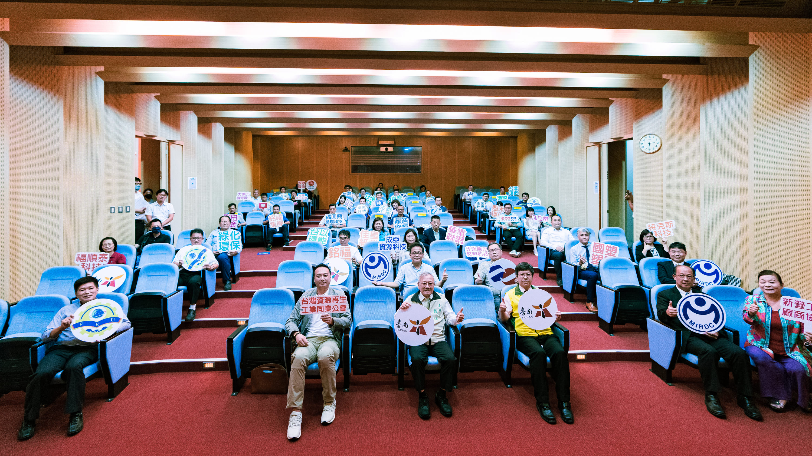

Figure2, group photo of the participated guests

