
新聞資料NEWS LETTER
Achieving net zero enhances industrial competitiveness as MIRDCT successfully assists the carbon reduction transformation of the fastener industry

In order to promote Taiwan's ability to accelerate the follow-up of carbon reduction goals, MIRDC attended a face-to-face joint symposium between fastener industry, industrial and commercial enterprises, and the Kaohsiung mayor on August 3rd. The symposium was about a sharing of the fastener industry promoting net zero carbon reduction and electricity saving-technology. the content includes global net zero trends and carbon reduction technology guidance. The detailed discussion also includes key process optimization, carbon reduction intelligent manufacturing and carbon footprint management, etc. In addition to promoting the fastener industry to move towards low carbon according to the existing technology, it also hopes to transform and upgrade the existing technology through process improvement and energy conversion in assisting Taiwan enterprises find solutions for carbon reduction.

In the face of extreme climate threats and severe epidemics, and many related policies have also extended to the global supply chain, more and more international companies have successively adopted ESG (the abbreviation for Environment, Social and Governance) as their corporate sustainable development policy and management standard. In order to accelerate the improvement of corporate resilience and transformation and adaptation capabilities to cope with unknown risk challenges. Considering that the global net zero emission trend and Carbon Border Adjustment Mechanism (CBAM), as well as CBAM Cerificates and Taiwan carbon fee are about to be implemented one after another, the transition to net zero to practice ESG is really critical to the international economic competitiveness of Taiwan industry.

Kaohsiung Mayor Chen, Chi-Mai stated that Taiwan is an important player in the international supply chain. In order to achieve the goal of global zero carbon emissions, the manufacturing industry will inevitably face severe conditions for carbon reduction. The early deployment of troops of Kashsiung is to formulate the "Net-Zero Urban Management Autonomy Ordinance" with the expectation that by coaching the industry, various carbon reduction goals and policies will be concretely implemented. In order to achieve the goal of "2050 Kaohsiung Net Zero", the city government has established the Industrial Net Zero Alliance, announced the net zero path, and formulated autonomy ordinance, serving as the most solid backing for the industry on the way to the net zero carbon emission goal.

Dr. Lin, Ren-Yi, the Chairman of MIRDC pointed out that, the industry needs to be more active in the transformation towards high value, so as to increase the added value of products. And through the establishment of closer upstream and downstream partnership to get rid of the pressure and restraint caused by carbon price. MIRDC operates Under the support and guidance of the Industrial Development Bureau (IDB) of the Ministry of Economic Affairs, Ministry of Economic Affairs and the Economic Development Bureau, Kaohsiung City Government, MIRDC will assist the Taiwan Industrial Fasteners Institute to set up a net zero team, take stock of the Fastener Industry and identify the needs of power saving and carbon reduction, and develop a promotion plan. Introducing relevant power saving and carbon reduction technology services, and implement the existing renewable energy plans and implement carbon reduction measures. In the future, we will actively invest in energy technology research and development while relevant technologies mature, process optimization and the proportion of renewable energy will increase, and we will gradually move towards the 2050 net zero emission target.
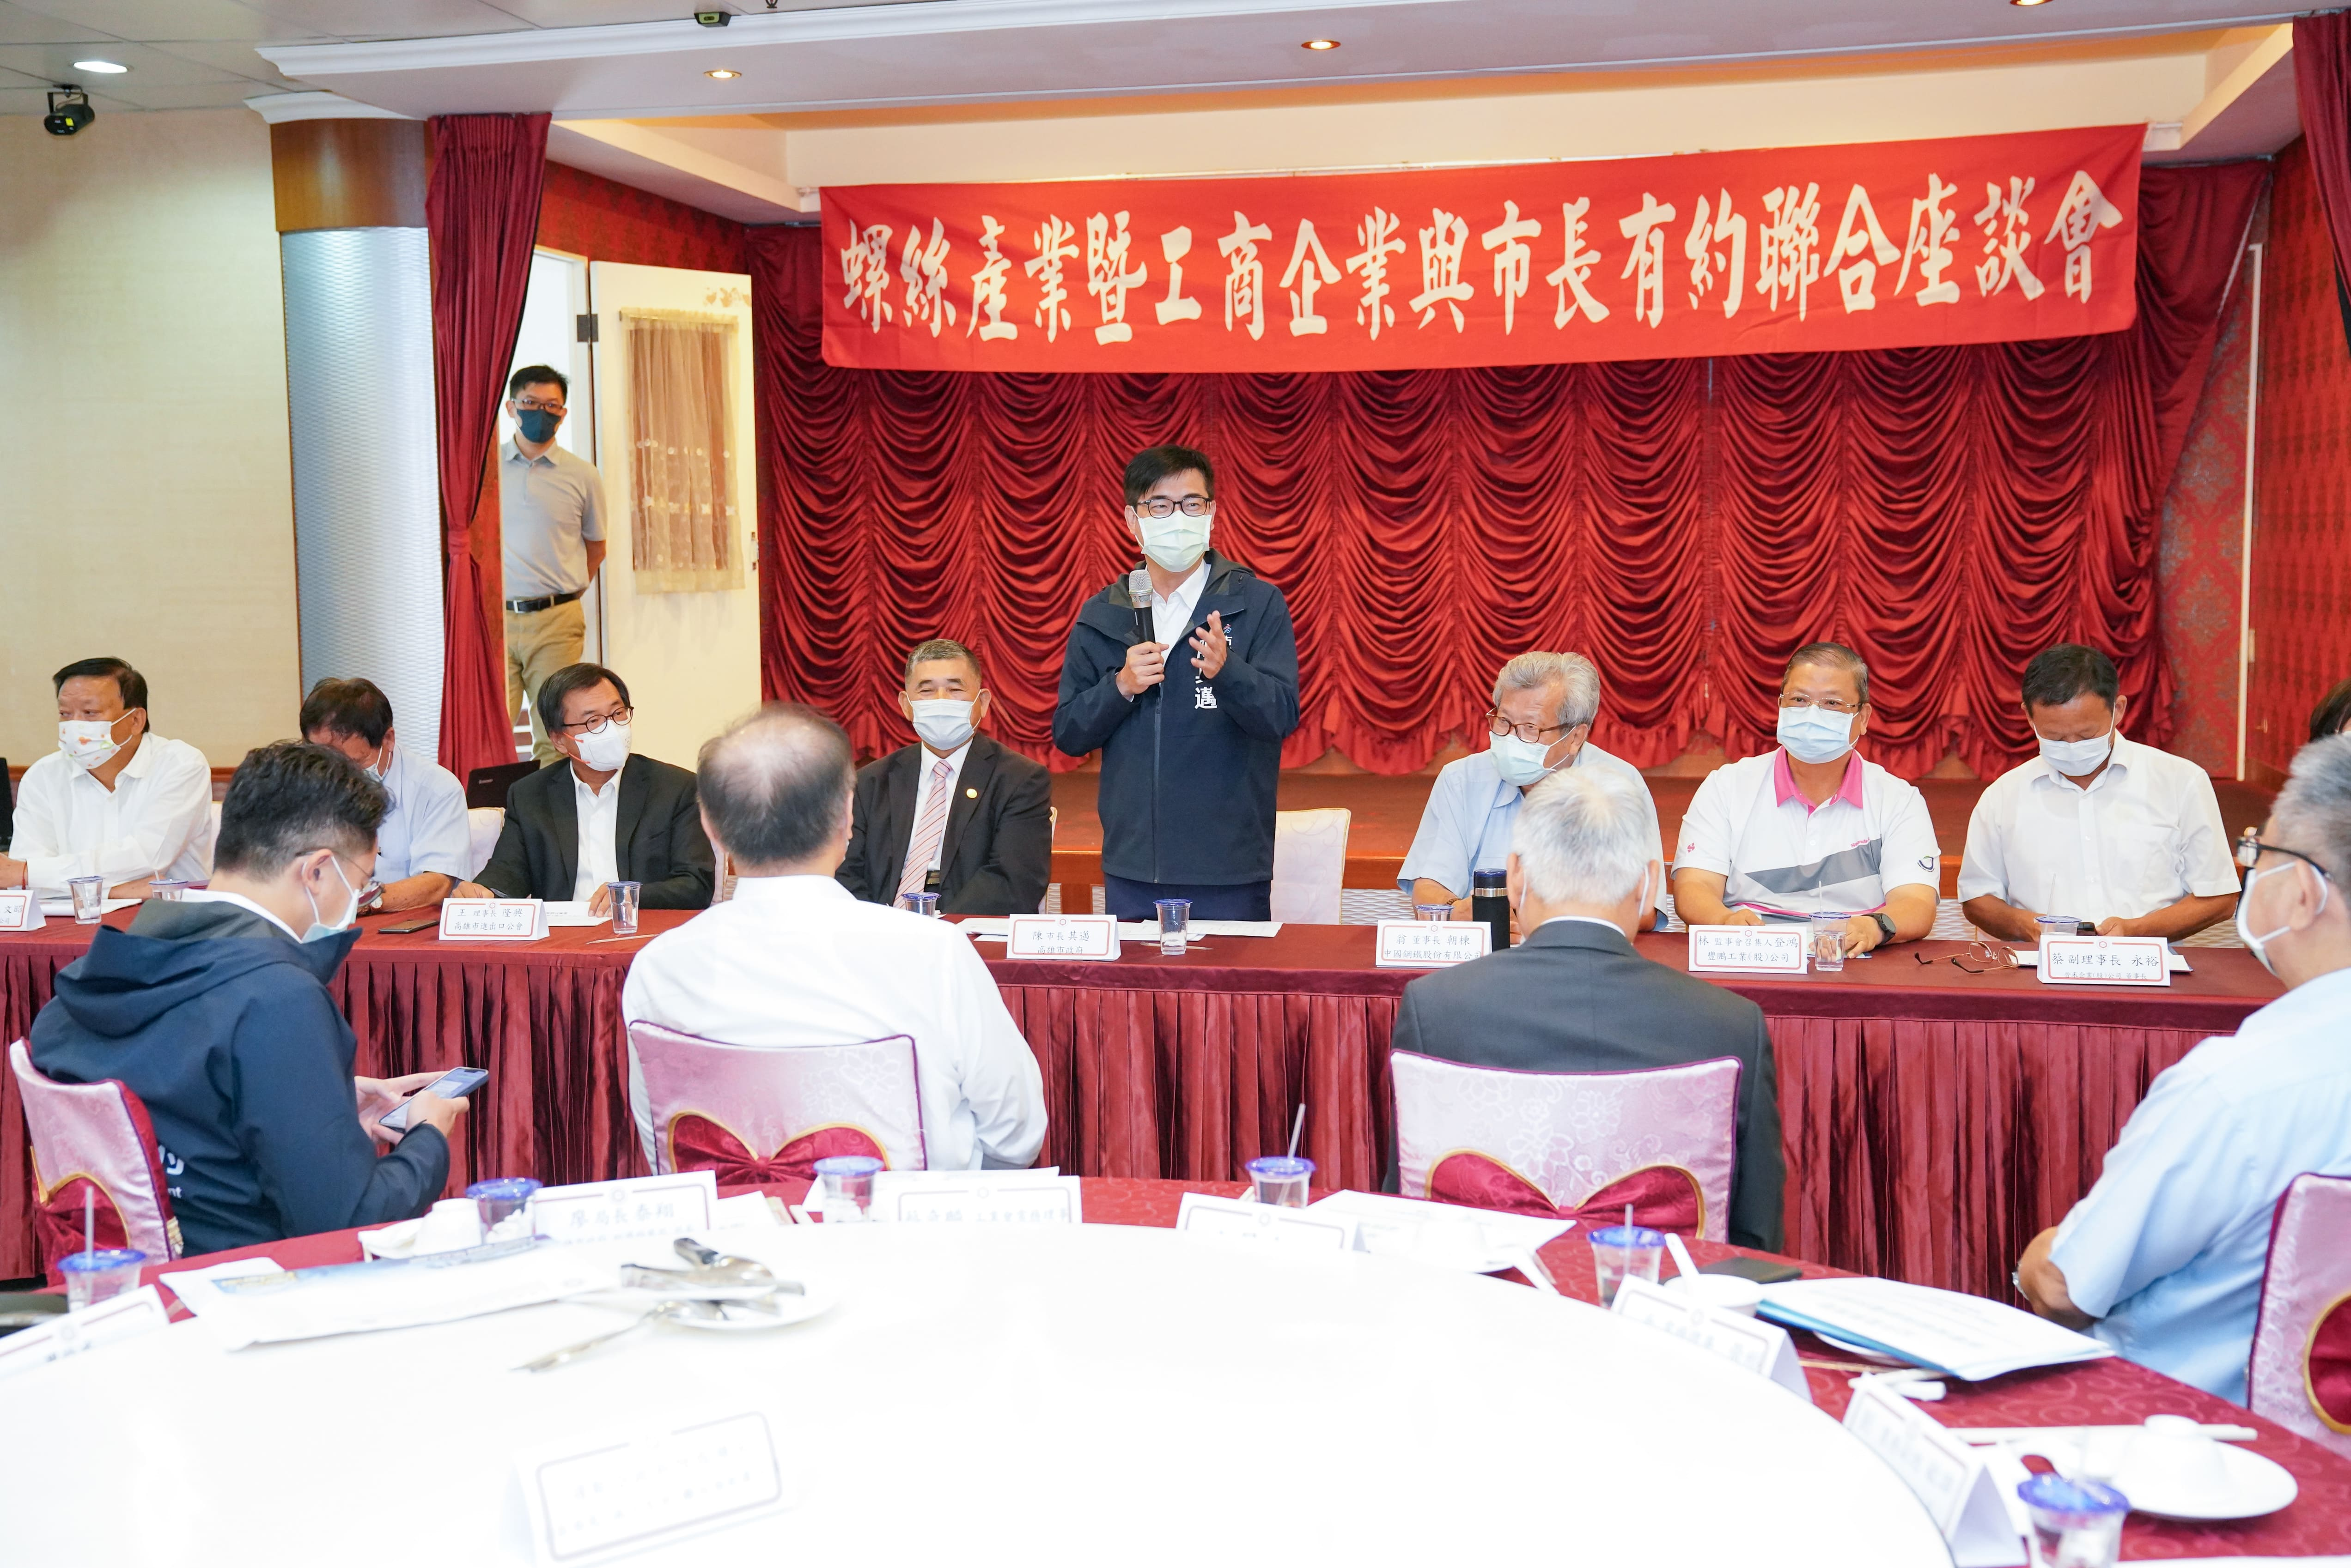

Fig1, the symposium between fastener industry and the Kaohsiung mayor
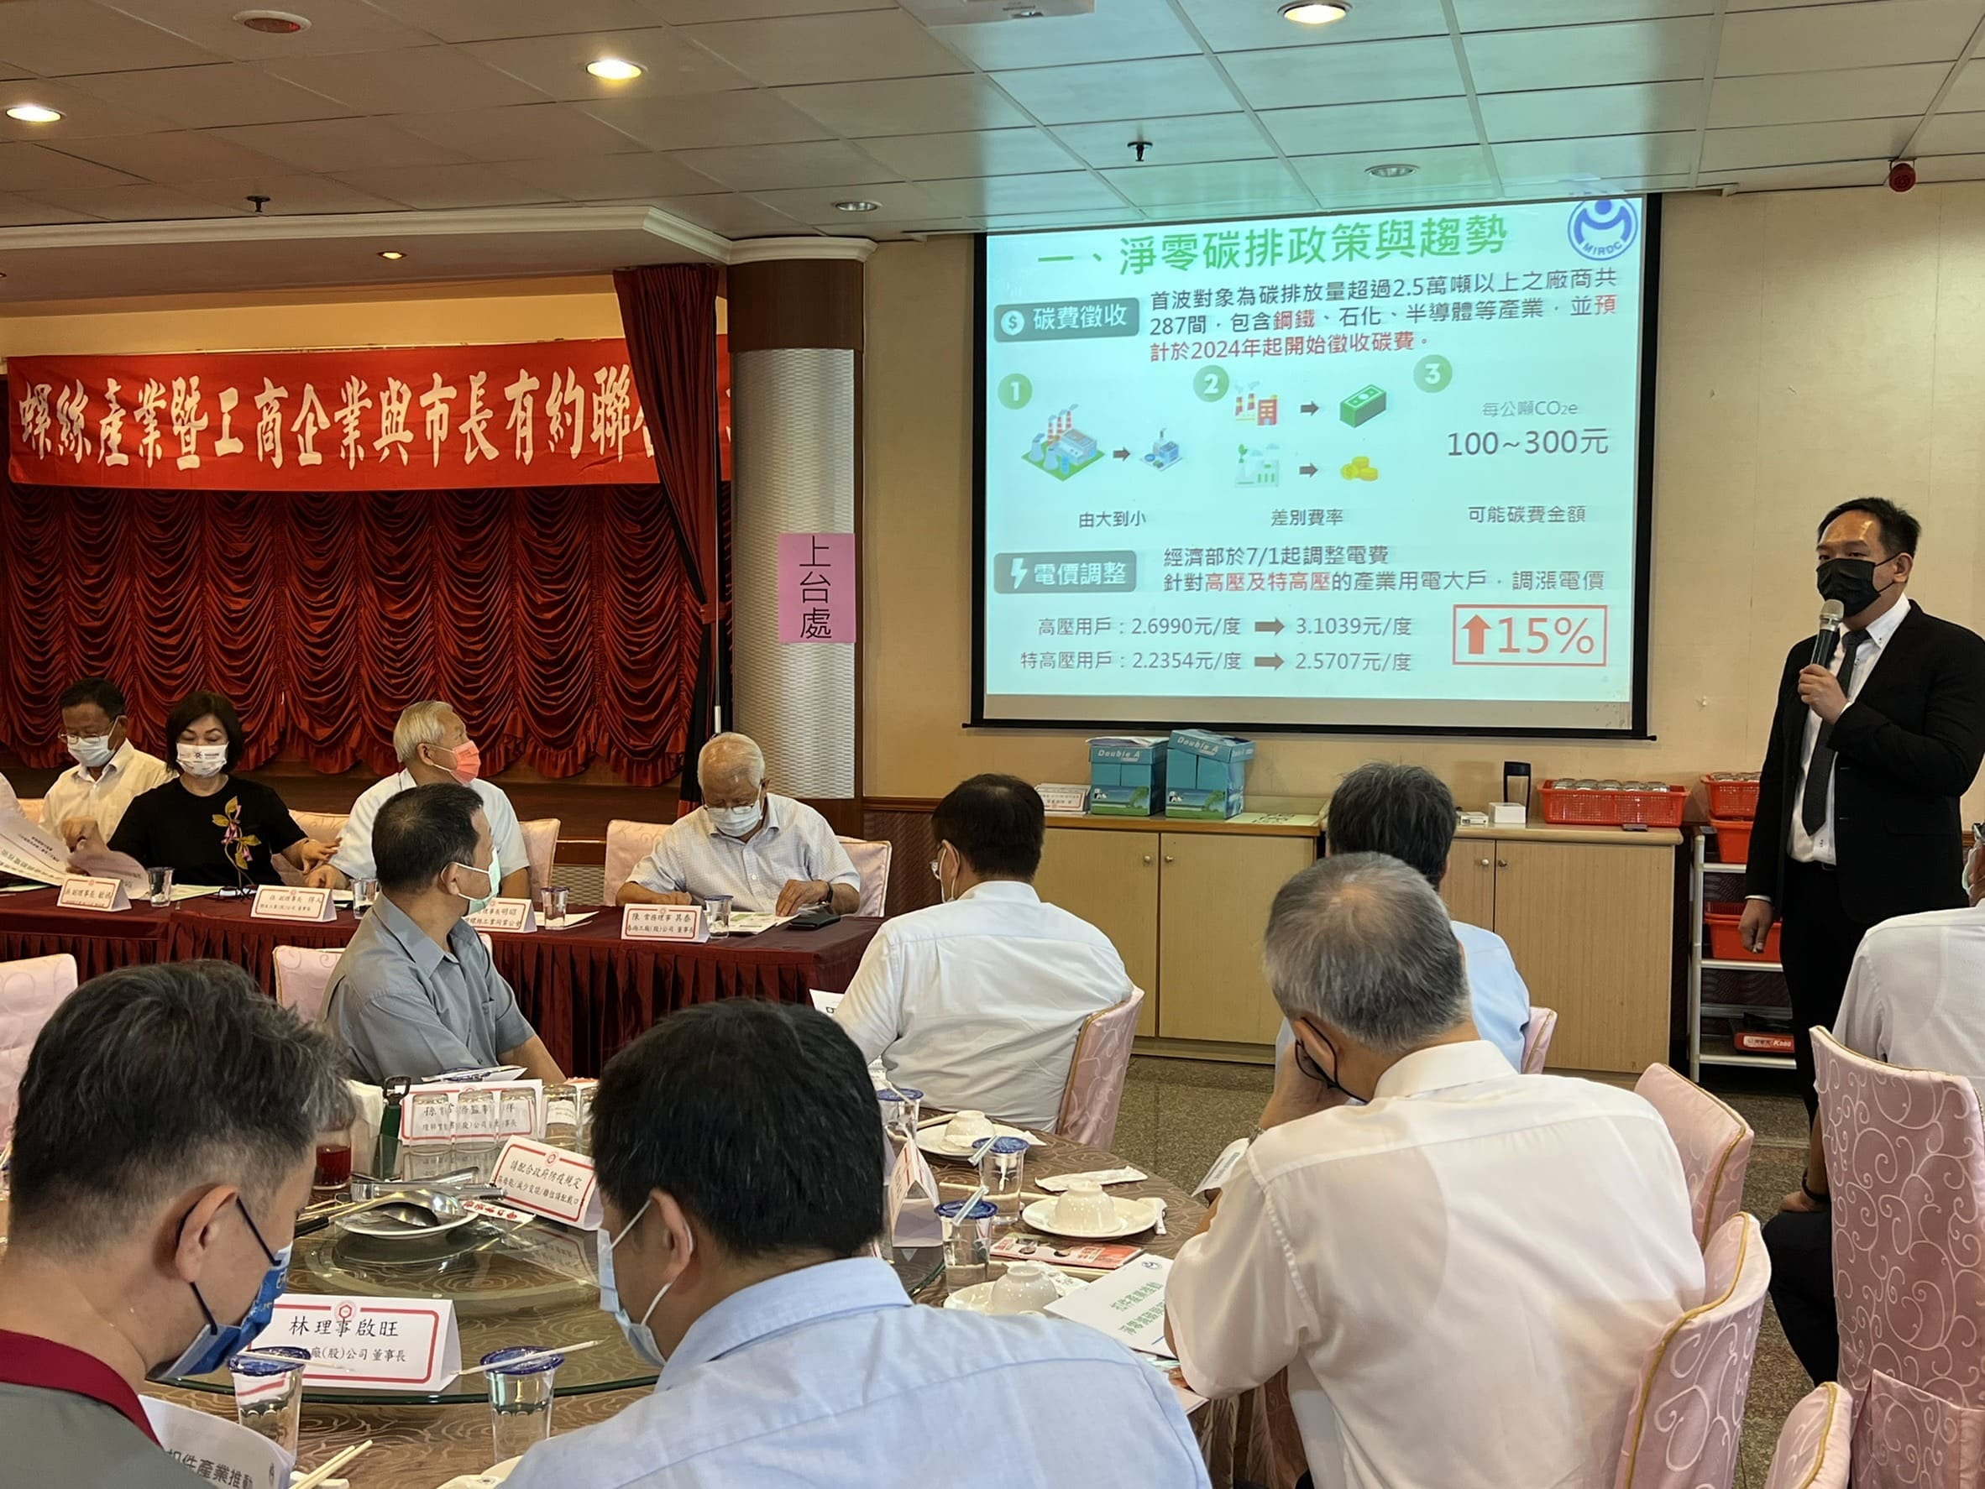

Fig2, MIRDC’S topic sharing on net carbon reduction promotion

