
新聞資料NEWS LETTER
“The Equipment of Stainless-Steel Corrosion Resistance and Surface Hardening System”, achievement of the technology project of the Ministry of Economic Affairs (MOEA) assists domestic fastener manufacturers to win global contracts

The Construction Products Regulations（CPR）2013 of the European Union set the regulation for requiring the exposed fasteners must be made of stainless steel when the buildings are used for more than 25 years. In the past, most of the fasteners used in construction were mainly carbon steel. Self-drilling, self-tapping, and self-locking for fixing into steel foundation would be completed at one time then. Though it did save a lot of time, carbon steel is easily rusted when exposed for a long time which endangers the safety of the building structure. The construction fasteners currently available in the market mostly use bi-metal self-drilling screws welded by carbon steel and stainless steel, which have the advantages of carbon steel hardness and stainless-steel corrosion resistance, etc. However, the processing procedures are complicated and there may be welding risks such as breakage of welded junctions or corrosion of carbon steel parts. There are still ways of seeking to improve the difficulties shown above.

With high corrosion resistance, austenite stainless steel is the most widely used metal material. However, to develop into a high value-added product, it is necessary to solve the problems of insufficient hardness, deterioration of corrosion resistance and insufficient mass production of stainless steel. Under the support of the Department of Industrial Technology (DoIT), Economic Affairs (MOEA), MIRDC has developed “The Equipment of Stainless-Steel Corrosion Resistance and Surface Hardening System”.
The surface of stainless steel is modified by gas activation to increase the hardness, so that the surface hardness exceeds HV 1,200. This treatment makes the surface of stainless steel higher than ordinary carbon steel without damaging the original corrosion resistance characteristics. The equipment processes a large number of stainless-steel objects at one time. Complex shapes can evenly form a hardened layer on the surface of the object. Through AI integrated judgment, parameters such as temperature, time, atmosphere, and flow rate can be accurately controlled, so that the hardness and permeation layer can be accurate which are within the requirements; at the same time, an exclusive IoT solution for the production line is established to implement the goal of intelligent production.

Taiwan's fastener industry is highly export-oriented and is the world's third largest exporter of screws and nuts. MIRDC is now cooperating with Taiwan Shan Yin International Co., Ltd, one of the major fastener manufacturers. Mr. Chiu, Sheng Lin, the Deputy General Manager of the company stated that Taiwan Shan Yin has more than 30 years of screw manufacturing experience, specializing in the production of various fasteners and screws, and has a number of patented products. Bi-metal self-drilling screws are also one of the main products of Taiwan Shan Yin, as they are widely used in building structures and are very popular in the market. However, the product has a complicated manufacturing process. Therefore, introducing the technology of Stainless-Steel Corrosion Resistance and Surface Hardening developed by MIRDC would assist the development of One-piece in manufacturing Bi-metal self-drilling screws. The stainless-steel screws produced have high strength and exceed HV 1,200, and it has also passed the 500-hour salt spray corrosion test and demonstrated performance beyond the norm, which not only improves the quality and performance advantages of new products, but also helps the company win international orders and to race together bridle to bridle.

In addition to industrial applications, the use of stainless-steel materials for people's livelihood is more common. However, if the hardness is not high and it is easy to wear, usually after a period of use, friction and collision will cause wear and scratches on the surface of the appliance, which will not only cause damage to the appearance of the appliance. It is more likely to breed bacteria or other dirt residues. Therefore, MIRDC assists Douxteel Co., Ltd in developing tableware with both high hardness and high corrosion resistance, and combined with the company's aesthetic design, combined with craftsmanship and technology, to give household items more appearance .

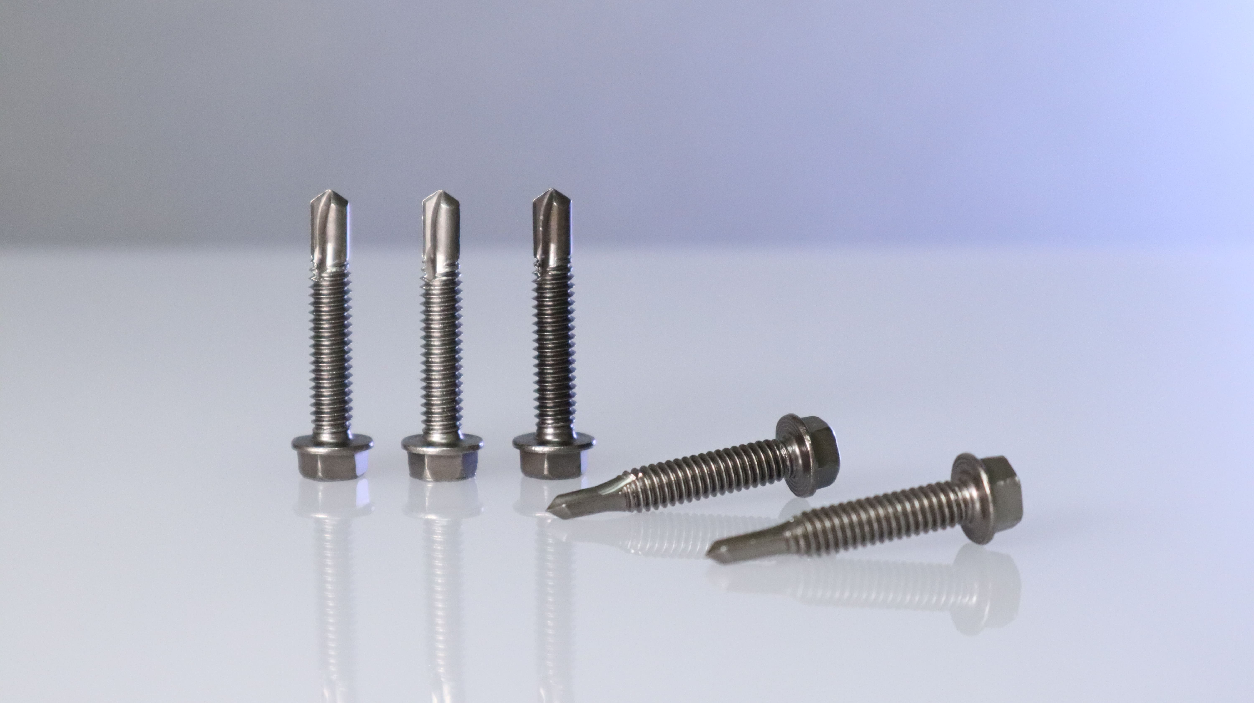

Fig 1, MIRDC assists Taiwan Shan Yin International Co., Ltd and introduces the technology of Stainless-Steel Corrosion Resistance and Surface Hardening to develop One-piece in manufacturing Bi-metal self-drilling screws, which are high hardness and high corrosion resistance

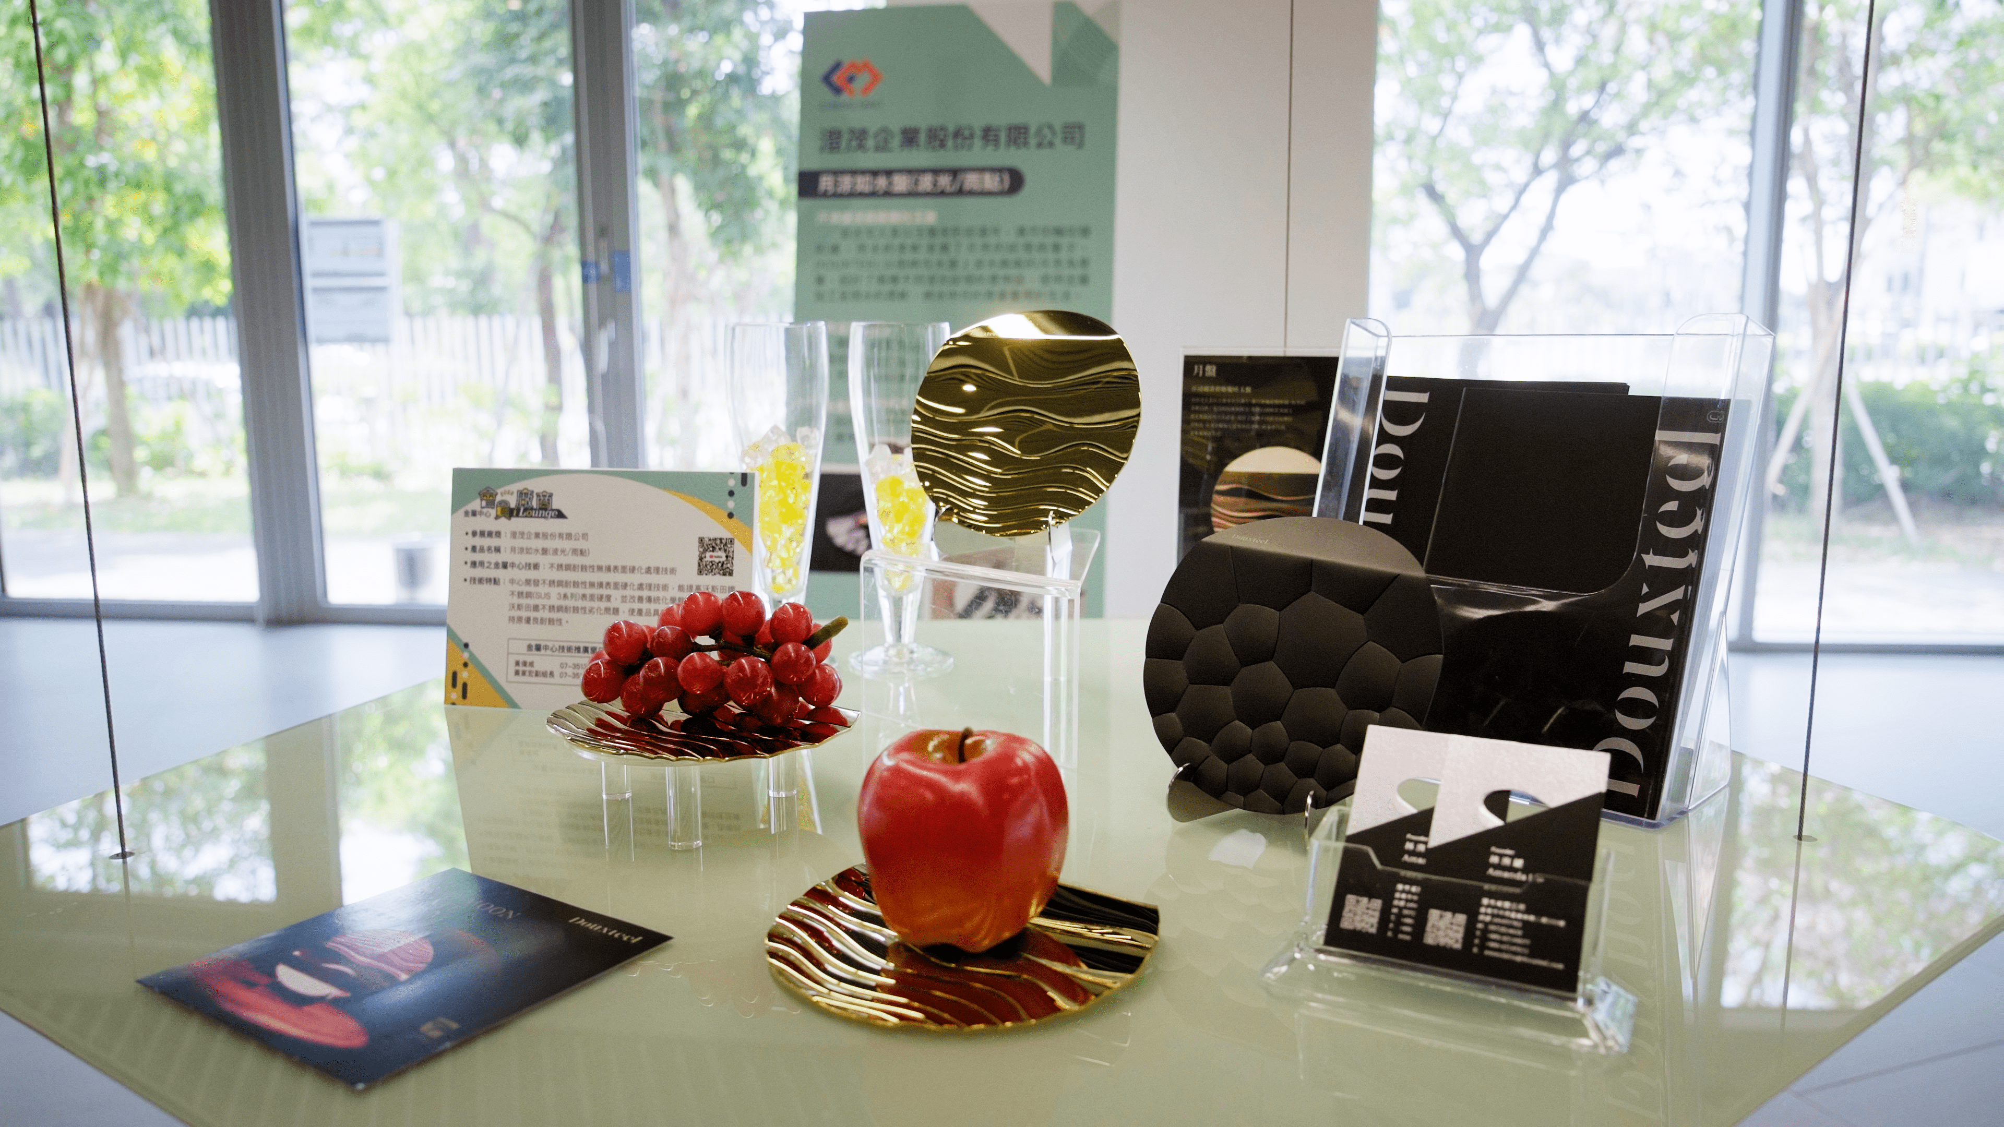

Fig2, MIRDC introduces Douxteel Co., Ltd the technology of Stainless-Steel Corrosion Resistance and Surface Hardening and applies to the self-designed aesthetic products which brings art into life and makes it more meaningful.
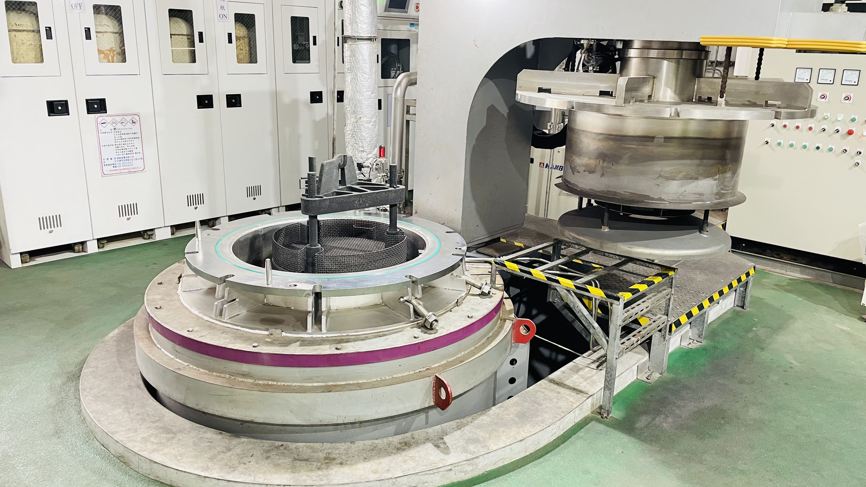

Fig3, Under the support of the Department of Industrial Technology (DoIT), Economic Affairs (MOEA), MIRDC has developed “The Equipment of Stainless-Steel Corrosion Resistance and Surface Hardening System” and assisted the development of high-valued stainless-steel industry

