新聞資料NEWS LETTER
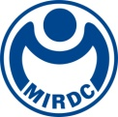
The world’s first Intelligent Orthopedic Surgical System won the German Red Dot product design award

The world’s first Intelligent Orthopedic Surgical System developed by MIRDC made a splash at a world-renowned design award, which is Red Dot 2022 product design. The system combined vertebral segmentation with registration techniques to enable real-time dynamic adjustments of each vertebral location through navigation images during operation. The position of each vertebral segment is corrected in real-time during the operation, with an accuracy rate of 94%. Also, the use of robotic arms can enhance the applicability and precision of the navigation system. It not only provides the best auxiliary medical treatment for spine surgery, but also reduces radiation exposure, reduces the risk of surgery, and shortens the operation time.

In the context of the aging global population, the demand for orthopedic medical materials is increasing. The global market value of orthopedic medical materials is estimated to reach US$58.08 billion in 2025. Among them, products such as spinal surgery navigation systems and surgical robots are growing the fastest, and it is expected to reach $13.38 billion by 2025. With the support of the Technology Development Program (TDP) of DoIT of Ministry of Economic Affairs, MIRDC developed the "Key Technology of Smart Orthopedic Surgery Assist System". Safety and efficacy, MIRDC is applying for the US FDA510K and Taiwan TFDA licenses, and it is expected that it will be marketed in the near future, providing a market-competitive price advantage to help the domestic industries develop and use this system by themselves.

Intelligent Orthopedic Surgical System combines technology and aesthetic design, and strengthens and integrates the interface of human factors and engineering from the perspective of the users, so as to meet the operability and space constraints of doctors in the operating room, and provide more accurate and effective clinical operations. The scheme also conforms to the spirit of the establishment of the Red Dot Award, which is to bring more convenient design solutions to the society and create infinite possibilities for future development. Therefore, it has won the affirmation of the 2022 German Red Dot Jury. In the future, MIRDC will continue to develop product designs in meeting the needs of people's livelihood or industry, and create a new style of application of research and development results with domestic independent innovative technologies.

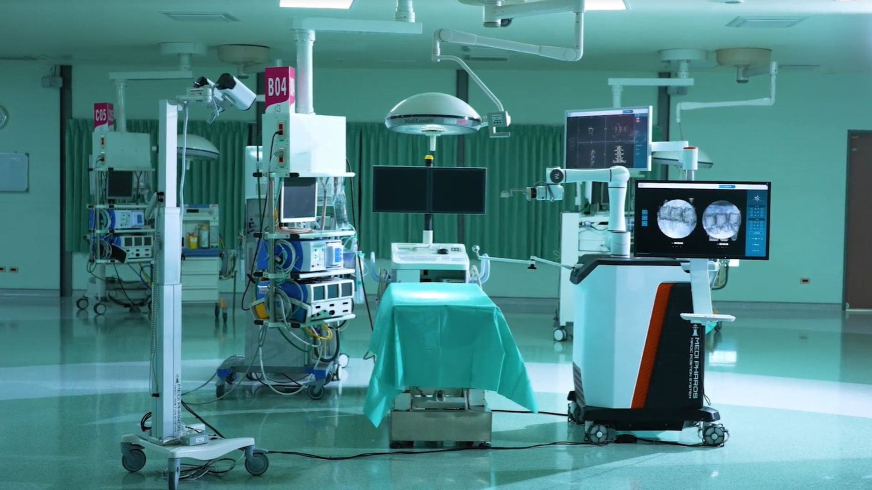
Fig1, Under the support of the Technology Development Program (TDP), MIRDC develops the smart orthopedic surgery assistance system, which provides precise positioning assistance for complex spine surgery

