
新聞資料NEWS LETTER
MIRDC assists manufacturers in creating new market opportunities together through industry guidance for digital medical devices and high-value medical device

To enhance the competitiveness of the medical device industry in Taiwan, on December 2nd, 2022, the Industrial Development Bureau (IDB) of the Ministry of Economic Affairs tries to find an outlet for innovative smart healthcare industries and entrusts MIRDC to host the “2022 Digital Medical Industry Development and Cross-area Promotional Plan Presentation” and the “2022 Medical Device Industry Technology Supervision and Promotional Plan Presentation” at Nangang Exhibition Center. MIRDC implements the “Digital Medical Industry Development and Cross-area Promotional Plan” and “Medical Device Industry Technology Supervision and Promotional Plan” launched by the Industrial Development Bureau, Ministry of Economic Affairs. Through technology improvement, reinforcement of legal regulations, cross-disciplinary talent cultivation, and international promotion. MIRDC has assisted 16 domestic manufacturers in upgrading their products and achieved brilliant performance. It successfully promotes the domestic medical device industry, enhances the added value of medical products in our country, and pushes forward BIO-ICT collaboration between different sectors and areas.

The presentation gathers 16 manufacturers together, including Big Data Mobile, Good Future Biomedical Technology, Compal/ Wistrend Technology, Hauman/ Radiant Health, JelloX Biotech, Biomedica Corporation, Imediplus, Hitspectra Intelligent, Freerider, Huang Liang, Yiben Technology, Neurobit Technologies, NaviFUS, Chiyitech, Sen Jewel Technology, and iPreg. Various smart medical devices and subsidiary products are exhibited, such as ECG illness clinical decision used in out-patient departments, automatic detection of circulating tumor cells, AI enclosing on angiogram, AI intraoperative depth of anesthesia monitoring, AI-aided recognition on 3D pathological images, AI-based bladder cancer screening, AI-assisted myocardial infarction diagnosis, GI endoscope image hyperspectral algorithm diagnosis, powered booster wheel development, new-type artificial joint, new minimally invasive surgery tools and devices for ladder flap grafting surgery, portable strabismus rapid diagnosis system, ultrasound 3D surgical needle with tracking system, disposable endoscope for spinal and pediatric surgeries, oral care gel, sperm motility chips, and vertical temperature difference culturing system. It successfully expands product visibility, establishes people’s trust on in domestic products, and helps more people understand the excellent strength on medical devices in of Taiwan.

According to the acting president of MIRDC, Lin Chih-Lung, under the impact of the aging society in Taiwan and the global epidemic, digital medical development is a trend all over the world. However, the “Medical Devices Act” clearly specifies that any software used on medical products (such as AI medical software) must obtain a medical device license for the application. Through the supervision resources and tools provided by the government, MIRDC assists the core technology in the whole healthcare industrial chain to get ready as well as integrates industry-government-university-institute-medicine capacities to create more business opportunities. The presentation discloses the comprehensive performance that our government made in supervising the medical devices industry.

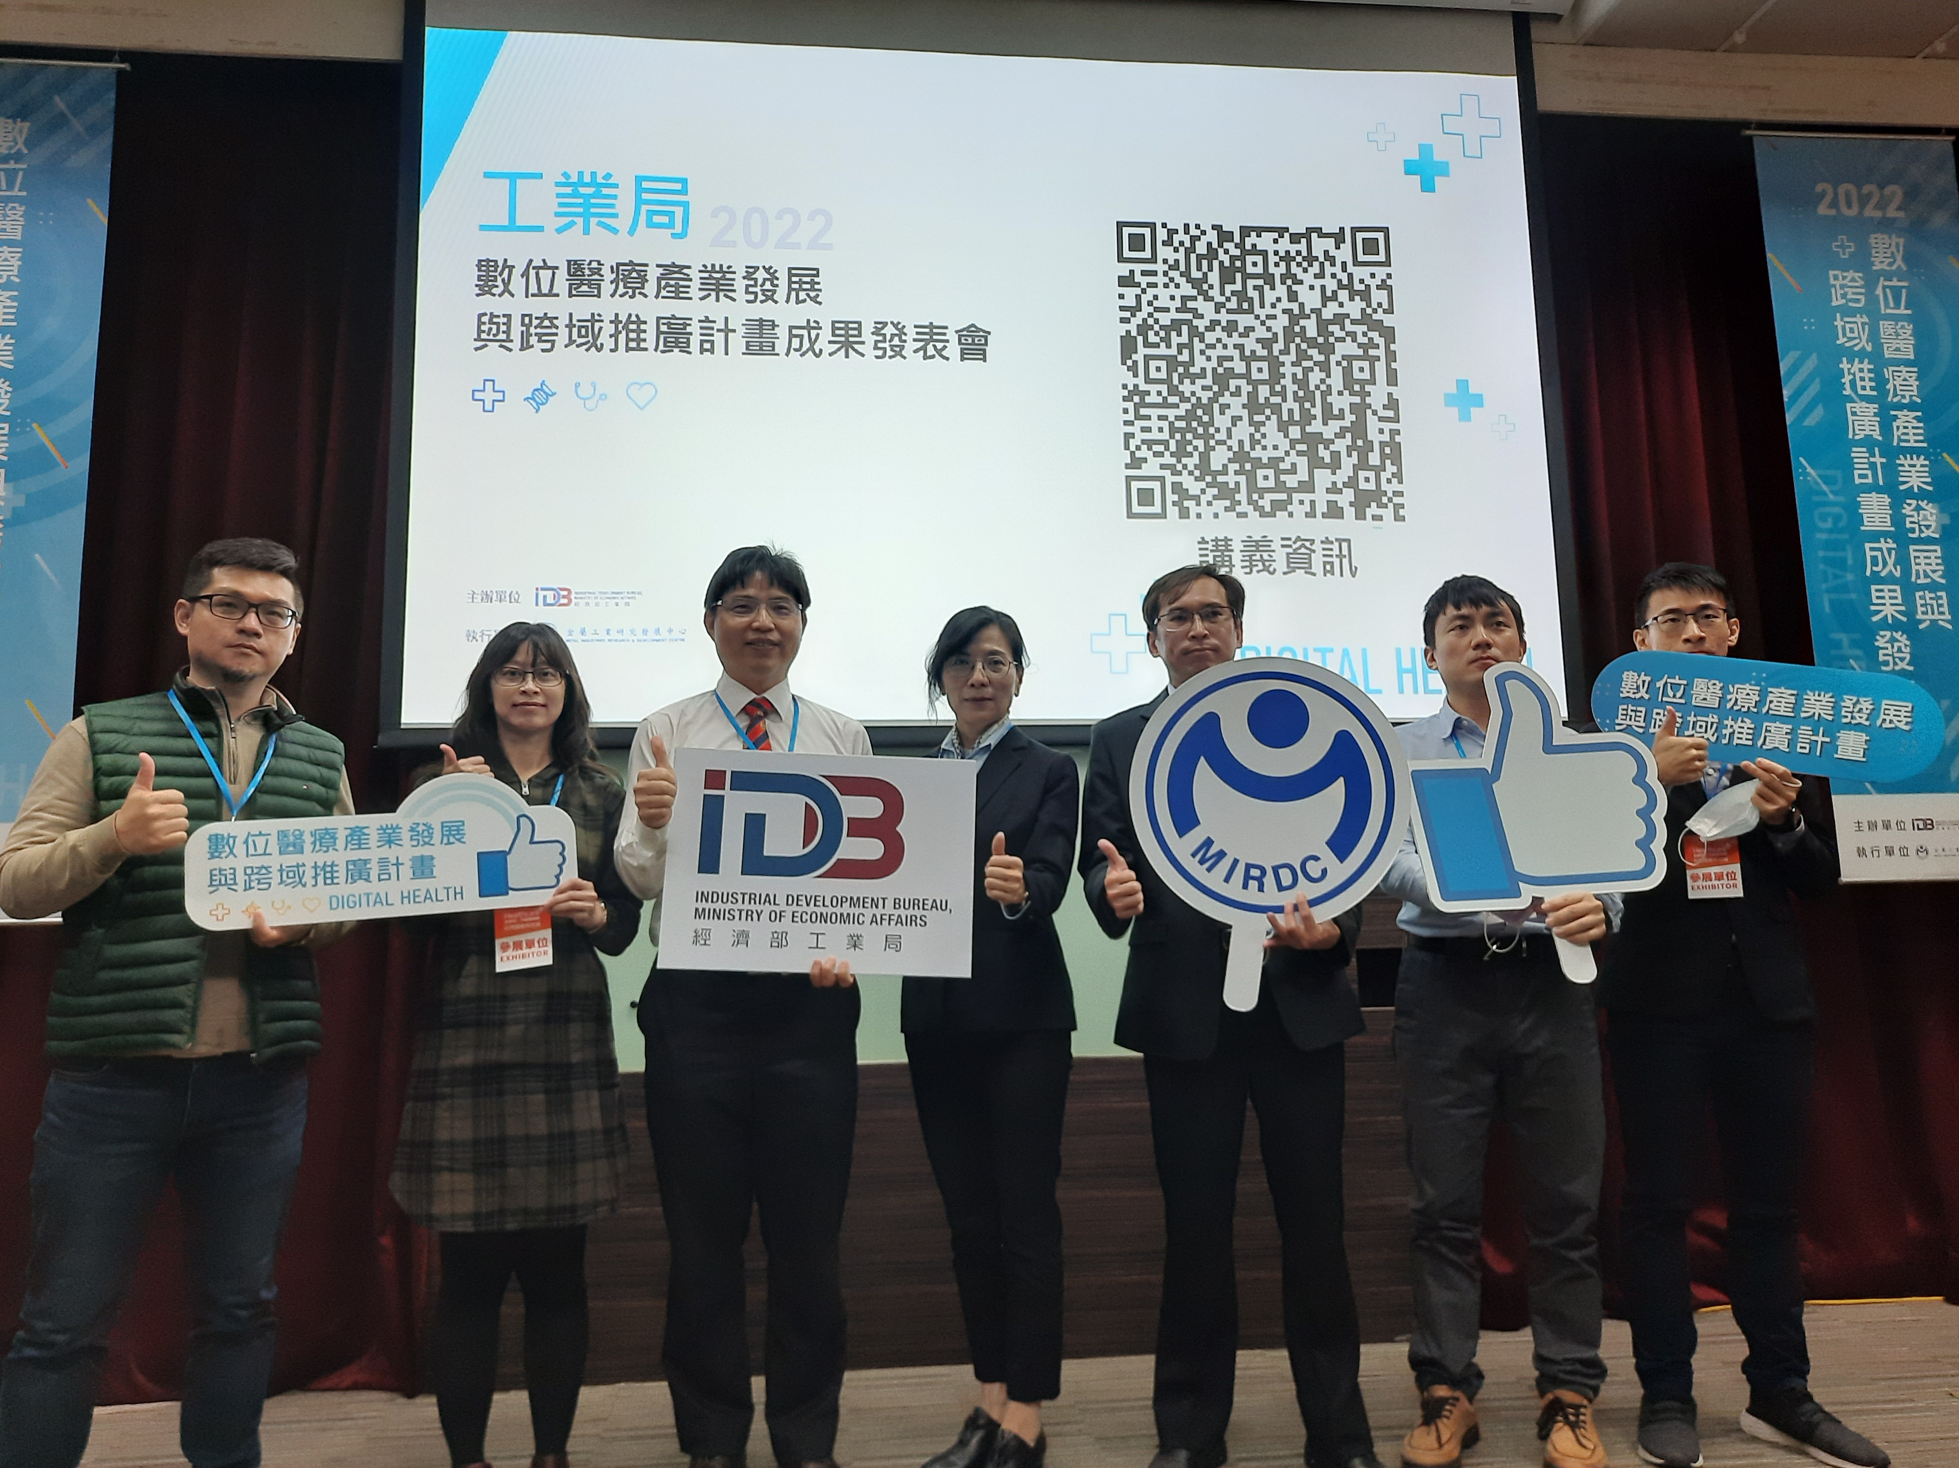

Fig1, Members of the MIRDC team that implemented the plans

