 | NEWS LETTER

By Increasing the Resistance to Corrosion of Stainless Steel, the Technology Development Program of the Ministry of Economic Affairs Creates New Business Opportunities

Early construction fasteners were mainly carbon steel with high hardness; drilling, tapping, fixing and locking could be completed at one time, which greatly saved construction time, but due to time exposure, were prone to rust and endangered building safety. At present, carbon-steel stainless steel bimetal welded composite fasteners are mainly used to address such issues. However, in addition to the complicated processing procedures, such composite fasteners are also prone to fracture at the weld, and prone to corrosion of the carbon steel section. In order to solve the issues mentioned above, MIRDC developed “Corrosion-Resistant, Surface Hardening System Equipment for Austenite Stainless Steel (CRSH),” with the support of the Department of Industrial Technology, MOEA. The technology has been applied to the construction fasteners material, Austenitic (300-series) stainless steels, which are high corrosion resistant and widely used. The treated stainless-steel fasteners have high hardness and good corrosion resistance.

Furthermore, the equipment has won awards at this year’s R&D 100 Awards. Through the precise production controls and special design, gas is used to treat the stainless-steel surface. The hardness of the stainless steel is enhanced through gas nitriding, carburizing, or carbonitriding, which allows the surface hardness to be over HV 1,200. The hardness is far above normal carbon steel and it retains its original corrosion resistance. The process is also able to handle large amounts of complex shapes at one time. Additionally, it can provide low quantity, high variety customized processing, and is equipped with smart production and systematic service functions.

Margaret Kao, Chairwoman of Marketech International Corp., stated that the semiconductor industry has always been an important pillar for Taiwan. The parts used in the machines are rather sophisticated and require corrosion resistance and high hardness. If the fasteners become stuck in the equipment due to low hardness, it would increase the difficulty of repairs, which would then affect the production process of semiconductors. Marketech and their OEM semiconductor customers hoped to use this technology to increase the hardness of stainless steel, thereby increasing the precision of their equipment quality. When they found out that the MIRDC possessed this technology, they sought to enter into a partnership with the Centre. The corrosion resistant/high hardness stainless steel parts were introduced in US and Japan semiconductor plants for testing, and they received great praise from photolithography companies in Japan and the US. At the present stage, the technology is being introduced in system equipment of Taiwanese manufacturing. In view of the developments of the semiconductor industry in Kaohsiung and the 5GAIoT industry, it has been announced that a Kaohsiung office will be established in the Asia New Bay Area-5GAIoT to help boost the government’s plan of key semiconductor equipment localization.

MIRDC acting president Chih-Lung Lin said a characteristic of stainless steel is that it is corrosion resistant, but its problem is low hardness. The Centre is using this equipment to remove the oxidized layer on the surface of stainless steel then increasing its hardness. This not only restores the corrosion resistance of stainless steel but also improves its hardness. In the future, the technology will be made available to more companies, such as LEADTECH International Co., Ltd. (stainless steel gaskets), FANCY Food Service Equipment Co., Ltd. (Stainless steel cooking surfaces), and Taiwan Shan Yin International Co., Ltd. (self-tapping screws). MIRDC will continue to help companies produce samples to drive new product development and corporate investment. The aim of the Centre is to lead related stainless-steel industries towards high-value developments.

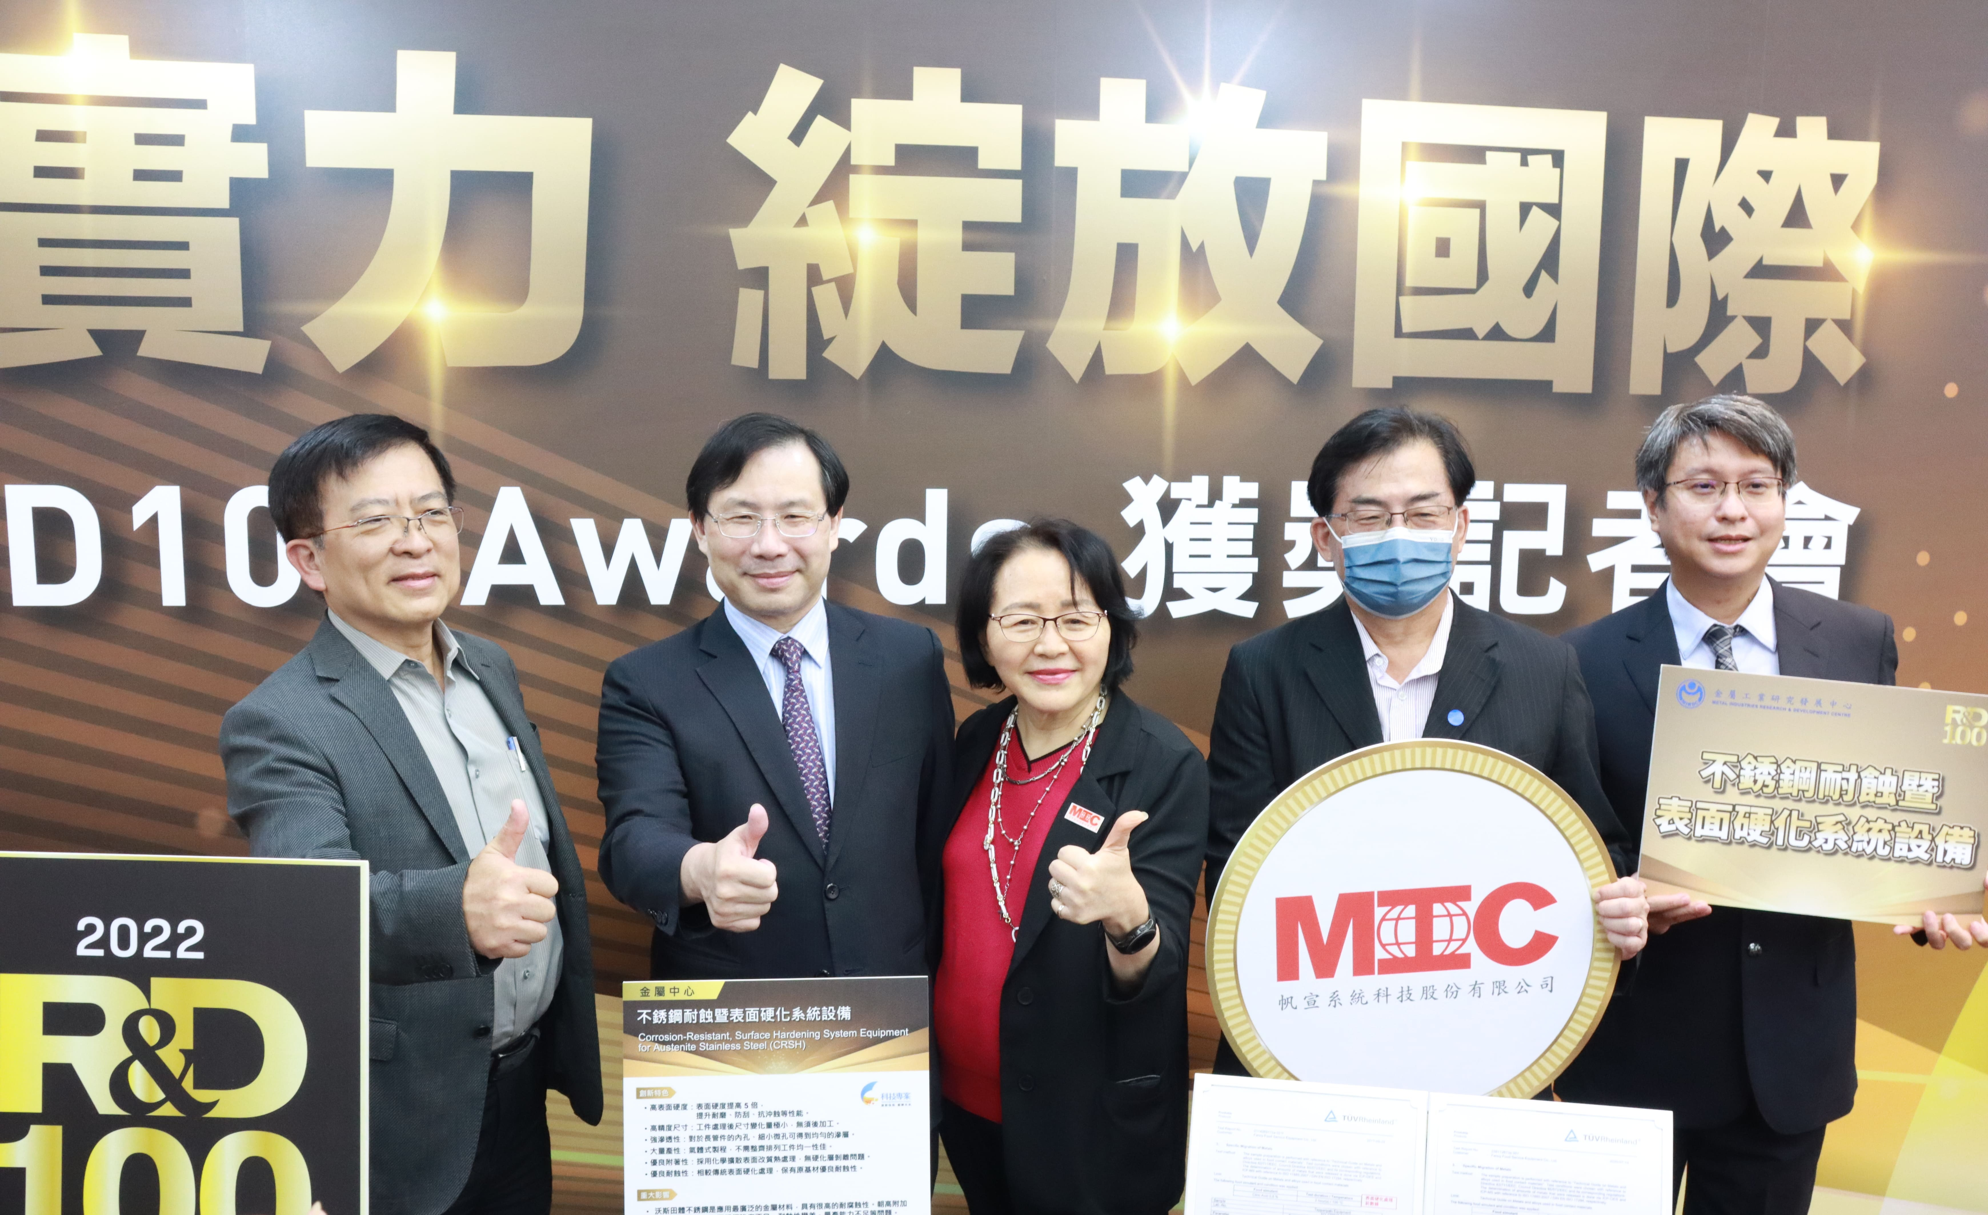
Photo 1. MIRDC acting president Chih-Lung Lin (first from the left), MOEA Vice Minister Chuan-Neng Lin (second from the left), and Marketech Chairwoman Margaret Kao (third from the left) attended the 2022 R&D100 winners press conference to witness this honor for the technology.

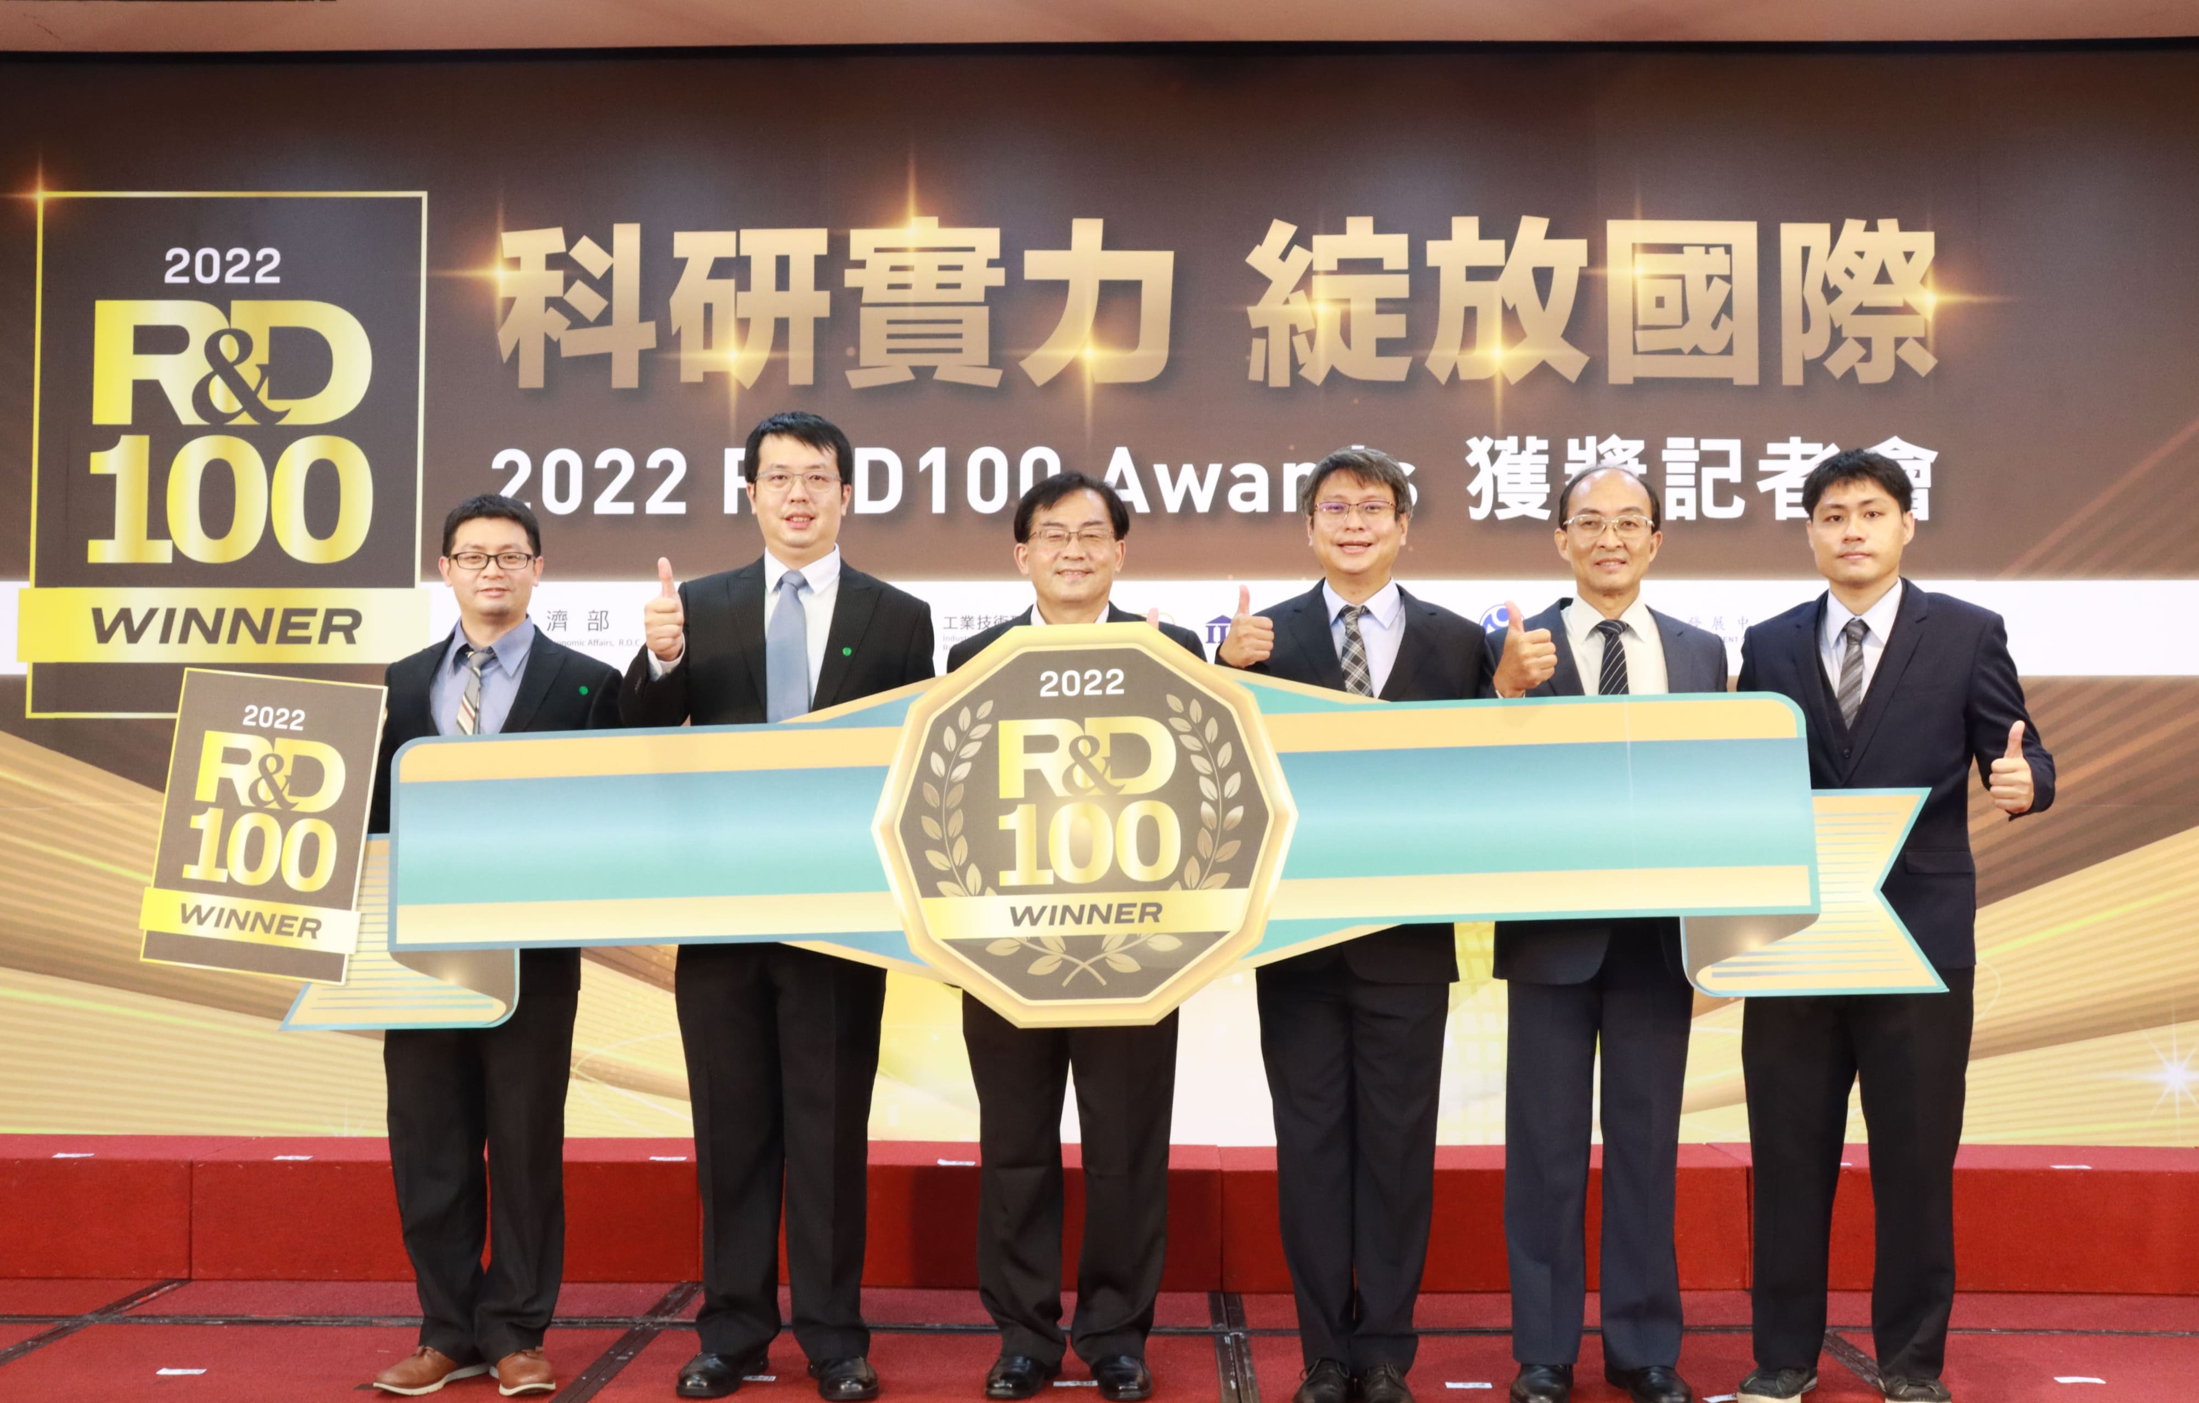
Photo 2. Photograph of the Technology Development Team led by Chong-Tian Lin, Director of the MIRDC Micro/Meso Mechanical Manufacturing (M4) R&D Department.
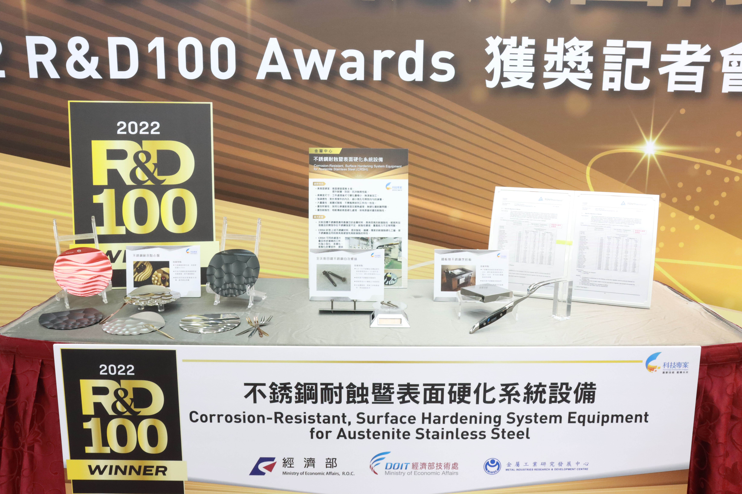
Photo 3. Smart cloud services have been introduced in the stainless-steel corrosion resistance and surface hardening system equipment, which is widely applicable for plates, utensils, and industrial fasteners, adding value to company products.

