 | NEWS LETTER

The Ministry of Economic Affairs Announces the World’s First “Multi-Vertebrae Real-Time Positioning Surgery Aid System” Prototype
The MIRDC Assembles a Minimally Invasive Spine Surgery Team in Taiwan to Assist the Domestic Medical Device Industry
Compete Internationally

During the Healthcare+ Expo Taiwan in Nangang Exhibition Center, the Department of Industrial Technology, MOEA, announced the first-generation prototype of the “world’s first multi-vertebrae real-time positioning surgery aid system” developed by the Metal Industries Research & Development Centre (MIRDC), and oversaw the signing of the MOU between EPED Inc., INTAI Technology Corp., United Orthopedic Corp., and Aplus Biotechnology Corp. The MOU focuses on gathering the technological capacity of domestic companies to invest in the domestic development of minimally invasive spine surgery aid systems. Implants enable the surgery aid systems to be used in clinical settings. A high-end and smart healthcare ecosystem is created with surgery aid systems plus implant brands, helping the domestic medical device industry to be further enhanced.

Chien-Cheng Tai, Senior Specialist of the Department of Industrial Technology, MOEA, stated that in recent years, in addition to introducing new policies, the Taiwan medical device industry is also actively introducing ICT technologies for research and development. The industry value has reached NT$133.7 billion last year (2021) but most products are home medical devices (blood glucose meters, contact lenses, and electric scooters) and mid to low end consumables for hospitals. Advanced medical devices for hospitals are still mostly imported. Taiwan is projected to become a super-aged society by 2025. The increase in the population of the elderly has also increased the demand for orthopedic medical devices and related surgeries. In order to implement precise medical care and improve minimally invasive surgery precision, the MIRDC has integrated key technologies, such as optical 3D composite positioning, real-time multi-point tracking during surgeries, domestically produced robotic arms, automated route planning developed by the MIRDC, and real-time positioning compensation technology for surgeries. The integration of technologies has produced the world’s first “multi-vertebrae real-time positioning surgery aid system” prototype. The MIRDC is using the world’s first optical 3D composite positioning technology, automated vertebrae segmenting and navigation, automated route planning, and real-time positioning compensation technology to provide better solutions for precise clinical surgery needs. For the smart multi-vertebrae surgery aid system, 13 cadaver tests have been conducted with a success rate of 98%. The system is planned to enter clinical testing in 2023. In the future, the MIRDC will work with various hospitals in Taiwan and the market price of the system is expected to be competitive.

Chi-Lung Lin, Acting President of the MIRDC, stated that as the elderly population continues to grow, medical needs are also increasing. Precise minimally invasive surgeries can reduce harm from surgery and reduce recovery times, which are needed by the patients. Reducing radiation damage during surgeries can greatly help the doctors. Taiwan is no longer a medical device technology follower and innovation will provide guarantees and support for brand continuity. The MIRDC invited leading technology pioneers in Taiwan, EPED Inc. and INTAI Technology, and orthopedic companies, United Orthopedic and Aplus Biotechnology, to sign a MOU and form the Taiwan team. The team includes Taiwanese companies and research institutes to implement the system in clinical settings. It further integrates clinical research to enhance the domestic minimally invasive spine surgery aid ecosystem chain together, thereby entering the international market.

With the support of the Department of Industrial Technology, MOEA, the MIRDC has invested in technological development. This product launch aims to demonstrate the achievements of the research and development efforts. It covers the multi-vertebrae real-time positioning surgery aid system, digital oral pathology detection, and pediatric hip joint fracture ultrasound AI identification system. Among the announced systems, the “multi-vertebrae real-time positioning surgery aid system” won the “2022 Red Dot Award”, “2022 R&D 100 Award”, and “National Innovation Award” this year. The “digital oral pathology detection” system has also won the “National Innovation Award” for two consecutive years. The “multi-vertebrae real-time positioning surgery aid system” uses the world’s first optical 3D composite positioning technology developed by the MIRDC. The system integrates the positioning labels into a dodecahedron and miniaturizes it. After which, the system automatically segments and navigates the vertebrae to achieve real-time, multi-point tracking and positioning during surgery, solving the problem of re-registration due to spinal displacement during current clinical spine surgeries. The system also integrates domestically produced robotic arms and the automated route planning and real-time positioning compensation technology developed by the MIRDC, allowing multi-vertebrae minimally invasive surgery to be more precise and user friendly, which greatly increases the penetration of surgery navigation aid systems in minimally invasive spine surgery.

During the launch, Dr. Meng-Huang Wu of Taipei Medical University Hospital was invited to demonstrate the multi-vertebrae real-time positioning surgery aid system, sparking discussions between many medical experts and companies. In addition, the “digital oral pathology detection system” includes dental plaque detection and gingivitis detection instruments. Through photo-response data, image analysis and identification, the diffuse reflection spectrometry compute model, and the AI model trained with clinical experience of doctors, the system can provide automated identification and assessment functions. The non-invasive detection method reduces discomfort for patients and shortens form-filling time for medical personnel. Furthermore, the “pediatric hip joint fracture ultrasound AI identification system” can use ultrasound AI imaging to map the hip joints of newborns before they are 6 months old. The system can automatically identify and capture identification standards from consecutive images to automatically calculate measurement angles. If underdevelopment is found, the problems can be identified early and physical therapy or other treatments can be provided during the optimal treatment period. In the future, smart medical technologies and products will continue to be developed with the guidance and support of the Department of Industrial Technology, together with the clinical needs of excellent clinicians and ICT industry technologies to develop more intelligent medical technologies and products to realize people-oriented medical care.

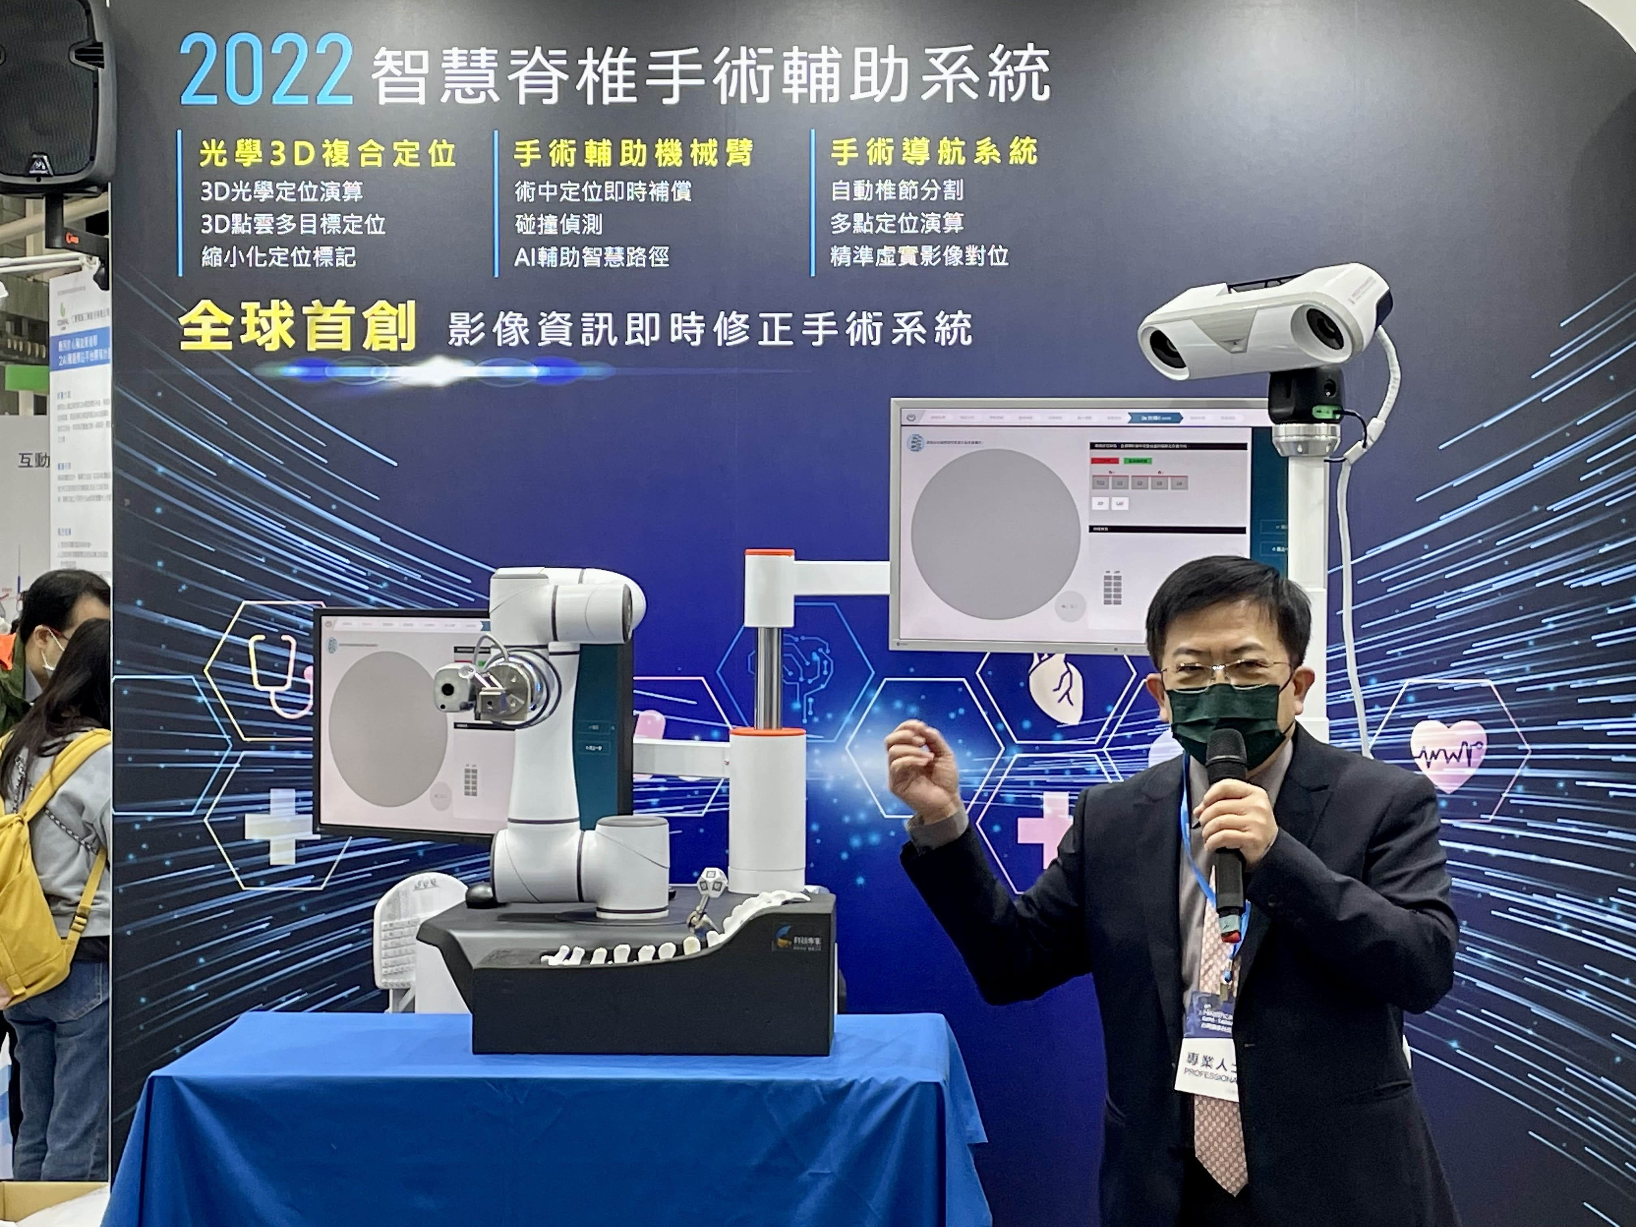
Photo 1. Chi-Lung Lin, Acting President of the MIRDC, demonstrates the world’s first multi-vertebrae real-time positioning surgery aid system prototype in Nangang Exhibition Center



Photo 2. The MUO for the multi-vertebrae real-time positioning surgery aid system was signed by (starting from the left) General Manager Andy Lo of Aplus Biotechnology, Chairman Jason Lin of United Orthopedic, Acting President Chi-Lung Lin of MIRDC, President Pao-Chang Lin of INTAI Technology, and Chairman Douglas Huang of EPED Inc.
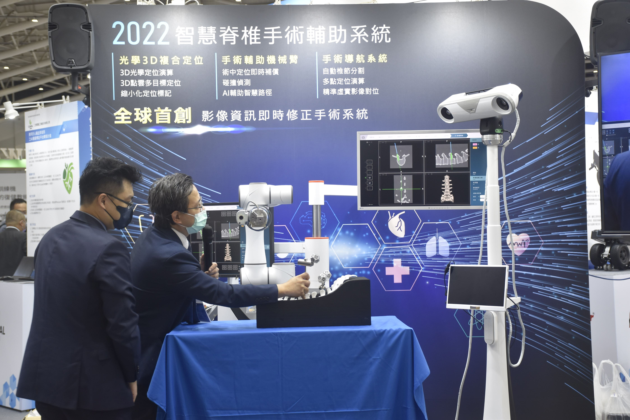

Photo 3. Dr. Dr. Meng-Huang Wu of Taipei Medical University Hospital (right) was invited to demonstrate the multi-vertebrae real-time positioning surgery aid system with Acting Chief Bing-Feng Huang of MIRDC

