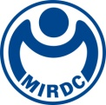
NEWS LETTER
The First Batch of Seed Trainers of “Netherlands - Taiwan Offshore Wind Joint Talent Cultivation Cooperation Program” Received Training Certificates and the New Force of Offshore Wind Power Is Poised for Development

Metal Industry Research & Development Centre (MIRDC), Energy Research Center of National Taiwan University (NTU) and the Netherlands Office Taipei held the “Taiwan-Dutch Offshore Wind Power Talent Cultivation Cooperation Program - Certificate Award Ceremony” during the 2022 Energy Taiwan. The Acting President Lin, Chi-Lung of the MIRDC, Deputy Representative Matthijs of Netherlands Office Taipei, Vice President Chen, Ming-Hsien of NTU as well as Director Chiang, Mao-Hsiung of Energy Research Center were invited to attend the ceremony to jointly witness the important milestone of Taiwan and Netherlands in offshore wind power talent cultivation.

There are a total of 4 offshore wind farms under construction in the western waters of Taiwan, and it is estimated that more than 200 offshore wind turbines can be built in the Taiwan Strait by the end of 2022. By 2025, the capacity of offshore wind power installations will reach 5.6GW, creating about 20,000 jobs, making the demand for talent urgent and self-evident. This batch of 31 seed teachers from domestic universities, research institutions, and industries will also shoulder the responsibility of cultivating domestic offshore wind power talents, and implementing the local talent cultivation model.

In his speech, Mr. Chen Ming-Hsien, the Vice President of NTU, said that in the future, NTU and the MIRDC will continue to promote such high-quality international talent cultivation programs, attract and gather more resources, combine more professional technology and practical experience, and develop more professional courses that meet the actual needs of the industry. “Taiwan-Dutch Offshore Wind Power Talent Cultivation Cooperation Program” is fully subsidized by the Dutch government, which entrusts the TNO, TU Delft/DUWIND, and the Deltares to plan courses, and the first batch of seed trainers are jointly promoted and recruited by the Energy Research Center of NTU and the MIRDC (Service Innovation and Development Department), in a hope to retain the seeds of know-hows and technologies of Dutch offshore wind power and marine engineering, and help thrive Taiwan’s offshore wind power industry. The Deputy Representative Matthijs of Netherlands Office Taipei especially thanked the MIRDC and the NTU for helping to promote and recruit the first batch of seed trainers in Taiwan. The success of this joint project confirms the determination of the Dutch government to jointly develop Taiwan’s offshore wind power talents.

The Acting President Lin, Chi-Lung of the MIRDC said that earlier this month, the Maritime Technology Innovation Center, which was commissioned by the Bureau of Energy and operated by the MIRDC, was awarded the 2022 Highly Commented - Safety & Compliance Award Fidelity by Global Wind Energy Organization (GWO). Since obtaining GWO certification in January 2021, the Maritime Technology Innovation Center has stood out from more than 500 training institutions around the world for two consecutive years and won the affirmation of GWO, showing that domestic and foreign wind power operators recognize the training capacity and quality of the Maritime Technology Innovation Center. In the future, the MIRDC and the Energy Research Center of NTU will continue to expand the faculty capacity of the Taiwan-Dutch Offshore Wind Power Talent Cultivation Cooperation Program, conduct training courses, and accelerate the cultivation of domestic offshore wind power talents through the integration of industry-university-research and international cooperation.

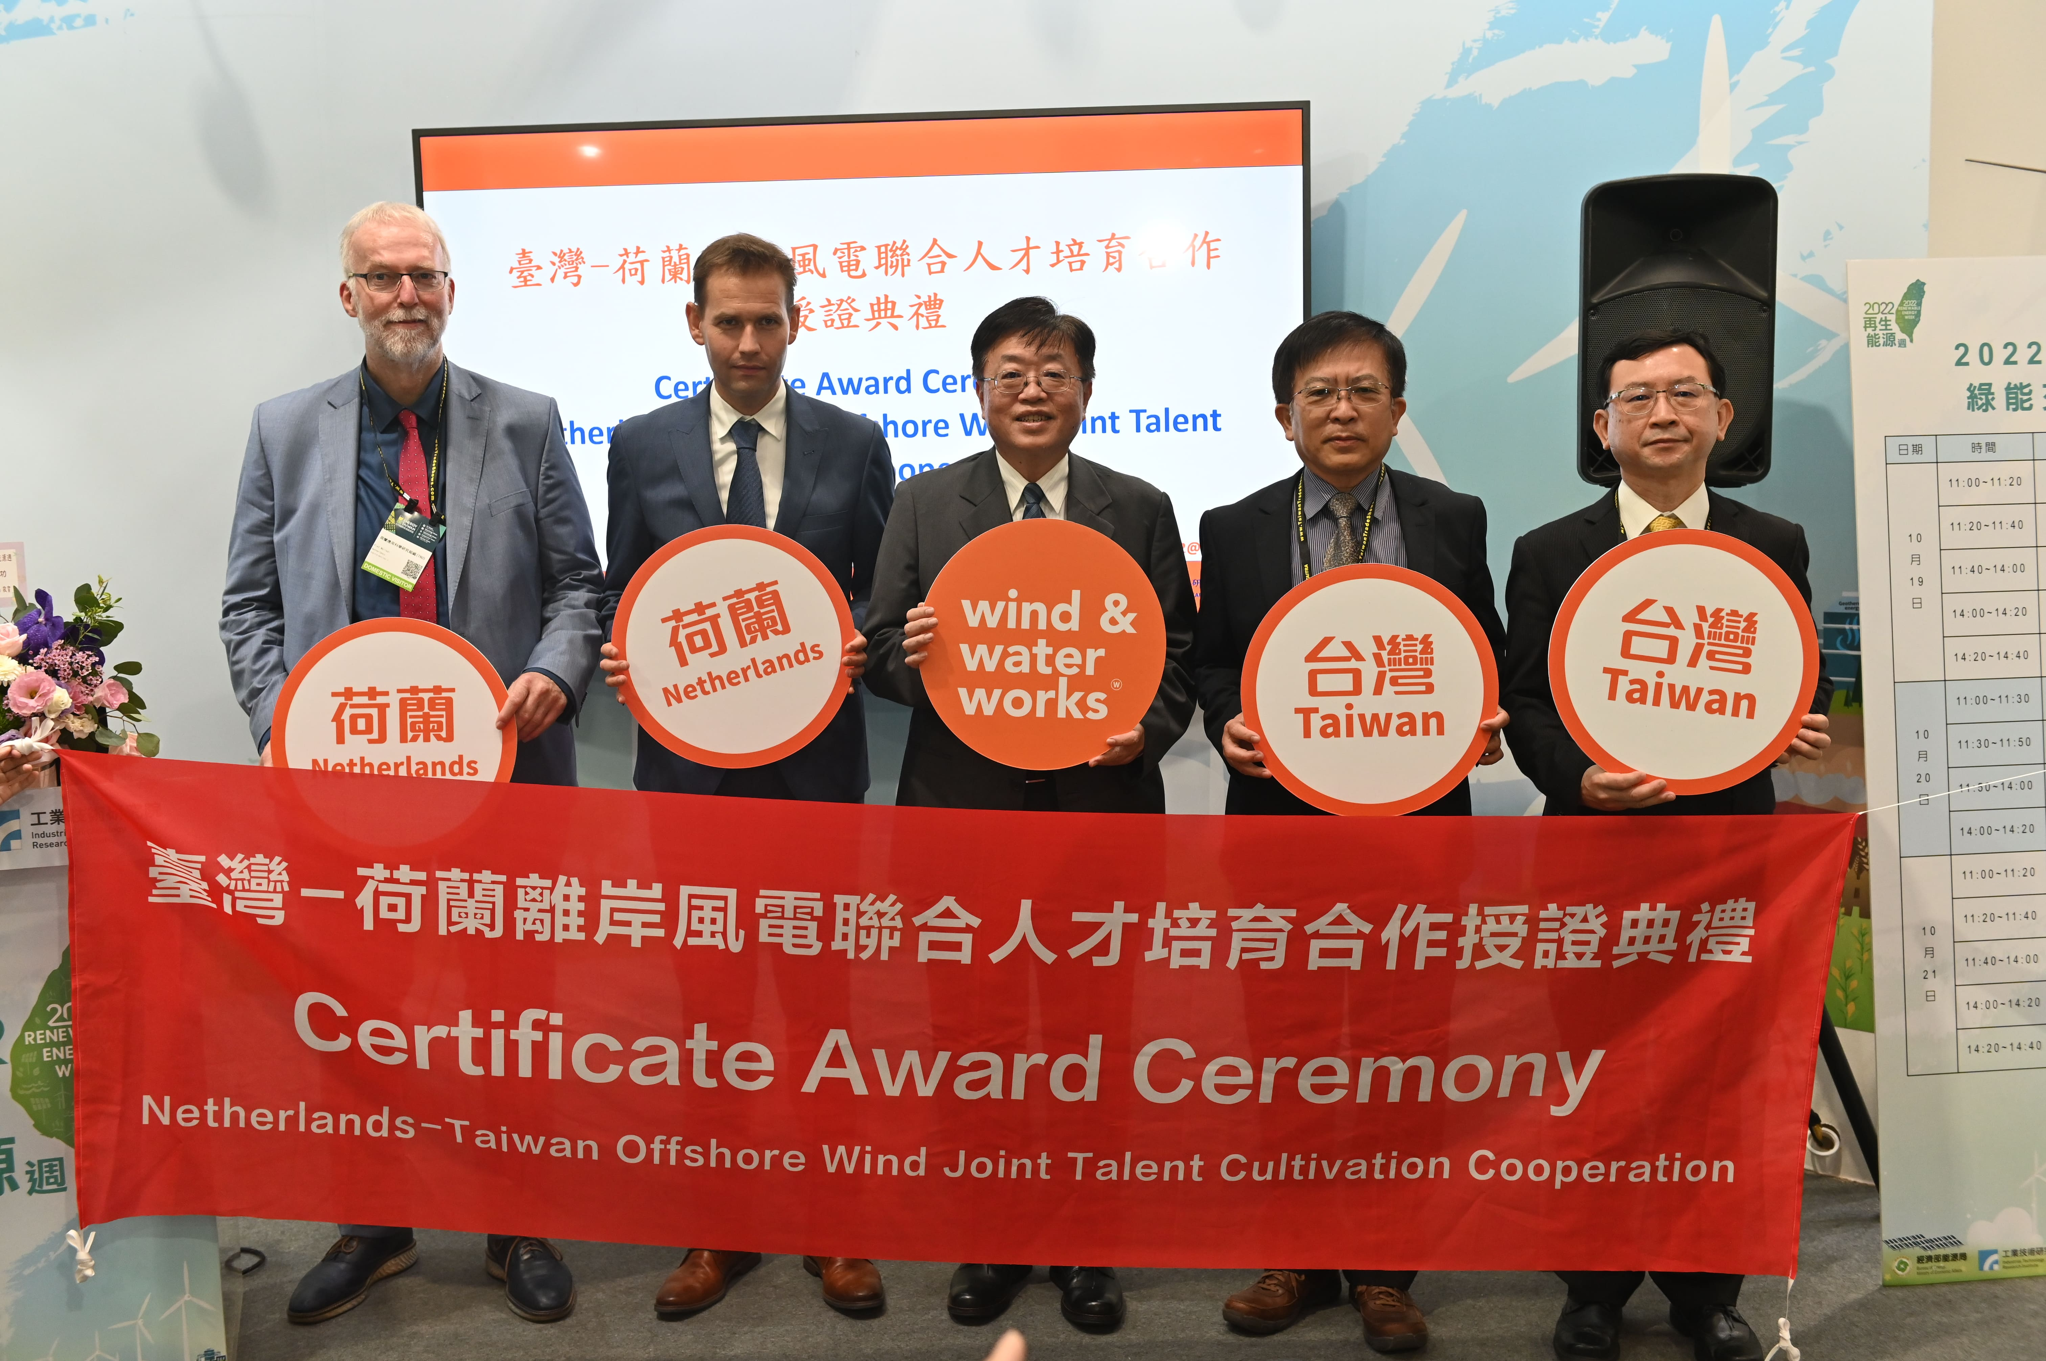

Fig. 1 (from the left) Peter Vano, Senior Wind Energy Business Development Manager, TNO, Matthijs, Deputy Representative of Netherlands Office Taipei and Director of Ministry of Economic Affairs, Chen, Ming-Hsien, Vice President of NTU, Lin, Chi-Lung, Acting President Lin, Chi-Lung of the MIRDC and Chiang, Mao-Hsiung, Director of Energy Research Center, NTU witnessed the certificate presentation.
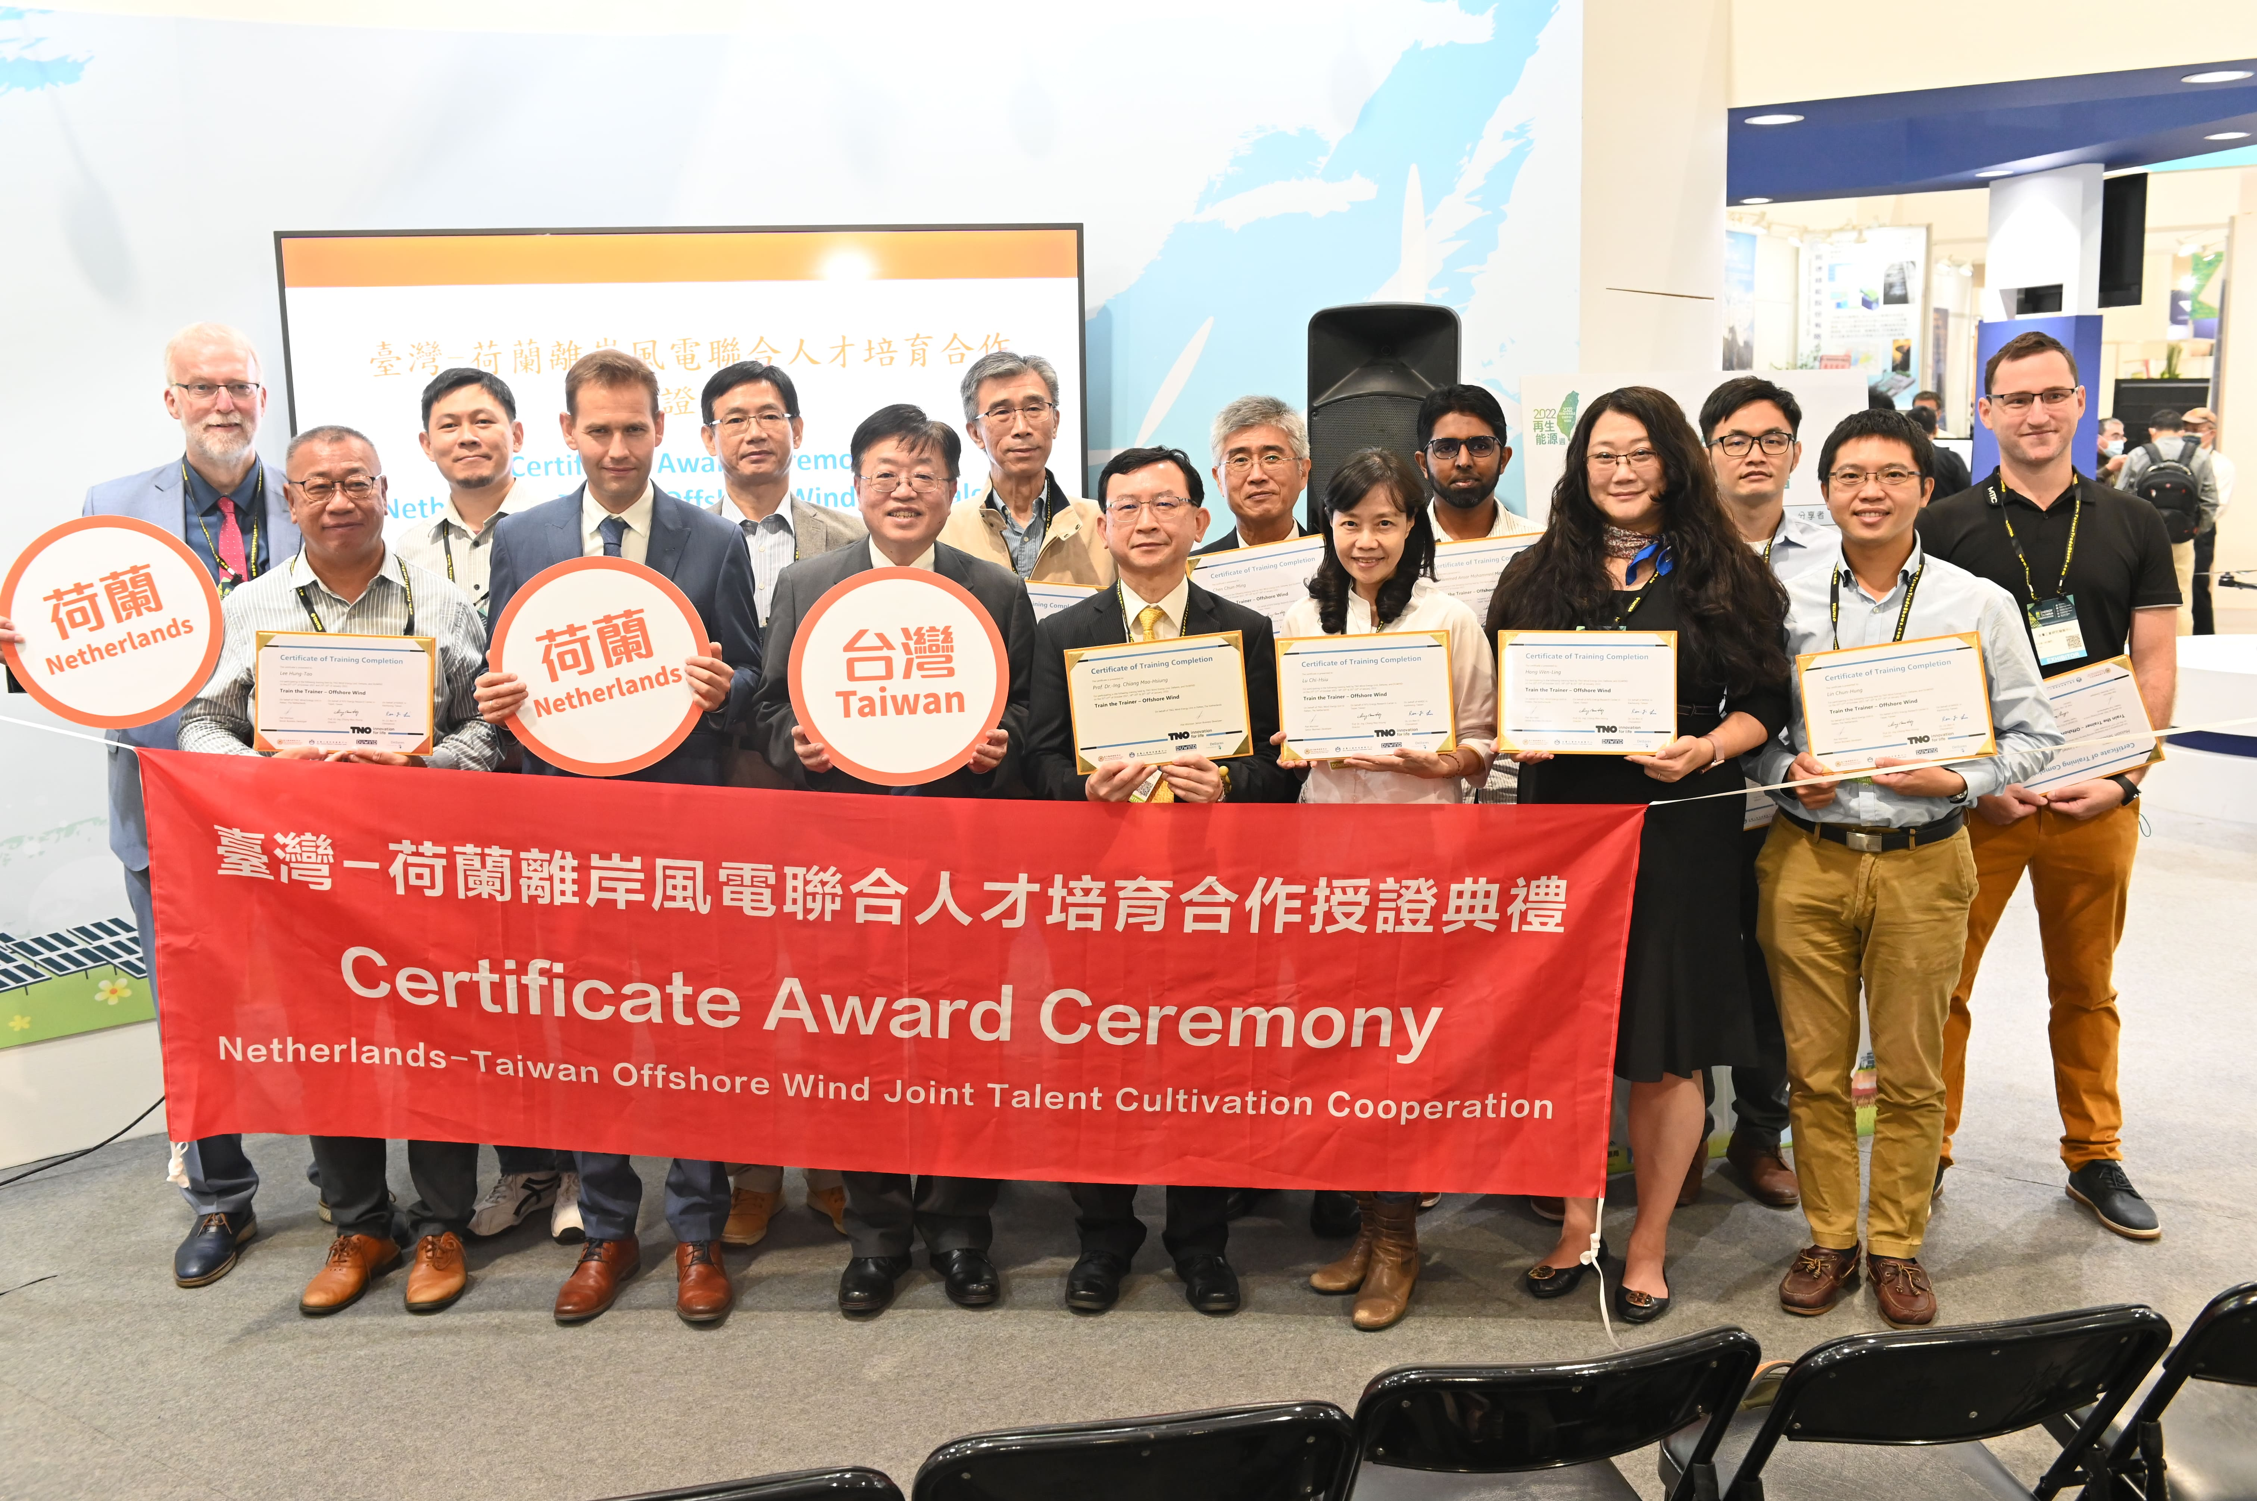

Fig. 2 Group Photo of Distinguished Guests and Seed Trainers and a Successful Completion of Certificate Award Ceremony

