
NEWS LETTER

Metal Industries Research & Development Centre promotes industry-university-institute alliance for mold and die.
Government works with the industry to boost advanced manufacturing technology R&D on mold and die.

Center With the witness of Vice Minister of Ministry Economic Affairs, Lin Chuan-Neng, and Lin Tai-Hua, the legislator, and Deputy Director-General of Kaohsiung City Economic Development Bureau, Kao Chen-Yuan, Metal Industries Research & Development Centre (MIRDC) hosted a ceremony of launching “Taiwan Mold and Die Joint Service Center” on October 29th, 2022. MIRDC signed “MOU on Industry-University-Institute Alliance for Mold and Die” jointly with National Kaohsiung University of Science and Technology, National Taiwan Ocean University, Chung Yuan Christian University, Mold & Die Industry Association, Steel & Iron Industries Association, Industrial Fasteners Institute, Transportation Vehicle Manufacturers Association, and Unmanned Aircraft Systems Association. The purpose is to speed up the advanced manufacturing capabilities in the mold and die industry in Taiwan to join the international supply chain system and strengthen the winning possibility of the international purchase order and competitiveness.
Vice Minister of the Ministry of Economic Affairs, Lin Chuan-Neng, mentioned in his speech that mold and die are mothers of industry. It is an important basic industry in the country, and almost all the production for end products and components relies on it. The Mold & die industry is also a key industry that supports the development of the manufacturing industry. It plays a specifically essential role in the local industries of fasteners, electric cars, aerospace, and medical devices in Kaohsiung. Therefore, the Ministry of Economic Affairs actively promotes advanced manufacturing in the mold and die industry to respond to the demands of digital transformation and net zero emissions in global enterprises. To assist the mold and die industry in advancing manufacturing capability, and to improving supply chain resilience. Ministry of Economic Affairs also spares no effort to promote the digital transformation among local enterprises in Kaohsiung by entrusting MIRDC to establish Asia New Bay Area 5G AIoT Project Office and providing subsidized resources like an A+ plan and industrial guidance to assist intelligence upgrading in the local industry.

Lin Chih-Lung, the acting president of MIRDC highlighted the establishment of the Taiwan Mold and Die Joint Service Centre will link legal persons and schools from the north to the south together. Based on the industrial demands summarized by the Mold & Die Industry Association, including four key areas in “plastic injection, stamping, die casting, and materials”, relevant R&D and guidance capacity will be invested. Through the promotion of the mold and die industry advanced manufacturing transformation project by Industrial Development Bureau, MOEA, next year (2023), government will invest and provide resources of technology guidance, industry-university collaboration, and technical workshops to support the advanced manufacturing technology development in the mold and die industry in Taiwan, provide diverse services to the domestic tooling factories, speed up the upgrading and transformation in the mold and die industry in our country, and enhance international competitiveness.
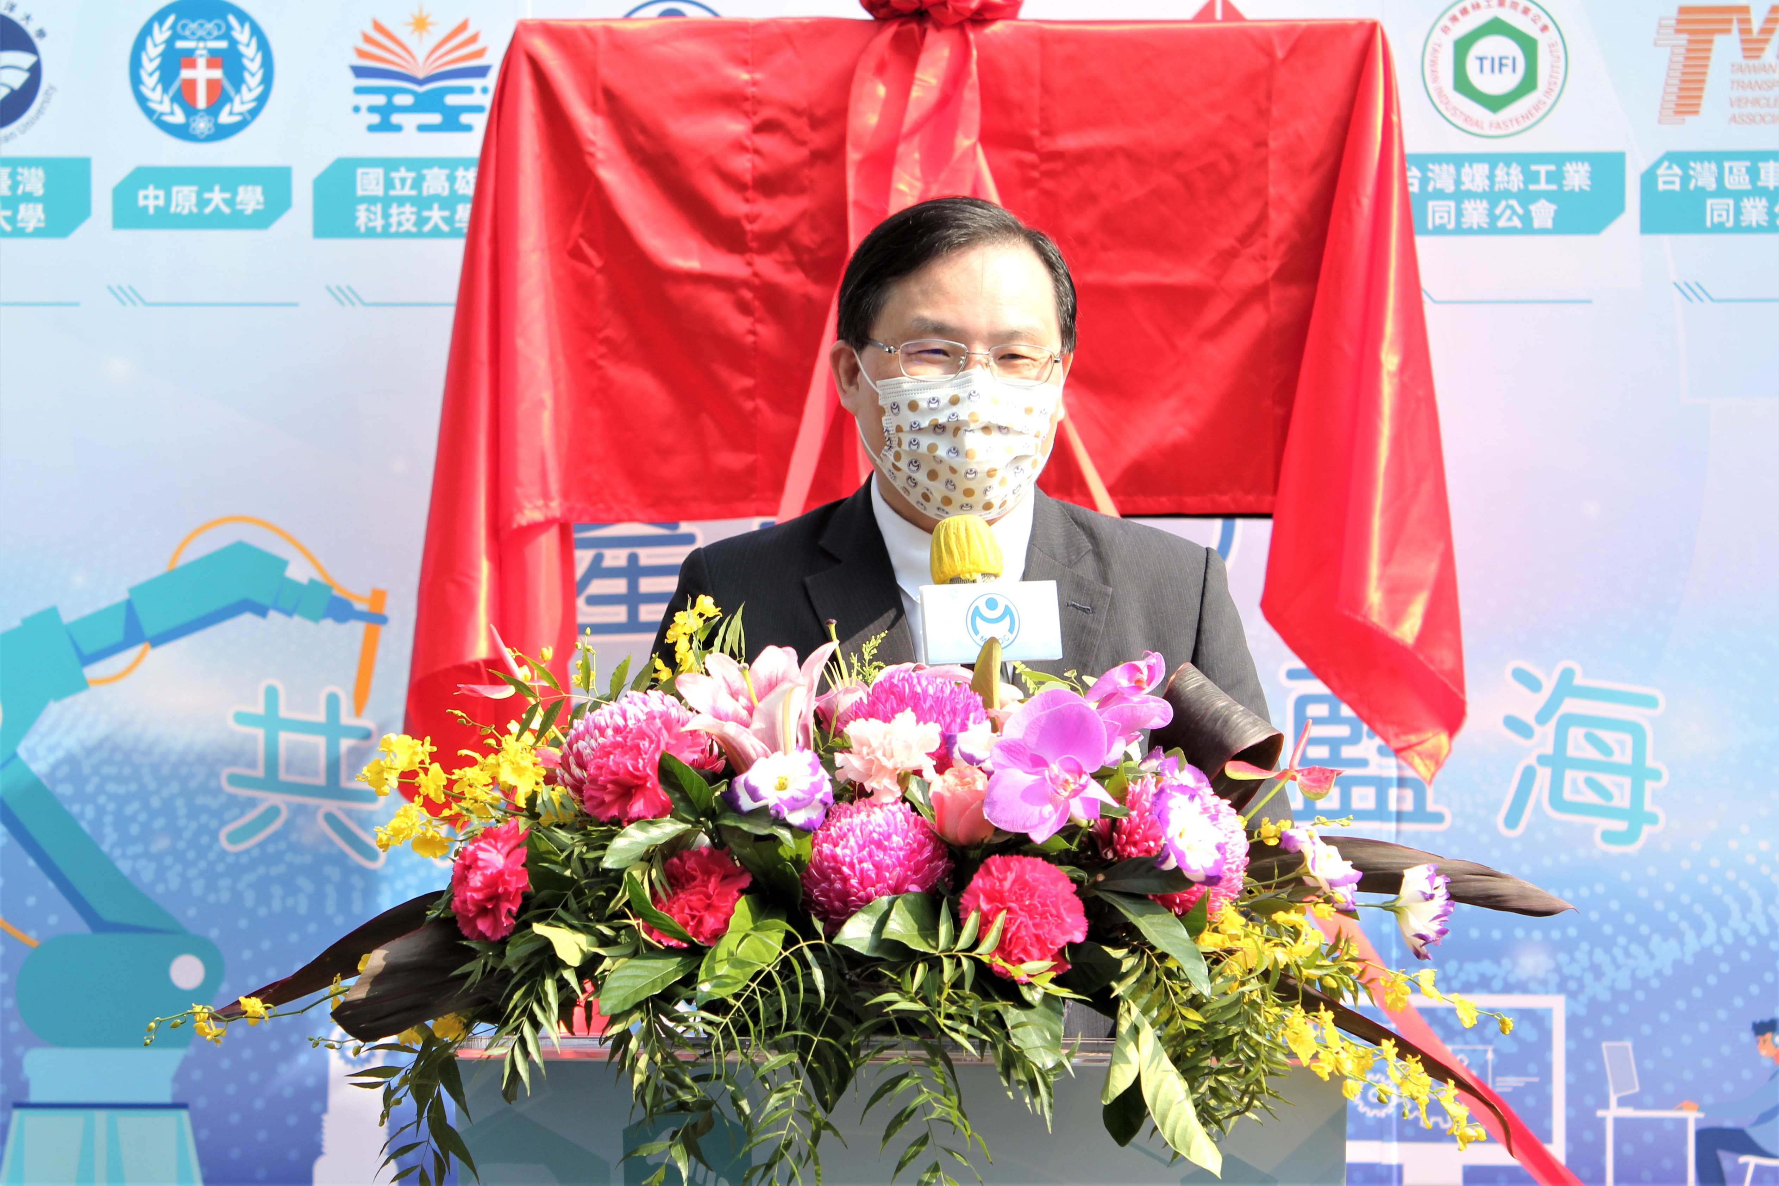

Photo 1: Speech by the Vice Minister of the Ministry Economic Affairs, Lin Chuan-Neng
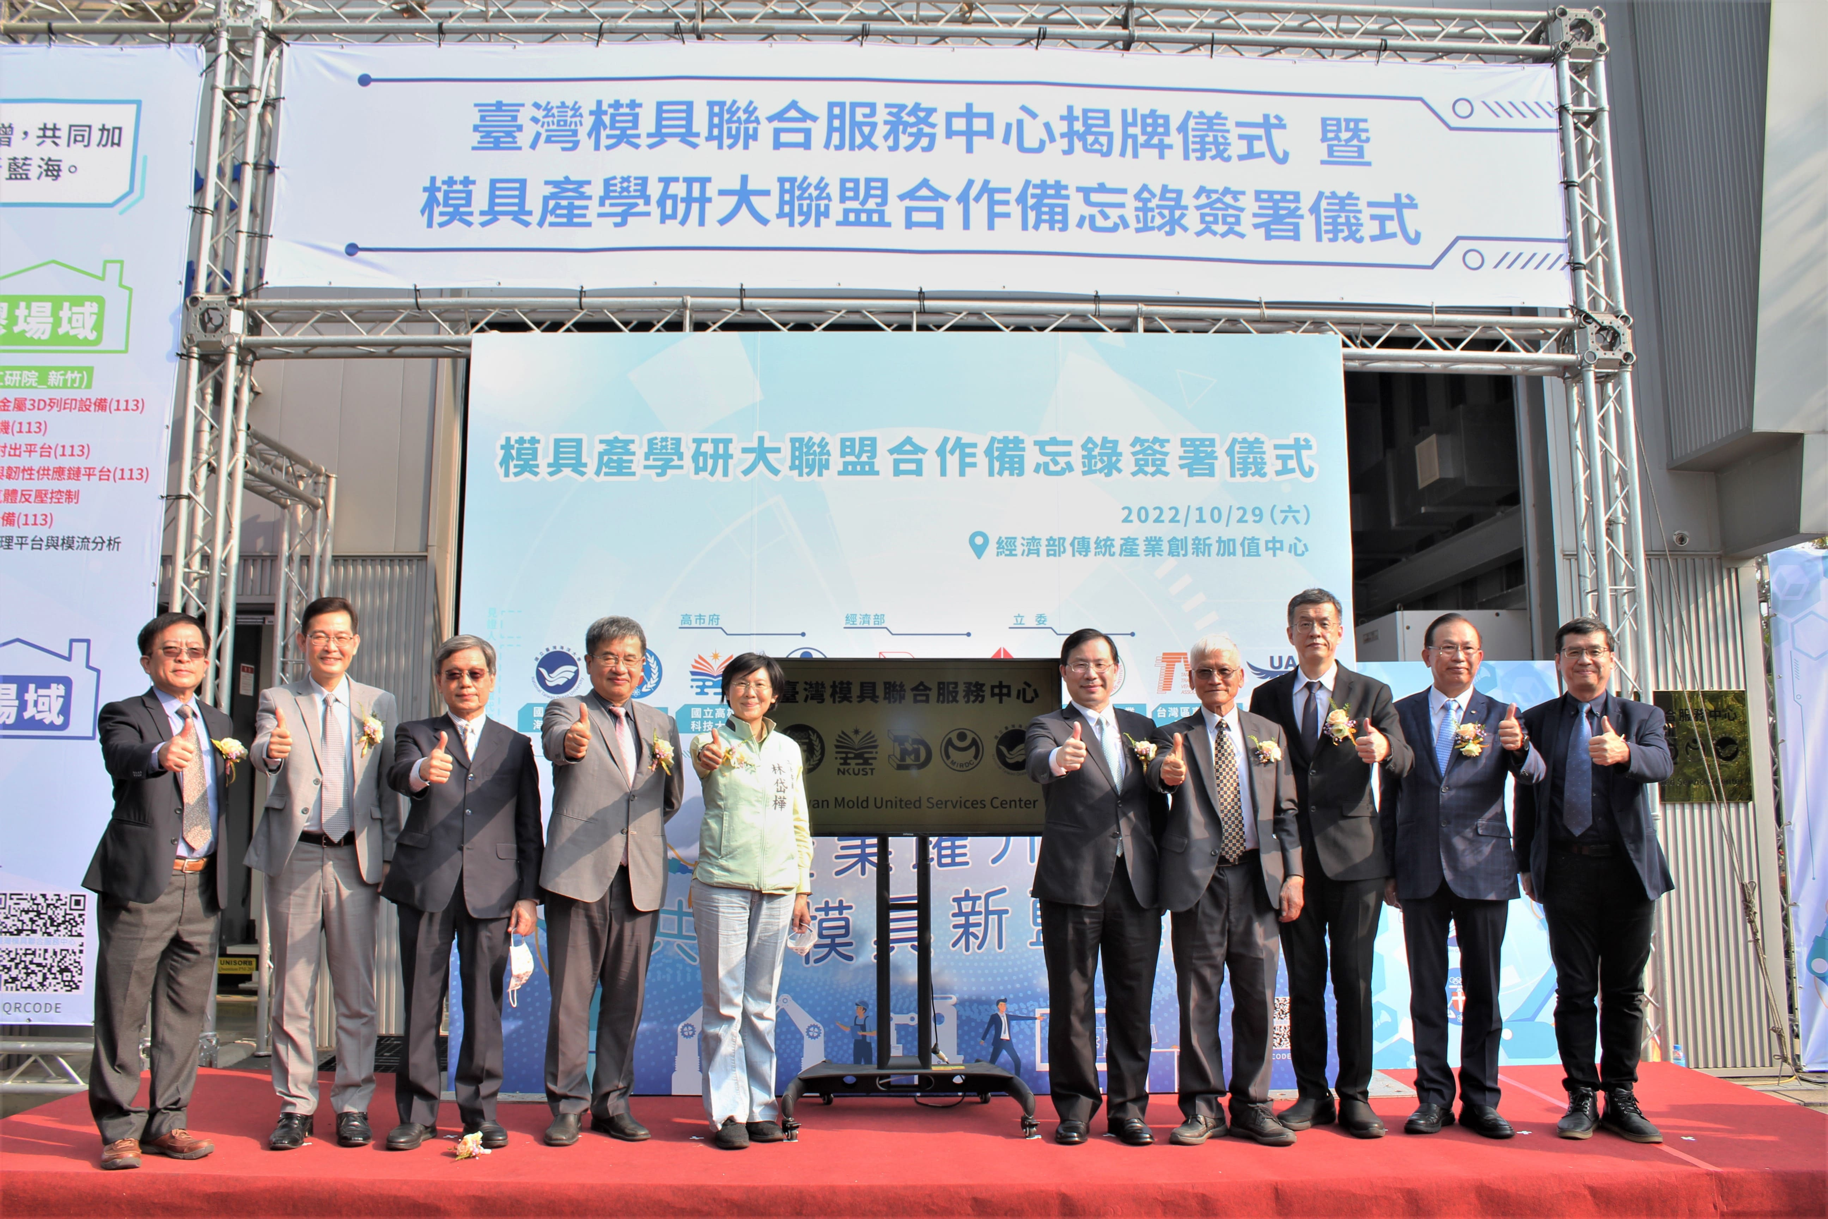

Photo 2: Group photo of VIPs participating in the unveiling ceremony of Taiwan Mold and Die Joint Service Centre (from left to right of Metal Industries Research & Development Centre, Lin Chih-Lung, the acting president of MIRDC; Chief Secretary of Chung Yuan Christian University,
Yen Kang-Tsung; Professor at National Taiwan Ocean University, Chuang Shui-Wang; Chancellor of National Kaohsiung University of Science and Technology, Yang Ching-Yu; Legislator, Lin Tai-Hua; Vice Minister of Ministry Economic Affairs, Lin Chuan-Neng; President of Metal Industries Research & Development Centre, Lin Ren-I; Section Chief of Industrial Development Bureau, Lin Hua-Yu; Chairman of Mold & Die Industry Association, Cheng Kun-Mu; Deputy Director-General of Kaohsiung City Economic Development Bureau, Kao Chen-Yuan)
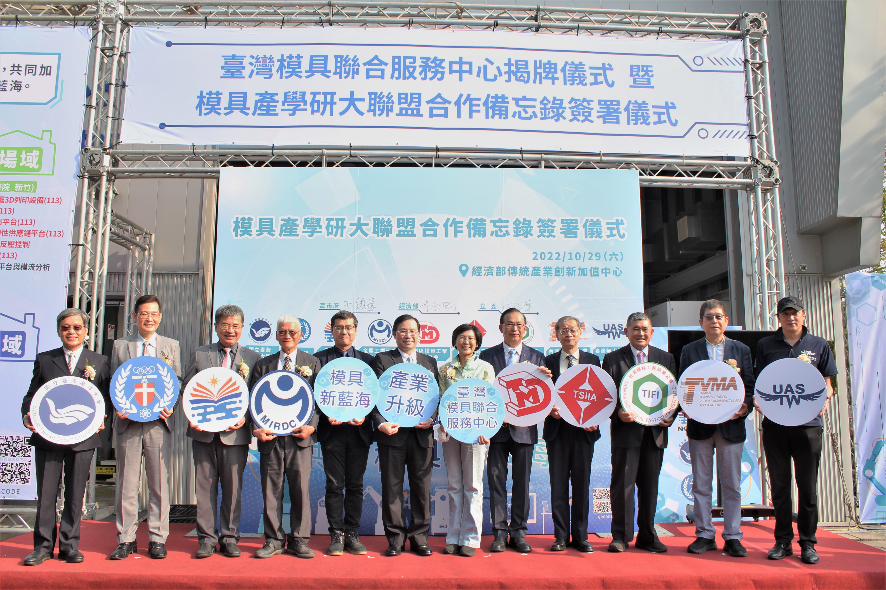

Photo 3: Group photo of VIPs participating in the signing ceremony of MOU on Mold and Die Industry-University-Institute Alliance (from left to right: Professor at National Taiwan
Ocean University, Chuang Shui-Wang; Chief Secretary of Chung Yuan Christian University, Yen Kang-Tsung; Chancellor of National Kaohsiung University of Science and Technology, Yang Ching-Yu; President of Metal Industries Research & Development Centre, Lin Ren-I; Deputy Director-General of Kaohsiung City Economic Development Bureau, Kao Chen-Yuan; Vice Minister of the Ministry Economic Affairs, Lin Chuan-Neng; Legislator, Lin Tai-Hua; Chairman of Mold & Die Industry Association, Cheng Kun-Mu; Managing Director of Steel & Iron Industries Association, Wang Hsi-Chin; Chairman of Industrial Fasteners Institute, Tsai Tu-Chin; Deputy Secretary-General of Transportation Vehicle Manufacturers Association, Wu Chih-Kuei; Chairman of Unmanned Aircraft Systems Association, Chang Yang)

