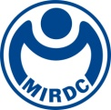
NEWS LETTER
Digital Transformation in Kaohsiung Curtain Industry, and
MIRDC promotes featured industrial chain clusters in Ho Fa Industrial Park

Metal Industries Research & Development Centre (MIRDC) hosted “Metal Curtain Industry Achievement Presentation” in Ho Fa Industrial Park, Kaohsiung the other day. Traditional manufacturers for aluminum doors and windows from all over Taiwan as well as companies engaging with curtain design and production were invited to participate in the event. Deputy Mayor of Kaohsiung City, Lo Ta-Sheng, also visited the event and recognized development from central resources supporting industrial promotion to local implementation. Besides, Legislator of Kaohsiung City, Lin Tai-Hua, who also attended the event, pointed out that the important principle of deepening service industry is to actively strive for central resources to support the transformation of local featured traditional industries as well as effectively implement resources and policies through the collaboration between central and local governments.

President of MIRDC, Lin Ren Yi Lin, expressed in his speech that metal curtain industry stretches over the architecture industry and metal manufacturing industry and can be used as an important subject to promote industrial upgrading and digital transformation. MIRDC worked with Kaohsiung Association of Aluminum Doors and Windows Management, Kaohsiung Glass Commercial Association, and Taiwan Corrugated Steel Industry Association for the activity this time. Besides, speakers with international perspective, including General Manager of PKD Engineering Consultants, Chen Yu-Chieh; General Manager of Bright Curtain Metal Co., Ltd., Tai Hsin-Jung; General Manager of Kao Chuan Tswen Enterprise Co., Ltd., Chien Tien-Pao; General Manager of Ching Chyau Co., Ltd., Chang Chien Ching-Ching, and General Manager of Solara Enterprises Ltd., Su Chien-Yin, were invited to share and exchange the results as well as arranged field trip to the factory. All the 150 guests who participated in the event and enjoyed the abundant knowledge related to technology and industry.

MIRDC undertakes “University and Institute Double Engines Promoting Local Industry Technology-Added Innovative Program,” a technology project from Department of Technology, Ministry of Economic Affairs. It focuses on the curtain featured industry clusters in Kaohsiung City and adopts digital transformation and upgrading as the key strategy. Industrial clusters of Wan (Da), Da (Fa), and (Ho) Fa industrial parks within a radius of 3.5 kilometers form a one-stop industrial chain and ecological supporting system from upstream materials, metal forming, surface treatment, machining to assembly testing. Since 2021, MIRDC has been supported by Department of Technology, Ministry of Economic Affairs, and Kaohsiung City, in developing innovative forming technology without mold through digital simulation analysis and comparison. It provides special-shaped surface precise connecting function and main body structure support to complete the unit of curtain in special shape as well as assist better presentation of the performance of metal curtain industry in Kaohsiung.

In response to the issue of energy saving and carbon reduction, the energy saving & thermal insulation and aluminum recycling in the door and window curtain industry will be a key of development in the industry in the future. In addition, MIRDC also works with Kaohsiung Association of Aluminum Doors and Windows Management for planning relevant testing and verification service proposals so that government can cooperate with the demand in the industry and invest relevant resources. It is anticipated it can be continuous expanding and extending to promote a better future and industry outlook for local door and window curtain industry in Kaohsiung.

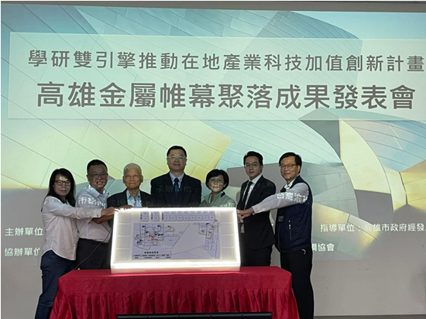

Fig1, Group photo with guests (from left to right: Director of Ho Fa Industrial Park, Chang Ho-I; General Manager of Kao Chuan Tswen Enterprise Co., Ltd., Chien Tien-Pao; President of Metal Industries Research & Development Centre, Lin Ren-Yi; Deputy Mayor of Kaohsiung City, Lo Ta-Sheng; Legislator of Kaohsiung City, Lin Tai-Hua; Director-General of Economic Development Bureau, Liao Tai-Hsiang; Director of Metal Industries Research & Development Centre, Lin Lieh-Chuan)

