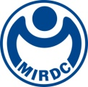
新聞資料NEWS LETTER
MIRDC's elites and their technologies shine internationally

The winners of the 8th MIRDC Elite Awards of 2022 have been announced. The award selects internal elites through every year's competition. This year, 4 groups and 7 individuals have won this honor, and the award ceremony was held on October 24th . Ren Yi Lin, the chairman of the board, affirmed the dedication of each winner and the team to the deepening of technology and the promotion of the industry and encouraged MIRDC colleagues to continue to develop and innovate to become heroes behind the scenes in many different sectors and shine on the international stage.

Excellent elites and capable talents represent a positive image of a company as well as decide the future development of the company. The MIRDC Elite Awards select the role models of the year, showing the organization's people-oriented research and development core. MIRDC selected internal elites through the awards, covering three categories which include R&D technology, industry guidance, and administrative services and so on. It is particularly worth mentioning that this year MIRDC invited Mei Yue He, the national policy advisor to the Taiwan president, and Sun Yat-sen University professor Professor Hung Tun Yang from National Sun Yat-sen University to be judges. And both gave high recognition and encouragement to the winning groups and individuals.

In terms of the technical achievement award, Micro gear by heat treatment technology drives Tesla's developed by the Micro/ Meso Mechanical Manufacturing R&D Department won the award. This technology also won the 2021 R&D 100 Awards and successfully enhanced Taiwan's industrial technology international status. In terms of industry pilot awards, the Intelligence and System R&D Department developed tasty and healthy tapioca balls that successfully assisted technology transfer manufacturers. It also started the construction of the whole jelly sphere plant and the whole line. The addition of a turnover of more than 40 million NT dollars and the investment of more than 100 million NT dollars domestically by manufacturers are receiving orders one after another. In addition, "MIRDC medical energy takes the lead in helping fight the epidemic" developed by the Medical Devices R&D Service Department, dental medical groups. assisted in establishing dental demonstration clinics, chains, and flagship as a system of various dental groups, triggering business opportunities through clinical trials to trigger actual purchases through word-of-mouth introductions.

It is worth mentioning that MIRDC has also received outstanding international honors this year. Continuous Tracking Surgical Assistance System of Smart Orthopedic Surgery Assistance System, Corrosion-Resistant, Surface Hardening System Equipment for Austenite Stainless Steel and 4D (3D+Dissimilar) Printed of Solid State Process won the R&D 100 Awards. In addition to being the world’s first Continuous Tracking Surgical Assistance System, has also won the product design awards of German Reddot awards. Also, the other international honor Renewable Polymorphic Transition Materials (Poly-T Materials) won the Edison Awards, known as the Oscars of Innovation.

The chairman of the board from MIRDC, Ren Yi Lin stated that innovation is people-oriented. MIRDC continuously invests in elite talents in R&D technology. It is hoped that the MIRDC employee will continue to enhance their R&D capabilities, work hard for the industry, show better research results, and help enhance Taiwan's international competitiveness.

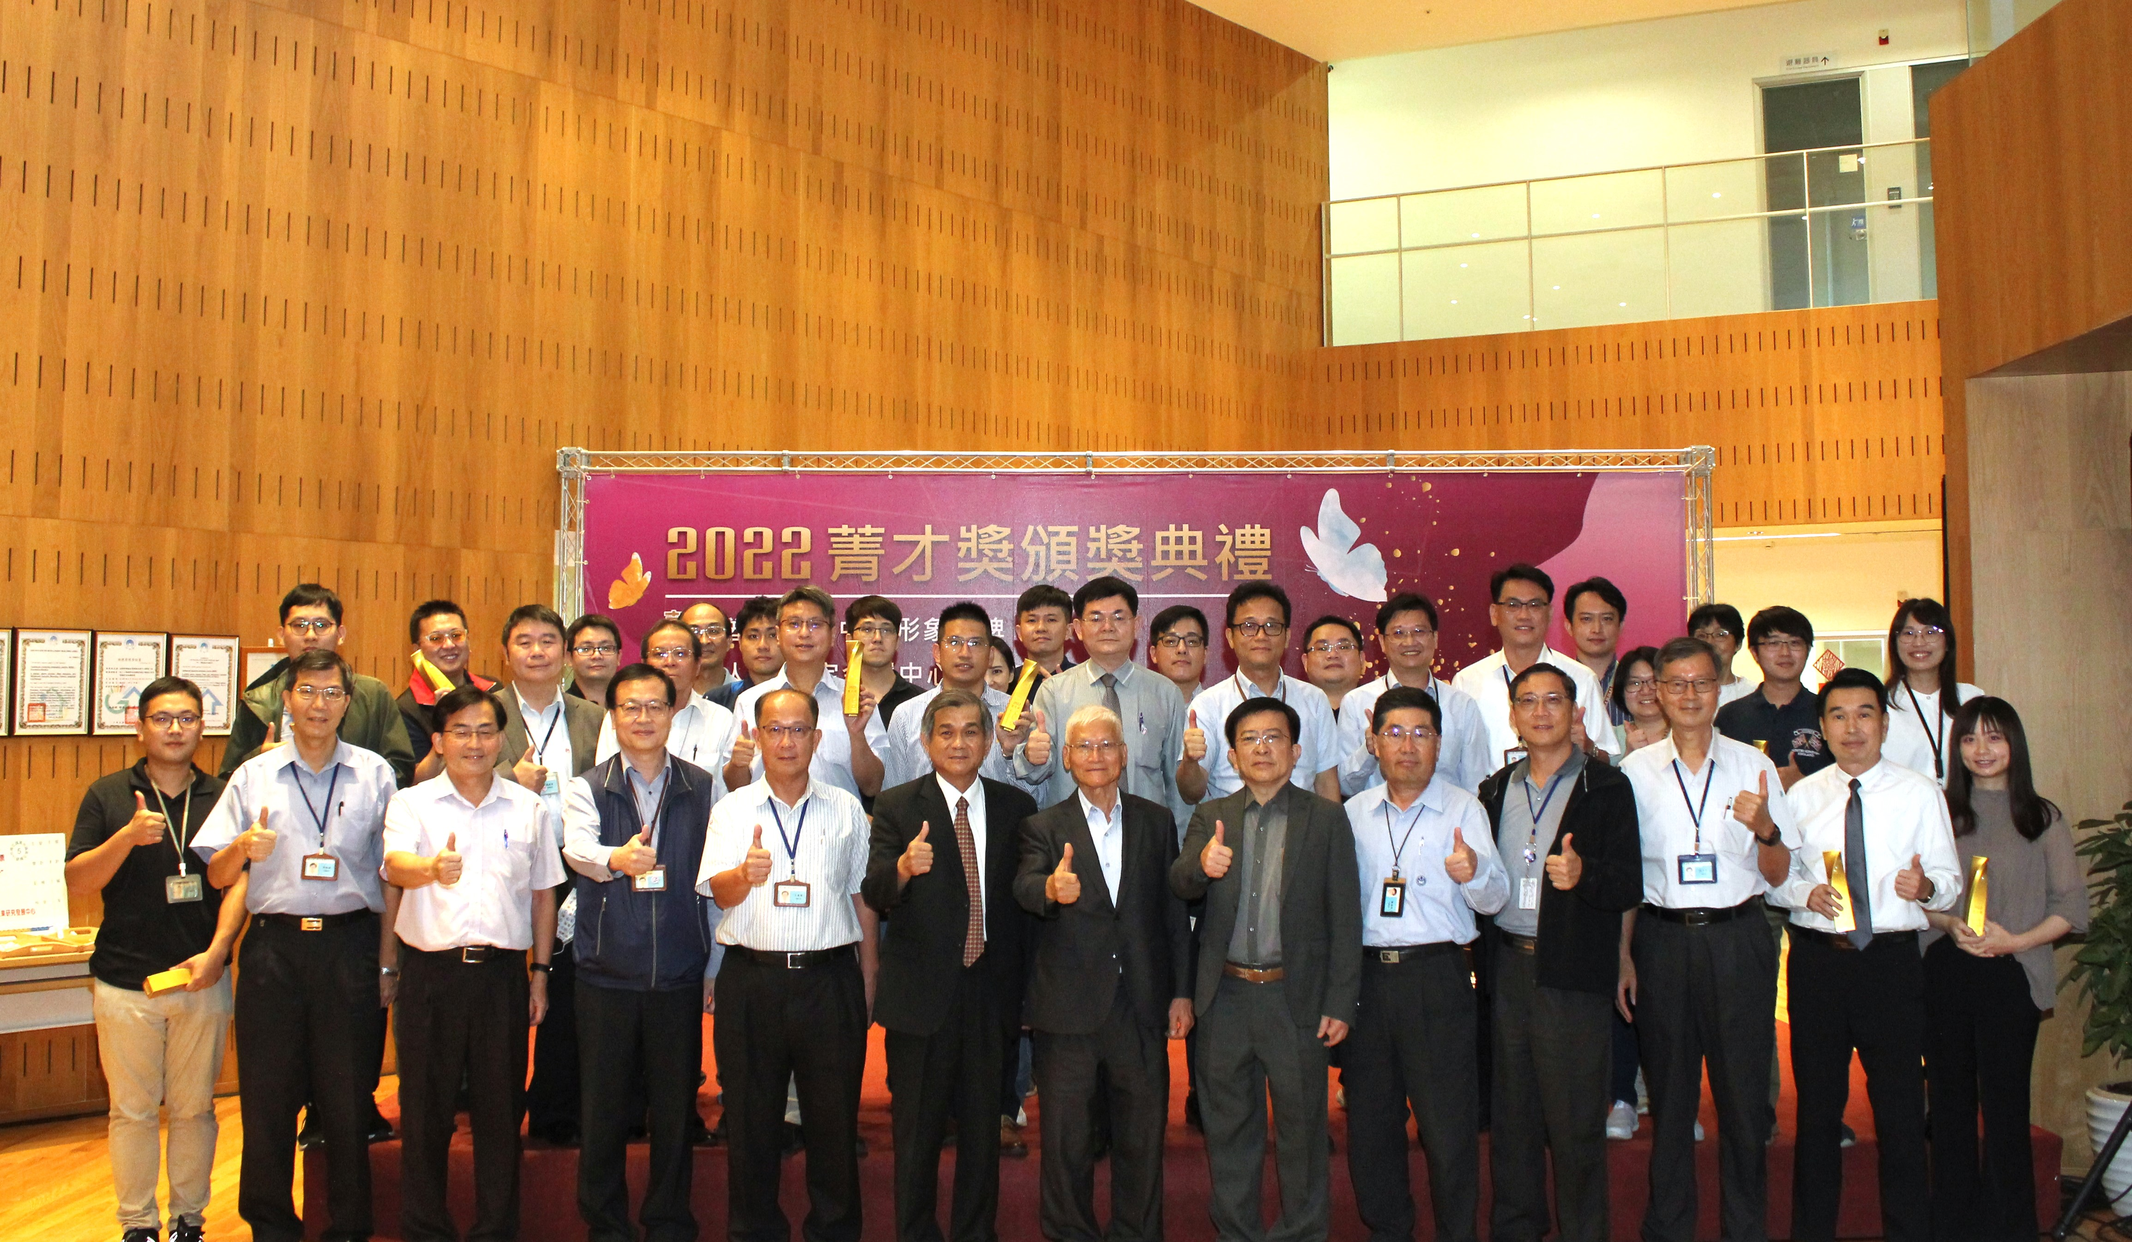

Fig1. The winners of the 8th MIRDC Elite Awards of 2022 had a group photo taken with
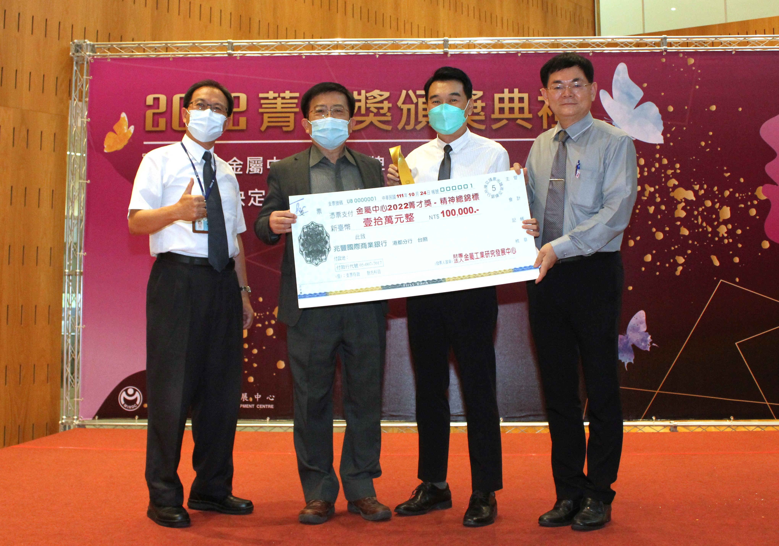
Professor Hung Tun Yang (Sixth from left to right in first row) from National Sun Yat-sen University, chairman Ren Yi Lin, and the acting president Chih Lung Lin from MIRDC.

Fig2. The winner of honor in Enthusiasm this year, Service Innovation and Development Department.

