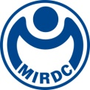 | NEWS LETTER

Hsinchu Science Park forms a group to march toward the EU to win global opportunities for medical devices after the epidemic

To help Hsinchu Science Park’s medical device companies develop the market, MIRDC was appointed to help organize a visit to the European Union. Led by Shu-Zhu Chen, the Deputy Director-General of Hsinchu Science Park Bureau (HSPB), National Science and Technology Council, nine medical equipment companies of Hsinchu Science Park will make their visit to the European Union on November 8th, 2022 for market development. They will visit enterprises and healthcare institutions in Denmark and Germany to conduct future collaborations and exchanges and participate in MEDICA, the world’s largest trade fair for medical equipment, from November 14th to the 17th to showcase medical devices and introduce products to the European market.

The European Union is the second largest medical device market in the world. MEDICA, the world’s largest and most iconic medical device exhibition, is held every November in Dusseldorf, Germany. It is the best platform for exchanges between healthcare institutions, enterprises, and government organizations around the world. As the COVID-19 pandemic is gradually slowing down, countries are relaxing border controls. To help Hsinchu Science Park’s companies seize opportunities in the post-pandemic era, HSPB organized this event to promote international exchanges and connect with business opportunities. HSPB appointed MIRDC to plan the event and will lead nine extraordinary medical device companies; BROADSIMS Inc., Insight Medical Solutions Inc., Instant NanoBiosensors Co., Ltd., S&T BioMed Co., Ltd., Energy Resources International Co., Ltd., Sangtech Lab Inc., V5 Technologies Co., Ltd., North-vision Tech Inc., and AeproMED Innovation Corp., Ltd.; in setting up the Hsinchu Science Park Pavilion at MEDICA 2022. The pavilion’s theme will be precision health and the latest products and technologies will be showcased to seek opportunities to exchange with global companies and distributors.

Acting President Chih-Lung Lin of MIRDC pointed out that precision healthcare and senior care are global healthcare trends. The medical device industry of Hsinchu Science Park is strong in cross-domain technologies including semiconductors, optoelectronics, AI, and ICT, and the park is Taiwan’s key Bio-ICT development site. Through this group trip to Europe will help the companies in the park to deepen global cooperation, accelerate the development of the European market and win big business opportunities in precision medicine and smart healthcare. Thus, in addition to exhibiting at MEDICA 2022, MIRDC has also planned visits to well-known healthcare institutions and enterprises in Denmark and Germany, such as the Sundhed.dk foundation in Denmark, Healthcare DENMARK, Medicon Valley in Sweden, the Asklepios Kliniken International in Germany, and The Fraunhofer-Gesellschaft, to promote exchanges and deepen cooperation with companies of Hsinchu Science Park.

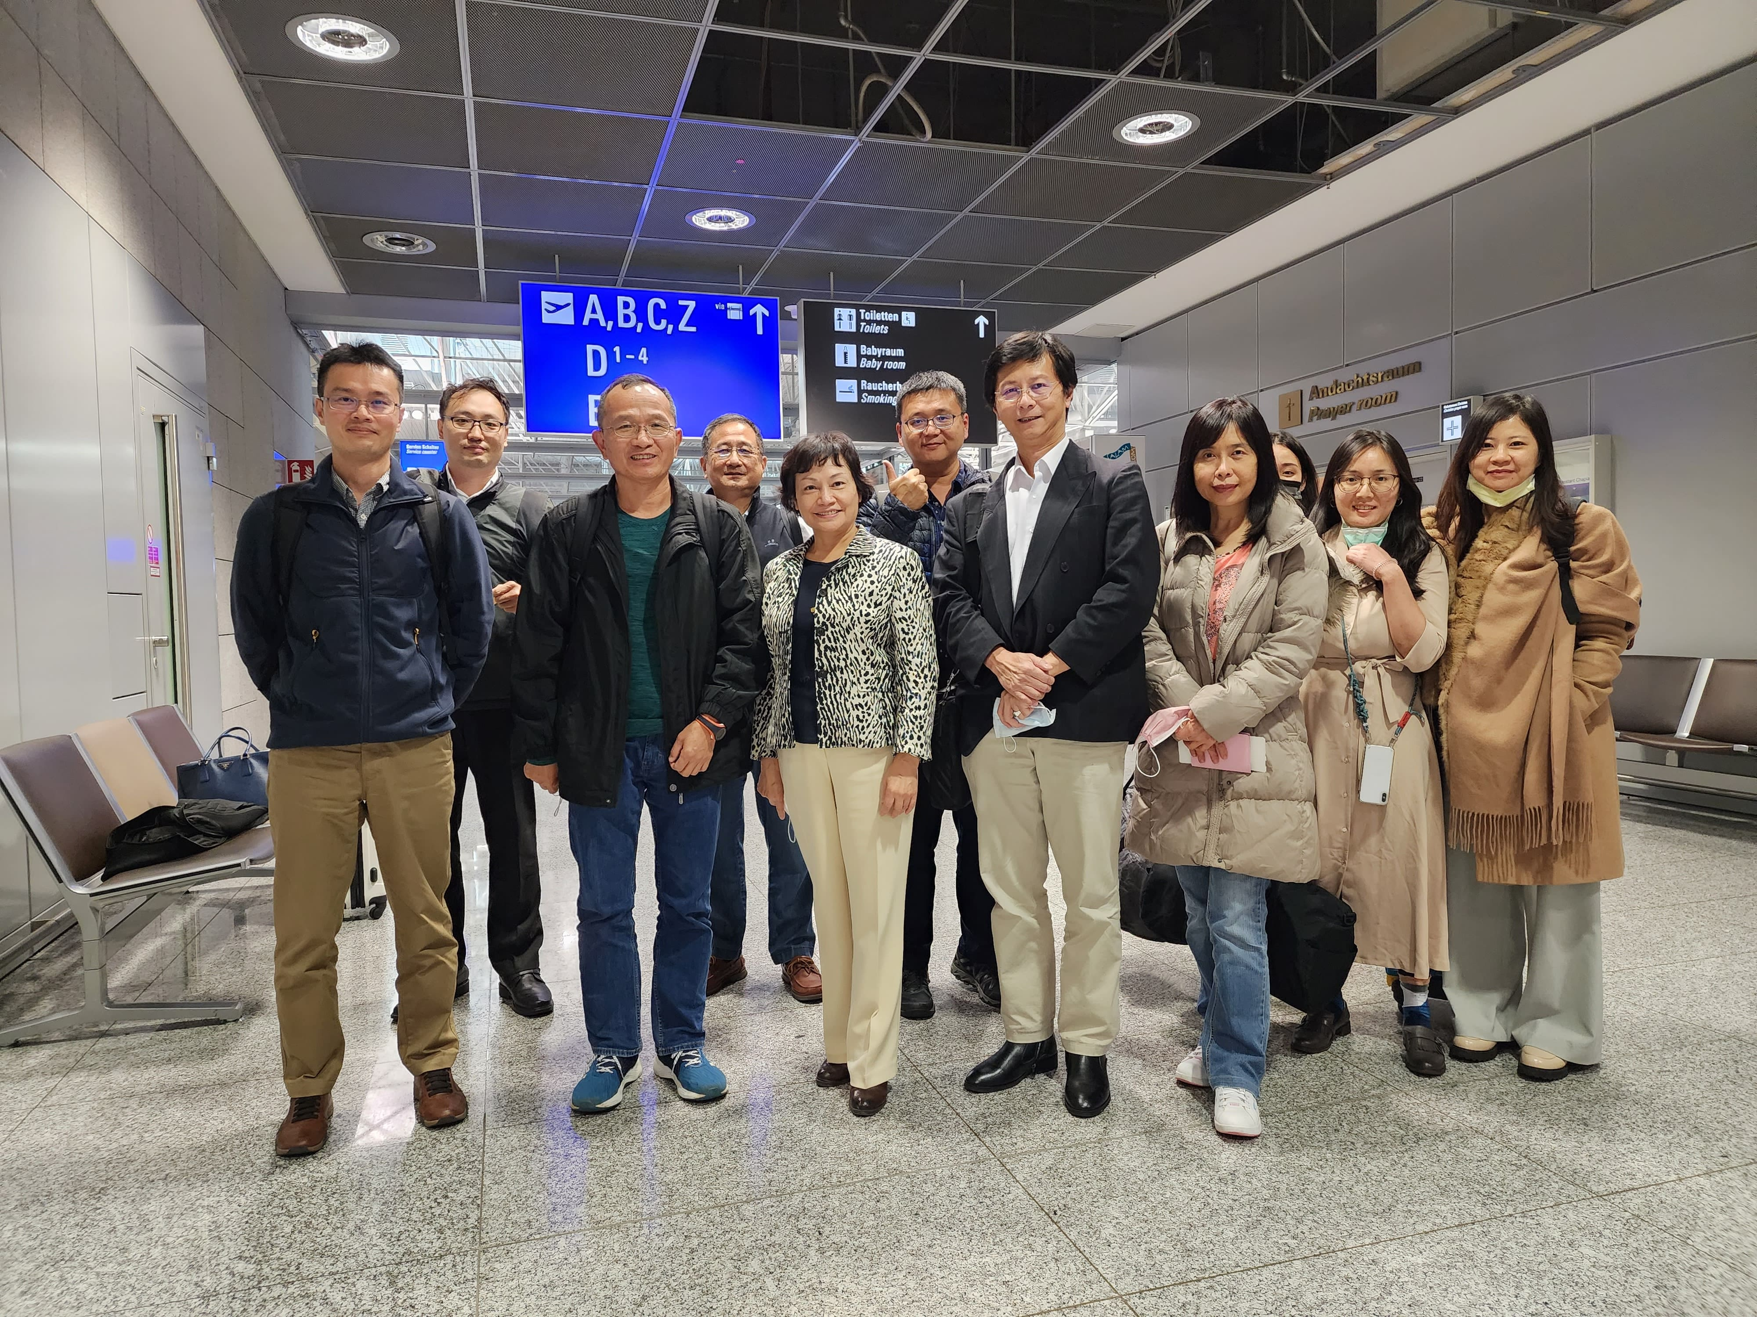
Caption: Led by Shu-Zhu Chen (front row, third from the left), Deputy Director-General of Hsinchu Science Park Bureau, National Science and Technology Council, the group is on its way to a connecting flight from Frankfurt to Copenhagen, Denmark to follow the itinerary for global exchanges and participate in MEDICA 2022 in Dusseldorf, Germany.

