
新聞資料NEWS LETTER
MIRDC showcased 18 technologies to attract visitors at the Sustainable Taiwan Expo 2022 this year

The Sustainable Taiwan Expo 2022 ended successfully at Kaohsiung Exhibition Center a few days ago (11/5). The opening day was kicked off with speeches by Shu Hsin Lai, the director of Taiwan Alliance for Sustainable Supply (TASS), and Ren Yi Lin, the Chairman of MIRDC was also invited to the opening ceremony. Facing 2050 carbon neutrality, and net zero as Taiwan has always played an important key role in the global supply chain, and we must actively carry out green and sustainable transformation from the policy and industry perspectives. This year's conference combines five major features with exhibitions, forums, and business matching activities for enterprises to find business opportunities. MIRDC focused on Advancing Net Zero & Redefining New Metal, emphasizing resource recycling and zero waste, and showing the Department of Industrial Technology (DoIT), Ministry of Economic Affairs several achievements in providing industry operators with complete solutions in the circular economy.

In recent years, the Department of Industrial Technology (DoIT) of the Ministry of Economic Affairs has actively promoted the recycling of aluminum materials. By enhancing the value of recycled aluminum metal products and entrusteding MIRDC to implement the "Technology development plan of circular aluminum innovative application process" and developed many innovative technologies, among which " 4D (3D+Dissimilar) Printed of Solid State Process" was awarded the 2022 R&D100 Awards. Friction stir welding technology is environmentally friendly processing with low energy consumption and no welding fumes. Combining the technology with numerical simulation analysis, not only replaces the traditional trial and error method but also accelerates the product development time process. Compared with traditional arc welding, and its carbon emission can be reduced by about 75 tons of CO2e/year. At present, the technology has been introduced into the 5G signal and electric vehicle industries to help the industry quickly respond to the development needs of new product structures to win orders from major international manufacturers.

In addition, when it comes to the process, the concept of green process is added to build aluminum alloy warm/hot forming technology. In response to the trend of lightweight vehicles and the demand for increased strength of aluminum alloys, the difficulty of forming has also increased. However, the domestic cold stamping process often faces poor formability. Since the sheet parts are easily broken, it requires repeated die adjustment or multiple passes and shapes to overcome this problem. The first domestic demonstration production line of aluminum alloy warm/hot forming reduces the secondary processing waste caused by the forming failureWhen facing aluminum alloy arts with complex curved surfaces can be integrally formed in a single pass and have the control of dimensional accuracy. In the future, it can help the industry to use it in aerospace and rail vehicles, showing a circular economy business model and high-value products.
The acting president of MIRDC, Chi Lung Lin stated that apply different proportions of waste oyster shells and waste stone materials, combined with temperature conversion and then converted into temperature-resistant oxides at high temperature, replacing the imported sand material that traditional casting used.

Also, the thermal cracking of oxides in water solves the technical gap that is difficult to remove with traditional shell mold. Combining the characteristics of this material with 3D printing, it is used for marine coral restoration to replace the current plastic, glass fiber, and ceramic bases. Since it is similar to corals (both calcium carbonate), it accelerates the attachment of symbiodinium on the seabed and promotes the growth of coral polyps. The restoration of corals is in a very good state. Now, in cooperation with the National Museum of Marine Science & Technology and the Taiwan Eco-Angel Environmental Conservation Association, a batch of restoration results has been implemented on the north coast of Keelung, which is estimated to save nearly 6 billion in waste disposal costs every year, and create nearly 15 billion new material application business opportunities every year, and contribute to environmental protection.
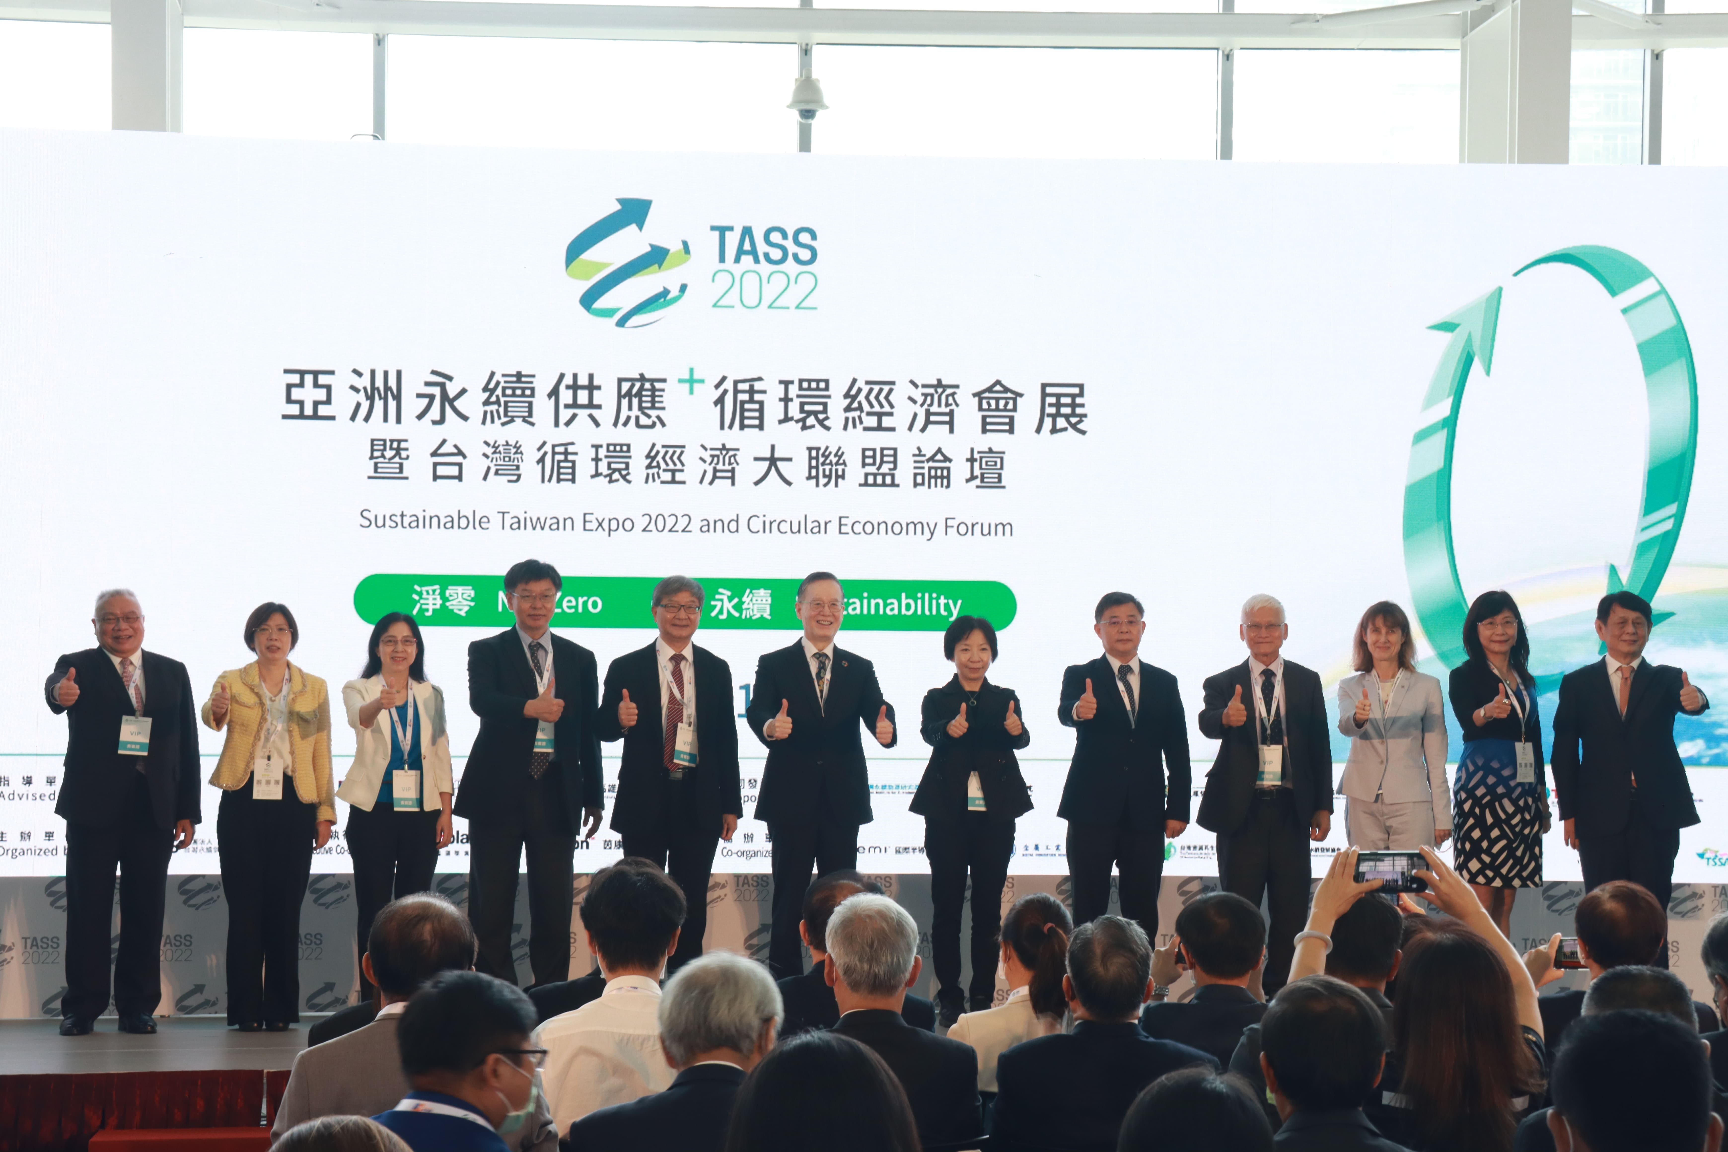

Fig 1, VIPs from different business fields attended the opening ceremony of the Sustainable Taiwan Expo 2022.

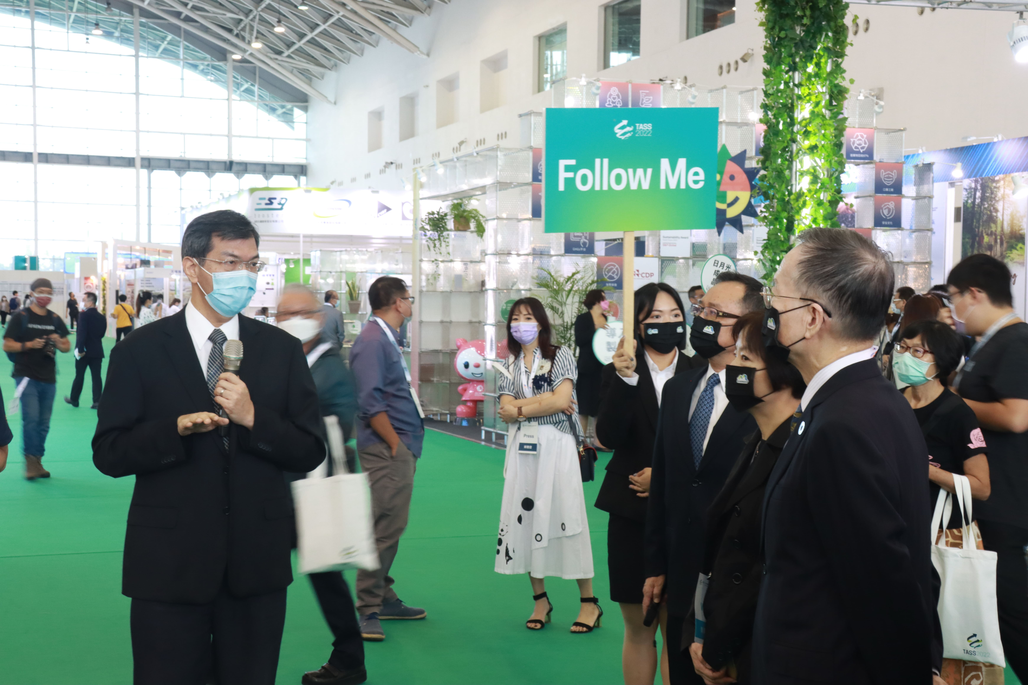

Fig 2, Ping Kuo Cheng, the director of the Metal Processing R&D Department, MIRDC
guided a tour of MIRDC’s R&D achievements.

