
新聞資料NEWS LETTER
Through grasping the real-time supply and demand of base metals would help the stable operation of the domestic market

Since 2021, global base metal prices have fluctuated. This year, including the Russia-Ukraine war that shocked the world and the interest rate hikes in major economies affecting the world, had an impact on the operation and order of the metal market. It is helpful to grasp a real-time supply and demand situation of base metals and assist the industry. On the 19th of October, 2022, the Industrial Development Bureau (IDB), Ministry of Economic Affairs (MOEA), and Metal Industries Research and Development Centre (MIRDC) jointly held the current situation and the results presentation of the future trend of base metal supply and demand in 2022. Through this event, hoping many would join together with the industry to understand better the supply and demand, price, and industry pulse of base metal to promote the steady development of the industry.

To help the industry grasp a real-time supply and demand situation of base metals and take appropriate measures in advance, IDB has promoted the plan of the development monitoring of the domestic base metal supply and demand situation since 2021. This plan focuses on six strategic metals, including steel, stainless steel, aluminum, copper, nickel, and titanium, and has continuously observed the development of supply, demand, quantity, and price of the above metals. Integrate the analysis of domestic and foreign market demand and the overall economy, and then study the import and export volume of various metals and the trend of price changes in different regions. Collecting different opinions from the experts to analyze the future volume trend and price and the impact on the possibility of the industry in the short term would be helpful. Expanding services to the industry, it is also strongly recommended to send regularly relevant research results to the 19 associations of domestic trade as well as the members to help support the stable development of Taiwan's industries.

A total of 96 participants made this event active. Wei Ting Chen from the administration Department of China Steel Corporation (CSC) and MIRDC's industry analyst to share the current status of metal supply and demand and the industrial and future prospects. Wei Ting Chen, the representative of the administration department, CSC, kicked off the event by sharing the current status of the internal and international steel market. The topic of stainless steel mainly focused on the trend of carbon reduction, transformation, and layout, as well as the impact of CPTPP on Taiwan's stainless steel and its suggestions. The topic for nickel metal is to discuss the impact of nickel trading liquidity and the development of electric vehicles on the nickel market. Issues related to the aluminum industry, the relevant experts analyzed the supply and demand price of aluminum, the low-carbon transformation of the aluminum industry in sharing the domestic market conditions, and the progress and impact of carbon tariff policies. The topics related to copper focused on the supply and demand pulse of the copper industry at home and abroad, as well as the development trend of low-carbon transformation of the industry. Finally, the topic of titanium was spoken by the relevant experts on the industrial value chain and domestic and foreign supply and demand.

In the face of such a rapidly changing industrial environment, grasping future trends and pulses can help stand out in the industry. In the future, MIRDC will continue to monitor the development of supply, demand, volume, and the price of the metals and help the industry to grasp the real-time supply and demand situation. Let's hope that providing metal supply, demand, and price information will benefit manufacturers to make early deployment and proper response and help maintain market stability and operation in Taiwan. Those interested in the development monitoring platform of Taiwan base metal supply and demand are more than welcome to contact MIRDC Ms. Wu at 07-3513121#2380 for more details.

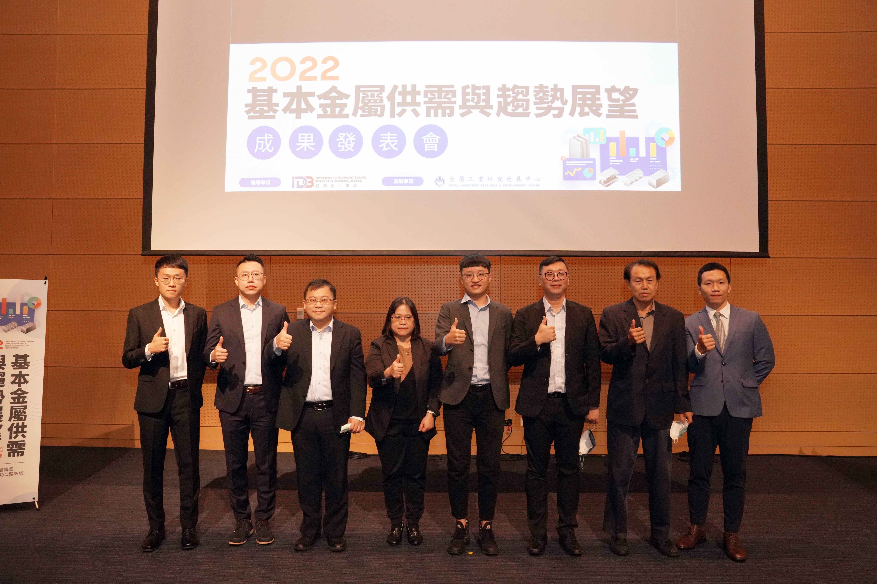

Fig1, Wei Ting Chen (third from the left)
from the administration Department of China Steel Corporation, Sally Lee
(fourth from the left) from MIRDC and Tsung Yen Tsai from the Industrial Development Bureau of MOEA (fifth from the left) gathered together
with other honorable guests

