
新聞資料NEWS LETTER
Congratulations on MIRDC’s shine internationally, as there are 3 technologies developed at MIRDC that are among this year’s R&D 100 Award winners

Every year, the R&D 100 Awards, also known as Oscars of Innovation, pick up innovative technologies that can change the world and benefit the future from world-renowned industry-university-institute. This year, MIRDC stood out from thousands of participating technical works from all over the world, has won three awards directly, and was tied with national laboratories such as MIT Lincoln Laboratory, Lawrence Berkeley National Laboratory, Sandia National Laboratories, Oak Ridge National Laboratory, etc., not only deeply rooted in Taiwan the core capabilities and innovative energy of industrial development but have also established the international status and image of Taiwan's industrial science and technology.

The acting president of MIRDC, Chih Lung Lin, has pointed out that MIRDC’s 2022 R&D 100 winning technology, Smart Orthopedic Surgery System-Continuous Tracking Surgical Assistance System integrated optical 3D composite positioning, multi-vertebral image navigation system, and surgical assistance robotic arm. It can improve the existing surgical equipment and solve the problems of shadowing and poor accuracy caused by the large volume of the positioning target. This technology subverts the existing navigation software that treats the image model as a continuous rigid body. The multi-vertebral image navigation system can dynamically track more than three vertebrae, which means each vertebra can be positioned independently. Even if the patient changes their positions, the displacement of each vertebra is corrected in real-time. And the real-time information on the actual situation of the spine is helpful for the surgical doctors during the operation. The Smart Orthopedic Surgery System assists physicians in achieving more precise, safer, and more efficient complex long spine surgery.

Austenite Stainless Steel is a widely used and corrosion-resistant metal material. However, the insufficient strength defect, deterioration of corrosion resistance, and insufficient mass production of stainless steel make it challenging to develop high-value-added products. Corrosion-Resistant, Surface Hardening System Equipment for Austenite Stainless Steel solves the processing problem of stainless-steel materials and provide an intelligent continuous corrosion resistance and hardening process, so that the objects have high hardness and high resistance at the same time, and it can process objects of complex shapes straight away and provide innovative solutions for the stainless-steel industry. Precision components such as optoelectronic semiconductors, machine tools, aerospace, electric vehicles, medical equipment, food processing, chemicals, fasteners, and valves can apply the technology.
4D (3D+Dissimilar) Printed of Solid-State Process through pre-analyzing and dividing the product into multiple heterogeneous workpieces, and then using solid-state lamination to perform the process of dissimilar material joining and friction stir lamination. Made of different materials, the combined product not only reduces the thermal effect on the metal material, but also maintains the mechanical strength of the material. Compared with CNC processing, and the processing material can be reduced by 40%. Compared with expensive 3D electron beam or laser lamination equipment, and the cost can be reduced more than 80%. The innovative process of 3D shaping metal products provides low-cost 3D shapes while meeting various characteristics. It is ideal for manufacturing lightweight orbital satellite fuel tanks with both fuel compatibility and mechanical strength characteristics.

With the support of the Ministry of Economic Affairs, MIRDC implements the R&D achievements of the Department of Industrial Technology (DoIT), in Technology Development Programs to assist the government in enhancing research capabilities for industrial transformation and upgrading and promoting Taiwan's next-generation industries development. This year, three technologies have been recognized by the R&D 100 Awards. MIRDC will continue to make persistent efforts to promote the energy of R&D achievements to the world and leap to the world stage.

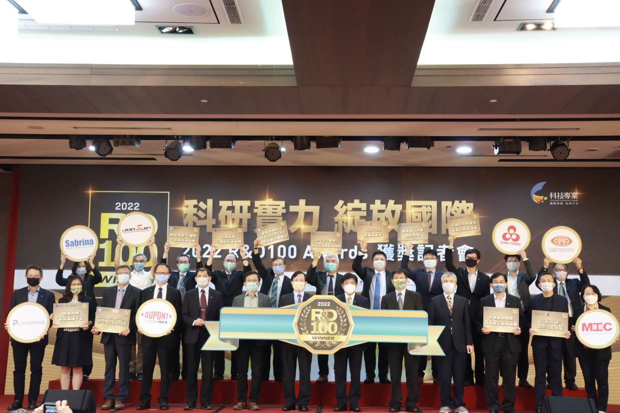

Fig1 One of the group photos was of the Vice Minister of the Ministry of Economic Affairs, Chuan Neng Lin, winning institutions, and the cooperative industries.
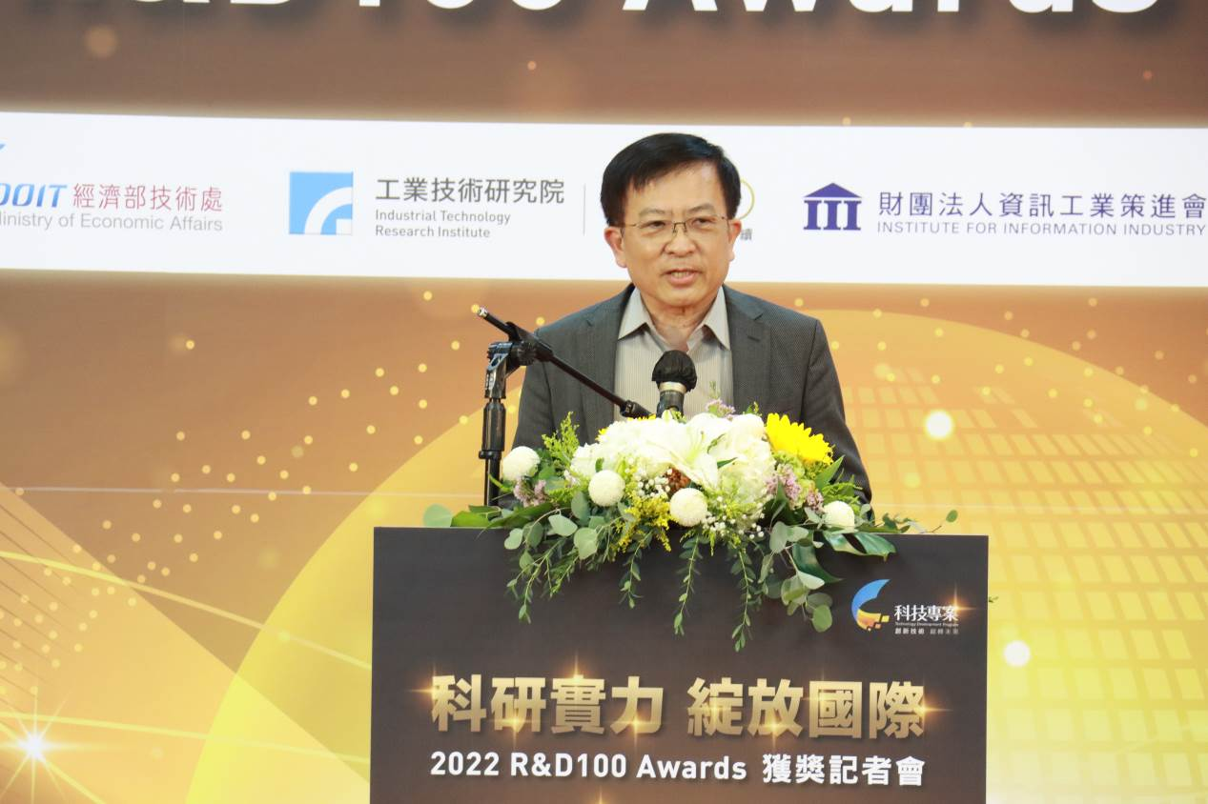

Fig2 The acting president of MIRDC, Chih Lung Lin was delivering his remarks.

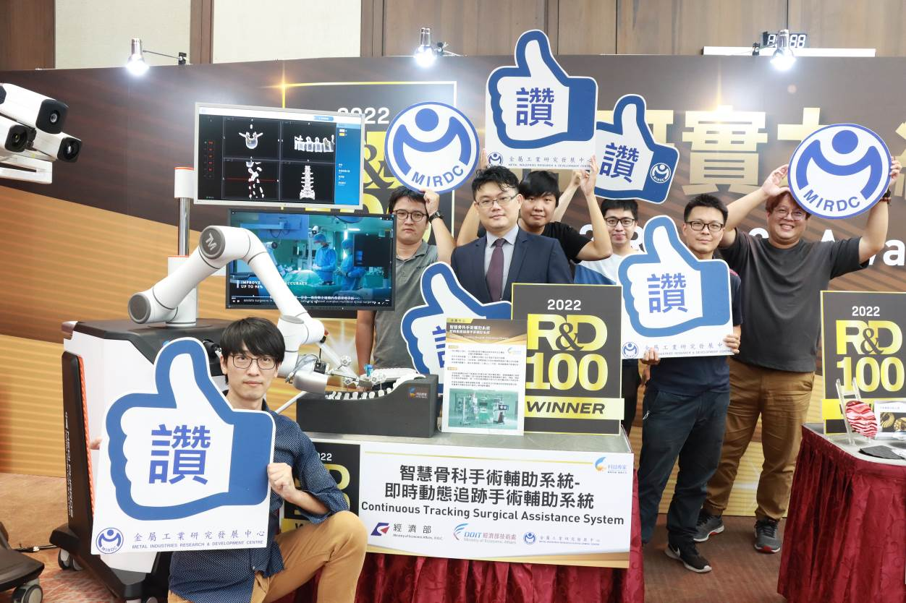

Fig3 Winning Technology, a photo of the winning team, Smart Orthopedic Surgery System-Continuous Tracking Surgical Assistance System
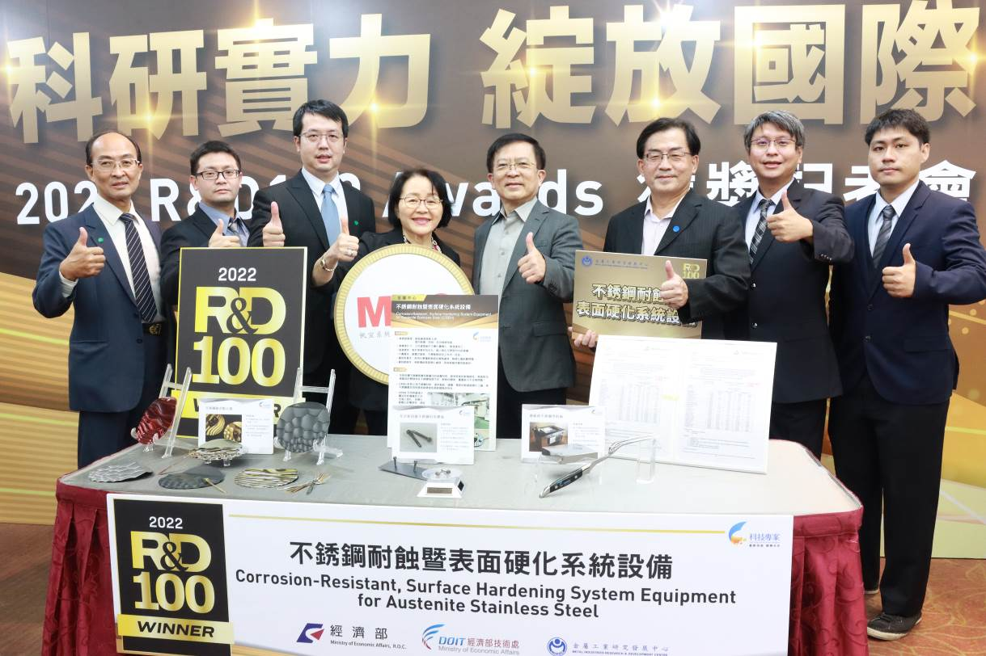

Fig4 Corrosion-Resistant, Surface Hardening System Equipment for Austenite Stainless Steel, the winning team took the photo with the Chairman, Hsin Ming Kao of Marketech International Corp.
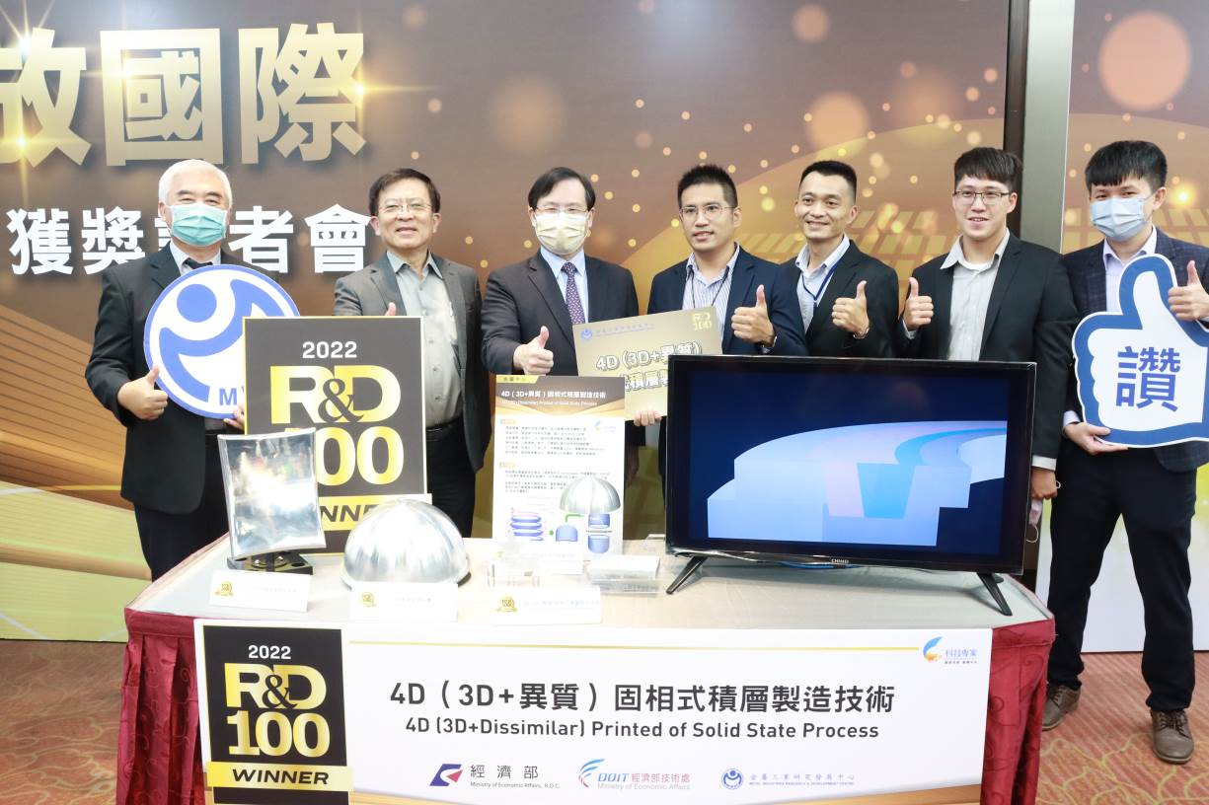

Fig5 4D (3D+Dissimilar) Printed of Solid-State Process, the winning team took the photo with the Vice Minister of the Ministry of Economic Affairs, Chuan Neng Lin.

