
新聞資料NEWS LETTER
2018台灣創新技術博覽會發明競賽
金屬中心奪最高榮譽鉑金獎！

2018台灣創新技術博覽會已於9月底在台北世貿一館完美落幕，金屬中心於會中展示『鞋底自動打粗系統』、『多椎節分割術前規劃軟體』、『無鉛易切削抗脫鋅黃銅材料』，特別是鞋底自動打粗系統吸引相當多的媒體採訪報導。而眾所矚目的發明競賽，總計20個國家、704件作品共同角逐，其中金屬中心『熱處理收料裝置』專利技術於眾多參賽作品中脫穎而出，勇奪最高榮譽鉑金獎！展現金屬中心前瞻創新技術與科技能量。

金屬中心研發全球首創之連續式精微熱處理設備，專門用於微小零件肉厚Ф2 mm以下的產品，可有效控制微小螺絲的焠火、回火速率，克服以往扣件廠商使用大型熱處理爐生產時，常發生微小螺絲扭力不足、脆化斷裂、品質不穩定等問題，更可依客戶需求進行熱處理程序的模組化設計並打造連續式精微熱處理產線，廣泛應用在微小探針、鏈條、齒輪、插銷、螺絲等精微零件，協助廠商提高3C元件產品良率，為扣件產業再創新藍海。

此外，金屬中心另一項專利『微波加熱乾燥裝置』也獲得銀牌獎，藉由專利設計將微波分布均勻化，免除傳統需藉由旋轉盤及擾動片來分散駐波能量方式，同時掌握微波設備設計製作量能，可開發各種客製化微波設備(如1.5米與60公分小幅寬連續式微波設備) ，不僅應用於工業上，未來可擴大到石化材料、金屬廢液回收等，加速綠色微波製程設備推廣與應用。

金屬中心長期深耕各項技術提升國內研發能量，促進關鍵零組件的國產化，協助國內業者布局全球市場，往後將提供更多元的解決方案與有感技術，以促進產業蓬勃發展！

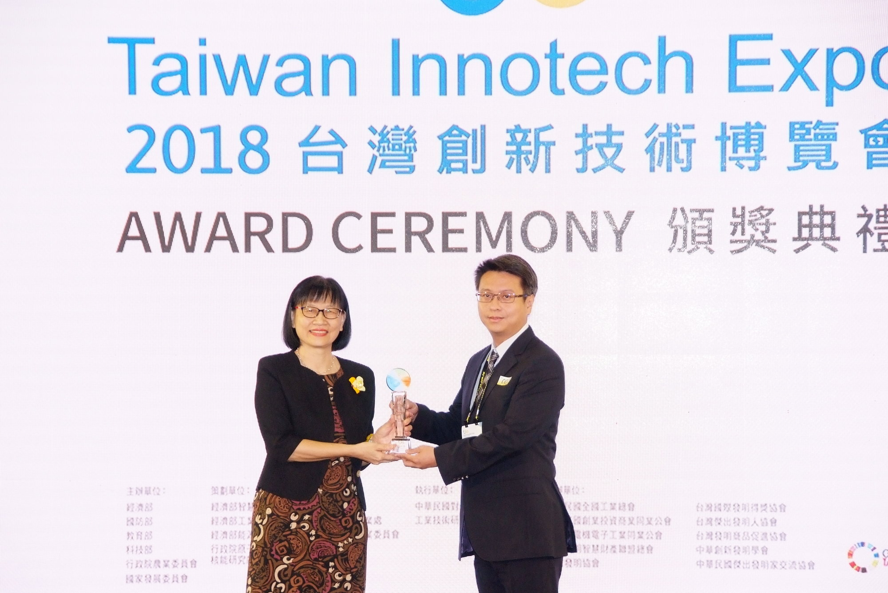

圖一：智慧財產局洪淑敏局長(左)親自頒發鉑金獎，並與『熱處理收料裝置』專利研發團隊代表(右)合影。

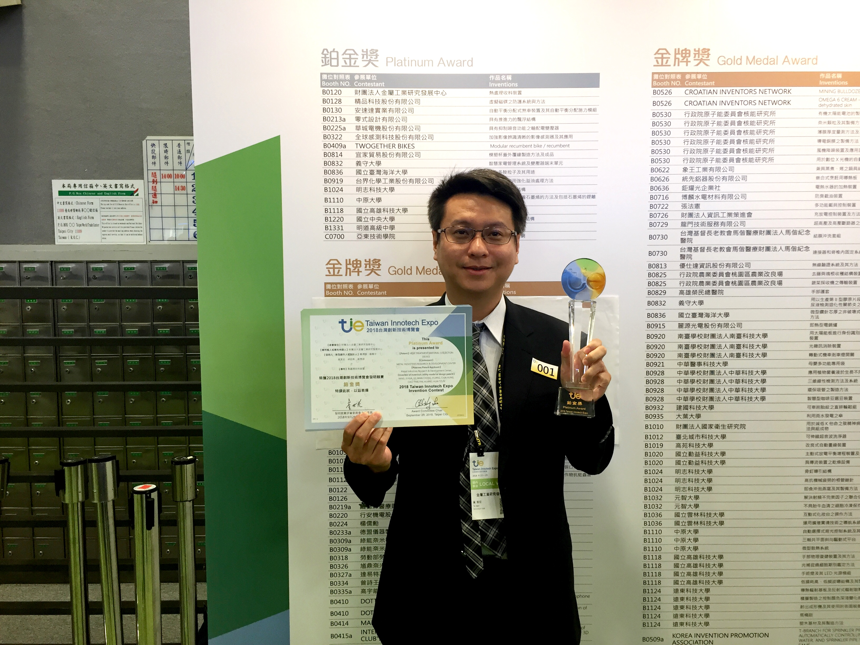

圖二：金屬中心『熱處理收料裝置』專利研發團隊勇奪最高榮譽「鉑金獎」。

NEWS LETTER
MIRDC won the Platinum Award in
2018 Taiwan Intotech Expo Invention Competition

2018 Taiwan Inotech Expo came into the perfect ending at Exhibition Hall 1 of Taipei World Trade Center in late September. In the Expo, MIRDC had exhibited “Automatic Identification of Shoe Roughing Equipment”, “Preoperative Planning Software of Tissue Segmentation”, and “Lead Free, Good Machinability and Dezincification Brass Materials”. The Automatic Identification of Shoe Roughing Equipment, in particular, attracts a large number of media. 704 works from 20 countries competed in the famous invention competition, and the utility model patent of “Heat Treatment Collection System” of MIRDC stood out from other works, winning the greatest honor of Platinum Award and showing the pioneering innovating technologies as well as technical capabilities of MIRDC.

The worldwide first consecutive precise heat treatment system invented by MIRDC is specifically designed for products with micro-components with thickness under Ф2 mm. It can effectively control the speed of quenching and tempering of micro-screws, and overcome their problems of insufficient torque, embrittlement, and unstable quality during production in large heat treatment furnace by fastener manufacturers. It can also conduct modular design of heat treatment process according to customers’ requirements, and establish consecutive precise heat treatment production line which is widely applied to micro-components, such as micro-probes, chains, gears, pins, screws, etc. The system is able to assist manufacturers in increasing product yield rate of 3C components, and paves a new path for fastener industry.

In addition, the “Microwave Heating Drying Device”, another patent of MIRDC, won the silver award as well. It homogenizes the distribution of microwave through patent design. The device exempts the traditional way of dispersing the standing wave energy by rotating the disk and the isolation blade. It also controls the microwave device design to generate energy for developing various customized microwave devices. The developed device not only applies to industries, but also extends to recycling of petrochemical materials and metal waste liquid in the future, accelerating the promotion and application of green-processed microwave devices.

MIRDC has been enhancing various technologies to increase R&D capabilities in the country, promoting localization of key components, and assisting domestic manufacturers in deploying global market. In the future, MIRDC will continue to provide more diverse resolutions and user-friendly technologies in order to facilitate the prosperous development of industries.

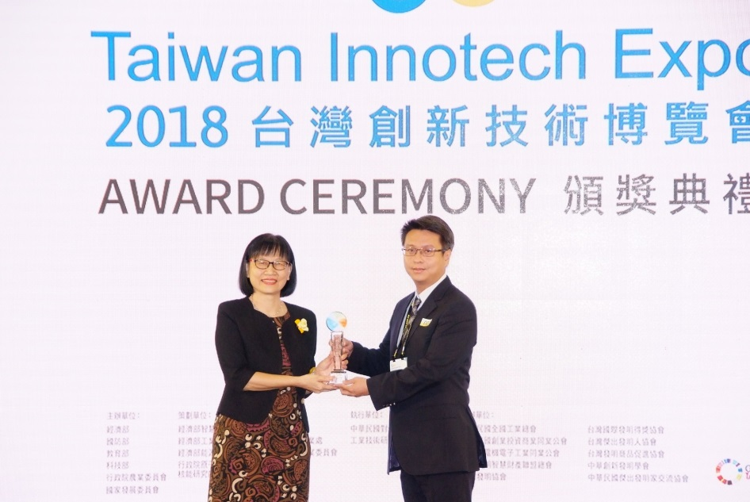

Fig. 1: Shu-Min Hong, Director General of Intellectual Property Office (Left), awarded the Platinum Award to the representative (right) of patent research team of “Heat Treatment Collection System”

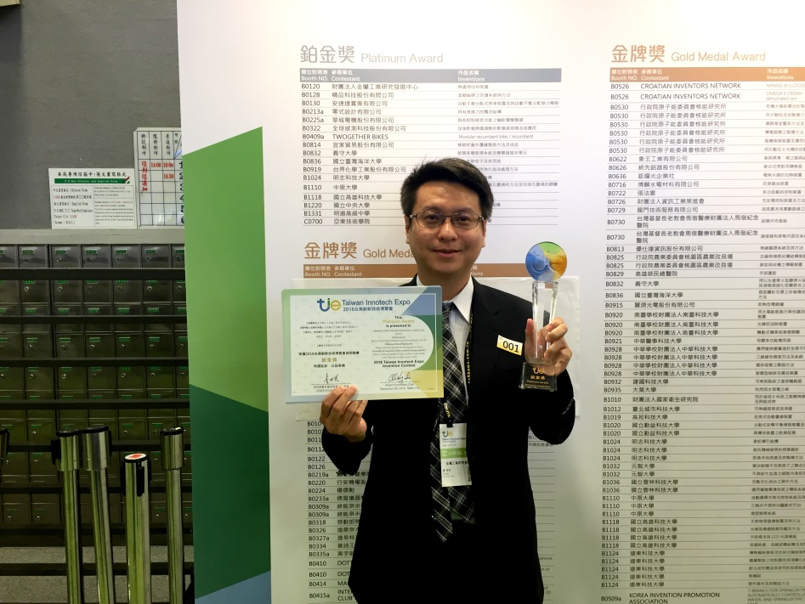

Fig. 2: Patent research team of “Heat Treatment Collection System” won the greatest honor of “Platinum Award”

