
NEWS LETTER
Take The First Look at the Highlight Technologies of MIRDC in Taipei Nangang Exhibition Center from 8/29 to 9/1

The 2018 Series of Asia Industry 4.0 and Intelligent Manufacturing Exhibition has been grandly opened on Aug. 29th with renowned manufacturers joining the exhibition. The exhibition includes “Taiwan Automation Intelligence and Robot Show (TAIROS)”, “International 3D Printing Exhibition”, and “International Mold and Mold Producing Equipment Exhibition”. There are 32 core technologies in total of MIRDC jointly exhibited in this great gathering. With professional explaining, consulting, MIRDC is willing to share their experience with visitors from all kinds of fields are welcomed in the exhibition.

In terms of automation intelligence, MIRDC has been committed to promoting automated identification gumming system for sole, and thus developed the 4th generation of high-efficient gumming device with double robotic arms, whose capacity is 180 pairs of shoes processing per hour. Through linear 3D scanner, the edge of 3D image or the pathway of certain area can be identified, and the motion pathway as well as posture of robotic arms of the sole gumming device will be generated automatically, reducing the defect rate of manual sole gumming. Such can open the way to a new age for the shoe manufacturing industries in Taiwan.

As for 3D printing, with the application of 3D printing sand casting technology, MIRDC originates the technology of sheet metal stamping die, overcoming the issues of long developing time and high costs for core stamping, and gaining advantages of integrated hollow core and ability for complex design are developed. The design of lightweight structure loading analysis is also integrated with the strength of no limitations for shapes of sand mold by 3D printing. MIRDC now assists other manufacturers in introducing the production line of mold of fuel tank mold, reducing one-third of developing time, half of costs, and weight of products by 40%. Such can earn the greatest profits for industries.

When it comes to mold and the producing equipment, MIRDC has also been promoting the technology of micro-device processing in the long run, and thus developed the customized composite micro-processing device, with the processing precision being 1μm, which can be applied to micro-components or molds. In addition, MIRDC initially develops the continuous micro-heat treating device, specifically used for products with micro-components whose thickness is under Ф2 mm. Such overcomes the issues of insufficient torsion, embrittlement, and unstable quality of micro screws, and increase the yield of 3C components, creating a new world for fastener industries.

In recent years, MIRDC has been counseling traditional industries in the country to break through technological challenges and move forward to high-value products. They can surpass the basic manufacturing and be committed to moving toward to intelligence through innovative technologies. MIRDC welcomes everyone from all different fields to join and feel the new results of scientific and technological achievements.

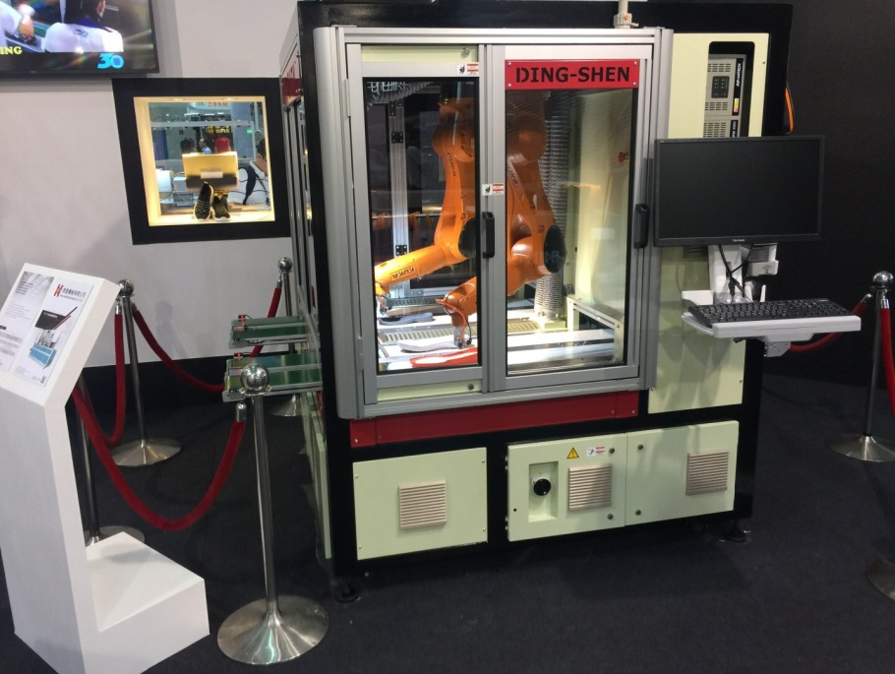

Fig. 1: High-Efficient Gumming Device with Double Robotic Arms

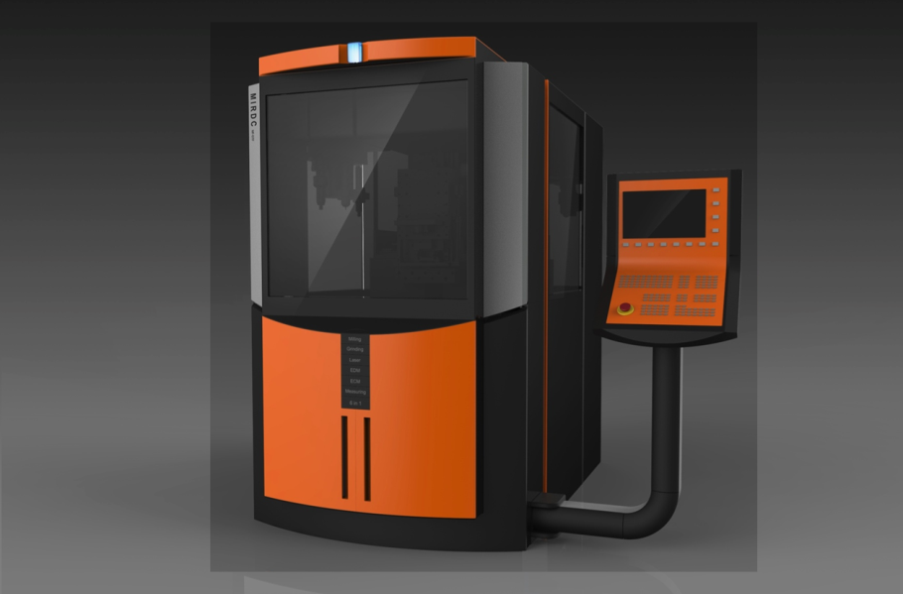

Fig. 2: CNC Composite Micro-Processing Device

