新聞資料NEWS LETTER

MIRDC extends its service capabilities by establishing the "Aerospace Science and Technology Industry Development Department"
The aerospace industry has highly complex and integrated technologies, and the government has included it as an important promotion project in the " 5+2 Industry Innovation" and the "Six Core Strategic Industries". In recent years, MIRDC has continued to provide services to the aerospace industry and promote the upgrading and transformation of domestic industries. The "Aerospace Science and Technology Industry Development Department" was established to further extend its service capabilities and implement the development of Taiwan’s aerospace technology, and its opening ceremony was held on October 3rd.

The ceremony featured Vice Minister Chuan-Neng Lin from the Ministry of Economic Affairs, who unveiled the division and delivered a speech. Vice Minister Lin mentioned that the government has actively promoted the development of indigenous aircraft design and building, F16 maintenance centers, and UAV industries in recent years. MIRDC has long served as a think tank for the Ministry of Economic Affairs, assisting the development of the aerospace industry through the military-civilian integration model, and coaching industries to establish dual-use key technologies that have achieved substantial results in industrial implementation. It is expected that MIRDC will expand and concentrate relevant resources in the future to continue to improve the capabilities of the domestic aerospace supply chain system.

The legislator Chih-Wei Chiu is concerned about MIRDC’s service capabilities and current promotions in the aerospace industry. And he pointed out that national defense and aerospace are Taiwan's domestic industries with strong demand in the future. MIRDC has a duty to develop key technologies and cooperate with the government to actively promote the development of indigenous aircraft design and building. MIRDC has a lot of room for development. It should invest more in research and technology development on key components and engines for aerospace and national defense, and provide guidance to industries to enter the market, so as to facilitate industrial clustering and development.

Ren-Yi Lin, Chairman of MIRDC, stated that MIRDC has always played an important role in promoting the development of the aerospace industry for the Ministry of Economic Affairs. Its main tasks include constructing key aerospace systems and supply chain systems for manufacturing and maintenance and assisting domestic industries in using government resources such as R&D subsidies and industrial cooperation to prepare to build key aerospace technologies and strive for business opportunities in domestic and foreign markets. In line with government policies, in the national defense aviation sector, the industry is encouraged to participate in projects such as indigenous aircraft design and building for jet trainers and F-16 aircraft maintenance centers to establish national defense independence and research and development capabilities; MIRDC also spares no effort to assist the development of the UAV industry and promote industry participation in the Ministry of National Defense Military Commercial Drone Program, and assisting in securing research and development subsidy resources to fill the gap in the domestic drone supply chain. In the space industry development section, in line with President Tsai’s announcement to enter the space industry, MIRDC continues to serve as a hub for industry, government, academia, and research institutes and assists in the establishment of satellite supply chain capacities.

MIRDC has enormous aerospace technology capabilities and provides technical services and support to domestic units such as Aerospace Industrial Development Corp (AIDC), Evergreen Aviation Technologies Corp (EGAT), National Aerospace Fasteners Corp (NAFCO), Coretronic Intelligent Robotics Corp (CIRC), and Taiwan Space Agency (TASA), covering areas including composite materials, fine electrical machining, special manufacturing process, forging molding, UAV development, etc., and maintaining good cooperative relations with local aerospace companies in Kaohsiung (such as Drewloong Precision, Inc., Magnate Technology Co., Kolead Aerospace Co., etc.) The establishment of the "Aerospace Science and Technology Industry Development Department" is the best testimony to demonstrate MIRDC’s aerospace technology guidance capabilities.

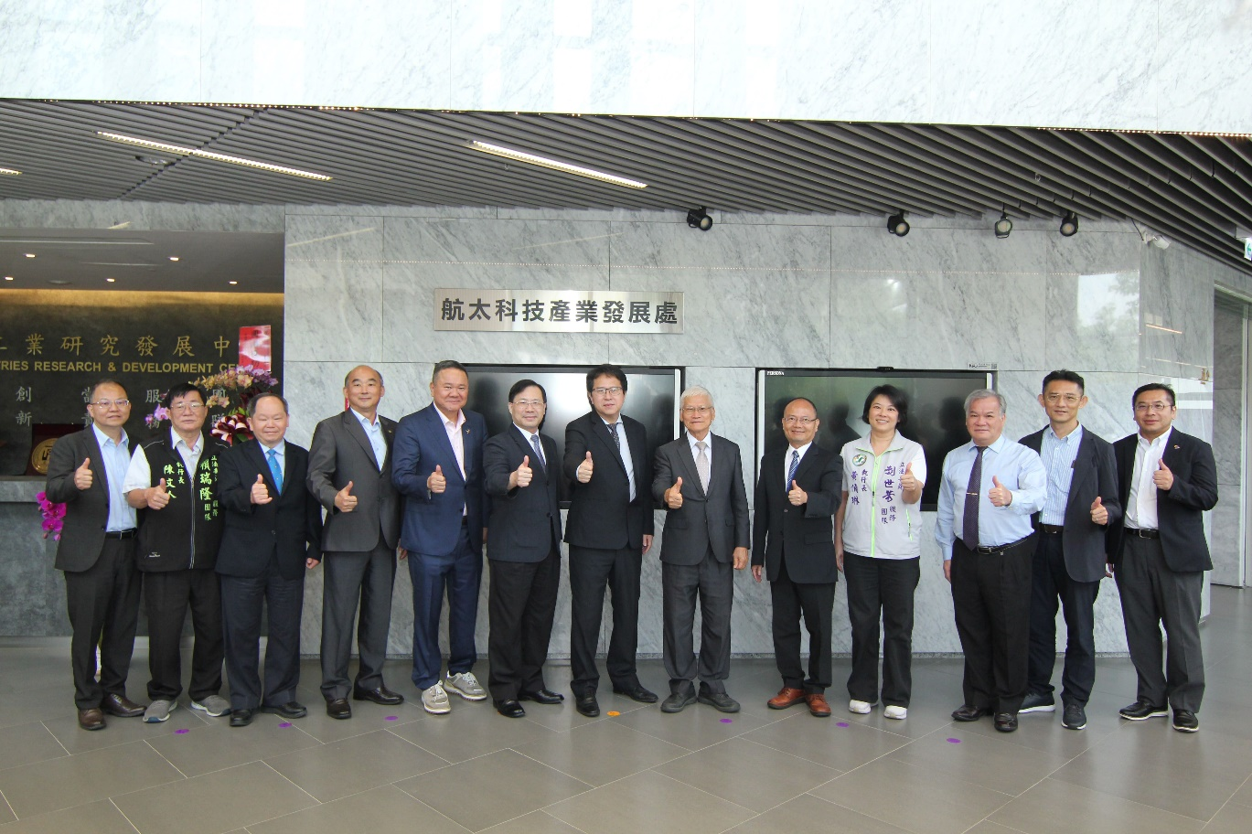

Picture 1、MIRDC's “Aerospace Science and Technology Industry Development Department” opening ceremony. Group photo with VIPs including Wen-Tsan Lu, Assistant Chief of Industrial Development Administration, Ministry of Economic Affairs、Wen-Ren Chen, CEO of the Legislator Jui-Lung Lai’s Office、Chun-Bin Chi Vice Director, Department of Industrial Technology, Ministry of Economic Affairs、Yun-Chun Hsieh, President of Magnate Technology Co.、Kun-Shen Wang, President of Drewloong Precision, Inc.、Vice Minister Chuan-Neng Lin from the Ministry of Economic Affairs、The legislator Chih-Wei Chiu、Ren-Yi Lin, Chairman of MIRDC、Yung-Hsiang Lai, President of MIRDC、Chun-Lin Huang, CEO of the Legislator Shyh-Fang Liu’s Office、Ten-Lin Lu, President of AirAsia、Zou-Zhong Guo, the chief of Industrial Development Administration, Ministry of Economic Affairs and Kuo-Hao Tseng, President of Aerowin Technology Corporation.

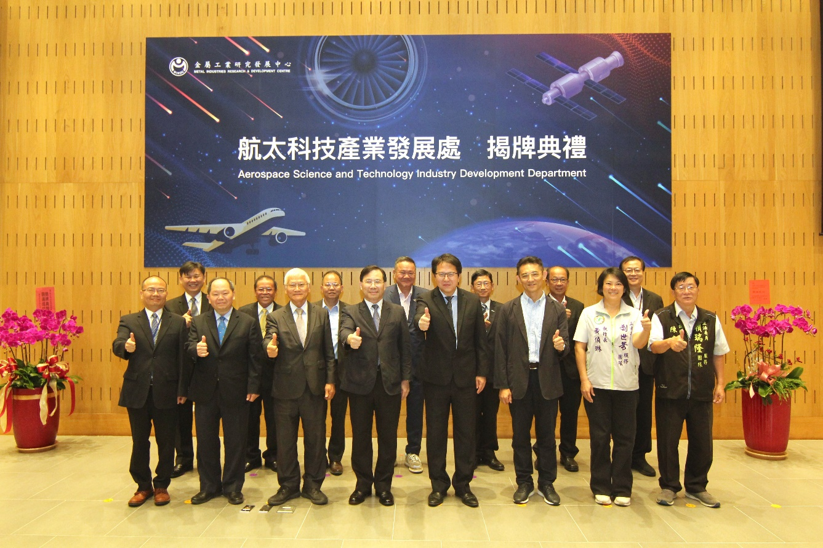

Picture2 、 Group photo of VIPs at the opening ceremony of “Aerospace Science and Technology Industry Development Department”

